please ask for:
direct line:
planning fax:
my ref:
your ref:
date:
Adam Birkett
01200 414571
01200 414487
3/2014/0436

31 July 2026

Applicant: Mr Andy Stanworth
Planning Application No: 3/2014/0436
Grid Ref: 374791 437678
Proposal: Prior notification of a proposed larger home extension. Proposed single storey rear extension to project beyond original rear wall by 3.5 metres, with a height to eaves of 2.65 metres and a maximum height of 3.65 metres.
Location: 1 Tithe Barn Cottage Pendleton Road Wiswell BB7 9BZ

Dear Sir/Madam

Town and Country Planning Act 1990
Town and Country Planning (General Permitted Development) Order 1995 (as amended)

42 Day Householder Prior Approval Application (Class A1 (e) of Part 1 of Schedule 2 of the Town and Country Planning (General Permitted Development) Order 1995 (as amended).

This is a notice about a proposed development that may affect your property. It is important that you read and understand this notice, because whether or not the local planning authority assess the impact of the proposed development is determined by whether or not any owner or occupier of any adjoining premises object to the proposed development. If you are not the only owner and occupier of your property, then you should forward a copy of this notice to all other owners and occupiers as soon as possible, because there is a deadline by which representations are to be received by the Local Planning Authority. The details of the proposed development are as follows:

The date by which representations are to be received by the local planning authority:

30 June 2014

Viewing the application
The application can be viewed at:
- Council Offices, Church Walk Clitheroe (8:45am – 5pm Mon – Fri)
- The Councils website at www.ribblevalley.gov.uk/planning

The local planning authority received the notification from the developer on 28 May 2014, and the date by which the local planning authority should issue a written notice to the developer is 8 July 2014.

This process is set out by condition A.4 of Schedule 2, Part 1, Class A of the Town and Country Planning (General Permitted Development) Order 1995 (as amended by SI 2008 No.2362 and SI 2013 No.1101).

It is important that you understand the following implications of whether or not you submit a representation to the local planning authority about the proposed development.

- If any of the owner or occupiers of any adjoining premises object to the proposed development, then the local planning authority will assess the impact of the proposed development on the amenity of any adjoining premises, and must take into account all representations made as a result of this consultation letter. The local planning authority will then decide either to give prior approval to the developer for the proposed development or to refuse prior approval for the proposed development.

- If none of the owners or occupiers of any adjoining premises object to the proposed development, then the local planning authority will not assess the impact of the proposed development on the amenity of any adjoining premises. The Local Planning Authority will then advise whether the proposed development can proceed.

Please also note the following:

- The term “representation” applies to most types of responses received by the local planning authority about a proposed development, including responses indicating objections, responses indicating support, and responses providing comments.
- For the purposes of this legislation, “height” is measured from the highest part of the surface of the natural ground immediately adjacent to the proposed development. If the proposed development includes parapet walls, then these may not be included in any reference to the “height of the eaves” of the proposed development.
- “Adjoining premises” refers to any property that shares a boundary (including to the rear) with the site the subject of the proposed development.

If you wish to submit a representation, then please ensure the following;

- That your representation is received by the local planning authority by 28-MAY-14. Recommendations after this date cannot be accepted.
- That your representation clearly states your name and address. Please note that if the address that you state is not the address of one of the adjoining premises, then the local planning authority will assume that you are not the owner or occupier of one of the adjoining premises (unless you clearly state otherwise).
- That your representation clearly states whether or not you object to the proposed development.

Please note that under the terms of the Local Government (Access to Information) Act 1985, any comments you make will be available for public inspection. (Please quote the above Application Reference in any correspondence)

You can write to me at the address below, or email planning@ribblevalley.gov.uk

All comments made will be taken into account in determining the application.

I regret that the Council is unable to enter into any written correspondence on this matter, but if you would like any further information, please contact the officer dealing with the notification on the above telephone number.

Yours faithfully
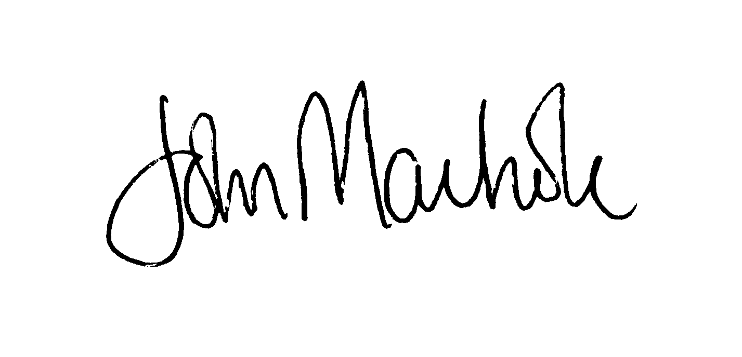
on behalf of
DIRECTOR OF DEVELOPMENT SERVICES

Please note:

HOUSEHOLDER APPLICATIONS: In the event of an appeal against the decision of this Council on planning applications classified as Householder Applications or Minor Commerical Applications there will not be an opportunity to send any further written comment to The Planning Inspectorate.
The Owner And/Or Occupier
STEPS COTTAGE
Pendleton Road
Wiswell
Lancashire
BB7 9BZ

