Urban Design Response |  |  |  |  | Officer: |  | Stephen Kilmartin
Description: | Pendle Hotel, Chatburn. |  |  |  |  |  | 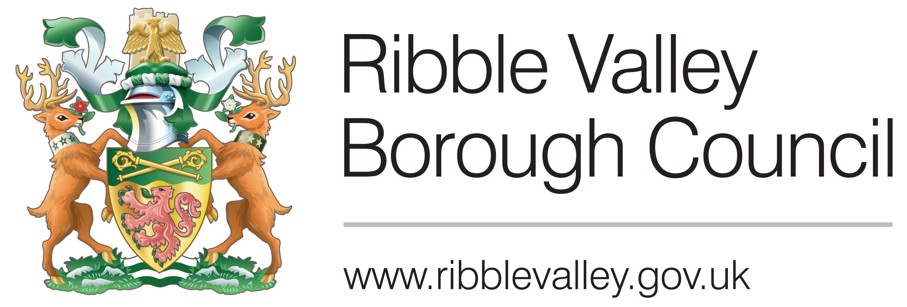
Application Ref: | 2014/1019 |  | Case Officer: |  | C.S
Response Ref: | 2014/1019/UDR/02 |  | Consult Date: |  | 03/03/15
Meeting Date: | N/A |  | Issue Date: |  | 05/03/15 |  | OFFICER REFERENCE ONLY
General Comments/Observations |  |  | DWG No: 1543/01B
  - Following the receipt of amended plans I still have outstanding concerns regarding the information associated with the application as follows:

- The north -west elevation fails to show details of the existing building.
- No existing/proposed land-levels/sections have been provided and it appears that the proposal involves the creation of a ‘lower ground floor’.
- A number of trees exist to the northern extents of the proposal site, no arboricultural impact assessment of tree constraints plan has been submitted in support of the application.
- No details of demolition/elements to be demolished have been submitted.
- The South West Elevation fails to show the proposed gable (which will project forward of existing building line).

There appears to be further conflict with a number of elevations failing to correspond as follows:

- S.E elevation: Gable element measures approximately 2.4m from roof interface to eaves; this conflicts with N.E Elevation which measures 1.6m at this point.
- N.E elevation: Main proposed roof ridge to proposed gable roof ridge measures 1.7m; this conflicts with a measurement of 1.3m on the N.W & S.E Elevation.
- S.E Elevation: roof interface point with existing building measures 4.5m below existing gable ridge; this conflicts with a measurement of 3.1m on the S.W Elevation.

  - Given the level of omissions/discrepancies contained within the application, notwithstanding detailed considerations, it is my opinion that the application should not be supported at this stage and would recommend refusal on the basis of conflicting information.

Observations: Design/External Appearance
South East Elevation

  - I have noted that the dormers have now been removed from this elevation.

  - I still have fundamental concerns regarding the overall treatment of this elevation. The ‘pediment gable’ is still disproportionate to the features found on the corresponding elevation on the existing building in scale and width, failing to be subservient to the parent property. I also consider that this element is poorly conceived insofar that its projection above the main ridge of the ‘proposed dwelling’ affords it unnecessary visual dominance upon approach this is compounded by its projection forward of the primary building line of the parent property/existing building affording it undue dominance (this has failed to be reflected on the S.W elevation).

North East Elevation

  - I maintain that the north east elevation appears to introduce window detailing that does not relate positively to the detailing found on the existing building (arched heads). I also consider the window proportioning fails to relate positively to those found on the existing building.

  - I would request that a section showing usable head heights be provided in respect of the high-level window serving bedroom 02 as I have concerns in respect of the bedroom being usable.

  - The north east elevation continues to raise concerns as covered in point 2.3 above in respect of the relationship of the gabled element and that of the ridge of the proposed dwelling and its overall response to the existing building.

North West Elevation

  - The elevations as presented still fail to show the position of existing openings or reflect any level of detail that is found on the existing building, I would therefore consider that an assessment of the relationship to the existing building cannot be made on the basis of the submitted information.

  - As previously stated, whilst I am not adverse to contemporary additions/introductions to non-designated heritage assets/period buildings. It is imperative that these are well considered and relate positively to the parent building. In this case it is my opinion that the detailing, scale and proportions of the primary gable (with recessed balcony) fail to respond positively to the parent building and would appear as an over-dominant and unsympathetic addition that would undermine the character and appearance of the area and that of the existing building.

  - I consider the window proportioning fails to relate positively to those found on the existing building.

  - I have noted that the dormers have been removed from this elevation.

Conclusions
  - Given the level of inaccuracies/omissions and concerns in relation to the overall design approach taken, it is my opinion that the proposal cannot be supported until these matters are resolved/clarified and do not consider that the amendments, as submitted, have addressed the previous concerns.

  - It is therefore my opinion that the application in its current form should be refused. Should you require clarification in relation to reasons for refusal please do not hesitate to consult me further.

  - The above observations have been provided on the basis of the level of information submitted and the comments contained within this response represent officer opinion only, at the time of writing, without prejudice.

 |  |  |  |  |  | Officer: |  | Stephen Kilmartin

