RECOMMENDATION FOR PLANNING AND DEVELOPMENT COMMITTEE

APPROVAL
DATE: December 2015
REF: SK
CHECKED BY:

APPLICATION NO: 3/2015/0759/P (GRID REF: SD 82476 8941)
REVISIONS TO HOUSE SITING, DESIGN AND ACCESS ROAD UNDER APPROVAL 3/2015/0167 FOR ERECTION OF 3 DETACHED DWELLINGS. LAND OFF MILL LANE, GISBURN BB7 4LN

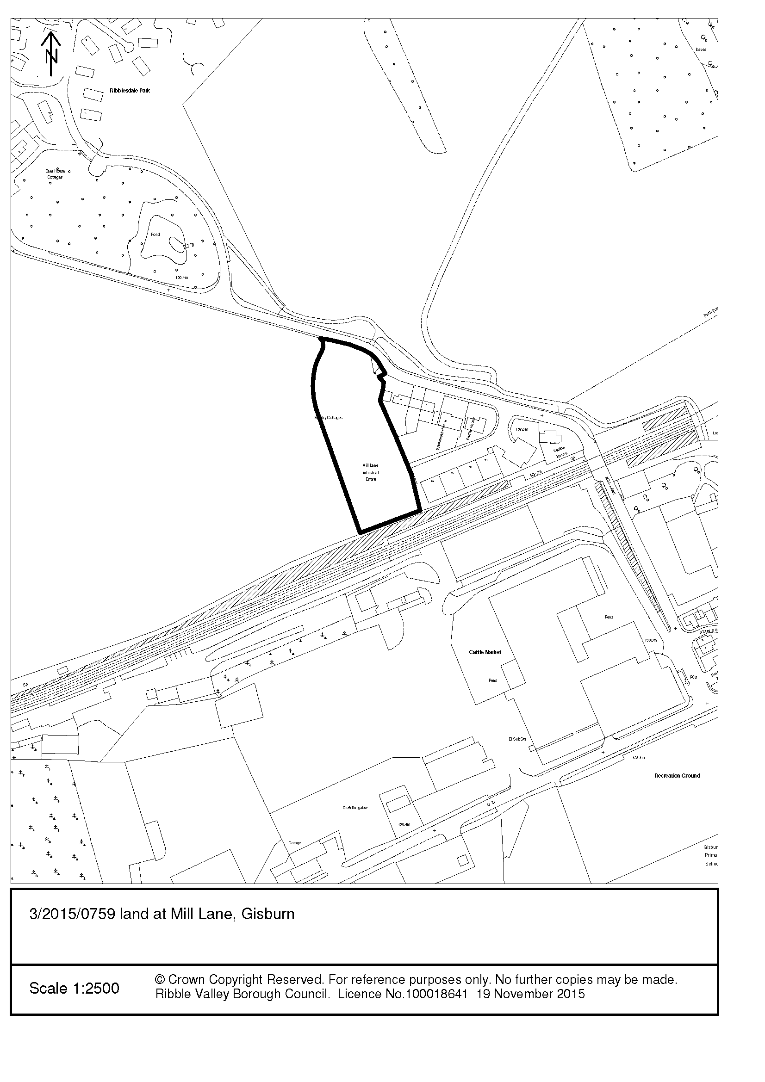
PARISH COUNCIL: | The Council object to the application. The changes to the intended layout of the development of three houses will result in an increased level of intrusiveness to the existing properties on Mill Lane which will border the development as well as increased noise levels for those same properties from the development’s road and occupants. The Parish Council believe that the changes to the development proposed are to the detriment of the residents of the existing properties on Mill Lane and are not readily justifiable.
ENVIRONMENT  DIRECTORATE  (COUNTY SURVEYOR): | No objections.
UNITED UTILITIES | No response received however members will note that no objection was raised in respect of the previous application (Ref: 3/2015/0167).
LCC ARCHAEOLOGY | No objections.
ADDITIONAL REPRESENTATIONS: | Letters of representation have been received from 12 households/addresses objecting on the following grounds:  - The repositioning of the dwellings will result in an unacceptable impact upon residential amenity  - It will lead to further applications on adjoining land  - The previously approved scheme had a lesser impact  - Noise from existing adjacent land uses  - The proposed access inadequate  - No provision of a pedestrian footway  - The new internal estate road will be of detriment to existing neighbouring amenities  - Increased light pollution  - No infrastructure capacity in the village for further housing  - Loss of privacy  - The proposal is contrary to the Adopted Core Strategy  - Impact upon the highway  - Impact upon existing business uses in the area  - Loss of wildlife  - The submission is not a minor amendment  - Devaluation of property  - Loss of view

1. Proposal

1.1 Consent is sought for the erection of three detached two-storey dwellings with associated garaging, landscaping and boundary treatments. The proposed dwellings will be faced in natural stone with natural slate roofs, the dwellings will be of a mock barn-conversion appearance employing cat-slide roof and dropped eaves arrangements.

1.2 The dwellings are served by a single point of access off Mill Lane with a dedicated shared drive continuing southward along the eastern extents of the site terminating in a turning head adjacent the drive to the southern-most plot.

1.3 The proposed dwellings are located to the west of the shared drive/access with vehicles being accommodated in dedicated detached garages. The majority of the plots benefit from a rearward western aspect over the defined open countryside with the primary elevations facing inward.

1.4 Curtilages will be delineated by post and rail fencing complimented by hedgerow planting, significant landscaping is proposed within the scheme with additional boundary landscaping to the western extents of the site to aid in minimising the visual impact of the development upon approach from the west. The application also details the creation of a new entry-point that will be delineated by the creation of a natural stone entrance feature wall with associated gating.

2. Site Location

2.1 The application site directly to the south of Mill Lane located within the Defined open Countryside and located outside, but adjacent, the defined settlement limit for Gisburn.

2.2 The site also lies within close proximity to the boundary of the Forest of Bowland AONB directly to the west. Directly to the east are a number of semi-detached and detached residential properties in a typically linear arrangement fronting Mill Lane. The application site occupies the north east corner of a large parcel of land that is currently in agricultural use with the application site being approximately 0.54 Ha in area.

3. Relevant History

3/2014/0300:
Outline application with some matters reserved for proposed construction of 28 no. residential properties (Refused)

3/2014/0701:
Outline application for the erection of three detached dwellings. (Refused)

3/2015/0167:
Proposed erection of 3 detached dwellings. (Approved with Conditions)

4. Relevant Policies

Key Statement DS1 – Development Strategy
Key Statement DS2 – Sustainable Development
Key Statement DMI2 – Transport Considerations
Policy DMG1 – General Considerations
Policy DMG2 – Strategic Considerations
Policy DMG3 – Transport & Mobility
Policy DMH3 – Dwellings in the Open Countryside
Policy EN2 – Landscape & Townscape Protection
Policy DME1 – Protecting Trees & Woodland
Policy DME2 – Landscape & Townscape Protection

National Planning Policy Framework (NPPF)

5. Environmental, AONB, Human Rights and Other Issues

5.1 Members will note that the principle of development of the site for residential purposes has been established as being acceptable through the granting of a previous consent (3/2015/0167 Erection of three detached dwellings), with the consent still remaining extant. It is therefore established that development of the site, for residential purposes for up to three dwellings is in accordance with Key Statement DS1 and the Development Strategy for the Borough with Gisburn being classed as a Tier 1 settlement to which the majority of the development (including other Principal and Tier 1 settlements) will be focused towards.

5.2 The proposal site lies directly to the west of 3 Smithy Cottages and Mil Lane Industrial Estate. A number of the dwellings benefit from an easterly aspect with offset distances ranging from 20 – 23.5m to the boundary of the residential curtilage of number 3 which is considered acceptable and it is not considered that there would be a detrimental impact upon residential amenities as a result of proximity or overbearing impact.

5.3 The dwellings adopt a semi-rural architectural language with natural stone heads, cills and surrounds being proposed. The dwellings have coach-door openings on their primary elevations which works in concert with the cat-slide roof and dropped eaves arrangements to ensure a positive response to the landscape context. It is proposed that the dwellings will be faced in natural stone with timber windows and black aluminium rainwater goods. In terms of external appearance and scale it is considered that the proposed dwellings represent an appropriate from of development and therefore are in accordance with aims and objectives of Policies DMG1 and DMH3 of the adopted Core Strategy.

5.4 A number of representations have been received in respect of additional impacts from the development when compared to the previous approval in that the current proposal proposes an internal roadway in close proximity to the eastern boundary, whereas the previous approval proposed gardens in this area. I note the concerns raised by objectors but consider that the impact as a result of the changes would not be unduly harmful to residential amenities and consider the offset distances proposed to be in excess of that which would raise any fundamental concerns relating to detrimental impact upon residential amenity.

5.5 Representations have been received in respect of the proposal setting a future precedent for further development and encroachment into the open countryside. Members will note that each case is determined upon its own merits and in this case do not consider such a precedent would be set.

6. Conclusion

6.1 Given the separation distances between existing and proposed dwellings and taking account of the orientation of primary habitable room windows I do not consider that the proposal would result in any significant detrimental impact upon existing or future residential amenity.

6.2 Whilst I am mindful that the current proposal represents a significant deviation to that of which has been previously approved, each application must be considered on its own merits. In this respect I do not consider that the application, as submitted, raises any material issues that would warrant the refusal to grant planning permission.

6.3 It is for the above reasons and having regard to all material considerations and matters raised that I recommend accordingly.

RECOMMENDATION: That planning permission be GRANTED subject to the following condition(s):

1. The development must be begun no later than the expiration of three years beginning with the date of this permission.

Reason: Required to be imposed in pursuance to Section 91 of the Town and Country Planning Act 1990.

2. Unless explicitly required by condition within this consent, the development hereby permitted shall be carried out in complete accordance with the proposals as detailed on drawings:

- Construction Section Detail (un-numbered)
- Access Plan and Site Plan (Drawing 2591.1)
- Proposed Elevations/Floorplans (Drawing: 2591.2)

REASON: For the avoidance of doubt and to clarify which plans are relevant to the consent.

3. Precise specifications or samples of all external surfaces, including surfacing materials of the development hereby approved shall have been submitted to and approved by the Local Planning Authority before their use in the proposed development.

REASON: In order that the Local Planning Authority may ensure that the materials to be used are appropriate to the locality in accordance with Policies DMG1 and DMH3 of the Ribble Valley Core Strategy.

4. All new and replacement windows shall be constructed in timber, details of which shall be submitted to and agreed in writing by the Local Planning Authority prior to their use in the development. For the avoidance of doubt the submitted details shall include elevational and section profiles/detail. The development shall be carried out in strict accordance with the approved details and thereafter retained unless otherwise agreed in writing by the Local Planning Authority.

REASON: In order that the Local Planning Authority may ensure that the detailed design of the proposal is appropriate to the locality and responds appropriately to the character of the area in accordance with Policies DMG1 and DMH3 of the Ribble Valley Core Strategy.

5. Notwithstanding the submitted details, prior to the commencement of the development, details of the proposed roof mounted Photovoltaic Panels, including section details, shall have been submitted to and approved by the Local Planning Authority. The development shall be carried out in strict accordance with the approved details.

REASON: In order that the Local Planning Authority may ensure that the detailed design and external appearance of the proposal is appropriate to the locality in accordance with Policies DMG1 and DMH3 of the Ribble Valley Core Strategy.

6. Notwithstanding the details shown upon the approved plans, the proposed roof lights shall be of the Conservation Type, recessed with a flush fitting, details of which shall be submitted to and approved by the Local Planning Authority prior to installation.

REASON: In order that the Local Planning Authority may ensure that the detailed design of the proposal does not undermine the character and appearance of the area in accordance with Policies DMG1 and DMH3 of the Ribble Valley Core Strategy.

7. Notwithstanding the submitted details, prior to the commencement of the development, details at a scale of not less than 1:20 of the proposed boundary treatments/fencing and walling shall have been submitted to and approved by the Local Planning Authority. For the avoidance of doubt the submitted details shall not include the provision of pier mounted ‘800 x 700 illuminated glass lanterns’ (as indicated on drawing 2591.1). The development shall be carried out in strict accordance with the approved details.

REASON: To protect the character and visual amenities of the area from inappropriate additions and in order that the Local Planning Authority may ensure that the detailed design and external appearance of the proposal is appropriate to the locality and reflective of its residential use in accordance with Policies DMG1 and DMH3 of the Ribble Valley Core Strategy.

8. The approved landscaping scheme shall be implemented in the first planting season following first occupation or use of the development and shall be maintained thereafter for a period of not less than 10 years to the satisfaction of the Local Planning Authority. This maintenance shall include the replacement of any tree or shrub which is removed, or dies, or is seriously damaged, or becomes seriously diseased, by a species of similar size to those original planted.

REASON: To ensure the proposal is satisfactorily landscaped and appropriate to the locality in accordance with Policies DMG1, DME1 and DME3 of the draft Ribble Valley Core Strategy.

9. Notwithstanding the submitted details, prior to the commencement of the development, including any site preparation works, details of measures to control the emission of dust and dirt during construction period of the development shall be submitted to and agreed by the Local Planning Authority. The approved details and Construction Method Statement shall be implemented, retained and adhered to throughout the construction period unless otherwise agreed in writing by the Local Planning Authority.

REASON: In the interests of protecting residential amenity from noise and disturbance and to ensure the safe operation of the highway during the construction phase of the development in accordance with Policies DMG1 and DMG3 of the Ribble Valley Core Strategy.

10. Notwithstanding the provisions of the Town and Country Planning (General Permitted Development) (England) Order 2015 or any Order revoking and re-enacting that Order, the dwelling hereby permitted shall not be altered or extended, no new windows shall be inserted, no alterations to the roof shall be undertaken and no buildings or structures shall be erected within the curtilage of the dwellings hereby approved unless planning permission has first been granted by the Local Planning Authority.

REASON: To enable the Local Planning Authority to exercise control over development which could materially harm the character and visual amenities of the immediate area in accordance with Policy DMG1 of the Ribble Valley Core Strategy.

11. The garage(s) hereby approved shall be kept available for the parking of vehicles ancillary to the enjoyment of the household(s) and shall not be used for any use that would preclude the ability for their use for the parking of private motor vehicles, whether or not permitted by the provisions of the Town and Country Planning (General Permitted Development) Order 2015 or any order amending or revoking and re-enacting that order.

REASON: To ensure to ensure that the development remains compatible with the character of the area that adequate parking provision is retained that limits the visual impact of the parked motor-vehicle upon the landscape in accordance with Policy DMG1 of the Ribble Valley Core Strategy.

