RECOMMENDATION FOR PLANNING AND DEVELOPMENT COMMITTEE

APPROVAL

DATE: 30 June 2016
REF: RH
CHECKED BY:

APPLICATION REF: 3/2016/0354

GRID REF: SD 374129 442357

DEVELOPMENT DESCRIPTION:

KITCHEN AND SUN ROOM EXTENSION TO SIDES AT THE BEECHES, WADDINGTON ROAD, CLITHEROE

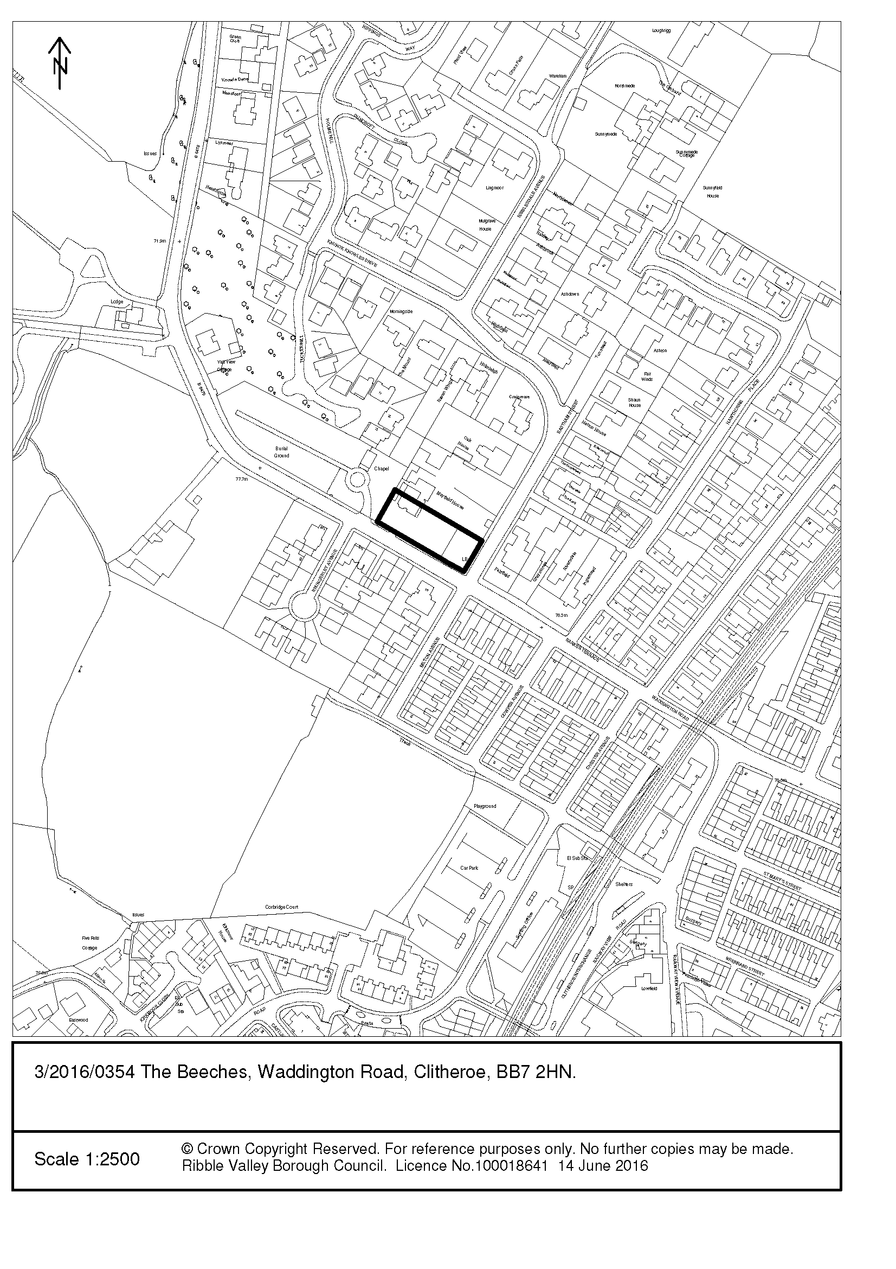
CONSULTEE RESPONSES/ REPRESENTATIONS MADE:

PARISH COUNCIL:

No objection.

HIGHWAYS:

No objection.

ADDITIONAL REPRESENTATIONS:

No representations have been received in respect of the proposed development.

1. Site Description and Surrounding Area

1.1 The application property is a substantial two storey semi-detached dwelling set within a large curtilage to the front and side of the property. The application site is located on the edge of the settlement of Clitheroe. The application property is faced with white render & red rosemary tile cladding, slate roof tiles and timber window frames and doors. It is noted that there are a number of semi-detached dwellings in the vicinity of varying design but similarly occupying large gardens.

2. Proposed Development for which consent is sought

2.1 Consent is sought for the erection of a kitchen extension to the west (side) elevation and a sun room extension to the east (side) elevation at The Beeches, Waddington Road, Clitheroe. The proposed kitchen extension will project 2.5m from the side elevation and have a width of 4.1m. It will have a pitched roof with an eaves height of 2.4m and a ridge height of 3.9m.The proposed sun room extension will project 3.5m from the side elevation and have a width of 5.8m. The proposed development will sit flush with the principle elevation. The proposal will have an eaves height of 2.7m and a ridge height of 4.8m.

3. Relevant Planning History

N/A

4. Relevant Policies

Ribble Valley Core Strategy
Policy DMG1 – General Considerations
Policy DMH5 – Residential & Curtilage Extensions

National Planning Policy Framework

5. Assessment of Proposed Development

5.1 Impact upon Residential Amenity:

5.1.1 It is important to consider the potential impact the proposed development would have on the residential amenity of the occupiers of nearby dwellings. There are no windows proposed on the side elevation of the kitchen, therefore it is considered that the extension would not harm the amenities of this neighbour through loss of light or outlook.

5.1.2 The proposed sun room includes the insertion of two windows to the north east elevation of the proposed extension. These would provide direct views over the private amenity space of Mayfield House. Following officer negotiation with the agent it has subsequently been agreed that the two windows will be heavily obscured and the window panel closest to the boundary will have boarding fitted to the inside. Therefore the extension would not harm the amenities of this neighbour through loss of light, privacy or outlook. Should consent be granted, the use of obscure glass shall be sought via a condition.

5.2 Visual Amenity/External Appearance:

5.2.1 Policies DMG1 and DMH5 of the Ribble Valley Core Strategy requires extensions to be in keeping with the existing house and the surrounding buildings in terms of scale, size, design and facing materials. Any extension should be well proportioned and sit comfortably with the original building. It should respect the scale and proportions of the original dwelling and should not overwhelm it. Furthermore, new development should make a positive contribution to the local character and distinctiveness of the existing building.In terms of its design, the proposed extensions would be commensurate to the scale of the main dwelling; they would be set down considerably from the ridge line of the existing dwelling.

5.2.2 It is proposed to use white render & red rosemary tile cladding, slate roof tiles and timber
window frames and doors; it is considered that matching materials would maintain coherence between the main dwelling and the proposed development. It would not result in any harm to the appearance of the host dwelling or the surrounding area and would accord with Ribble Valley Core Strategy Policies DMG1 and DMH5.

6. Observations/Consideration of Matters Raised/Conclusion

6.1 The proposed development would not result in any significant harm to the character and appearance of the existing dwelling or the surrounding area, nor will it cause any significant harm to the amenity of neighbouring residents. The proposal would not have an unacceptable impact on protected species or highways safety. Accordingly, it is recommended that the application be approved.

RECOMMENDATION: That the application be APPROVED subject to the imposition of the following condition(s):

1. The development hereby permitted shall be commenced before the expiration of three years from the date of this permission.

REASON: Required to be imposed pursuant to Section 91 of the Town and Country Planning Act 1990 as amended by Section 51 of the Planning and Compulsory Purchase Act 2004.

2. Unless explicitly required by condition within this consent, the development hereby permitted shall be carried out in complete accordance with the proposals as detailed on drawing:

Plan & Elevations - Drg No. 410/1/2 Rev B – Received 27/05/2016

REASON: For the avoidance of doubt and to clarify which plans are relevant to the consent.

3. Notwithstanding the submitted details, precise specifications or samples of all external surfaces, including surfacing materials and their extents, of the development hereby permitted shall have been submitted to and approved by the Local Planning Authority before their use in the proposed development. The approved materials shall be implemented within the development in strict accordance with the approved details.

REASON: In order that the Local Planning Authority may ensure that the materials to be used are appropriate to the locality in accordance with Policies DMG1 and DMH5 of the Ribble Valley Core Strategy.

4. The two proposed windows which are to be introduced into the north east elevation of the sun room extension (Drg No. 410/1/2 Rev B) shall be fitted with obscure glazing (which shall have an obscurity rating of not less than 4 on the Pilkington glass obscurity rating or equivalent scale) and shall be non-opening, unless the parts of the window which can be opened are more than 1.7 metres above the floor of the room in which the window is installed. The windows shall remain in that manner in perpetuity at all times unless otherwise agreed in writing by the Local Planning Authority.

REASON: To protect nearby residential amenity in accordance with Policy DMG1 of the Ribble Valley Core Strategy.

BACKGROUND PAPERS

https://www.ribblevalley.gov.uk/site/scripts/planx_details.php?appNumber=3%2F2016%2F0354

