RECOMMENDATION FOR PLANNING AND DEVELOPMENT COMMITTEE

APPROVAL

DATE: 18 AUGUST 2016
REF: RH
CHECKED BY:

APPLICATION REF: 3/2016/0354

GRID REF: SD 374129 442357

DEVELOPMENT DESCRIPTION:

Kitchen and sun room extension to sides at The Beeches, Waddington Road, Clitheroe

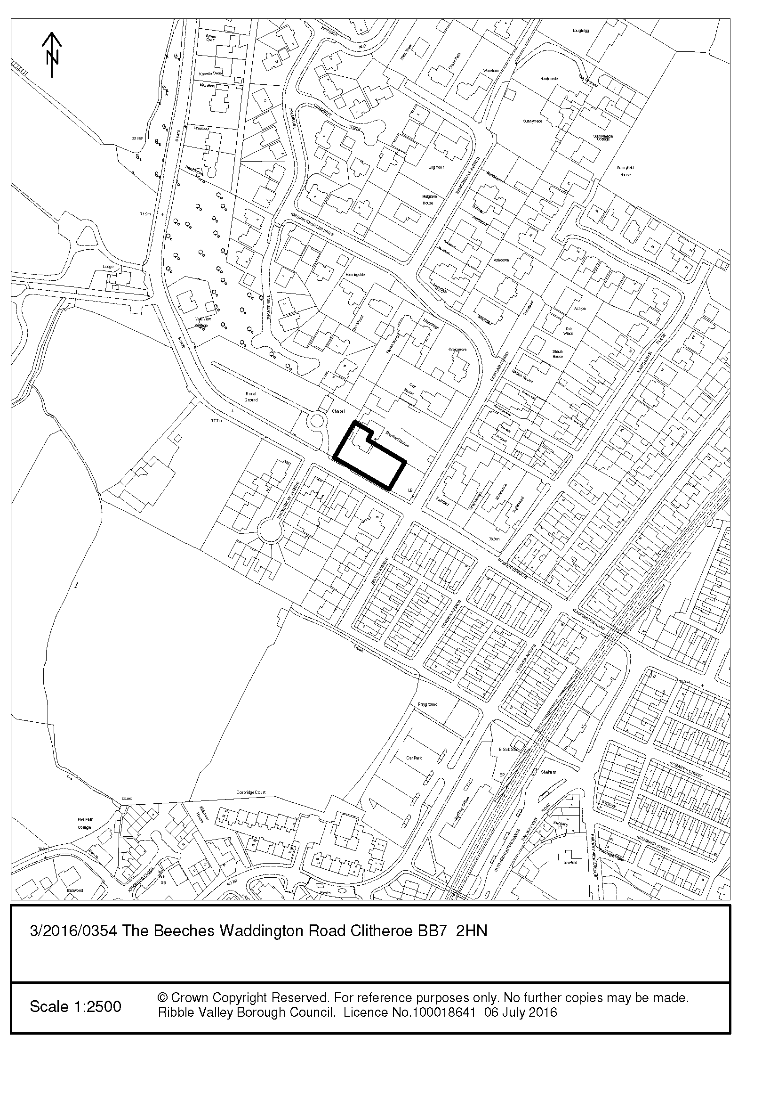
CONSULTEE RESPONSES/ REPRESENTATIONS MADE:

PARISH COUNCIL:

No objection.

HIGHWAYS:

No objection.

ADDITIONAL REPRESENTATIONS:

Letters of representation have been received from 2 individual households objecting to the application on the following grounds:

(Some of the comments relate to prior submission of the tree report)

- Closeness of proposed sun room to shared boundary
- Loss of outlook/view from bay window
- Noise pollution
- Threat to biodiversity
- Insufficient detail on the impact the proposed work would have on the tree
- Loss or damage to the boundary fence
- Threat to original features of a non-designated historical asset
- Loss of amenity due to overlooking, overbearing and loss of light issues.

1. Site Description and Surrounding Area

1.1 The application property is a substantial two storey semi-detached dwelling set within a large curtilage to the front and side of the property. The application site is located on the edge of the settlement of Clitheroe. The application property is faced with white render & red rosemary tile cladding, slate roof tiles and timber window frames and doors. It is noted that there are a number of semi-detached dwellings in the vicinity of varying design but similarly occupying large gardens.

2. Proposed Development for which consent is sought

2.1 The original planning application included details for the erection of a kitchen extension to the west (side) elevation and a sun room extension to the east (side) elevation of the application dwelling. The proposed kitchen extension has subsequently been removed from the proposed application as the works constitutes permitted development so can be constructed without the need for planning consent.

2.2 Consent is sought for the erection of a sun room extension to the east (side) elevation at The Beeches, Waddington Road, Clitheroe. This has also been amended in part to take into account the tree report. The proposed sun room extension will project outwards from the side elevation 3.550m and will have a width of 5.600m resulting in the proposed development sitting flush with the principle elevation. It will have a pitched roof with an eaves height of 2.950m and a ridge height of 4m. The proposal will be clad in cement render, solar/active tinted selfclean roof glass, cream grain PVC framework and Georgian gothic arches to lower window frames.

3. Relevant Planning History

N/A

4. Relevant Policies

Ribble Valley Core Strategy
Policy DMG1 – General Considerations
Policy DMH5 – Residential & Curtilage Extensions
Policy DME1– Protecting Trees and Woodlands

National Planning Policy Framework

5. Assessment of Proposed Development

5.1 Impact upon Residential Amenity:

5.1.1 It is important to consider the potential impact the proposed development would have on the residential amenity of the occupiers of nearby dwellings.

5.1.2 The proposed sun room includes the insertion of windows to the north east elevation of the proposed extension. These would provide direct views over the private amenity space of Mayfield House. Following officer negotiation with the agent it has subsequently been agreed that these windows will be heavily obscured and non-opening. I note the objections but do not consider that the proposed development would result in any significant harm to the amenities of this neighbour through loss of light, privacy or outlook. Should consent be granted, the use of obscure glass shall be sought via a condition.

5.1.3 The objections which were raised related primarily to the overbearing size of the proposal and the impact the development would have on the adjoining property Mayfield House through loss of outlook and light, noise pollution and loss of outlook/view from bay window. It should be noted that the sun room has been moved away from the shared boundary by 0.8m and the proposed materials have been altered, due to the redesign it has resulted in a reduction of the roof pitch to 20 degrees. With this in mind it is considered that the proposed development would not have an unacceptable impact on the amenity of the occupiers. The proposed extension is modest in size and whilst is may result in some loss of light to the neighbour’s bay window this would not warrant refusal.

5.1.4 The objections which were raised relating to loss of view of the castle, access to maintain the proposed development, loss/damage to boundary fencing, boxing in of shared drain pipe are not material considerations and should not be taken into account when assessing the application.

5.2 Visual Amenity/External Appearance:

5.2.1 Policies DMG1 and DMH5 of the Ribble Valley Core Strategy requires extensions to be in keeping with the existing house and the surrounding buildings in terms of scale, size, design and facing materials. Any extension should be well proportioned and sit comfortably with the original building. It should respect the scale and proportions of the original dwelling and should not overwhelm it. Furthermore, new development should make a positive contribution to the local character and distinctiveness of the existing building.In terms of its design, the proposed extensions would be commensurate to the scale of the main dwelling; they would be set down considerably from the ridge line of the existing dwelling.

5.2.2 It is considered that the proposed development would not adversely harm the historical features of the existing dwelling nor would it result in any harm to the host dwelling or the surrounding area, the materials proposed would maintain coherence between the main dwelling and the proposed development and would accord with Ribble Valley Core Strategy Policies DMG1 and DMH5.

5.3 Landscape/Ecology:

5.3.1 In respect of trees, the application is accompanied by an Arboricultural Report. Three individual trees were surveyed in respect of the proposed development. The trees were allocated a high retention value (Category A), a moderate retention value (Category B) and to be unsuitable for retention (Category U), with the latter being recommended for removal as soon as is practicable for risk management reasons. The report concluded that T1 was offered a high retention value, T2 a moderate retention value and T3 was unsuitable for retention.

5.3.2 The submitted report found that the proposed extension would encroach 6.5% into the total Root Protection Area (RPA) of tree T1 a Cut-Leaf Beech. It is noted that Section 7.5 of BS5837:2012 states that: “The insertion of specially engineered structure within RPAs may be justified if this enabled the retention of a good quality tree that would otherwise be lost (usually categories A or B)” and that “Root damage can be minimized by using:

- Piles, with site investigation used to determine their optimal location whilst avoiding damage to roots important for the stability of the tree, by means of hand tools or compressed air spoil displacement, to a minimum depth of 600mm; and
- Beams, laid at or above ground level, and cantilevered as necessary to avoid tree roots by side investigation.”

5.3.3 It was concluded that in order to construct the extension in the proposed located it would be necessary to use a pile and beam foundation systems, with the beam sat at or above current ground levels and a void between the underside of the structures floor and the existing ground.

5.3.4 In view of the above, the Council’s Countryside Officer has raised no objection to the planning application. Should consent be granted, a condition shall be attached to the permission to ensure that no development, including any site preparation, demolition, clearance or tree works/removal shall commence or be undertaken on site unless/until the details of a detailed specification drawing for a beam on a pile foundation in accordance with BS5837 Trees in Relation to Demolition, Design and Construction [special materials & working methods for proposed construction within root protection areas] has been submitted to and approved in writing by the Local Planning Authority.

6 Observations/Consideration of Matters Raised/Conclusion

6.1 The proposed development would not result in any significant harm to the character and appearance of the existing dwelling or the surrounding area, nor will it cause any significant harm to the amenity of neighbouring residents. The proposal would not have an unacceptable impact on protected species or highways safety. Accordingly, it is recommended that the application be approved.

RECOMMENDATION: That the application be APPROVED subject to the imposition of the following condition(s):

1. The development hereby permitted shall be commenced before the expiration of three years from the date of this permission.

REASON: Required to be imposed pursuant to Section 91 of the Town and Country Planning Act 1990 as amended by Section 51 of the Planning and Compulsory Purchase Act 2004.

2. Unless explicitly required by condition within this consent, the development hereby permitted shall be carried out in complete accordance with the proposals as detailed on drawing:

Amended Design – Sun room/conservatory (Received 01/08/2016)

REASON: For the avoidance of doubt and to clarify which plans are relevant to the consent.

3. Notwithstanding the submitted details, precise specifications or samples of all external surfaces, including surfacing materials and their extents, of the development hereby permitted shall have been submitted to and approved by the Local Planning Authority before their use in the proposed development. The approved materials shall be implemented within the development in strict accordance with the approved details.

REASON: In order that the Local Planning Authority may ensure that the materials to be used are appropriate to the locality in accordance with Policies DMG1 and DMH5 of the Ribble Valley Core Strategy.

4. The proposed windows which are to be introduced into the north east elevation of the sun room extension (Amended Design – Sun room/conservatory (Received 01/08/2016) shall be fitted with obscure glazing (which shall have an obscurity rating of not less than 4 on the Pilkington glass obscurity rating or equivalent scale) and shall be non-opening, unless the parts of the window which can be opened are more than 1.7 metres above the floor of the room in which the window is installed. The windows shall remain in that manner in perpetuity at all times unless otherwise agreed in writing by the Local Planning Authority.

REASON: To protect nearby residential amenity in accordance with Policy DMG1 of the Ribble Valley Core Strategy.

5. Notwithstanding the submitted details, no development, including any site preparation, demolition, scrub/hedgerow clearance or tree works/removal shall commence or be undertaken on site unless and until the details of a detailed specification drawing for a beam on a pile foundation in accordance with BS5837 Trees in Relation to Demolition, Design and Construction [special materials & working methods for proposed construction within root protection areas] has been submitted to and approved in writing by the Local Planning Authority.

The details as submitted shall also include tree protection fencing in accordance with BS5837 (2012): ‘Trees in Relation to Construction’ for trees identified T1 and T3 in the Arboricultural Impact Assessment. Such fencing shall be erected in its entirety prior to any other operations taking place on the site. This fencing should not be breached or removed during development. Furthermore within the areas so fenced the existing ground level shall be neither raised nor lowered and there shall be no development or development-related activity of any description including the deposit of spoil or the storage of materials unless expressly agreed by the Local Planning Authority.

REASON: To protect trees/hedging of landscape and visual amenity value on and adjacent to the site or those likely to be affected by the proposed development in accordance with Policies DMG1 and DME1 of the Ribble Valley Core Strategy.

BACKGROUND PAPERS

https://www.ribblevalley.gov.uk/site/scripts/planx_details.php?appNumber=3%2F2016%2F0354

