RECOMMENDATION FOR PLANNING AND DEVELOPMENT COMMITTEE

REFUSAL

DATE: 18 August 2016
REF: AD
CHECKED BY:

APPLICATION REF: 3/2016/0442

GRID REF: SD 377848 444341

DEVELOPMENT DESCRIPTION:

CHANGE OF USE OF AGRICULTURAL LAND TO CAR PARK FOR GREENDALE VIEW CAFÉ AT LAND AT TOWNHEAD FARM, DOWNHAM ROAD, CHATBURN

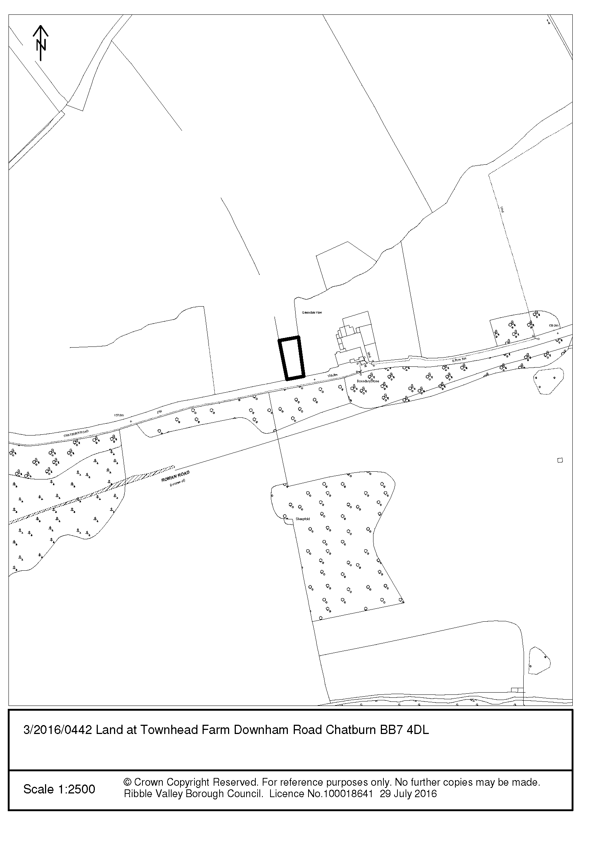
CONSULTEE RESPONSES/ REPRESENTATIONS MADE:

PARISH COUNCIL:

No observations to make.

ENVIRONMENT DIRECTORATE (COUNTY SURVEYOR):

The Highway Development Control Section does not have any objections regarding the proposed Change of use of agricultural land to car park and are of the opinion that the proposed development should have a negligible impact on highway safety and highway capacity in the immediate vicinity of the site.

It is also explained that the new vehicular access, within the adopted highway fronting the property will need to be constructed under a section 184 agreement of the 1980 Highways Act (Vehicle crossings over footways and verges) and 5 conditions are suggested as part of the formal planning decision.

HISTORIC ENGLAND:

Do not consider it necessary for this application to be notified to Historic England.

LEAD LOCAL FLOOD AUTHORITY:

No comment because LLFA Flood Risk Standing Advice should have been applied and the proposals are not listed in the ‘When to Consult the LLFA’ document or in the Development Management Procedure Order 2010.

UNITED UTILITIES:
Consulted, no representations received at time of report writing.

LCC AONB OFFICER:

Consulted, no representations received at time of report writing.

ADDITIONAL REPRESENTATIONS:

None received.

1. Site Description and Surrounding Area

1.1 Greendale View is a late C19 stone built house now converted to a café. It lies at the top of a north-west facing escarpment in the open countryside between Chatburn and Downham (outside of both village boundaries shown in the 1998 Local Plan). The escarpment forms the north-western boundary of the Forest of Bowland AONB Pendle Hill outlier; local topography results in strong inter-visibility with the main body of the AONB to the north. The application site is immediately west of the existing Greendale View curtilage.

1.2 The boundary treatment of Greendale View and the proposed car park site with the road comprises traditional and more formal walling/gate posts and hedgerow. The site faces the continuous stone wall boundary to the gardens of Downham Hall (Grade II* listed; ‘Country house, 1835, by George Webster’- list description) which also forms the northern boundary to Downham Conservation Area (the Conservation Area boundary extends to the west just beyond the application site before it returns to the south). The site is within the setting of and is inter-visible with Downham Conservation Area. The site may be considered to be within the setting of the listed building if the garden wall is considered to be a curtilage structure to the principal building [section 1(5) Planning (Listed Buildings and Conservation Areas) Act 1990.

1.3 The Downham Conservation Area Appraisal (The Conservation Studio consultants, 2005; subject to public consultation) identifies:

“Downham Hall and Parkland to the west”; “remarkable surviving historic appearance, with almost complete lack of 20th century alterations and accretions”; “spacious layout devoid of 20th century infill”; “rural setting of the village”; “trees, both in the surrounding landscape and beside the road”; “local details … stone boundary walls” (Summary of special interest);

“The Conservation Area boundary encloses the whole of the village settlement and parkland west of Downham Hall which is important to its setting … unlike many similar English villages, Downham has not suffered from loss of open space due to 20th century infill or construction of garages or off-road parking” (The character of spaces within the area);

“The prevalence of stone as a building material, not only in habitable buildings, but also for walls, gate piers … unifies the Conservation Area, giving it a distinctive local identity and harmonising the many elements of the built environment” (Building methods, materials and local details);

“The Conservation Area is notable for its stone boundary walls … stone gate piers are also a feature” (Local details and features);

“Picturesque rural village popular with tourists; dedicated tourist parking; exceptionally unspoilt character and appearance”; “absence of road markings” (Strengths);

“The current main threat to the character and appearance of the Conservation Area is traffic and the pressure of tourism” (Threats).

1.4 A line of mature trees runs north-south and approximates to the western boundary of the proposed car park.

2. Proposed Development for which consent is sought

2.1 Planning permission is sought for the change of use of agricultural (grazing) land and associated works to car park. The car park area is 575 m2 and is proposed to provide 13 parking spaces (3 disability spaces).

2.2 A 2.4m x 60m visibility splay is shown necessitating the demolition/modification of boundary walling and gate posts. Macadam surfacing is shown between the edge of the public highway and a new gate which is indented 6.5m into the site.

2.3 A Tree Survey has not been submitted despite works obviously being within influencing distance of the development.

2.4 The Design and Access Statement suggests that the car park is required: to sustain the current tenant’s business model (reliant on passing trade which may be dissuaded by number of roadside parked cars); allow safe movement of pedestrians from vehicles to café (no existing footpath and national speed limit applies); improve the visual amenity of the approach to the Conservation Area and provide improved safety for general users of the highway.

2.5 The Design and Access Statement suggests that locating a car park within the curtilage of Greendale View has been discounted because customers want to eat outside and enjoy their surroundings and views and the tenants will lose their personal space.

2.6 The application includes a letter of support from Councillor G. Scott (Chatburn Ward) which, in summary, is concerned at the National Speed Limit on this road and advocates the proposed car park because of the improved pedestrian and vehicular highway safety and help to securing the future of the café through removal of vehicles from the highway.

3. Relevant Planning History

3.1 Pre-application advice was provided in respect of the proposed development on 26 February 2016. Concern was expressed that the proposed roadside boundary modifications (loss of distinct walling and hedgerow) and car park would be incongruous, conspicuous and intrusive in the landscape and of harm to the character of the Forest of Bowland Area of Outstanding Natural Beauty and the character and appearance of Downham Conservation Area.

3.2 There is no planning record of a change of use of the site to a café suggesting the long-standing operation of the business.

4. Relevant Policies

Ribble Valley Core Strategy:

Key Statement DS1 – Development Strategy
Key Statement DS2 – Sustainable Development
Key Statement EN2 – Landscape
Key Statement EC1 – Business and Employment Development
Key Statement EN5 – Heritage Assets
Policy DMG1 – General Considerations
Policy DMG2 – Strategic Considerations
Policy DMG3 – Transport and Mobility
Policy DME4 – Heritage Assets
Policy DME2 – Landscape and Townscape Protection
Policy DMB1 - Supporting Business Growth and the Local Economy
Policy DMB3 – Recreation and Tourism Development
Planning (Listed Buildings and Conservation Areas) Act 1990

National Planning Policy Framework (NPPF)
National Planning Practice Guidance (NPPG)
5. Assessment of Proposed Development

5.1 Land use

5.1.1 The site lies within the open countryside outside the settlements of Downham and Chatburn. It is also within the Forest of Bowland Area of Outstanding Natural Beauty.

5.1.2 Key Statement DS1 of the adopted Core Strategy sets out the development strategy for the Borough. It seeks to direct the majority of new retail and leisure development toward the centres of Clitheroe, Longridge and Whalley. In addition, development will be focussed towards the Tier 1 villages (Chatburn) which are the more sustainable of the 32 defined settlements. In the remaining Tier 2 Village Settlements (Downham) development will need to meet proven local needs or deliver regeneration benefits. Considerations will include proposed small scale developments in the smaller settlements that are appropriate for consolidation and expansion or rounding off of the built up area.

5.1.3 Key Statement DS1 also states that the Council will have regard to the AONB in consideration to the scale, extent and form of development.

5.1.4 Policy DMG2 sets out further detail in relation to the strategic requirements of the plan. It effectively sets out exceptions which might be considered in relation to development within the Tier 2 villages and locations outside the defined settlement areas. These include:

“1. The development should be essential to the local economy or social well-being of the area.
4. The development is for small scale tourism or recreational developments appropriate to a rural area.
5. The development is for small-scale uses appropriate to a rural area where a local need or benefit can be demonstrated”.
5.1.5 In respect to such considerations, DMG2 also states:

“Within the open countryside development will be required to be in keeping with the character of the landscape and acknowledge the special qualities of the area by virtue of its size, design, use of materials, landscaping and siting” and

“In protecting the designated Area of Outstanding Natural Beauty the Council will have regard to the economic and social wellbeing of the area. However, the most important consideration in the assessment of any development proposals will be the protection, conservation and enhancement of the landscape and character of the area … development will be required to be in keeping with the character of the landscape and acknowledge the special qualities of the AONB by virtue of its size, design, use of material, landscaping and siting”.

5.1.6 Furthermore, Key Statement EN2: Landscape identifies in respect to the AONB that “Any development will need to contribute to the conservation of the natural beauty of the area” and will be expected “to be in keeping with the character of the landscape, reflecting local distinctiveness, vernacular style, scale, style, features and building materials”.

5.1.7 Policy DMB1 (Supporting Business Growth and the Local Economy) also emphasises the requirement of compatibility of new development with its landscape:

“The expansion of established firms on land outside settlements will be allowed provided it is essential to maintain the existing source of employment and can be assimilated within the local landscape”.

5.1.8 In my opinion, the proposed car park (which is outside a settlement and not in a suitable location for the rounding off of built development) and associated alterations to traditional walling and gateposts will be incongruous, conspicuous and intrusive in the landscape and of harm to the character of the Forest of Bowland Area of Outstanding Natural Beauty.

5.1.9 Policy DMG3 of the Core Strategy recognises that transport considerations are key to the delivery of sustainable development. Such considerations were a key part in defining the settlement hierarchy which now forms the basis of Key Statement DS1. In my opinion, the location could not be considered highly accessible by public transport and is likely to increase car borne journeys.

5.2 Setting of Downham Conservation Area and Downham Hall

5.2.1 The duties at section 72 and section 66 of the Planning (Listed Buildings and Conservation Areas) Act 1990 require that ‘special attention’ and ‘special regard’ be given to the desirability of preserving (‘doing no harm’) or enhancing the character or appearance of a conservation area and the preserving of the setting of a listed building.

5.2.2 Policy DME4 (Protecting Heritage Assets) of the Core Strategy also relates to the setting and views into and out of conservation areas and considerations to the setting of listed buildings:

“Conservation Areas:

Proposals within, or affecting views into and out of, or affecting the setting of a conservation area will be required to conserve and where appropriate enhance its character and appearance and those elements which contribute towards its significance. This should include considerations as to whether it conserves or enhances the special architectural and historic character of the area, as set out in the relevant Conservation Area Appraisal. Development which makes a positive contribution and conserves and enhances the character, appearance and significance of the area in terms of its location, scale, size, design and materials and existing buildings, structures, trees and open spaces will be supported

Listed Buildings:

“Alterations or extensions to listed buildings or buildings of local heritage interest, or development proposals on sites within their setting which cause harm to the significance of the heritage asset will not be supported”.

5.2.3 The Downham Conservation Area Appraisal identifies that Downham Hall and its Parkland, the lack of ostensibly modern development (including off-road parking and road markings), the village’s rural setting, trees beside the road and local stone walling are key to its significance. In my opinion, the proposed roadside boundary modifications and car park will be incongruous, conspicuous and intrusive and of harm to the character and appearance of Downham Conservation Area.

5.2.4 The harmful impact of proposed development on the designated heritage asset should also to be considered in respect to the importance of the cultural heritage of the AONB (NPPF paragraph 115) which is described in the Forest of Bowland AONB Management Plan April 2014 - March 2019:

“The area was designated as a landscape of national significance due to a variety of factors, including… the landscape’s historic and cultural associations … the distinctive pattern of settlements”.

“Collectively these historic and cultural elements of the environment serve to enrich the landscape’s scenic quality, meaning and value”.

5.2.5 The status of the Downham Hall parkland boundary wall is unclear and possible concerns as to the impact upon the setting of the listed building are therefore not reflected in the refusal recommendations.

5.3 Landscape/Ecology:

5.3.1 Policy DME2 (Landscape and Townscape Protection) states:

“Development proposals will be refused which significantly harm important landscape or landscape features including:
- traditional stone walls
- hedgerows and individual trees”.

In my opinion, the proposed alterations to walling in order to meet safe access to the car park does represent significant harm to the landscape feature.

In the absence of a Tree Survey, the Borough Council’s Countryside Officer is to undertake an amenity assessment of the trees within influencing distance of the proposed development. The results of the assessment and any recommendations will be reported verbally to Committee.

5.4 Highway Safety and Accessibility

5.4.1 I am satisfied that the proposed development implemented in accordance with the conditions recommended by Lancashire County Council (Highways) would have an acceptable impact upon highway safety. I am mindful that one of these conditions requires:

“Before the access is used for vehicular purposes, that part of the access extending from the highway boundary for a minimum distance of 6m into the site shall be appropriately paved in tarmacadam, concrete, block paviours, or other approved materials.

Reason: To prevent loose surface material from being carried on to the public highway thus causing a potential source of danger to other road users”.

I am also mindful that whilst Lancashire County Council (Highways) does not have any objections to the scheme, its comments do not suggest any particular requirement for the proposed car park scheme.

5.5 Impact upon Residential Amenity

5.5.1 In my opinion, the proposals do not have a significant impact upon the amenity of adjoining or nearby residents.

6. Observations/Consideration of Matters Raised/Conclusion

6.1 Mindful of NPPG (“In general terms, substantial harm is a high test, so it may not arise in many cases”) I consider the impact to the character and appearance of Downham Conservation Area to be less than substantial harm. In my opinion, clear and convincing justification (NPPF paragraph 132) for the harm to the designated heritage asset has not been submitted and it is therefore difficult to assess and weigh the importance of public benefits (NPPF paragraph 134).

6.2 Therefore, in giving considerable importance and weight to the duties at section 16 and 66 of the Planning (Listed Buildings and Conservation Areas) Act 1990, in giving ‘great weight’ to the conservation of the designated heritage asset (NPPF paragraph 132) and in consideration to Key Statements DS1, DS2, EN2 and EN5 and Policies DMG1, DMG2, DMG3, DMB1, DME4 and DME2 of the Ribble Valley Core Strategy, I would recommend that planning permission be refused.

RECOMMENDATION: That the application be REFUSED for the following reasons:

1. The proposal is considered contrary to Key Statements DS1 and EN2 and Policies DMG1, DMG2, DMB1 and DME2 of the Ribble Valley Core Strategy Adopted Version in that the car park would be incongruous, conspicuous and intrusive in the defined open countryside within the Forest of Bowland Area of Outstanding Natural Beauty and harmful to the development strategy for the borough. It is further considered that the approval of this application would lead to an unsustainable form of development placing further reliance on the private motor-vehicle contrary to the NPPF presumption in favour of sustainable development.

2. The proposal is harmful to the character and appearance of Downham Conservation Area and the cultural heritage of the Forest of Bowland Area of Outstanding Natural Beauty because the car park and associated traditional boundary wall modifications are prominent, ostensibly modern and suburban in appearance and compromise the rural setting and important views with the Conservation Area. This is contrary to Key Statement EN5 and Policies DMG1 and DME4 of the Ribble Valley Core Strategy and the National Planning Policy Framework Paragraph 17 (conserve heritage assets in a manner appropriate to their significance), Paragraph 60 (reinforce local distinctiveness), Paragraph 115 (conserve cultural heritage), Paragraph 131 (development sustaining and enhancing the significance of heritage assets and positively contributing to local character and distinctiveness) and Paragraph 132 (great weight to conservation).

BACKGROUND PAPERS

https://www.ribblevalley.gov.uk/site/scripts/planx_details.php?appNumber=3%2F2016%2F0442

