RECOMMENDATION FOR PLANNING AND DEVELOPMENT COMMITTEE

APPROVAL

DATE: 10 NOVEMBER 2016
REF: RH
CHECKED BY:

APPLICATION REF: 3/2016/0909

GRID REF: SD 374669 442184

DEVELOPMENT DESCRIPTION:

PROPOSED ERECTION OF CANOPY OVER EXTERNAL DISPLAY AREA AND FENESTRATION ALTERATIONS. CLADDING OF EXTERNAL WALLS. PROPOSED CHANGE OF USE FROM CLASS A1 (FUNERAL PARLOUR) TO SUI GENERIS (MOTORBIKE SALES SHOWROOM). RESUBMISSION OF WITHDRAWN APPLICATION 3/2016/0733 WITH DESIGN AMENDMENTS AT SPEED PARLOUR, CHATBURN ROAD, CLITHEROE

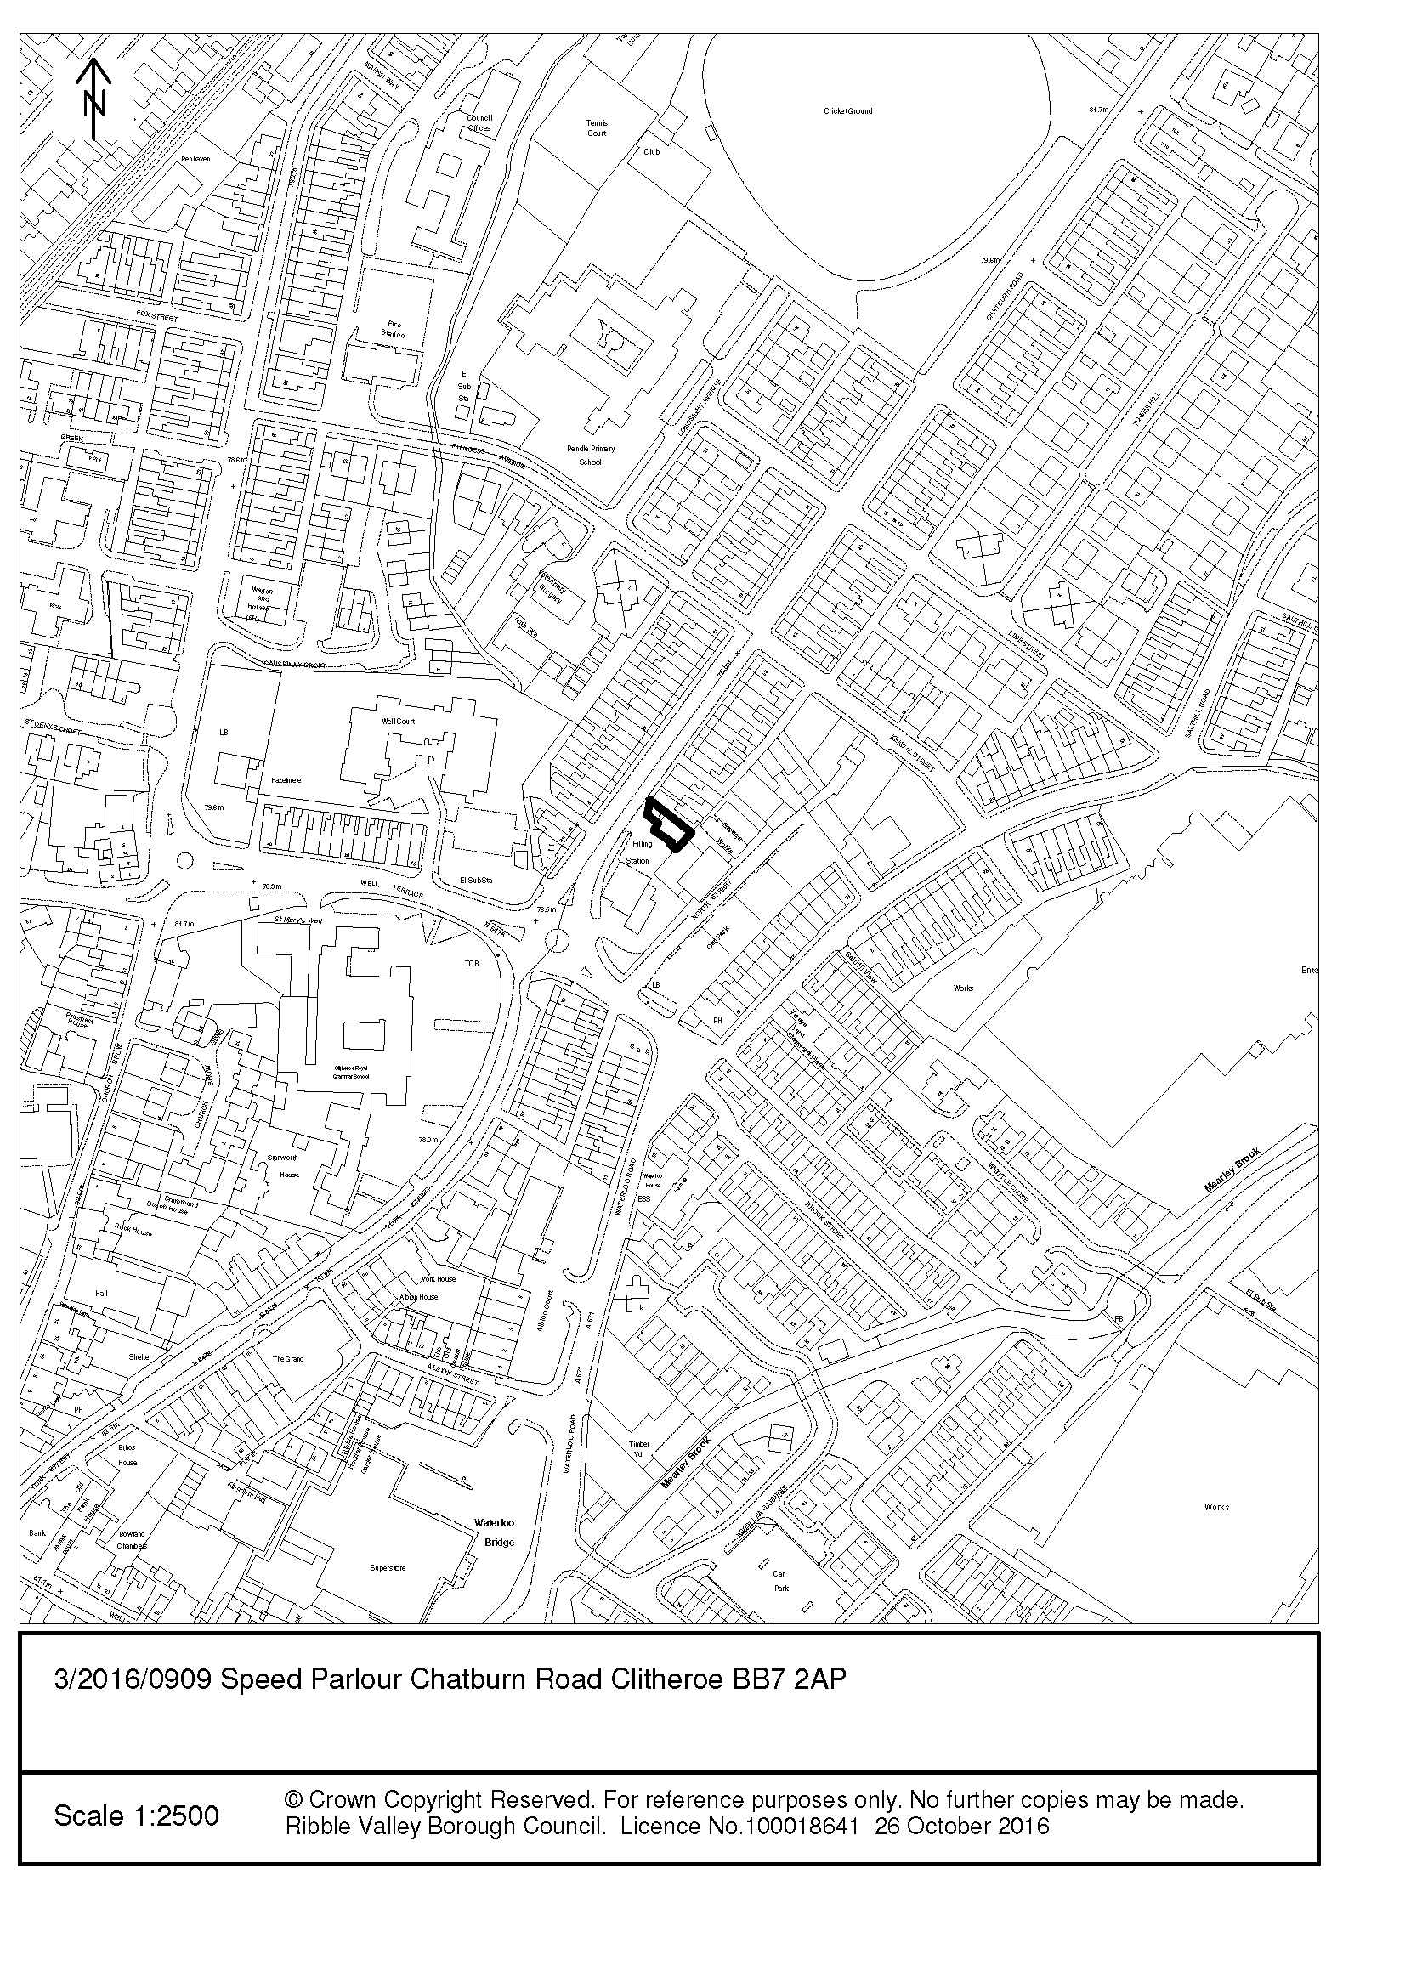
CONSULTEE RESPONSES/ REPRESENTATIONS MADE:

PARISH COUNCIL:

No representations have been received in respect of the proposed development.

LCC HIGHWAYS:

The Highway Development Control Section does not have any objections regarding the proposed canopy over external display area and associated works and are of the opinion that the proposed development should have a negligible impact on highway safety and highway capacity in the immediate vicinity of the site.

ENVIRONMENTAL HEALTH:

Environmental Health has no concerns with this application.

ADDITIONAL REPRESENTATIONS:

Letters of representation have been received from 13 individual households objecting to the application on the following grounds:

- Noise disturbance – Not the right type of business to operate in a residential area
- Highway safety

- A modern showroom is not in keeping with the area
- Devalue property
- Opening hours

1. Site Description and Surrounding Area

1.1 The application site is situated off Chatburn Road within the settlement of Clitheroe. It is located directly adjacent to a BP Petroleum Filling Station. The application relates to a 1 ½ storey pitched roof structure with a single storey flat roof element attached to the front which separates the 1 ½ storey structure from the terraced house gable which the site is attached to. The site is located within a mixed area of commercial to the East (rear) and residential to the North.

2. Proposed Development for which consent is sought

2.1 This application seeks full planning consent for the change of use of the building from a funeral parlour (Class A1) to a Motorbike Sales Showroom (Class Sui Generis). The proposed development includes the erection of a canopy over the front display yard; this would create 17.5m² of covered external display area. The canopy would project 6.1m from the principle elevation of the building and would have a width of 4.8m. It would be set back 1.2m from the front terrace building line. The canopy would have a flat roof with an eaves height of 2.6m and a ridge height of 3.450m. It would be supported by circular section metal columns and an open lattice roof structure, finished in a dark grey colour.

2.2 Fenestration and alterations are proposed to the existing building, these include the insertion of a glazed corner and alterations to the front entrance door and glazing, to create a central double door to improve access into the shop. The proposal includes the re-rendering of the existing external wall. These would be painted an off white colour with a black band plinth above the ground.

3. Relevant Planning History

3/2016/0733: Proposed erection of canopy over external display area and fenestration alterations. Cladding of external walls using matt aluminium. Proposed change of use from Class A1 (funeral parlour) to sui generis (motor sales showroom) (Withdrawn).

4. Relevant Policies

Ribble Valley Core Strategy:
Key Statement DS1 – Development Strategy
Key Statement DMI2 – Transport Considerations
Key Statement EC1 – Business and Employment Development

Policy DMG1 – General Considerations
Policy DMG2 – Strategic Considerations
Policy DMG3 – Transport & Mobility
Policy DMB1 – Supporting Business & Growth and the Local Economy

National Planning Policy Framework (NPPF)
National Planning Practice Guidance (NPPG)
Technical Guidance to National Planning Policy Framework

5. Assessment of Proposed Development

5.1 Principle of Development:

5.1.1 The Ribble Valley Core Strategy Policies EC1 & DMB1 encourages appropriate business growth and this proposal will help to secure employment locally. The application site is located within the settlement of Clitheroe and as such the principle of the development is considered to be acceptable when assessed against the adopted development plan.

5.2 Impact upon Residential Amenity:

5.2.1 The unit is adjoined by the BP Petroleum Filling Station to the South West. To the East (rear) is a number of small scale commercial business and to the North is a residential dwelling No. 2 Chatburn Road. The immediate area has a mixed residential and commercial use, although Chatburn Road is predominantly residential. There are a number of other commercial uses in the area which include Cycles Recycled, Park Garage and Abbey Mills Carpet & Blinds shop. On the basis that it is a mixed use area and the ability to restrict the hours of use I consider the proposal would not significantly adversely impact on adjacent residential amenities.

5.2.2 The applicant states that the current business hours are 8.30am to 5.30pm Monday to Saturday with opening on a Sunday by appointment only. I do not consider that this will cause undue disturbance to neighbouring amenity given the opening hours of the directly adjacent BP Petroleum Filling Station are 06.30am – 10.30am Monday to Sunday.

5.2.3 The proposal includes the insertion of a small bike prep workshop & store to the rear of the shop. This would be used to prep the bikes which have been delivered. This includes fixing or registration plated and other bespoke optional manufacturers’ parts to suit the customers’ requirements and cleaning. The proposed works will use only non-powered or no-pneumatic hand tools and a silent hydraulic work platform. It is considered that the proposed layout and associated activities would not have any undue impact upon residential amenity of the attached residential dwelling No. 2 Chatburn Road or the commercial buildings to the rear of the property.

5.3 Visual Amenity/External Appearance:

5.3.1 Member will note a previous application 3/2016/0733 was withdrawn following a meeting to review the design issues identified by the Local Planning Authority. It is considered that the previously proposed development would have adversely affected the character and appearance of the existing building and surrounding area. It would have detracted from the character and the present configuration of the building. Its approval would thus have been perceived to be detrimental to the visual amenities of the application building and the surrounding area. This has subsequently been amended due to officer negotiation with the agent.

5.3.2 The amendments to the proposal included the removal of the aluminium wall cladding and the re-design of the proposed canopy. The current application is considered to be more sympathetic and responds more positively to the application building and the surrounding area.

5.3.3 The proposed canopy would be positioned to the front of the property. It would consist of a lattice roof structure which would allow views through, creating a lightweight attractive aesthetic that reflects the framework of a MC Agusta Bike. Whilst the proposal would be afforded a high level of visibility within the streetscene, it is considered that the design and appearance of the proposal would be in keeping with the character and appearance of the application property and the surrounding area and would not be considered a prominent addition.

5.3.4 In view of the above, it is considered that the proposed development would preserve the character and appearance of the application building and the surrounding area in accordance with national and local policies.

5.4 Highway Safety and Accessibility:

5.4.1 The application property benefits from 6 on-site parking spaces for motorcycles. Objections have been raised from nearby residents on the ground that the area is already severely congested with traffic from the BP Garage, nearby school traffic, pedestrians and children going to and from the three schools in the area.

5.4.2 The County Highways Officer has raised no objection to the application on highway grounds, and is of the opinion that the proposed development should have a negligible impact on highway safety and highway capacity in the immediate vicinity of the site. In view of the above, it is considered that the proposal does not raise any highways concerns.

5.5 Economic Benefit:

5.5.1 The submitted application does not include specific details of the economic benefits of the proposed development. However, it is clear that the proposal would bring small scale employment benefits to the area and bring people/visitors to Clitheroe.

6. Observations/Consideration of Matters Raised/Conclusion

6.1 The proposed development would be considered compatible with its location within Clitheroe and would not unduly affect the amenity of nearby occupiers. The proposal would not have a negative impact upon the visual character and appearance of the application building or the surrounding area. Accordingly, it is recommended that the application be approved.

RECOMMENDATION: That the application be APPROVED subject to the imposition of the following condition(s):

1. The development must be begun not later than the expiration of three years beginning with the date of this permission.

REASON: To comply with the requirements of section 91 of the Town and Country Planning Act 1990 as amended by Section 51 of the Planning and Compulsory Purchase Act 2004.

2. Unless explicitly required by condition within this consent, the development hereby permitted shall be carried out in complete accordance with the proposals as detailed on drawings:

Proposed Plans – Drawing No: 5161-04B
Proposed Elevations – Drawing No: 516-03D

REASON: For the avoidance of doubt and to clarify which plans are relevant to the consent.

3. Notwithstanding the submitted details, precise specifications or samples of all external surfaces, including surfacing materials and their extents, of the development hereby permitted shall have been submitted to and approved by the Local Planning Authority before their use in the proposed development. The approved materials shall be implemented within the development in strict accordance with the approved details.

REASON: In order that the Local Planning Authority may ensure that the materials to be used are appropriate to the locality in accordance with Policy DMG1 of the Ribble Valley Core Strategy.

4. The Motorbikes Sales Showroom use hereby approved shall only operate between the hours of 8.30 - 17.30 Monday to Saturday inclusive, and there shall be no operation on Sundays or bank holidays. There shall be no business operated from the site outside the stated operating hours.

REASON: In order to safeguard the amenity of nearby residents in accordance with Policy DMG1 of the Ribble Valley Core Strategy, and the NPPF.

5. Unless otherwise agreed in writing with the Local Planning Authority, and notwithstanding the provisions of the Town and Country Planning (General Permitted Development) (England) Order 2015, or any equivalent Order following the revocation and re-enactment thereof (with or without modification), the application building shall be used as a Motorbike Sales Showroom and for no other use within Class Sui Generis as defined in the Town and Country Planning (Use Classes) Order 1987 (as amended).

REASON: To ensure that the unit is used solely as a Motorbike Sales Showroom as any other use within use class Sui Generis may not be considered acceptable in the interest of amenity of the area in accordance with Policy DMG1, of the Ribble Valley Core Strategy.

6. No vehicle repairs other than minor works associated with vehicles for display or sale as contained within the Planning, Design and Access Statement (Ref: 5161 Version: 1-02 (Rev A)) shall be undertaken on this premises unless otherwise agreed in writing with the Local Planning Authority

REASON: In order to safeguard the amenity of nearby residents in accordance with Policy DMG1 of the Ribble Valley Core Strategy, and the NPPF

BACKGROUND PAPERS

https://www.ribblevalley.gov.uk/site/scripts/planx_details.php?appNumber=3%2F2016%2F0909

