RECOMMENDATION FOR PLANNING AND DEVELOPMENT COMMITTEE

APPROVAL

DATE: 16 February 2017
REF: AD
CHECKED BY:

APPLICATION REF: 3/2016/0928 (PA)

GRID REF: SD 374390 441732

DEVELOPMENT DESCRIPTION:

CHANGE OF USE FROM B1 (OFFICE USE) TO C3 (DWELLING) TO FORM TWO DWELLINGS AT STANLEY HOUSE, LOWERGATE, CLITHEROE BB7 1AD.

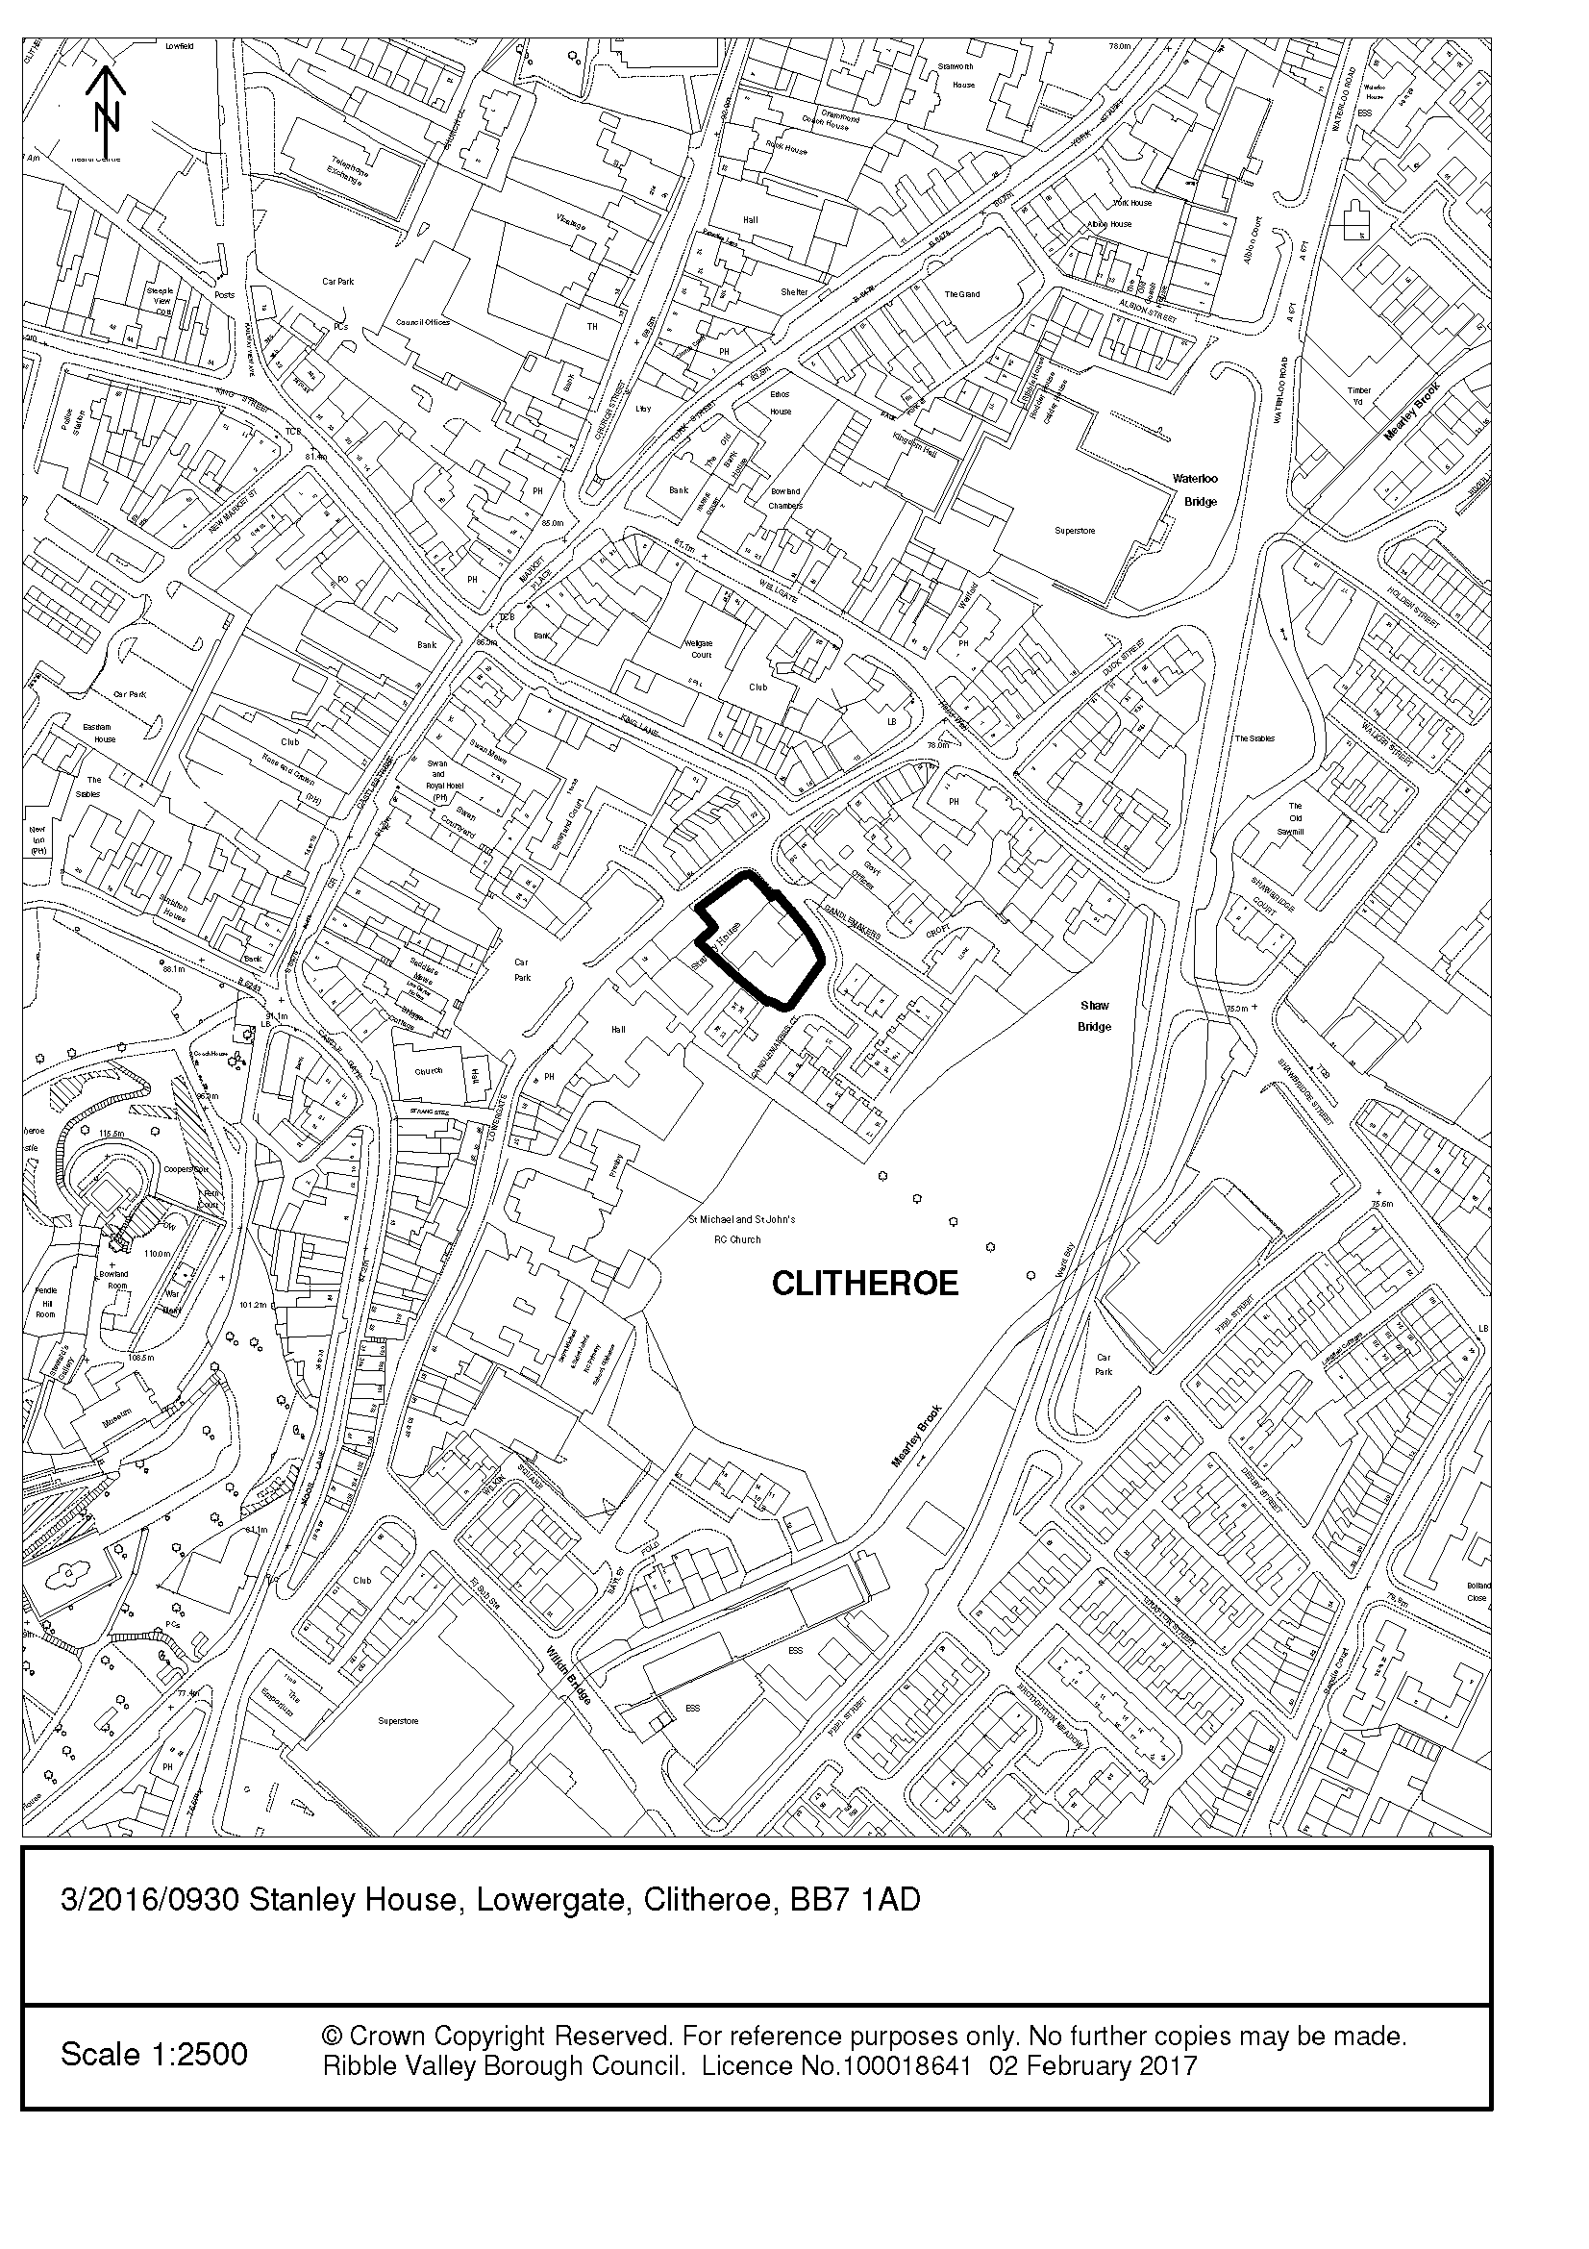
CONSULTEE RESPONSES/ REPRESENTATIONS MADE:

TOWN COUNCIL:

Objects because of concerns as to the architectural merits of the proposals which will change the listed building significantly.

LCC HIGHWAYS:

No objections. Should have a negligible impact on highway safety and highway capacity in the immediate vicinity of the site.
The applicant has provided adequate off road parking provision for this type and size of development.
The ground floor study is capable of being used as an additional bedroom and as such each property should be allocated with three off road car parking spaces each. A condition is suggested requiring the approval of a car park and manoeuvring scheme.

HISTORIC AMENITY SOCIETIES:

Consulted, no representations received.

ADDITIONAL REPRESENTATIONS:

No letters of representation have been received.

1. Site Description and Surrounding Area

1.1 Stanley House is a Grade II listed (19 May 1950) building prominently sited within Clitheroe Conservation Area.

The list description identifies:

“C18 … Central doorway with semi-circular head … semi-circular fanlight and 6-field panelled door … To the right is a 2-storey C19 extension … A shield of arms with recarved bearing has crest weathered out of recognition”

A basement doorway of possible earlier date than C18 (found during site inspection) suggests that the site (one of Clitheroe’s few evident burgage plots) may have had an interesting historical development.

Typically, the list description does not refer to the building interior.

Stanley House is within the setting of a number of other listed buildings including Nos 33 and 35 Lowergate, Nos 39 and 41 Lowergate and St Michael's Primary School Lowergate (all Grade II listed) which ‘form a group’ (list description).

The Clitheroe Conservation Area Appraisal (The Conservation Studio consultants; adopted by the Borough Council 3 April 2007 following public consultation) identifies:

“The relatively intact medieval layout of the original settlement; The architectural and historic interest of the area’s buildings, 88 of which are listed; A pleasing historic townscape enhanced by the town’s changes of level and curves in the old streets” (Summary of Special Interest).

“The Clitheroe Conservation Area contains the historic core of the medieval town including its principal medieval streets: Castle Street, Market Place, Church Street, Wellgate, Lowergate and Duck Street” (Location and Context).

“The core of the conservation area which is centred on Castle Street, Church Street, Wellgate and Lowergate is also the core of the town’s original 12th century settlement. Historic burgage plots are evident in, for instance, the long, thin strip of land occupied by today’s Rose and Crown (formerly the Starkie Arms c1850) and the sites of two large dwellings, Stanley House in Lowergate and Hazelmere beside Well Terrace” (General Character and Plan Form).

“The conservation area hosts a mix of primarily business, commercial and residential uses … In brief, the Clitheroe Conservation Area contains the commercial, administrative and business heart of a Lancashire market town with a population of 14,000” (Activities/uses).

“This borough settlement took the form of the classic, two-row planned settlement with castle and church at either end … Lowergate formed a second axis, more or less parallel to the main thoroughfare, on its east side” (The Effect of Historical Development on Plan Form).

“The conservation area is most notable for buildings from the late 18th century and 19th century, many of which replaced earlier structures - even the Church of St. Mary Magdalene dates primarily from a rebuilding in 1828 … In Clitheroe, as in other market towns the 18th century marked a movement away from traditional vernacular building to a more consciously designed ‘polite’ form of architecture. Buildings from this period are influenced by a sense of proportion and incorporate sliding sash windows and elements of classical detailing such as pediments and friezes” (Architectural and Historic Character).

Stanley House is pictured at page 20 of the Appraisal.

“Loss of architectural detail (original windows, doors etc); Insensitive alteration of historic buildings” (Weaknesses: Principal Negative Features).

Nos. 22-34 Lowergate (opposite Stanley House) are identified as Buildings of Townscape Merit making a positive contribution to the character and appearance of the Conservation Area.

1.2 Brunskill R.W. ‘Illustrated Handbook of Vernacular Architecture’(1978 page 112) identifies:

“The essential characteristic of the double-pile plan is that it is entirely two rooms in depth. In all other plans the principal room has run through from front to back walls … The basic version of the double pile plan consists of four rooms …The double pile plan was introduced high in the social scale towards the beginning of the C17, by the middle of the C18 it had spread to all parts of the country and all levels of society”.

1.3 The Historic England Listing Selection Guide ‘Domestic 2: Town Houses’ (2011) identifies specific considerations when considering town houses for designation:

“Status and Survival - The Georgian town houses that survive today will tend, through natural selection, to be the grander examples … In all cases, the things to look for are the same: the survival of exterior and interior features, and of plan form …

Interiors - Many houses have never been inspected internally, and features of interest may survive which have never been considered: new discoveries and new designations thus remain to be made … Internally they include staircases; fireplaces; decorative plasterwork; joinery: doors, architraves, panelling, shutters etc; built-in cupboards or shelved niches …

Alteration - Internally, the loss of major elements such as the staircase, or the room plan of the principal floors, or the stripping out of internal features, will undermine the case for listing. Alterations to the less prominent parts of a house, such as bedrooms and service areas, may have less of an impact than alterations to the principal spaces”.

1.4 Site inspection suggests that the building has an interesting and complicated history e.g. basement stone door surround (of C17 type) and floor support structure. C18 maps (Sketch of 1740; Lang’s of 1766) suggest a wide rectangular building in this location – is the two-storey ‘C19 extension’ a possible rebuild or remodelling of an earlier structure? The building is difficult to ‘read’ building because modern interventions are not sufficiently differentiated from historic build and historic fabric has been incorporated from other historic sites (e.g. doors). However, some understanding can be made from the existing plans for 3/1982/0635 & 0616 & 0617.

2. Proposed Development for which consent is sought

2.1 Planning permission is sought for the subdivision of the office building (B1 use) to facilitate a change of use into two dwellings. The proposals as originally submitted proposed significant and harmful alteration/loss to historic building plan form and fabric.

2.2 Delay to application determination has resulted from the paucity of information submitted concerning the significance of the listed building’s plan form and historic fabric affected. NPPF paragraph 128 states “local planning authorities should require an applicant to describe the significance of any heritage assets affected …. The level of detail should be proportionate to the asset’s importance … sufficient to understand the potential impact of the proposal on their significance … As a minimum … heritage assets assessed using appropriate expertise”. The case officer, mindful that applications 3/2012/0838 & 0839 and 3/2016/0469 & 0470 were not accompanied by this significance information and the latter were refused because of “unsympathetic alterations to plan form and the loss of important historic fabric” has therefore sought the minimum but necessary information to comply with NPPF and the duty at section 16 of the Act (harm has to be identified before its acceptability can be considered). On 19 December 2016 the case officer accepted an extension of time on application consideration for this purpose. On 24 January he reiterated the information request and specified some relevant matters for consideration “what was the purpose of the historic extension? Does the original build have a distinctive plan type – double-pile? Are there remnants (basement doorway) of an even earlier plan form type?”. In the agent’s response of 31 January 2017, it has been recognised that “Stanley House maintains a traditional double pile plan form … of heritage value as a feature of the original house” and that the C19 extension had a distinct identity “the extension would most likely have been added as required staff accommodation”. The agent’s response recognises that proposals are harmful.

2.3 The impact of works has significantly lessoned following consideration to the specific concerns highlighted in the file report for 3/2016/0469 & 0470. A revised scheme submitted 19 December 2016 removes all works harming the historic fabric and clarifies the impact of subdivision on the listed building’s immediate setting.

2.4 The Conservation Area site has trees of amenity value. The agent has amended the scheme so that a tree report is not required. However, the Borough Council Countryside Officer’s initial inspection has identified potential tree resentment issues (Yew tree) from the subdivision proposed. He confirms that if any works are to be carried out to any of the tree stock within the curtilage of Stanley House, a tree works application will be required.

3. Relevant Planning History

No pre-application advice has been sought in respect to the proposed development.

3/2016/0469 & 0470 - Change of use from B1 office to class C3 residential. Resubmission of application 3/2012/0838. PP and LBC refused 15 July 2016 because of “because of unsympathetic alterations to plan form and the loss of important historic fabric”.

3/2012/0838 & 0839 – Proposed change of use from class B1 office to class C3 residential (two houses). LBC & PP granted 19 November 2012.

3/1996/0777 & 0778 – Temporary office for six months. PP & LBC granted 30/31 January 1997.

3/1980/0196 & 0197 – Proposed demolition and development for housing. LBC refused (PP withdrawn) 22 May 1980.

3/1982/0635 – Proposed alterations to divide into two separate units of office accommodation to enable essential repairs to be carried out. LBC granted 13 December 1982.

3/1982/0616 & 0617 - Proposed alterations and extension to form additional office accommodation. PP & LBC granted 13 January 1983.

4. Relevant Policies

Ribble Valley Core Strategy:
Key Statement EC1 – Business and Employment Development
Key Statement EN5 – Heritage Assets
Key Statement DS1 – Development Strategy
Key Statement HS1 – Housing Provision
Policy DMB1 – Supporting Business Growth and the Local Economy
Policy DMG1 – General Considerations
Policy DME4 – Protecting Heritage Assets

Planning (Listed Buildings and Conservation Areas) Act 1990
‘Preservation’ in the duties at sections 16, 66 and 72 of the Act means “doing no harm to” (South Lakeland DC v. Secretary of State for the Environment [1992]).

Clitheroe Conservation Area Appraisal

NPPF
NPPG

5. Assessment of Proposed Development

5.1 The main consideration in the determination of this planning application is the impact upon the special architectural and historic interest and setting of the listed building (section 66 of the Act). Consideration is also made to the impact upon the character and appearance of Clitheroe Conservation Area (section 72 of the Act), the impact upon the setting of other listed buildings (section 66 of the Act), the loss of employment use, provision of housing, highway safety and residential amenity.

5.2 Impact upon the special architectural and historic interest and setting of the listed building:

5.2.1 I concur with the agent that there is harm from the current proposals (and note the concurrent recognition to the importance of the Georgian double-pile plan and the service wing to building historical development). I am also mindful of the concerns of Clitheroe Town Council in respect to impacts upon the special architectural interest of the listed building.

5.2.2 In my opinion, the division of the listed house into two residential units is unfortunate. Stanley House’s Georgian double-pile plan is a distinct and important element of special architectural interest and will be compromised by the separation into the C19 service wing of the front right-hand room of the C18 build over four floors and the blocking of access routes between the house and service wing. Whilst these works may be potentially reversible, I am mindful of paragraph 43 of Historic England’s ‘Making changes to Heritage Assets’ (2016; appended) that “reversibility alone does not justify alteration; If alteration is justified on other grounds then reversible alteration is preferable to non-reversible”.

‘Making changes to Heritage Assets’ also identifies:
“The plan form of a building is frequently one of its most important characteristics and internal partitions, staircases (whether decorated or plain, principal or secondary) and other features are likely to form part of its significance. Indeed they may be its most significant feature. Proposals to remove or modify internal arrangements, including the insertion of new openings or extension underground, will be subject to the same considerations of impact on significance (particularly architectural interest) as for externally visible alterations” (paragraph 45).

However in my opinion, the removal of damaging proposals to the historic fabric and clarity on the treatment of the setting results in the minimisation of harm to the special architectural and historic interest of the listed building to that necessary to achieve a viable use. Mindful of the original (albeit single) residential use of Stanley House and of the potential harm to the listed building from alternative edge of town centre uses, I am satisfied that the Optimum Viable Use (NPPG ‘Conserving and Enhancing the Historic Environment’ 015) is being approached (NPPF paragraph 134 ‘public benefits’).

5.2.3 ‘Making changes to Heritage Assets’ paragraph 54 states in respect to heritage assets in general:

“Where the proposal involves a change of use, particularly to single or multiple residential units, local planning authorities may consider that the impact on the building and its setting of potential future permitted development, such as conservatories, garden sheds and other structures associated with residential use, make the change of use proposal unacceptable in principle. Conditions preventing or limiting such future permitted development may make the change of use proposal acceptable”.

In my opinion, the restriction of permitted development rights is not necessary in this case because of listed building consent requirements (section 7 of the Act) and the stricter thresholds related to development within the curtilage of a listed building.

5.3 Impact upon the character and appearance of Clitheroe Conservation Area:

5.3.1 I am now satisfied that the proposals will have an acceptable impact upon the character and appearance of Clitheroe Conservation Area following clarification by the applicant of tree and garden impacts.

5.4 Impact upon the setting of other listed buildings:

5.4.1 I am now satisfied that the proposals will have an acceptable impact upon the setting of the other listed buildings in the group following clarification by the applicant of tree and garden impacts.

5.5 Loss of employment use:

5.5.1 I am mindful of progress on the Housing and Economic Development (DPD). A report was considered by P&D committee on 14th April 2016, where this site was listed in an appendix as an existing employment site (appendix 5 - Economy and Employment Land Issues Paper). Since this P&D report, the Regulation 18 (Issues and Options stage) of the HED DPD and the Draft Proposals Map has been consulted upon (between 26th August and 7th October 2016). Whilst the site is designated on the Draft Proposals Map as an existing employment area, this represents an existing land use but does not preclude change of use. However, it does require compliance with policy DMB1.

5.5.2 At that time of consideration of application 3/2016/0469 insufficient information had been provided in relation to criterion 5 of Policy DMB1. In relation to this application however, I note in para 5.2.33 of the applicant’s planning statement submitted as part of this application that information is provided relating to the marketing history of the site. Whilst more detailed information would be useful (dated marketing materials for example), I note that lack of information was not cited as a reason for refusal in the previous planning decision and therefore I consider that sufficient information has been provided which deals with criterion 5 of DMB1.

5.5.3 I am comfortable from the information provided that the loss of the employment use and the creation of an additional 2 dwellings in this location would not undermine the Development Strategy, as set out in the adopted Core Strategy and I therefore consider the proposals to be acceptable.

5.6 Housing provision and residential amenity:

5.6.1 The Borough has a revised 5 year supply figure of 4.99 years when measured against the most recent monitoring information. The significance being that the Council cannot demonstrate a 5 year supply and the implications of paragraph 49 of NPPF must be taken into account in making any decisions on the application.

NPPF Paragraph 49 states that:
“Housing applications should be considered in the context of the presumption in favour of sustainable development. Relevant policies for the supply of housing should not be considered up-to date if the local planning authority cannot demonstrate a five-year supply of deliverable housing sites.”

Where the council cannot demonstrate a 5 year supply the presumption is in favour of sustainable development.

5.6.2 The provision of additional housing is to be welcomed. I do not believe that the proposals would result in an unacceptable impact upon the amenities of adjoining or nearby residents

5.7 Highway safety:

5.7.1 I am mindful of the comments of LCC Highways and would recommend should members be minded to grant planning permission that a condition be attached to ensure an acceptable car park and manoeuvring scheme

6. Observations/Consideration of Matters Raised/Conclusion

6.1 In my opinion, the harm to the special architectural and historic interest of the listed building is ‘less than substantial’. NPPF paragraph 134 requires that this harm be “weighed against any public benefits of the proposal, including securing its optimum viable use’ and in my opinion the minimal harm to plan form is acceptable because of the securing of the long-term use and repair of the building.

6.2 Therefore, in attaching considerable importance and weight to the preservation of (i.e. avoiding harm to) the listed building, its setting and its features of special architectural and historic interest [section 16 of the Planning (Listed Buildings and Conservation Areas) Act 1990] and in giving ‘great weight’ to conservation (NPPF paragraph 132), I would recommend that listed building consent be approved subject to condition.

RECOMMENDATION: That the application be APPROVED subject to the following conditions:

1. The development must be begun not later than the expiration of three years beginning with the date of this permission.

REASON: Required to be imposed pursuant to Section 18 of the Planning (Listed Buildings and Conservation Areas) Act 1990.

2. This permission shall be implemented in accordance with the proposal as amended by the email received from the agent on 16 December 2016 and the revised ‘Proposed Floor Plans for the Division of Stanley House into Two Houses’ received from the applicant 19 December 2016.

REASON: For the avoidance of doubt since the proposal was the subject of agreed amendments and in order to safeguard the special architectural and historic interest of the listed building.

3. Precise specifications of works to the fabric of the listed building (including walling up of doorways) shall have been submitted to and approved by the Local Planning Authority before the implementation of this element of the works.

REASON: In order to safeguard the special architectural and historic interest and significance of the listed building.

4. Precise specifications of new services (exterior and interior impacts) shall have been submitted to and approved by the Local Planning Authority before the implementation of this element of the works.

REASON: In order to safeguard the special architectural and historic interest and significance of the listed building.

5. Precise specifications of a car park and manoeuvring scheme is to be submitted to and approved by the Local Planning Authority and the car parking spaces and manoeuvring areas marked out in accordance with the approved plan, before the use of the premises hereby permitted becomes operative and permanently maintained thereafter and clearly showing ownership of each parking bay.

REASON: To allow for the effective use of the parking areas.

BACKGROUND PAPERS

https://content.historicengland.org.uk/images-books/publications/dlsg-town-houses/domestic_2_rev_final.pdf/
(Historic England Listing Selection Guide ‘Domestic 2: Town Houses’)

http://www.legislation.gov.uk/ukpga/1990/9/contents
[Planning (Listed Buildings and Conservation Areas) Act 1990]

https://www.historicengland.org.uk/images-books/publications/conservation-bulletin-73/
(page 46 ‘The Big Issue of Little Harm’, Conservation Bulletin: Issue 73 Winter 2014)

https://www.gov.uk/government/publications/national-planning-policy-framework--2
(National Planning Policy Framework)

https://www.gov.uk/guidance/national-planning-policy-framework/12-conserving-and-enhancing-the-historic-environment
(National Planning Policy Guidance: Conserving and Enhancing the Historic Environment)

https://www.gov.uk/government/publications/principles-of-selection-for-listing-buildings
(‘Principles of Selection for Listed Buildings’)

https://www.historicengland.org.uk/images-books/publications/making-changes-heritage-assets-advice-note-2/
(‘Making Changes to Heritage Assets’, Historic England, 2016)

https://content.historicengland.org.uk/images-books/publications/conservation-principles-sustainable-management-historic-environment/conservationprinciplespoliciesguidanceapr08web.pdf/
(paragraph 38 ‘Conservation Principles, Policies and Guidance’, Historic England, 2008)

https://content.historicengland.org.uk/images-books/publications/gpa2-managing-significance-in-decision-taking/gpa2.pdf/
(‘Managing Significance in Decision-Taking in the Historic Environment’, 2015, paragraph 47)

https://www.ribblevalley.gov.uk/download/downloads/id/10010/adopted_core_strategy.pdf
(Adopted Core Strategy)

https://www.ribblevalley.gov.uk/downloads/download/3329/clitheroe_conservation_area
(Clitheroe Conservation Area Appraisal)

