RECOMMENDATION FOR PLANNING AND DEVELOPMENT COMMITTEE

REFUSAL
DATE: 6 September 2018
REF: AB
CHECKED BY: JM

APPLICATION NO: 3/2018/0595/P (GRID REF: SD 371022 433653)

PROPOSED RAISED TERRACE TO REAR AT THE LORD NELSON PUBLIC HOUSE, WHALLEY OLD ROAD, LANGHO, BB6 8DU

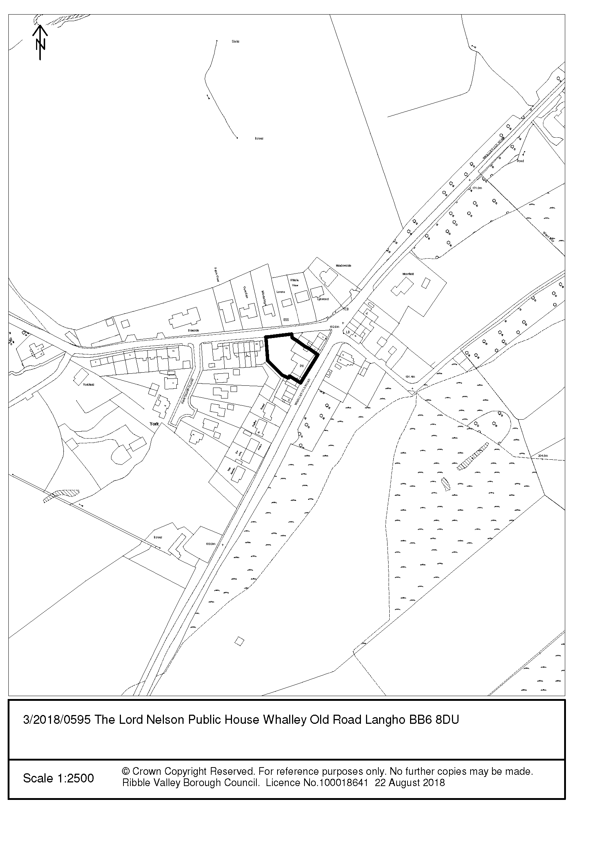
PARISH/TOWN COUNCIL:

None received.

HIGHWAYS (LCC):

No objection.

ADDITIONAL REPRESENTATIONS:

Letters have been received from the occupants of 12 neighbouring properties and have raised concerns with the proposed development as follows:

- The pub does not need to add this terrace in order to prosper.
- Terraces elevation and siting would give rise to major problem of overlooking gardens.
- Noise issue that exists would become worse.
- Proposed steel framed terrace would be an ugly blot.
- The application does not include any noise assessment.
- Customer use of the ground floor level patio area has previously resulted in a number of noise complaints.
- Raised area will allow noise to travel more widely.
- Light pollution from the site.
- Strongly urge the Council to consider conditions restricting terrace opening times, outdoor illumination and provision of noise mitigation to the boundaries with residential properties.
- In breach of previous planning conditions.
- Odour of food from the balcony.
- Lack of parking and highway safety concerns.

1. Proposal

1.1 The proposal is to form a raised terrace, accessed from the ground floor bar, to the rear of the public house. This would replace the existing timber staircase. The proposed platform would be 2.8 metres above ground level and would measure 4m x 7m. It would be constructed from steel with a glass balustrade. The applicant has confirmed that the terrace would be used as an outdoor seating area. The proposed times of use are 16.00-21.30 Monday to Thursday and 12.00-22.00 Friday to Sunday.

2. Site Location

2.1 Planning consent is sought for the erection of a raised terrace to the rear of The Lord Nelson Public House, Whalley Old Road, Langho. The Lord Nelson is a traditional village pub facing onto Whalley Old Road, Langho. The pub is part of a small terrace of properties. It is adjoined on the south side by no.9 Whalley Old Road, which is in the applicant’s ownership and used as bed and breakfast accommodation and, beyond that, no.11 which is a residential dwelling. The public house is not directly adjoined to the north – however, there is a terraced row of three dwellings, 3-7 Whalley Old Road, approximately 9 metres from the gable end.

2.2 The cluster of buildings which The Lord Nelson forms part of is located outside the main settlement of Langho and is known as York Village. The site is located within the designated Green Belt. The Lord Nelson is a stone building and is of considerable age being denoted on the 1845 1:10,000 historic map.

2.3 The front elevation of the public house is two storeys. Due to a change in levels from front to back, the rear elevation is three storeys in height. To the rear of the building is the garden which can be accessed via an existing staircase with landing. The pub garden bounds the residential gardens of no.11 Old Whalley Road, no.1 Hawthorn Close and no.18 York Road.

3. Relevant History

3/2003/0164 - Extension of licensed area into adjacent cottage and formation of staircase to rear. Withdrawn.

4. Relevant Policies

Ribble Valley Core Strategy
Key Statement EN1 – Green Belt
Policy DMG1 – General Considerations
Policy DMB1 – Supporting Business Growth and the Local Economy

Other Material Considerations:
National Planning Policy Framework (NPPF)
Technical Guidance to the National Planning Policy Framework
Planning Practice Guidance (PPG)

5. Assessment of Proposed Development

5.1 The main considerations in determining this application are the impact of the development of the visual appearance of the existing building and the surrounding area, its effect on the residential amenities of neighbouring residents and its impact on the Green Belt.

5.2 Designated Green Belt

5.2.1 Having regard to Green Belt policy, the proposed raised terrace is an alteration to an existing building and does not result in disproportionate additions over and above the size of the original building. As such, it is deemed that the proposals are not inappropriate development in the Green Belt.

5.3 Visual appearance and design

5.3.1 As noted above, the public house is a stone building with a traditional appearance. The erection of a raised terrace constructed from steel and glass would not reflect the host building’s character. The Lord Nelson is a building of some historic merit by virtue of its historic, cultural and aesthetic significance. Whilst the impact of the development would not result in sufficient visual harm to justify refusal of the application consideration should be given to the use of traditional materials and, in the officer’s opinion, a timber framed structure would be a more sympathetic addition.

5.4 Impact on the residential amenity of neighbours

5.4.1 In assessing the application the impact of development on the residential amenity of neighbouring occupants is a material consideration. The application building is located within a predominantly residential area. On the south side the proposed terrace would be located 4.5 metres from the boundary with the garden of no.11 Whalley Old Road. As submitted, patrons would have a close, elevated and unobscured view of the private rear garden of no.11 Whalley Old Road resulting in an unacceptable loss of privacy for this neighbour and some loss of privacy for the neighbours further south.

5.4.2 To the rear of the application site are the rear gardens of 1 Hawthorn Close and 18 York Lane. The boundaries for these gardens are approximately 20m from the proposed balcony. During my site visit it was noted that high deciduous shrubs and trees obscured clear views of the private amenity space associated with these properties. The evergreen hedge to the rear of the site along the boundary with 18 York Lane is located on land owned by the applicant and therefore their retention and ongoing maintenance could be secured by condition. There would be a requirement for the hedge to be maintained at a height of 2-2.5 metres and the immediate replacement of any dead, dying or dangerous plants in order to maintain privacy levels. There are a number of trees and shrubs within the garden of 1 Hawthorn Close which would maintain an acceptable level of privacy for the occupants of that particular dwelling.

5.4.3 To the north there is a degree of separation between the north side of the proposed raised terrace and no.7 Whalley Old Road. The pub building projects rearwards on its north side and this rear projection would provide some screening of views towards the private garden of 7 Whalley Old Road. The terrace does however project out to a point where some views towards the rear garden of no.7 would be possible.

5.4.4 In order to reduce the level of overlooking of gardens to the north and south, the Council could impose a requirement for the erection of 1.8m high privacy screens. However, it is the planning officer’s view that in this case the erection of privacy screens along the north and south sides would fail to reduce the harm to residential amenity to an acceptable level. Views could still be gained from the rear (east) of the balcony to the rear garden of no.11 Whalley Old Road and the erection of the raised balcony in such close proximity to this neighbouring property would be severely detrimental to the occupant’s ability to enjoy their private space.

5.4.5 In addition to a loss of privacy, the erection of the raised terrace would raise concerns regarding noise and disturbance in the area. Consideration has been given to noise guidance set out in The Framework (revised July 2018), the National Planning Practice Guidance (NPPG), and the Noise Policy Statement for England. It is noted that there have been a small number of complaints received by the Council in relation to noise from the site. The applicant has stated that the proposed development would not result in any additional noise when compared with the existing use. It was evident from a visit to the site that the pub garden is used as an outside seating area, however, the existing licensing agreement for the Lord Nelson does not include the garden area to the rear and, as such, based on the current license there is no outdoor drinking permitted.

5.4.6 Regardless of the license conditions, which could be subject to change, noise would still result from customers using the rear garden. The existing pub garden is bound on the south side by a high fence. Hedging and fencing also bound the garden to the north and west and these boundaries would provide some noise attenuation from sound emitted at ground level. The result of raising the area from which noise would originate is that it would project over the boundaries of the site and, without a detailed assessment of noise to suggest otherwise, it is considered that the provision of a raised terrace, in particular so close to the rear windows and boundary of no.7 Whalley Old Road, would result in a considerable amount of disturbance and a significant adverse effect which would cause a material change in the behaviour and/or attitude of neighbouring residents. As such, the development would be contrary to Core Strategy Policy DMG1 and paragraphs 127 and 180 of the NPPF.

6. Conclusion

6.1 Despite highway safety being raised as a concern by neighbours, no objections have been received from the County Surveyor. Having regard to the above, it is recommended that the application be refused due to the significant adverse impact that would arise from noise and disturbance and loss of privacy.

RECOMMENDATION: That the application be refused for the following reason(s):

1, The proposed development, by virtue of the raised terrace’s siting and elevated position, would fail to accord with Policy DMG1 of the Ribble Valley Core Strategy. The use of the balcony would result in unacceptable noise and disturbance, especially during evenings and weekends, which is likely to have a negative impact on the amenity of existing residents and would impact on the ability of neighbours to enjoy their gardens peacefully. Furthermore, it would facilitate overlooking of residential gardens resulting in an undue loss of privacy.

BACKGROUND PAPERS
https://www.ribblevalley.gov.uk/site/scripts/planx_details.php?appNumber=3%2F2018%2F0595

