RECOMMENDATION FOR PLANNING AND DEVELOPMENT COMMITTEE

REFUSE

DATE: 3rd October 2019
REF: HM
CHECKED BY: JM/NH

APPLICATION REF: 3/2019/0331

GRID REF: SD

DEVELOPMENT DESCRIPTION:

CREATION OF A NEW OFF-ROAD, MULTI-USE LINK BETWEEN THE VILLAGES OF DOWNHAM AND CHATBURN TO ACCOMMODATE WALKERS, CYCLISTS, HORSE-RIDERS AND THOSE WITH MOBILITY ISSUES INCLUDING CHAIR USERS. RESUBMISSION OF PLANNING APPLICATION 3/2018/0754. CHATBURN ROAD, DOWNHAM

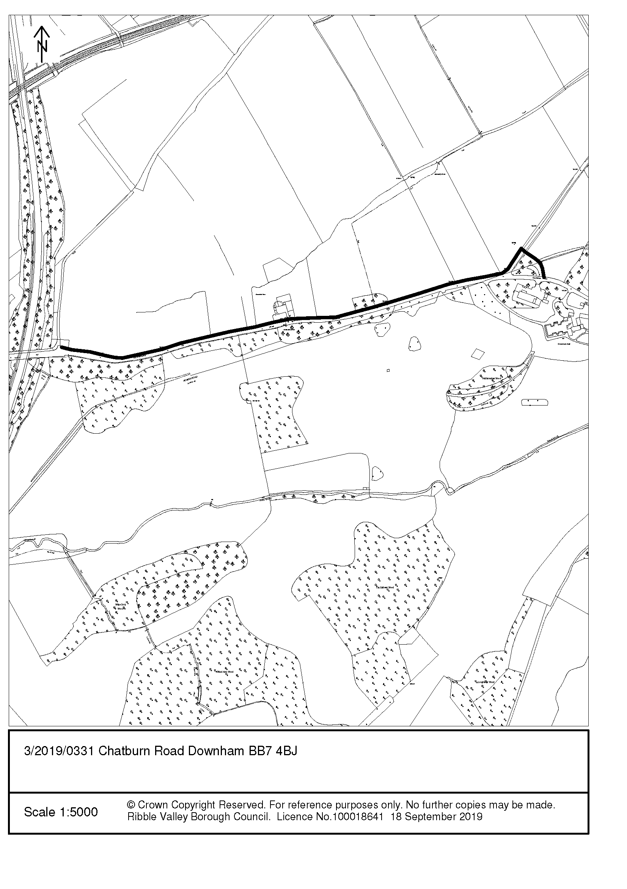
CONSULTEE RESPONSES/ REPRESENTATIONS MADE:

DOWNHAM PARISH COUNCIL:

Downham Parish Council have raised no objections to the proposed development.

CHATBURN PARISH COUNCIL:

Chatburn Parish Council have stated that the provision of a link between Chatburn and Downham will be welcome on this dangerous stretch of road.

HIGHWAYS (LCC):

The County Highways Surveyor has recommended refusal of the application for the following reasons:

- Poor visibility for users emerging to cross Green Lane.
- The proposed off-road multi-use link will emerge onto the footway at Greendale Café, this area is frequently obstructed by vehicles.

ARCHAEOLOGY (LCC):

Raise no objection to the proposed works subject to a recommended condition.

ADDITIONAL REPRESENTATIONS:

2 letters of support have been received with respect to the proposed development, the comments are as follows:

- Would provide a safe alternative to walking along the dangerous road.
- Community benefit

1. Site Description and Surrounding Area

  - The application relates to an area of land which runs parallel to the northern side of Chatburn Road and a portion of Green Lane between the villages of Downham and Chatburn. The submitted details seek consent for an off-road multi-use track and concessionary bridleway including the provision of equestrian/pedestrian holding areas and other associated works.

2. Proposed Development for which consent is sought

2.1 It is proposed that the concessionary bridleway will be approximately 1Km in length and provide a dedicated off-road route for pedestrians, cyclists, wheelchair users and horse-riders. It is proposed that the route of the bridleway will commence in the village of Downham whereby it will link Pendle Road with Green lane and then subsequently run westward along the northern extents of Downham Road/Chatburn Road where it terminates prior to the Chatburn Road Bridge

3. Relevant Planning History

3/2018/0754 - Creation of a new off-road, multi-use gravel track 2.5m wide between the villages of Downham and Chatburn. The one kilometre connection would accommodate walkers, cyclists, horse-riders and those with mobility issues including chair users. (Withdrawn)- following the receipt of highways observations and to enable further work to be undertaken in respect of potential heritage impacts and the impacts upon trees.

4. Relevant Policies

Ribble Valley Core Strategy:

Key Statement DS1 - Development Strategy
Key Statement DS2 - Sustainable Development
Key Statement EN2 – Landscape
Key Statement EN5 – Heritage Assets
Key Statement DMI1 - Planning Obligations
Key Statement DMI2 - Transport Considerations

Policy DMG1 - General Considerations
Policy DMG2 - Strategic Considerations
Policy DMG3 - Transport and Mobility
Policy DME1 - Protecting Trees and Woodlands
Policy DME2 - Landscape and Townscape Protection
Policy DME4 – Protecting Heritage Assets
Policy DMB3- Recreation and Tourism Development
Policy DMB5- Footpaths and bridleways

Other Material Considerations:

National Planning Policy Framework (NPPF)
Technical Guidance to the National Planning Policy Framework
Planning Practice Guidance (PPG)

5. Assessment of Proposed Development

5.1 Given consent is sought for the creation of a dedicated multi-use track/bridleway matters relating to visual amenity, highways safety, ecological/biodiversity impact and residential amenity must be given due consideration.

5.2 Principle of Development

5.2.1 As the proposal seeks to reinforce pedestrian/cycle and equestrian connectivity between the settlements of Downham and Chatburn the principle of the proposal, notwithstanding other development management considerations, is considered to be in broad alignment with the main aims of Policy DMB5 of the Ribble Valley Core Strategy which seeks to ensure, amongst other matters, the improvement of by-ways and the public right of way network.

5.2.2 The proposal will increase the level of inter-connectivity between two settlements and also afford an increased level of access to the Forest of Bowland AONB for a wide range of users including those who are mobility impaired. In this respect the proposal is considered to be in compliance with Paragraph 96 of the National Planning Policy Framework (NPPF) which seeks to promote access to a network of high-quality open spaces and opportunities for sport and physical activity.

5.3 Design and Visual Impact

5.3.1 The site lies within the designated AONB, The Forest of Bowland. The proposed path will be located within the field on the northern side of the tall boundary wall. The proposed surfacing, stock fencing and the installation of additional hedgerows are not considered to result in any significant negative harm on the visual amenity or special character of the AONB and surrounding area.

5.4 Effects upon Amenity

5.4.1 Policy DMG1 of the Core Strategy states that development must not result in any adverse impacts upon the amenities of the surrounding area. In this respect consideration must also be given to the potential for negative impacts upon residential amenities that may be resultant from the development. The route has a direct interface with numbers 1 and 2 Greendale View with the route passing in front of the aforementioned dwellings. It is proposed that the garden area associated with number 1 will be reduced slightly in size to allow for the provision of the bridleway route.

5.4.2 Whilst it is accepted that the bridleway route will be located within close proximity of existing dwellings, it is not considered that the frequency or usage of the route would be so significant as to have a measurable negative impact upon the residential amenities of the occupiers of the dwellings.

5.5 Highway Safety

5.5.1 The Highways Development Control section have raised objections in relation to the proposal stating that the proposal will be of detriment to pedestrian safety by virtue of poor visibility for users exiting on to Green Lane and that the proposed route, adjacent Greendale View Kitchen would result in equestrians having to traverse, on horse-back, an area that is frequently obstructed by vehicles.

5.5.2 In respect of these matters the Local Planning Authority is of the view that the bridleway will result in overall betterment given it will allow for the provision of a dedicated off-road route, which will be designed to accommodate a multitude of users rather than the current scenario whereby walkers/riders are forced to walk on the highway, with no dedicated footway provision, for a considerable distance along an a extent of highway, which in the evening, remains largely unlit.

5.6 Trees and Ecology

5.6.1 A tree survey was submitted with the application which details a number of trees that may be affected as a result in the proposed footpath; the submitted survey included the provision of acceptable root protection measures that will ensure works within the root protection areas will not undermine the long-term retention of the trees.
5.6.2 The submitted survey included the recommendation of one low quality Ash tree to be felled; in addition the proposal includes the removal of some sections of field hedges, the loss of these sections of hedgerows is considered to be acceptable due to the installation of an additional boundary hedge to the north of the proposed path which will mitigate the loss and result in a net increase of the extent of hedgerow in the area.

5.7. Heritage Assets

5.7.1 The proposed off road multi use track will cross the Roman Road at the north-eastern end of the bridleway, this detail was discovered upon the original application by Lancashire Archaeological Advisory Service, following these comments an archaeological survey was commissioned and a meeting was held to discuss the results of the survey and the methodology, to minimise the archaeological impact and preserve as much of the identified remains of the roman road in situ. It was agreed that a formal archaeological watching brief would be required during groundworks, this is recommended to be enforced via a suitable condition, should consent be granted.

6. Observations/Consideration of Matters Raised/Conclusion

6.1 Whilst the concerns of the Highway Authority are noted it is considered that the proposed provision of a safe pedestrian route will increase the level of pedestrian inter-connectivity between two small rural villages, will improve the existing pedestrian facilities and will contribute to the overall enhancement of the Public Right of Way network within the Borough and as such is considered to be in accordance with Key Statements EN2 and EN5 and Policies DME1, DME2, DME4, DMB3 and DMB5 of the Ribble Valley Core Strategy.

6.2 It is further considered that the proposal will not result in any detrimental impact upon the character or visual amenities of the area nor the inherent character of the protected AONB landscape. As such, for the above reasons and having regard to all material considerations and matters raised it is recommended that the application be approved subject to the imposition of conditions.

RECOMMENDATION: That the application be APPROVED subject to the imposition of the following conditions:

Time

1. The development hereby permitted shall be commenced before the expiration of three years from the date of this permission.

REASON: Required to be imposed pursuant to Section 91 of the Town and Country Planning Act 1990 as amended by Section 51 of the Planning and Compulsory Purchase Act 2004.

Plans

2. Unless explicitly required by this consent, the development hereby permitted shall be carried out in complete accordance with the proposals as detailed on drawings:
- Drawing numbers TBC

REASON: For the avoidance of doubt and to clarify which plans are relevant to the consent.

Materials

3. Notwithstanding the submitted details, details or specifications of all surfacing materials to be used on the footpath hereby approved shall have been submitted to and approved in writing by the Local Planning Authority before their use in the proposed development. The development thereafter shall be completed in accordance with the approved materials.

REASON: In order that the Local Planning Authority may ensure that the materials to be used are appropriate to the locality and protect the visual amenity of the AONB

4. For the avoidance of doubt this consent does not include the provision of external lighting.

REASON: In order to ensure a satisfactory appearance in the interests of visual amenity and to prevent any nuisance arising

Landscape and Ecology

5. Notwithstanding the submitted details, no development, including any site preparation, demolition, scrub/hedgerow clearance or tree works/removal shall commence or be undertaken on site unless and until a scheme for protective fencing for trees within and adjacent to the site, has been submitted to and approved in writing by the Local Planning Authority.

Such fencing shall be in accordance with BS5837 (2012): ‘Trees in Relation to Construction’. Such fencing shall be erected in its entirety prior to any other operations taking place on the site.

This fencing should not be breached or removed during development. Furthermore within the areas so fenced the existing ground level shall be neither raised nor lowered and there shall be no development or development-related activity of any description including the deposit of spoil or the storage of materials.

REASON: To protect trees/hedging of landscape and visual amenity value on and adjacent to the site or those likely to be affected by the proposed development

Heritage Assets

6. No development, site clearance/preparation, or demolition shall commence until the applicant or their agent or successors in title has secured the implementation of a programme of archaeological work in accordance with a written scheme of works, which shall be submitted to, and approved in writing by, the Local Planning Authority. The programme of works shall include

(i) A formal archaeological watching brief during the groundworks required in the field crossed by the Roman road;

(ii) Agreement of the location of the location of any new posts required for the hurdle closures to the agricultural crossing of the new link within the field;

(iii) The production and submission of a report on the work undertaken and the results obtained.

All archaeological works shall be undertaken by an appropriately qualified and experienced professional archaeological contractor and comply with the standards and guidance set out by the Chartered Institute for Archaeologists (CIfA). The development shall be carried out in accordance with the agreed details.

REASON: To ensure and safeguard the investigation and recording of matters of archaeological/historical importance associated with the development.

BACKGROUND PAPERS

https://www.ribblevalley.gov.uk/site/scripts/planx_details.php?appNumber=3%2F2019%2F0331

