RECOMMENDATION FOR PLANNING AND DEVELOPMENT COMMITTEE

APPROVAL

DATE: 1 August 2019
CHECKED BY: RM

APPLICATION REF: 3/2019/0463

GRID REF: SD 377057 444597

DEVELOPMENT DESCRIPTION:

ERECTION OF SIX POLY TUNNELS AND FORMATION OF CAR PARKING AREA IN ASSOCIATION WITH FORMATION OF A MARKET GARDEN ON LAND AT SAWLEY ROAD, CHATBURN, BB7 4LD

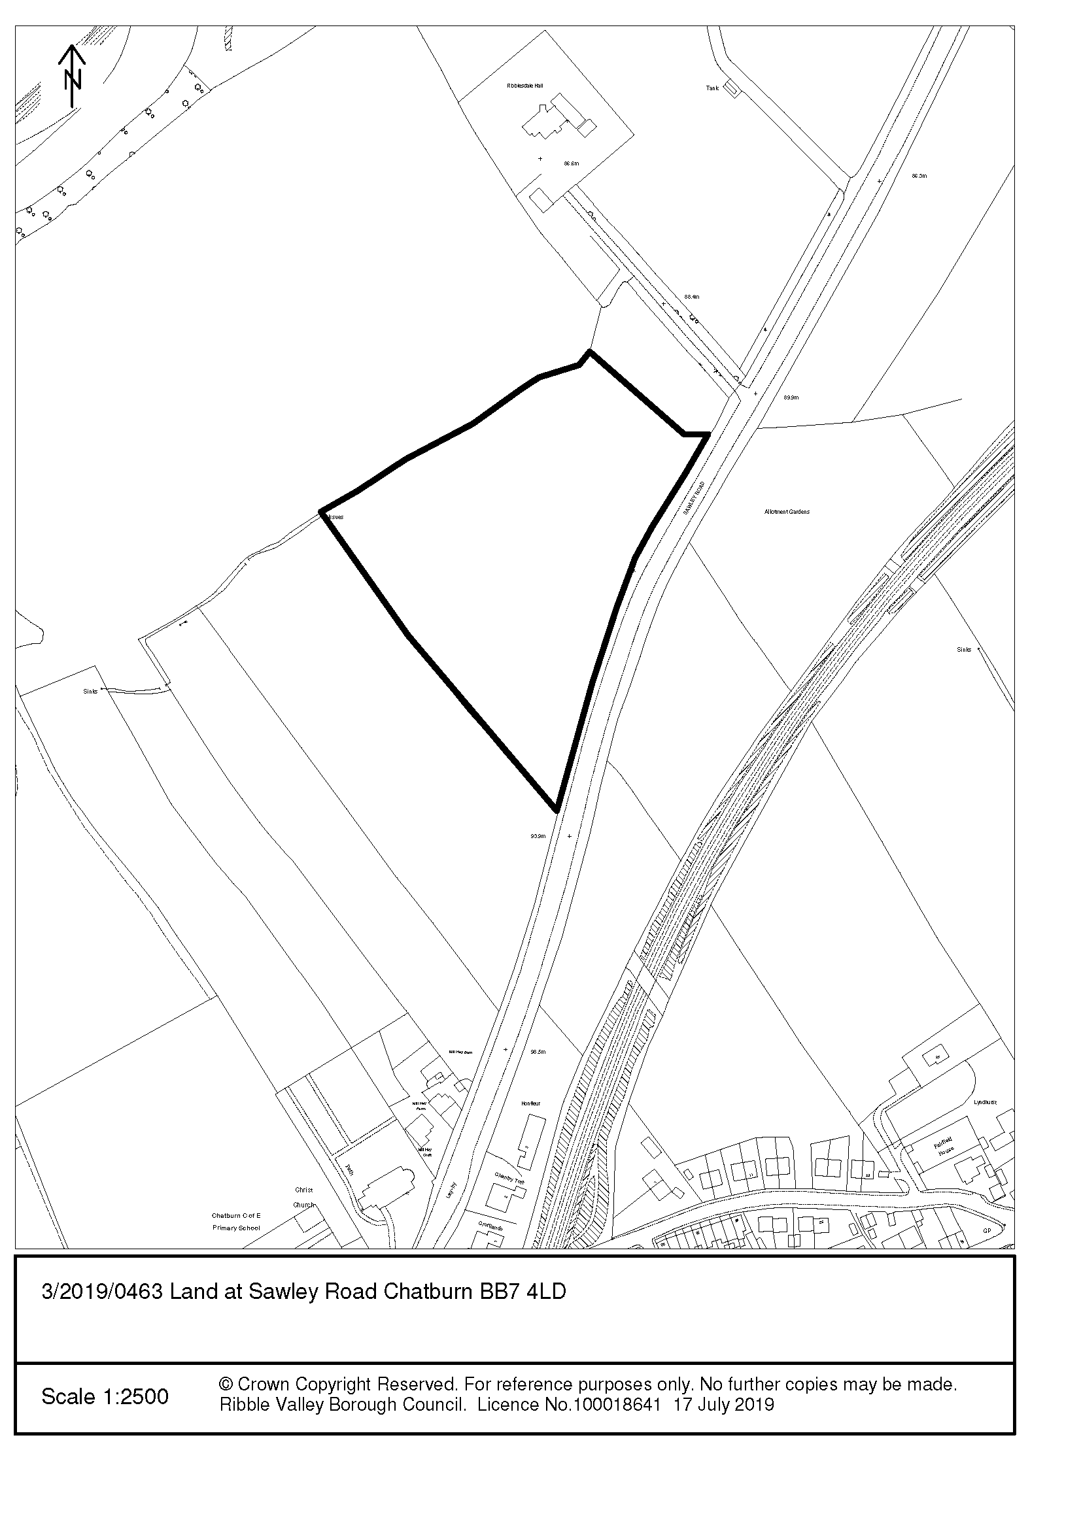

CONSULTEE RESPONSES/ REPRESENTATIONS MADE:

PARISH COUNCIL:

Chatburn Parish Council have provided the following comments:

- Concerned that this is a ribbon development that will extend the village to an unacceptable level;
- Chatburn already has a similar business and approval of this application will set a precedent for future development of the site;
- The site is outside of the 30mph speed limit restriction and speeding vehicles is a problem on this stretch of road;
- School buses and allotment holders park on this section of road;
- No water or electricity facilities on site;
- No provision for storing equipment necessary to run the business;
- Detrimental impact on visual aspect of the village;
- If approved there must be a condition that the site will be returned to open countryside.

LCC HIGHWAYS:

No objection subject to a condition that the access is appropriately surfaced prior to it being brought into use

UNITED UTILITIES:

No comments received

ADDITIONAL REPRESENTATIONS:

Three letters, representing two households, have been received. The points raised in these representations are listed below:

- Already traffic and car parking problems in this area;
- Inadequate car parking provision will result in on street car parking;
- Future development/expansion on site – resulting in another garden centre;
- Impact upon neighbouring residential amenity;
- Development of this site could lead to ribbon development outside of the village settlement boundary, which in turn could lead to infill of adjacent sites;
- Need for another similar use to the existing “garden centre”;
- Proposal offers little benefit to the village;
- This is a speculative application and further clarification is required in respect of the applicant’s intentions;
- Set an undesirable precedent for open field throughout the borough to be developed for “market gardens”;
- What proportion of sales will be for retail or for wholesale – impact on town centre;
- Contrary to national guidance of town-centre-first approach to retail;
- A retail sequential test should have been undertaken to identify why this site has been chosen over others;
- The applicant has planted 1,000 Christmas trees and the sale of these will generate 100 vehicles a day visiting the site over a two week period;
- How will sale of goods be controlled by the Council?;
- If business fails would the site be considered brownfield and then suitable for residential development or other retail?;
- Visual impact on open countryside and nearby AONB;
- Significant engineering works required to level the land;
- Unsustainable location that will be reliant on visitors using motor vehicle;
- Suitability of the access – width and visibility;
- Surface water drainage issues in the area;
- Where will staff facilities be provided?;
- Where will equipment be stored?;
- No details in respect of opening hours.

1. Site Description and Surrounding Area

  - The application relates to a field measuring approximately 5 acres on Sawley Road, Chatburn. The site is situated approximately 140m north of the settlement boundary of Chatburn and is therefore within the open countryside.

  - The land slopes downwards away from Sawley Road and is reasonably well screened by a mature hedgerow along its frontage. The remaining boundaries are defined by a mixture of vegetation, although the application states that the boundary fencing has recently been replaced and new native hedgerows planted. An existing field gate and dropped kerb provides access into this field.

  - The application site is adjoined by agricultural fields, however some 100m to the north is the residential property known as Ribblesdale Hall which is accessed via a lengthy track off Sawley Road. On the opposite side of the A59 are open fields and an allotment site.

  - The submission details how the applicants purchased the site 2016 and have recently planted 1000 Christmas trees in the south eastern corner of the site.

2. Proposed Development for which consent is sought

2.1 The application seeks consent to erect six polytunnels on this site and operate as a market garden. The polytunnels would be situated on the lower ground at the northern end of the land, each measuring 24m x 8m with a maximum height of 4.3m. As a result in the change in the sloping nature of the site an element of cut and fill will need to be undertaken to provide level land for the siting of the polytunnels. In terms of appearance each polytunnel would have a curved roof and be of a diffused polythene construction with the sides coloured green. Rainwater from the roofs of the polytunnels will be harvested and used for the watering of plants.

2.2 In addition to the polytunnels the application also includes the provision of a vehicle parking and manoeuvring area. This would be created in the north east corner of the site, close to Sawley Road. The car parking area would be finished in a loose surface with no markings and accommodate up to 30 cars.

2.3 In respect of the use the application states that this will be an agricultural/horticultural business and that only fruit, vegetables and plants grown on the site (either within the polytunnels or on the land itself) will be sold. As such the proposed retail element of the site is considered to be ancillary and incidental to the main use of the site for growing plants, fruit and vegetables (agricultural/horticultural). The site will be open to both the public and for trade.

3. Relevant Planning History

3.1 N/A

4. Relevant Policies

Ribble Valley Core Strategy:

Key Statement DS1 – Development Strategy
Key Statement DS2 – Sustainable Development
Key Statement DMI2 – Transport Considerations
Key Statement EN2 – Landscape
Key Statement EC1 – Business and Employment Development
Key Statement EC3 – Visitor Economy

Policy DMG1 – General Considerations
Policy DMG2 – Strategic Considerations
Policy DME3 – Site and Species Protection and Conservation
Policy DME6 – Water Management
Policy DMG3 – Transport & Mobility
Policy DME2 – Landscape & Townscape Protection
Policy DMB1 – Supporting Business Growth and Local Economy
Policy DMB3 – Recreation and Tourism

National Planning Policy Framework (NPPF)
National Planning Practice Guidance (NPPG)

5. Assessment of Proposed Development

5.1 Principle of development

5.1.1 The Ribble Valley Core strategy seeks to support business growth and the local economy. Key Statement EC1 states that “Employment development will be directed towards the main settlements of Clitheroe, Whalley and Longridge as the preferred locations to accommodate employment growth together with land at Barrow Enterprise Site, the Lancashire Enterprise Site at Samlesbury and locations well related to the A59 corridor”. The application site is located approximately 450m to the south of the A59, and will be accessed off Sawley Road which connects directly to the A59. Given the short distance from the application site to the A59 it is considered that the application site is “well-related” to the A59 corridor in accordance with Key Statement EC1.

5.1.2 In addition, Key Statement EC1 also offers support for proposals that result in farm diversification and the strengthening of the wider rural economy, and this is considered to be applicable to this application as the proposal seeks to grow and produce all goods that would be sold on site. As such the main use of the site would be agricultural and horticultural with an element of retail which is considered to be ancillary and incidental to the main use of the site.

5.1.3 Policy DMB1 also supports proposals that are intended to support business growth and the local economy. This includes “The expansion of established firms on land outside settlements will be allowed provided it is essential to maintain the existing source of employment and can be assimilated within the local landscape”. It is accepted that this proposal relates to a new site, however the submission details how the proposal relates to an expansion and diversification of the applicants existing landscaping and maintenance business and will generate an additional six jobs (2 x full time, 2 x part time and 2 x seasonal). The visual impacts of the proposal are discussed later in this report.

5.1.4 Policy DMB3 relates to recreation and tourism development, and given that the proposed development would likely result in people visiting the site, particularly as a result of its location in relation to the A59, this policy is also considered to be of some relevance. Policy DMB3 seeks to support proposals that would attract visitors to the Ribble Valley, provided that the site is physically well related to an existing main settlement, village or existing group of buildings. In this case the application site is located 140m from the settlement boundary of Chatburn (Tier one village) and therefore is considered to be well related to a main settlement.

5.1.5 With regard to Policy DMG2, this policy states that developments outside of the defined settlement boundaries must meet one of six considerations.

1. The development should be essential to the local economy or social wellbeing of the area.
2. The development should be needed for purposes of forestry or agriculture.
3. The development should be for local needs housing meeting an identified need and would be secured as such.
4. The development is for small-scale tourism or recreation purposes that are appropriate to a rural area.
5. The development is for small-scale uses appropriate to a rural area where a local need or benefit can be demonstrated.
6. The development is compatible with the enterprise zone designation.

5.1.6 In respect of the above, as mentioned earlier the proposal would create new job opportunities, as well as providing a facility for local products to be grown and bought. The proposal therefore represents some economic and social benefits to the area.

5.1.7 With regard to use, the proposed market garden would sell fruit, vegetables and plants that are produced from the site and therefore the retail element is considered to be ancillary to the main horticultural and agricultural use of the site. It is therefore considered that the development represents a small scale use that is appropriate to a rural area in accordance with Policy DMG2.

5.1.8 Concerns have been raised in respect of this being the correct location for this type of use, however a market garden which grows its own produce would be expected to be located within the open countryside (not within a settlement) purely on the basis of the amount/area of land that would be required to grow the produce. Furthermore, as detailed elsewhere in this report the site is situated very close to the settlement boundary of Chatburn (140m) and the A59 (450m), and therefore benefits from good transport links in comparison to other sites in the open countryside. As such it is considered that this is an acceptable location for the proposed use.

5.1.9 An objector has referred to the need to carry out a sequential test for the retail element of the proposal. In response to this para 88 of the NPPF states the “…sequential approach should not be applied to applications for small scale rural offices or other small scale rural development”. As detailed above the LPA consider this to be a “small scale rural development” and therefore a sequential test is not required. Furthermore and as detailed earlier, the retail element is considered to be ancillary and incidental to the main use of the site as agricultural and horticultural, and consequently the main use of the site would not be suited to a town-centre or edge-of-centre location.

5.1.10 To clarify the above a condition has been attached to the recommendation which ensures that the retail element of the use remains incidental and ancillary to the horticultural and agricultural use of the site, and that 90% of the goods sold are produced on site. The other 10% of goods that can be sold from site include related items such as trays, pots, fertiliser etc… A concern has been raised that the approval of this development would result in brownfield site that could be developed in the future, however the aforementioned condition ensures that the main use of the site is agricultural/horticultural and that the retail use is ancillary only, thus retaining its greenfield definition.

5.1.11 In view of the above, the principle of the development on this site, close to the settlement boundary of Chatburn and the A59, is considered to be acceptable, subject to other considerations and compliance with Council Policies detailed below.

5.2 Impact Upon Residential Amenity

5.2.1 The nearest residential property is Ribblesdale Hall, situated approximately 100m north of the application site with intervening land in-between. At such a distance it is considered that the proposed polytunnels, measuring 4.3m tall to the highest point, would not have any undue impact residential amenity by way of overshadowing, loss of daylight and outlook. Furthermore the existing boundary treatment on the application site, and on land associated with the dwelling at Ribblesdale Hall, would provide sufficient screening.

5.2.2 To the south the nearest residential property is the property at Mill Hey Barn which is located at the edge of the settlement boundary. This property is located approx. 140 from the southern boundary of the site and approximately 250m from the proposed polytunnels and car parking area. At such a distance, and for similar reasons to those detailed above, it is not considered that the development would have a negative visual impact upon the residential amenity of the properties to the south.

5.2.3 In respect of use of the land, it is accepted that the proposal would result in an intensification of activities in comparison to its existing use as an agricultural field. Nevertheless the planting of fruit, vegetables and plants on the site does not require consent, and therefore the main consideration in respect of neighbouring amenity is the impact the proposed ancillary retail element would have.

5.2.4 The submission details how the site would only sell fruit, vegetables and plants that are produced on site, and the application does not include any specific retail building on site. The proposal does not include any proposed hours of operation however a condition has been attached restricted the hours of opening to 08:00 - 18:00 Monday to Saturday and 09:00 – 17:00 on Sunday, and the applicant has confirmed their agreement to these hours. In addition the application as submitted includes no external lighting, ensuring that the use will be restricted to “daytime” hours, and a condition has been attached which requires details of any lighting to be installed on the site must first be submitted for the writing approval of the LPA.

5.2.5 In view of the above it is considered that the proposed development will share an acceptable relationship with neighbouring uses in accordance with the amenity requirements of Policy DMG1.

5.3 Visual Impact and design

5.3.1 The application includes two elements - the proposed polytunnels and the car parking area - which have the potential to have a visual impact on the open countryside and the character of the area.

5.3.2 With regard to the polytunnels, these would be sited at the northern end of the site, on the lower section of the land and away from the highway of Sawley Road. Due to the sloping nature of the land an element of cut and fill will need to take place to provide a level section for the polytunnels however the proposed level changes are considered to be acceptable (approx. 1m at maximum point).

5.3.3 It is acknowledged that the polytunnels would cover a large footprint, however being 4.3m tall to the highest point would not particularly prominent, and whilst they would be visible from sections of Sawley Road, and longer distances, they would be reasonably well screened by boundary vegetation, vegetation within neighbouring fields and in the future by additional vegetation to be planted within the development site in conjunction with the horticultural/agricultural use. In addition, the side elevations of the polytunnels would be coloured green to reduce the visual impact and seek to blend in with the surroundings.

5.3.4 In view of the above, due to the siting, finish and height of the proposed polytunnels, as well as surrounding vegetation, it is not considered that the polytunnels would be a visually prominent or detrimental to the character of the area, and polytunnels are not an uncommon structure/feature within the open countryside. Furthermore there is an allotment garden on the opposite side of the road which has a similar visual impact to the proposal.

5.3.5 With respect of the car parking area, this would be positioned towards the front of the site and would be finished in a loose porous material so as to ensure that drainage is not impacted but also to retain a more rural appearance as opposed to a tarmac/concrete surface with markings. Given the surrounding boundary hedgerows it is considered that the car parking area, and vehicles parked within this area, would be well screened.

5.3.6 It is acknowledged that the AONB is situated approximately 500m to the east, and that the Christ Church some 200m to the south of the site is a Grade II Listed Building. In terms of the AONB, whilst sections of the site may be visible from some elevated positions at a long distance within the AONB, these would be limited due to the surrounding vegetation and it is not considered that the proposed development would have a harmful impact upon the AONB. With regard to the Listed Church, this is located a significant distance from the application site, with intervening buildings/dwellings at Mill Hey Farm situated in-between and thus the proposal would not impact upon the setting of this Listed Building.

5.3.7 In summary of the above, it is considered that the visual impact of the proposal is limited and would not be detrimental to the visual amenity of the area.

5.4 Landscape and Ecology

5.4.1 The proposal would result in the loss of some of an existing agricultural field for the siting of the ploytunnels and the creation of the car park, however as detailed earlier the applicant has planted new boundary hedging and the proposed horticultural use of the site would result in a net gain in biodiversity in comparison to an agricultural field.

5.5 Highways

5.5.1 The Highway Officer has raised no objection to the application, subject to a condition requiring that the first 5m of the access, from the highway boundary, is appropriately surfaced so as to prevent loose surface material entering the highway from the site. Further conditions have also been attached requiring the car parking area to be provided before any trade/retail sales take place from this site and that the access gates are set back 5m from the back of the highway, so as to allow a vehicle to park free of the highway and open the gates at the beginning and end of the day.

5.5.2 Objections have been raised in respect of the number of vehicle movements that would be created by the proposal, the quality of the access and potential for vehicles to park on the highway. In terms of additional traffic, Sawley Road is a classified road which connects to the A59 some 450m to the north and as such the surrounding highway network is considered to be adequate to cater for the additional vehicle movements associated with this development. The Highway Officer has raised no objection to the suitability of the access and similarly the level of parking provision, up to 30 spaces, is considered to be adequate for the proposed use.

5.6 Drainage

5.6.1 As mentioned earlier the car park would be finished in a porous material so as to allow for water to drain and rainwater will be harvested from the polytunnels and re-used on site.

6. Other issues

6.1 A concern has been raised in respect of the development of this site acting as a ribbon development, allowing for future development of land between this site and the settlement boundary. Similarly concerns have been raised in respect of future applications at the development site for expansion of the business. In respect of these issues, each application is judged on its individual merits and this application has been considered on the basis of the information provided. There is no justifiable reason to refuse this application on the grounds of what may happen in the future at this site, or adjacent sites.

6.2 The Parish Council have commented that there is no mains electricity or water to the site. In response to this the applicant has confirmed that rainwater will be harvested from the site for watering of plants, nevertheless additional water may be needed and therefore the applicant is seeking to connect to the mains water. With regard to electricity the applicant’s agent has confirmed that electricity will likely be needed for irrigation purposes and this will be provided by a generator. The application does not include any details of this and subsequently a condition has been added requiring details of any plant/generators to be submitted to the LPA prior to installation on site.

6.3 It is noted that the proposal does not include any storage or staff facilities, however the applicant’s agent has confirmed that the business will operate on a “basic set up” with plants potted by hand and as such there is no need for any machinery or staff/storage buildings.

7. Conclusion

7.1 The principal of the development is considered to be acceptable in this location and would share an acceptable relationship with surrounding land uses. The proposal would have a limited impact on the visual character of the area, and would bring economic benefits to the local economy by way employment and visitors.

RECOMMENDATION: That the application be APPROVED subject to the imposition of the following condition(s):

Time Limit

1. The development must be begun not later than the expiration of three years beginning with the date of this permission.

REASON: Required to be imposed by Section 51 of the Planning and Compulsory Purchase Act 2004

Plans

2. Unless explicitly required by condition within this consent, the development hereby permitted shall be carried out in complete accordance with the proposals as detailed on drawings:

Bri/910/2635/01
Bri/910/2635/02
Bri/910/2635/03
Bri/910/2635/04

REASON: For the avoidance of doubt and to ensure that the development is carried out in accordance with the submitted plans.

Materials

3. The development hereby approved shall be carried out in complete accordance with the materials detailed within the approved drawings and section 7 of the application forms.

REASON: In order to ensure that the materials to be used are appropriate to the locality.

Use

4. Any retail sales from the site edged red on the submitted plans shall be incidental and ancillary to the horticultural/agricultural use of the site (i.e. used for the sale of plants, shrubs, trees, fruit, vegetables and items grown/grown on the site), other than for the sale of up to 10% (of the total volume of stock over any year) of other related items that may be imported from outside the site (e.g. seeds, compost, fertiliser, pots, trays, stakes) and for the sale of no other goods whatsoever.

REASON: To ensure that the retail use of the site remains ancillary and incidental to the main agricultural and horticultural use of the site, and as detailed within the submitted application.

Amenity

6. The site shall only be open for ancillary retail sales between the hours of 08:00-18:00 Monday to Saturday and 09:00 – 17:00 on Sunday.

REASON: In order to protect the amenity of nearby residential properties and to prevent nuisance arising.

7. No external lighting shall be installed on the polytunnels hereby approved, or elsewhere within the site including the car parking area.

REASON: In the interests of visual amenity of this rural location.

8. Full details/specifications of any plant machinery or equipment, including electricity generators, air conditioning units (including details of their position, appearance, noise levels and model numbers used) to be installed on site shall have first been submitted to and approved in writing by the Local Planning Authority prior to its installation on site. The equipment shall be installed in complete accordance with the approved details and all filters/equipment should be retained as agreed thereafter and maintained to ensure optimum operation.

REASON: To ensure that the development hereby permitted is not detrimental to the amenity of the surrounding area by reason of undue noise emission and/or unacceptable disturbance.

Highways

9. The car parking area as shown on approved drawing Bri/910/2635/02 shall be provided and made available for use before any ancillary retail element of the site becomes operative and retained as such thereafter.

REASON: In the interests of highway safety.

10. Prior to the access being used for vehicular purposes, the part of the access extending from the highway boundary for a minimum distance of 5m into the site shall be appropriately paved in tarmacadam, concrete or block paviours, and retained as such thereafter.

REASON: To prevent loose surface material from being carried on to the public highway thus causing a potential source of danger to other road users.

11. Any access gates located at the access point shall be positioned 5m behind the nearside edge of the carriageway, and shall only open into the site.

REASON: To permit vehicles to pull clear of the carriageway when entering the site.

Drainage

12. The car parking area as shown on approved drawing Bri/910/2635/02 shall be constructed in a porous material which allows water to drain. Thereafter porous materials shall be retained for the car park area.

REASON: To prevent an undue increase in surface water run-off and to reduce the risk of flooding.

BACKGROUND PAPERS

https://www.ribblevalley.gov.uk/site/scripts/planx_details.php?appNumber=3%2F2019%2F0463

