

Ribble Valley Borough Council

Council offices

Church Walk

CLITHEROE

BB7 2RA

My reference: 3/2020/0159

Direct Dial: (01200) 425111

Fax: (01200) 414487

Email: [planning@ribblevalley.gov.uk](mailto:planning@ribblevalley.gov.uk)

Date: 24 April 2020

Location: Land off Ribblesdale View Chatburn

Proposal: Discharge of conditions 2 (materials), 3 (boundary treatments), 5 (landscaping), 6 (highway frontage) and 7 (drainage scheme) from planning permission 3/2019/0763.

I write in response to your application to discharge the conditions pursuant to planning approval 3/2020/0159

|  |
| --- |
| Conditions 2 (materials), 3 (boundary treatments), 5 (landscaping), 6 (highway frontage) and 7 (drainage scheme) be partially discharged and fully discharged upon implementation. It is considered that the proposed materials are acceptable to the locality and the landscaping adequate for the immediate area. |

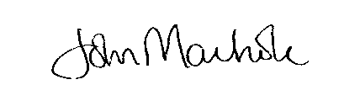

**pp NICOLA HOPKINS**

**DIRECTOR OF ECONOMIC DEVELOPMENT AND PLANNING**

Justin Swingler

Feazer Cottage

Feazer Developments Ltd

Slaidburn Road

Waddington

Clitheroe

BB7 3JJ

Agent