
My reference: 3/2020/0256
Direct Dial: (01200) 425111
Fax: (01200) 414487
Email: planning@ribblevalley.gov.uk
Date:7 April 2020

Mr W Horner
C/O Ian Swain
WBW Surveyors Ltd
Skipton Auction Mart
Gargrave Road
Skipton
BD23 1UD

Dear Mr Horner

Town & Country Planning Act 1990
Schedule 2 of Part 6 of the Town & Country Planning (General Permitted Development) Order 2015

Ribble Valley Borough Council, as local planning authority, hereby confirm that their PRIOR APPROVAL IS NOT REQUIRED for the proposed development at the address shown below, as described by the description shown below, and in accordance with the information that the developer provided to the local planning authority:

Address of the proposed development

Laneside Farm
Grindleton Road
West Bradford
BB7 4QJ

Description of the proposed development

Application to determine if prior approval is required for the proposed erection of an agricultural building.
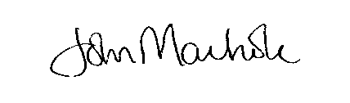

PP NICOLA HOPKINS
DIRECTOR OF ECONOMIC DEVELOPMENT AND PLANNING

