RIBBLE VALLEY BOROUGH COUNCIL
Development Department
Council Offices, Church Walk, Clitheroe, Lancashire, BB7 2RA
Telephone: 01200 425111 Fax: 01200 414488 Planning Fax: 01200 414487
Town and Country Planning Act 1990
REFUSAL OF NON MATERIAL AMENDMENT
APPLICATION NO: | 3/2020/0270
DECISION DATE: | 9 April 2020
DATE RECEIVED: | 27/03/2020
APPLICANT: |  |  | AGENT:
Mr Simon Moore  Rosenburgh  Settle Lane  Paythorne  BB7 4JD |  |  | Mr John Wharton  Craven House  Brook View  Carleton  Skipton  BD23 3EX

DEVELOPMENT PROPOSED: |  |  | Non-material amendment to planning permission 3/2019/1068 to allow re-siting of previously approved stables and formation of muck heap in garden to Rosenburgh.
AT: | Rosenburgh Settle Lane Paythorne BB7 4JD
Ribble Valley Borough Council hereby give notice in pursuance of the provisions of the Town and Country Planning Act 1990 that permission has been refused for the non material amendment to Planning Permission
3/2020/0270 for the following reason(s):
1 |  | The stable building is to be rotated 90 degrees which results in the development falling outside of the approved red edge to which the application relates (3/2019/1068) and there is no capacity under a non-material amendment application to extend the application site boundary as defined by criteria no.1 on the procedure note.
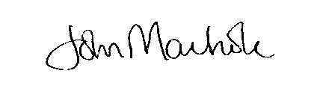
pp NICOLA HOPKINS
DIRECTOR OF ECONOMIC DEVELOPMENT AND PLANNING

