RECOMMENDATION FOR PLANNING AND DEVELOPMENT COMMITTEE

# DEFER AND DELEGATE FOR APPROVAL

**DATE: 25th November 2020**

**REF: SK**

**CHECKED BY: NH**

**APPLICATION REF: 3/2020/0325**

GRID REF: SD 375227 443018

**DEVELOPMENT DESCRIPTION:**

CONSTRUCTION OF 17 DWELLINGS WITH ASSOCIATED WORKS, LANDSCAPING AND ACCESS. LAND NORTH OF CHATBURN ROAD CLITHEROE BB7 2EQ

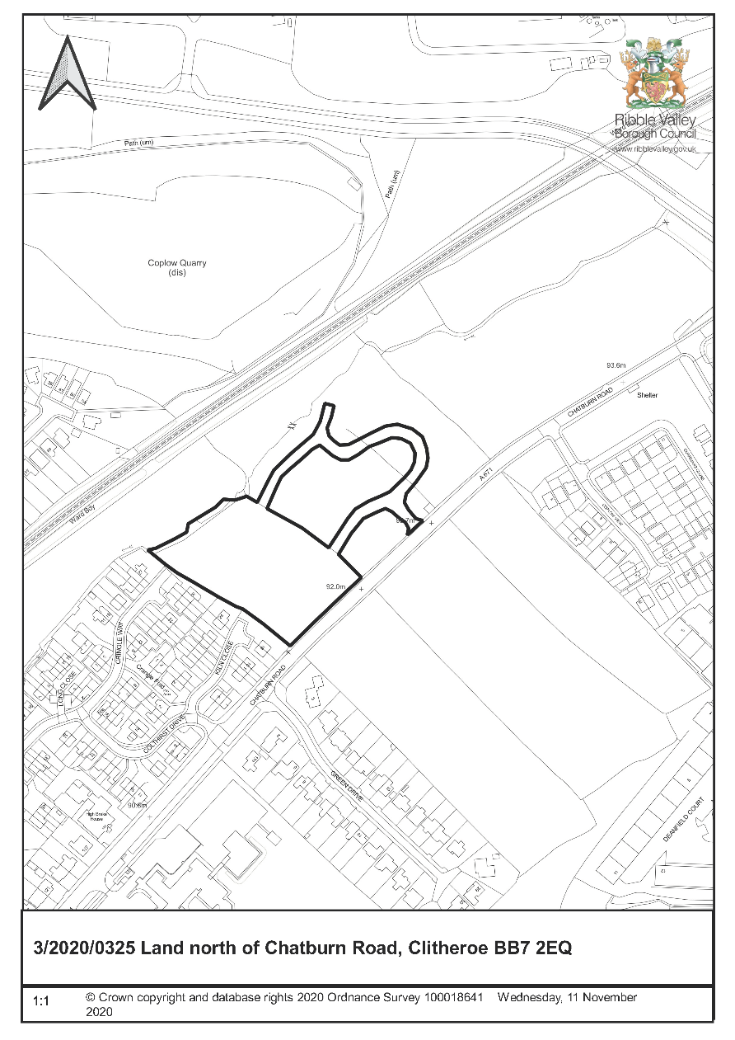

**CONSULTEE RESPONSES/ REPRESENTATIONS MADE:**

**CLITHEROE TOWN COUNCIL:**

No representations received in respect of the application.

**ENVIRONMENT DIRECTORATE (COUNTY SURVEYOR):**

No representations received in respect of the application.

**UNITED UTILITIES:**

No objections subject to the imposition of conditions.

**LLFA:**

The Lead Local Flood Authority has no objection to the proposed development subject to the imposition of conditions.

**LCC EDUCATION**

Based upon the latest assessment, taking into account all relevant approved applications, LCC Contributions will be seeking a contribution for 5 primary and 2 secondary school places.

Calculated at the current rates, this would result in a claim of:

Primary Places:

(£12,257 x 0.97) x BCIS All-in Tender Price (336 / 240) (Q1-2020/Q4-2008)

= £16,645.01 per place

£16,645.01 x 5 places = £83,225.05

Secondary Places:

(£18,469 x 0.97) x BCIS All-in Tender Price (336 / 240) (Q1-2020/Q4-2008)

= £25,080.90 per place

£25,080.90 x 2 places = £50,161.80

**ADDITIONAL REPRESENTATIONS:**

Three letters of representation have been received objecting to the proposal on the following grounds:

* Highway Safety
* Noise Disturbance
* Lack of existing infrastructure
* Lack of affordable housing
* Increase in traffic
* Increased flood risk
* Loss of wildlife
* Loss of view
* Loss of privacy

1. **Site Description and Surrounding Area**

* 1. The application relates to an area of greenfield land located within the defined settlement boundary for Clitheroe. The site is 0.9ha in size and is bounded to the south by Chatburn Road (A671), to the east by areas by an existing committed housing site (DS1 Designation) which is currently under construction. The site has a direct interface with a number of existing residential dwellings to the south-west with dwellings fronting Kiln Close and Cringle Way benefitting from a side-on relationship with the application site. The site is also bounded to the north by an existing watercourse and a number of trees with the Clitheroe rail-line lying further to the north.

2. **Proposed Development for which consent is sought**

2.1 Full consent is sought for the erection of 17 dwellings with associated works, landscaping and access. It is proposed that the primary vehicular access to the site will be via a direct interface with the adjacent on-going development to the north-east which currently benefits from access directly off Chatburn Road. The applicant has also provided a commitment to provide policy compliant provision of affordable housing.

2.2 The submitted details propose that the development, at its south-eastern extents, will adopt a linear arrangement that is largely informed by the rear building line of the adjacent housing development to the north-east. It is then proposed that the singular primary access road will swing northward terminating in a cul-de-sac turning area which then serves private drive areas, one of which interfaces with and acts as a continuation of an existing private drive arrangement found on the development to the north-east.

3. **Relevant Planning History**

The site to which the application relates has no planning history directly relevant to the determination of the application. Members will however note that the application acts as an extension to the existing housing development (which is at an advanced stage in construction) that lies directly to the north-east as consented by application 3/2017/0653.

4. **Relevant Policies**

**Ribble Valley Core Strategy**

Key Statement DS1 – Development Strategy

Key Statement DS2 – Presumption in Favour of Sustainable Development

Key Statement DMI1 – Planning Obligations

Key Statement DMI2 – Transport Considerations

Key Statement EN4 – Biodiversity and Geodiversity

Key Statement H2 – Housing Balance

Key Statement H3 – Affordable Housing

Policy DMB4 – Open Space Provision

Policy DME3 – Site and Species Conservation

Policy DME6 – Water Management

Policy DMG1 – General Considerations

Policy DMG2 – Strategic Considerations

Policy DMG3 – Transport and Mobility

Policy DMH1 – Affordable Housing Criteria

National Planning Policy Framework (NPPF)

National Planning Practice Guidance (NPPG)

5. **Assessment of Proposed Development**

5.1 Principle of Development:

5.1.1 The site is located within the defined settlement boundary for Clitheroe being located directly between existing residential development to the south-west and development which is underway that directly bounds the site to the north-east. As such, given the location of the site within the defined settlement boundary, Policy DMG2 is fully engaged.

5.1.2 Members will note that Policy DMG2 is two-fold in its approach to guiding development. The primary part of the policy DMG2(1) is engaged where development proposals are located ‘in’ principal and tier 1 settlements with the second part of the policy, DMG2(2) being engaged when a proposed development is located ‘outside’ defined settlement areas or within tier 2 villages, with each part of the policy therefore being engaged in isolation and independent of the other dependant on the locational aspects of a proposal.

5.1.3 The mechanics and engagement of the policy are clear in this respect insofar that it contains explicit triggers as to when the former or latter criterion are applied and the triggers are purely locational and clearly based on a proposals relationship to defined settlement boundaries and whether, in this case, such a proposal is ‘in’ or ‘outside’ a defined settlement.

Given the location of the site within the defined settlement boundary it is therefore considered that it is DMG2(1) which remains engaged for the purposes of determining the application which states that *‘development proposals in the principal settlements of Clitheroe, Longridge and Whalley and the tier 1 villages should consolidate, expand or round-off development so that it is closely related to the main built up areas, ensuring this is appropriate to the scale of, and in keeping with, the existing settlement.’*

5.1.4 As such, taking account of the criterion of DMG2(1) and that the proposal site lies between two parcels of existing development (one of which being currently under construction), and taking account that the site lies within the defined settlement limits of Clitheroe. It is considered that the proposal represents that which is considered ‘consolidation’ when taking account of the definition of consolidation as defined within the Ribble valley Core Strategy which states that *‘consolidation refers to locating new developments so that it adjoins the main built up area of a settlement and where appropriate both the main urban area and an area of sporadic or isolated development’.*

5.1.5 Taking into account the above matters, notwithstanding other development management considerations, it is considered that the principle of the development of the site for residential purposes raises no direct conflicts with the development strategy in relation to the aspirations for the location for new residential development within the Borough.

5.2 Impact upon Residential Amenity:

5.2.1 The proposed development has a direct interface and relationship with a number of existing residential dwellings fronting Cringle Way and Kiln Close which lie directly to the south-west of the site. As such due consideration must be given in respect of the potential for the development to have a negative or detrimental impact upon the standard of residential amenity currently experienced by the occupiers of the aforementioned dwellings.

5.2.2 In this respect, Plots 6-10 directly back on to the shared south-western boundary with the aforementioned existing dwellings with Plot 11 being orientated so that the side gable of the dwelling faces the shared boundary. In this respect Plots 6-10 are sited from the shared boundary at distances that range from 13.8m to that of 18.5m (approximately) also benefitting from offset distances ranging from 24.8m to 28m when measured from the rear of the proposed dwellings to the side elevations of the nearest directly affected residential dwellings. As members will note these spatial offset distances significantly exceed those that would normally be secured by the authority.

5.2.3 In respect of Plot 11, this dwelling is orientated to allow it to benefit from a side-gable to side-gable relationship with the nearest existing residential dwelling to the south-west with an offset distance of approximately 9m from the existing dwelling. Therefore, taking account of the aforementioned offset distance and orientation of the dwellings in relation to one another it is not considered that the proposal will result in any undue impact upon existing or future residential amenity.

5.2.4 Taking into account the above matters it is not considered that the proposed layout will result in any significant nor measurable undue detrimental or negative impact upon existing or future residential amenity by virtue of an over-bearing impact, loss of light or loss of privacy by virtue of direct-overlooking or proximity.

5.3 Matters of Design/Visual Amenity:

5.3.1 The proposed house types adopt a level of consistency within their elevational language through a simplified materials palette restricted to that of reconstituted stone and render as primary facing materials, similar to that of the existing adjacent development currently under construction. The elevational language of the proposed development is also similar to that of the existing adjacent housing development allowing for an element of visual synergy between both proposals. As such it is not considered that the proposed dwellings will appear unsympathetic or discordant when viewed in context with existing and nearby development.

5.3.2 Taking account of the above matters it is not considered that the proposed development will result in any undue impact upon the character or visual amenities of the area.

5.4 Highway Safety and Accessibility:

5.4.1 Lancashire County Council, as the Highway Authority, have raised no objections to the proposal.

5.5 Flood Risk and Drainage:

5.5.1 The Lead Local Flood Authority has no objection to the proposed development subject to the imposition of conditions requiring that the development be carried out in strict accordance with the submitted surface water drainage details.

5.6 Developer Contributions:

5.6.1 LCC Education are requesting a contribution towards both primary and secondary educational provision as a result of the development as follows:

Primary Places

Latest projections for the local primary schools show there to be a shortfall of 191 places in 5 years' time. These projections take into account the current numbers of pupils in the schools, the expected take up of pupils in future years based on the local births, the expected levels of inward and outward migration based upon what is already occurring in the schools and the housing development within the local 5 year Housing Land Supply document (or equivalent), which already have planning permission.

With an expected yield of 5 places from this development the shortfall would increase to 196. Therefore LCC Education are seeking a contribution from the developer in respect of the full pupil yield of this development, i.e. 5 places.

Secondary Places

Latest projections for the local secondary schools show there to be a shortfall of 353 places in 5 years' time. These projections take into account the current numbers of pupils in the schools, the expected take up of pupils in future years based on the local births, the expected levels of inward and outward migration based upon what is already occurring in the schools and the housing development within the local 5-year Housing Land Supply document, which already have planning permission.

With an expected yield of 2 places from this development the shortfall would increase to 355.Therefore LCC Education are seeking a contribution from the developer in respect of the full pupil yield of this development, i.e. 2 places.

5.6.2 As a result of the above LCC Education are requesting a contribution of a and based upon the latest assessment, taking into account all approved applications, LCC will be seeking a contribution for 5 primary and 2 secondary school places.

Calculated at the current rates, this would result in a claim of:

Primary places:

(£12,257 x 0.97) x BCIS All-in Tender Price (336 / 240) (Q1-2020/Q4-2008)

= £16,645.01 per place

£16,645.01 x 5 places = £83,225.05

Secondary places:

(£18,469 x 0.97) x BCIS All-in Tender Price (336 / 240) (Q1-2020/Q4-2008)

= £25,080.90 per place

£25,080.90 x 2 places = £50,161.80

5.6.3 A contribution towards leisure facilities within Clitheroe will also be required as part of the development. Based on the current proposed housing mix the contribution that will be sought and secured via section 106 agreement will be approximately £9,586.98.

5.7 Affordable Housing Provision:

5.7.1 The proposal brings forward a policy compliant level of affordable housing, also providing a compliant level of affordable and open market housing for those aged 55 and over. The affordable housing mix as proposed consists of 4 affordable rent apartments and two dwellings that will benefit from an occupancy restriction for those aged 55 and over., one of which being affordable and the other being open market.

6. **Observations/Consideration of Matters Raised/Conclusion**

6.1 Taking account of the above matters and all material considerations, it is considered that the proposed development is in a location that is considered to be in full alignment and compliance with the locational and spatial aspirations of the development strategy for the Borough. Particularly insofar that the proposal would represent residential development, within a defined settlement boundary, that would be considered as consolidation as required by Policy DMG2(1)

6.2 It is further considered that the proposal represents a suitable form of development that is of an appropriate scale, external appearance and density that responds positively to the inherent character of the area and adjacent built form as required by Policy DMG1 of the Ribble Valley Core Strategy. Furthermore, taking account of the separation distances between existing and proposed dwellings, it is not considered that the proposal will result in any significant measurable or quantifiable detrimental impact upon existing or future residential amenity.

6.3 For these reasons and all other reasons outlined above, the application is considered to be in broad alignment with the Development Strategy for the Borough and will assist in the delivery of affordable housing within the Borough and also assist in maintaining a robust five-year housing land supply. As such and in the absence of any other over-riding material considerations the application is recommended for approval subject to the satisfactory completion of a Section 106 agreement.

RECOMMENDATION: That the application be DEFERRED and DELEGATED to the Director of Economic Development and Planning for approval following the satisfactory completion of a Legal Agreement, within 3 months from the date of this Committee meeting or delegated to the Director of Economic Development and Planning in conjunction with the Chairperson and Vice Chairperson of Planning and Development Committee should exceptional circumstances exist beyond the period of 3 months and subject to the following conditions:

1. The development must be begun not later than the expiration of three years beginning with the date of this permission.

REASON: Required to be imposed by Section 51 of the Planning and Compulsory Purchase Act 2004.

2. Unless explicitly required by condition within this consent, the development hereby permitted shall be carried out in complete accordance with the proposals as detailed on drawings:

* Drawing No: 068-Loc01 Location Plan
* Drawing No: 068-P-01 Rev E Site Layout Plan
* Drawing No: 068-P-02 Rev B Fencing Layout
* Drawing No: 068-P-03 Rev B Vehicle Charging Layout
* Drawing No: 068-P-04 Rev B Street scene and Section
* Drawing No: 068-P-05 Rev B Site Layout with External Levels
* Drawing No: 19664-100 Revision 2 General Arrangement
* Drawing No: 19664-101 Revision 2 Contour Layout
* Drawing No: C-981-40 Rev B Landscape Proposal and Tree Survey
* Drawing No: 19.664 - 500 Revision 2 Drainage Layout
* Drawing No: 19.664 - 510 Rev C Drainage Long Section
* Drawing No: 19.664 - 530 Drainage Details
* Drawing No: 19.664 - 531 Headwall Detail and Outfall Long Section
* Drawing H3C – Headwall Flap Valve
* Drawing SHE-0104-5600-1500-5600 x2 – Hydrobrake Optimum & characteristics
* Drawing SHE-0126-7800-1280-7800 x2 – Additional Hydrobrake details & Characteristics
* Drawing No: 19.664 – 532 Drainage Details – Manhole and Hydrobrake
* Drawing No: 19.664 - 720 Long Sections
* 33624_LH_D1 – Rev A - polystorm attenuation tank - general arrangement
* Drawing No: 068-BOW-P01 Bowfell Plans
* Drawing No: 068-BOW-P02 Bowfell Elevations
* Drawing No: 068-BOW-SPL-P01 Bowfell Split Level Plans
* Drawing No: 068-BOW-SPL-P02 Bowfell Split Level Elevations
* Drawing No: 068-ENN-AG-P01 Ennerdale with attached garage Plans
* Drawing No: 068-ENN-AG-P02 Ennerdale with attached garage Elevations
* 068-GRA-P01 Grasmere Plans
* 068-GRA-P02 Grasmere Elevations
* 068-ROTH-P01 Rothay Plans
* 068-ROTH-P02 Rothay Elevations
* 068-WAS SPL-P01 Wasdale Split Level Plans
* 068-WAS SPL-P02 Wasdale Split Level Elevations
* 068-WAS-P01 Wasdale Plans
* 068-WAS-P02 Wasdale Elevations
* 068-MF-01A Material Finishes Layout
* 068-MF-01C Material House Types List Chatburn Road South
* Drawing Griz – P01
* Drawing Griz – P02
* Drawing Griz  - P03
* Drawing App P01 1 Rev A
* Drawing App P02 Rev A
* Drawing App P03 Rev A
* Proposed Tenure Layout 068/P/06 Revision D
* Detailed Landscape Proposals & Tree Survey c-981-40 Revision B

REASON: For the avoidance of doubt and to clarify which plans are relevant to the consent hereby approved.

*Landscape and Ecology*

3. The landscaping proposals hereby approved shall be implemented in the first planting season following the first occupation of the development, whether in whole or part and shall be maintained thereafter for a period of not less than 10 years to the satisfaction of the Local Planning Authority.

This maintenance shall include the replacement of any tree or shrub which is removed, or dies, or is seriously damaged, or becomes seriously diseased, by a species of similar size to those originally planted. All trees/hedgerow shown as being retained within the approved details shall be retained as such in perpetuity.

REASON: To ensure the proposal is satisfactorily landscaped and trees/hedgerow of landscape/visual amenity value are retained as part of the development.

4. No removal of vegetation including trees or hedges shall be undertaken within the nesting bird season (1st March – 31st August inclusive) unless a pre-clearance check on the day of removal, by a licenced ecologist, confirms the absence of nesting birds. A letter from the ecologist confirming the absence of nesting birds shall be submitted to the Council within one month of the pre-clearance check being undertaken.

REASON: To ensure that there are no adverse effects on the favourable conservation status of birds, to protect the bird population and species of importance or conservation concern from the potential impacts of the development.

5. During the construction period, all trees as shown to be retained within the submitted details shall be protected in accordance with British Standard BS 5837 (2012) or any subsequent amendment to the British Standard.

All protective fencing shall be in accordance with BS5837 (2012): ‘Trees in Relation to Construction’ and be erected in its entirety prior to any other operations taking place on the site. The agreed tree protection shall remain in place and be maintained for the duration of the construction phase of the development. For the avoidance of doubt no vehicle, plant, temporary building or materials, including raising and or, lowering of ground levels, shall be allowed within the protection areas(s) specified.

REASON: To protect trees/hedging of landscape and visual amenity value on and adjacent to the site or those likely to be affected by the proposed development hereby approved.

*Drainage and Flooding*

6. The development permitted by this planning permission shall be carried out in accordance with the surface water drainage scheme set out on drawing 19.664-500 Rev C. The surface water drainage scheme shall be fully implemented prior to occupation and in accordance with the timing / phasing arrangements embodied within the scheme. The surface water drainage scheme shall then be managed and maintained thereafter in accordance with the arrangements set out in the accompanying maintenance plan (by Reford Consulting Engineers Limited, dated July 2020).

REASON: To prevent flooding by ensuring the satisfactory storage of/disposal of surface water from the site. To reduce the risk of flooding to the proposed development and future occupants. To ensure that the drainage for the proposed development can be adequately maintained and to ensure that there is no flood risk on- or off-the site resulting from the proposed development or resulting from inadequate the maintenance of the sustainable drainage system.

*Highways Matters*

7. No development shall take place until a Construction Method Statement has been submitted to and approved in writing by the local planning authority. For the avoidance of doubt the submitted information shall provide precise details of:

1. The siting and location of parking for vehicles of site operatives and visitors
2. The siting and location for the loading and unloading of plant and materials
3. The siting and locations of all site cabins
4. The siting and location of storage of plant and materials used in constructing the development
5. The siting and locations of security hoarding
6. The siting location and nature of wheel washing facilities to prevent mud and stones/debris being carried onto the Highway (For the avoidance of doubt such facilities shall remain in place for the duration of the construction phase of the development).
7. The timings/frequencies of mechanical sweeping of the adjacent roads/highway
8. Periods when plant and materials trips should not be made to and from the site (mainly peak hours but the developer to identify times when trips of this nature should not be made)
9. The highway routes of plant and material deliveries to and from the site.
10. Measures to ensure that construction and delivery vehicles do not impede access to adjoining properties.
11. Days and hours of operation for all construction works.
12. Contact details for the site manager(s)

The approved statement shall be adhered to throughout the construction period of the development hereby approved.

REASON: In the interests of protecting residential amenity from noise and disturbance and to ensure the safe operation of the Highway for the duration of the construction phase of the development.

BACKGROUND PAPERS

https://www.ribblevalley.gov.uk/site/scripts/planx_details.php?appNumber=3%2F2020%2F0325