

please ask for:
direct line:
planning fax:
my ref:
your ref:
date:
Rebecca Bowers
01200 414518
01200 414487
3/2021/0029

09 February 2021

Dear Sirs

TOWN AND COUNTRY PLANNING (GENERAL PERMITTED DEVELOPMENT) ORDER 2015 PART 6 PRIOR NOTIFICATION OF AGRICULTURAL AND FORESTRY BUILDINGS AND ROADS

Proposal: Agricultural building for feed, machinery and temporary livestock housing
Location: Land to the South of Stella Maris Alston Lane Preston PR3 3BN

I refer to your notification made under Schedule 2, part 6 of the Town and Country Planning (General Permitted Development) Order 2015 to determine whether full details are required for the above proposal.

On the basis of the information you have provided, I wish to inform you that the Council have resolved that Prior Approval of details is NOT REQUIRED prior to the commencement of any development. However, I would draw your attention to the following:

- It is now a requirement under Part 6 Schedule 2 of the Town and Country Planning (General Permitted Development) (Amendment) Order 2015 for the developer to notify the Local Planning Authority, in writing within 7 days of the date on which the development was substantially completed. It is, therefore, requested that you write to the Council with the relevant information.

- Your proposal may also require consent under the Building Regulations 1985, and I would advise you to contact the Borough’s Building Control section, unless you have already done so.

- The development MUST be carried out in accordance with the details submitted under your Application for Determination, in particular drawing labelled:

Proposed Site Plan: Dwg no 12D amended plan received 08.02.2021
Proposed Plans:Dwg no 10A amended plan received 08.02.2021
Proposed Elevations: Dwg no 15A amended plan received 08.02.2021
Proposed Elevations: Dwg no 16A amended plan received 08.02.2021

- The development must be carried out within a period of 3 years from the date on which the Council received your Application for Determination which was 18/01/2021.

Please contact Rebecca Bowers if you require any further information.

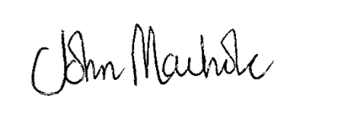

Yours faithfully
DIRECTOR OF ECONOMIC DEVELOPMENT AND PLANNING

ALH Design Services
Barley Cottage
Longridge
Preston
PR3 3NB

