RIBBLE VALLEY BOROUGH COUNCIL
Development Department
Council Offices, Church Walk, Clitheroe, Lancashire, BB7 2RA
Telephone: 01200 425111 |  | Fax: 01200 414488 |  | Planning Fax: 01200 414487
Town and Country Planning Act 1990, section 191 as amended by section 10 of the Planning and Compensation Act 1991

CERTIFICATE OF LAWFULNESS FOR AN EXISTING USE OR
ACTIVITY IN BREACH OF PLANNING CONDITION
APPLICATION NO: | 3/2021/0030
DECISION DATE: | 20 January 2021
DATE RECEIVED: | 15 January 2021
APPLICANT: |  |  |  | AGENT:
Mrs Judith Driver  32 Copperfield Close  Clitheroe  BB7 1ER |  |  |  | Mrs Judith Douglas  Judith Douglas Town Planning Ltd  8 Southfield Drive  West Bradford  Clitheroe  BB7 4TU

EXISTING USE OR ACTIVITY: Application for a Lawful Development Certificate for the adaptation of a garage to use as residential accommodation in breach of condition 7 of planning permission 3/2002/0187 and schedule 2 of S106 Agreement dated 24 March 2003.
AT: | 32 Copperfield Close Clitheroe BB7 1ER
Ribble Valley Borough Council hereby certify that on the received date the use, operations or matter detailed above in respect of the land indicated within the application, was lawful within the meaning of Section 192 of the Town and Country Planning Act 1990 (as amended), for the following reason(s):

 | On the basis of the evidence provided it is considered that the conversion of the integral garage at 32 Copperfield Close BB7 1ER to that of habitable floorspace (incidental to the household) in breach of condition 7 of planning consent 3/2002/0187 was undertaken and has been used for a period greater than 10 years and as such is considered lawful by virtue of section (3) of 171(B) of the Town and Country Planning Act 1990.
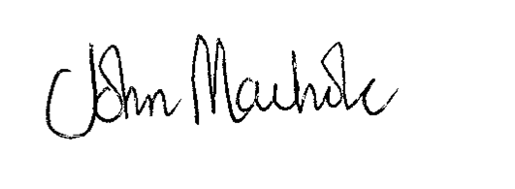

NICOLA HOPKINS
DIRECTOR OF ECONOMIC DEVELOPMENT AND PLANNING

Notes:

1 | This certificate is issued solely for the purpose of Section 191 of the Town and Country Planning Act 1990 (as amended).
2 | It certifies that the use, operations or matter as specified taking place on the land identified on the attached plan was lawful, on the specified date and thus was not liable to enforcement action under Section 172 of the 1990 Act on that date.
3 | This certificate applies only to the extent of the use, operations or matter described, and to the land specified and identified on the attached plan. Any use, operations or matter materially different from that described or which relates to other land may render the owner or occupier liable to enforcement action.
4 | The applicant is advised that should there be any deviation from the approved plan the Local Planning Authority must be informed. It is therefore vital that any future Building Regulation application must comply with the approved planning application.

