please ask for:
direct line:
planning fax:
my ref:
your ref:
date:
Rebecca Bowers
01200 414518
01200 414487
3/2021/0034
13 October 2021

Dear Sir

TOWN AND COUNTRY PLANNING (GENERAL PERMITTED DEVELOPMENT) ORDER 2015 PARTS 6 PRIOR NOTIFICATION OF AGRICULTURAL AND FORESTRY BUILDINGS AND ROADS

Proposal: Prior notification application for a proposed agricultural access track at Moorgate Farm
Location: Moorgate Farm Kenyon Lane Langho BB6 8AN

I refer to your notification made under Schedule 2, parts 6 & 7 of the Town and Country Planning (General Permitted Development) Order 1995 to determine whether full details are required for the above proposal.

On the basis of the information you have provided, I wish to inform you that the Council have resolved that Prior Approval is REFUSED for the following reason(s):

1 | The applicant has failed to provide sufficient information to demonstrate that the proposed development is reasonably necessary for the purposes of agriculture.

Please contact Rebecca Bowers if you require any further information.

Yours faithfully

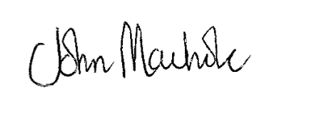
JOHN MACHOLC
HEAD OF PLANNING SERVICES

Gary Hoerty Associates
Suite 9
Grindleton Business Centre
The Spinney
Grindleton
BB7 4DH

