please ask for:
direct line:
planning fax:
my ref:
your ref:
date:
Adam Birkett
01200414571
01200 414487
3/2021/0274

28 July 2026

Dear Sir

TOWN AND COUNTRY PLANNING (GENERAL PERMITTED DEVELOPMENT) ORDER 2015 PARTS 6 PRIOR NOTIFICATION OF AGRICULTURAL AND FORESTRY BUILDINGS AND ROADS

Proposal: Proposed one agricultural building - in lieu of approval 3/2020/0364 which will not be built.
Location: Greenbanks Farm Green Lane Grindleton Road Grindleton BB7 4QJ

I refer to your notification made under Schedule 2, parts 6 of the Town and Country Planning (General Permitted Development) Order 2015 to determine whether full details are required for the above proposal.

On the basis of the information you have provided, I wish to inform you that the Council have resolved that it will be necessary for a full planning application to be submitted for approval prior to the commencement of any development for the following reasons:

- The applicant has failed to provide sufficient information to demonstrate that the proposed development is reasonably necessary for the purposes of agriculture and that the land which is the subject of the application is used for the purposes of an agricultural trade or business.

- The ground area covered by the structure(s), calculated as described in paragraph D.1(2)(a) of Part 6, would exceed 1,000 square meters and would not accord with criteria A.1 (e) of Schedule 2 Part 6 Class A.

- The development would include the erection of a building to be used for the accommodation of livestock and would be located within 400 metres of the curtilage of a protected building (defined at D.1(1)) and would not accord with criteria A.1 (i) of Schedule 2 Part 6 Class A.

Please contact Adam Birkett if you require any further information.

Yours faithfully

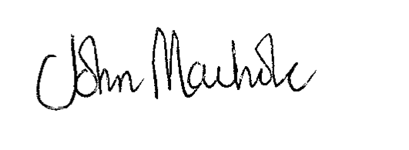
JOHN MACHOLC
HEAD OF PLANNING SERVICES

PGB Architectural Services Ltd
Lily Cottage
12 Glen Avenue
Knowle Green

