RECOMMENDATION FOR PLANNING AND DEVELOPMENT COMMITTEE

APPROVAL

DATE: 23 September 2021
REF: JM
CHECKED BY: NH

APPLICATION REF: 3/2021/0332/P

GRID REF: SD 373884 439302

DEVELOPMENT DESCRIPTION:

ERECTION OF A BALL STOP SAFETY FENCE ON THE 1ST FAIRWAY AT CLITHEROE GOLF CLUB ON LAND ADJACENT TO HOUSING ON ELBOW WOOD DRIVE, BARROW.

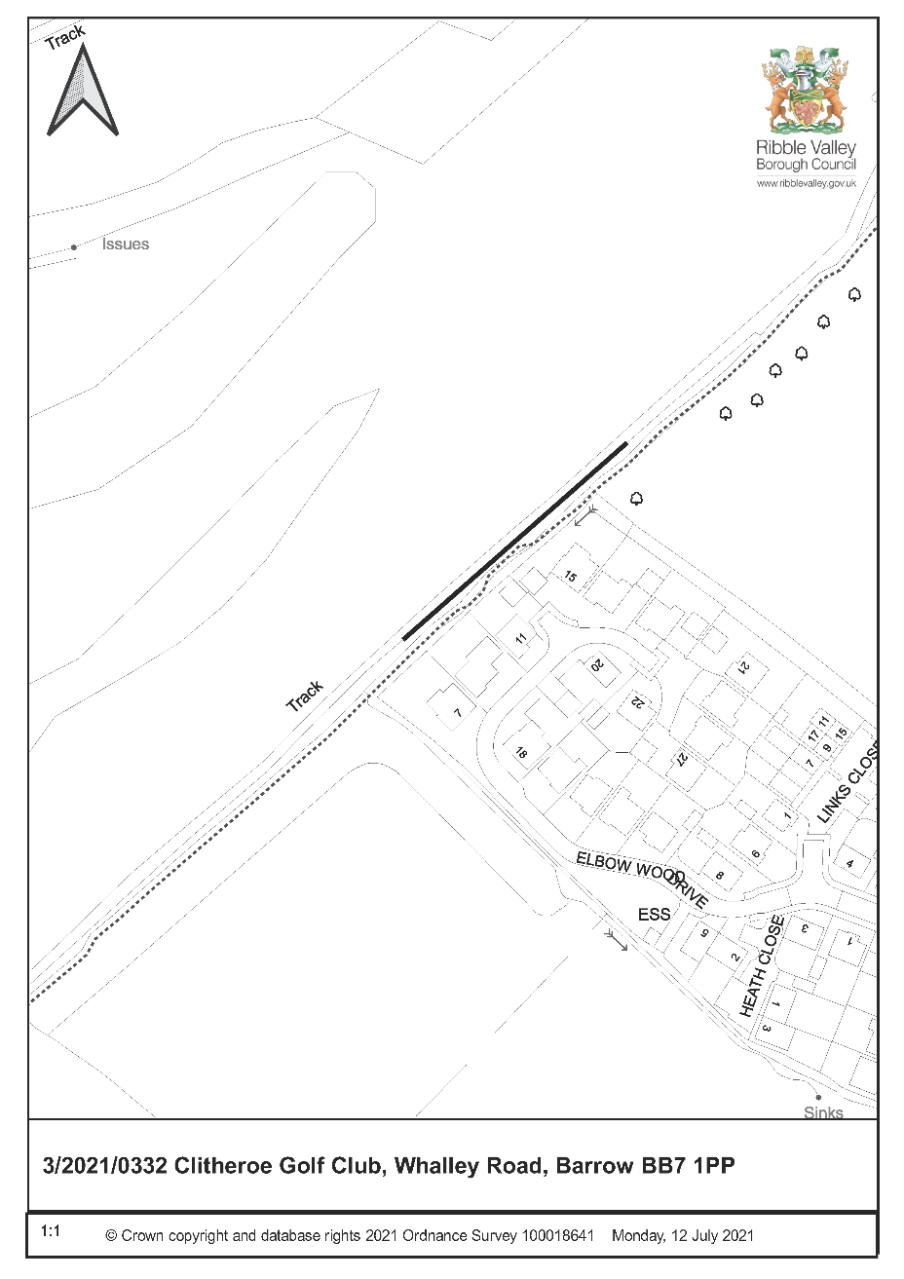
CONSULTEE RESPONSES/ REPRESENTATIONS MADE:

TOWN COUNCIL: No comments received at time of preparing this report

ADDITIONAL REPRESENTATIONS:

1 letter of support and in favour of safety measures but would like to see the fence extended towards the first tee.

6 letters of objection raising the following issues:

- Visual impact of the netting
- Harm to wildlife such as bird and bats
- Loss of view and reduce value of properties.
- Fence given its height and location would be oppressive and intrusive
- Impact on mental health of residents due to reduction in sunlight.
- Consider the fence would be ineffective and better solutions such as tee relocation and angling of fence towards fairway.

1. Site Description and Surrounding Area

1.1 The fence is located adjacent to the existing track within the golf club and adjacent to the gardens of 7,9,11 and 15 Elbow Wood Drive Barrow.

2. Proposed Development for which consent is sought

2.1 This application seeks detailed consent for the erection of a 6 metre high ball stop safety net for a length of 90 metres. The fence would have galvanised steel poles every 5 metres. The fence is open for the first 2 metres with the top 4 metres to have green netting and stainless steel cables.

3. Relevant Planning History

None specific to this part of the site.

4. Relevant Policies

Ribble Valley Core Strategy
Policy DMG1 – General Considerations

5. Assessment of Proposed Development

5.1 A justification statement has been submitted with this application but as the principle use as a golf course has been established the main issues to consider relate to visual impact, residential amenity and habitat matters.

5.2 Design:

5.2.1 In relation to the design it is considered that the fencing is of an appropriate appearance and of a design used for most types of golf ball netting. The colour of the netting has been changed from black to green to reduce the impact and relate better to the immediate landscape.

5.3 Visual:

5.3.1 It is evident that a fence measuring 90m long and 6 m high would have some visual impact but this has a localised impact on the users of the golf club and immediate residents. There is no long distant impact and views of the netting would be partially screened by existing vegetation.

5.4 Wildlife/Habitat:

5.4.1 Concerns have been expressed in relation to impact on wildlife and in particular bats and birds. The Councils countryside officer in consultation with an ecologist has confirmed that the fencing would not have any serious impact on such issues. It is important that the fence is tort to reduce any impact on the movement of bats.

5.5 Residential Amenity/ Noise:

5.5.1 The issues in relation to residential amenity are impact on light and the oppressive nature of the fencing. It is considered that the fencing is a sufficient distance away not to have an oppressive impact on the properties facing towards the net and the openness of the netting will not result in a harmful loss of light.

6. Other issues

6.1 Concern has been raised about the effectiveness of the netting and that other better options such as relocation of the first tee would be more effective. The comments are noted but the application needs to be determined as submitted. It is evident that the fencing will inevitably reduce the risk of errant golf balls and go some way to safeguard the residents and their properties from errant golf balls. The devaluation of properties and loss of view are not material planning considerations.

RECOMMENDED: That the application be APPROVED subject to the following conditions:

1. The development must be begun not later than the expiration of three years beginning with the date of this permission.

REASON: Required to be imposed pursuant to section 91 of the Town and Country Planning Act 1990 as amended by Section 51 of the Planning and Compulsory Purchase Act 2004.

2. Unless explicitly required by condition within this consent, the development hereby permitted shall be carried out in complete accordance with the proposals as detailed on drawings:

Location Plan CGCSF/2021/06
Proposed Elevations Plans CGCSF/2021/07

REASON: For the avoidance of doubt and to clarify which plans are relevant to the consent.

3. Precise details of external materials including details of the signage fixed to the first Tee area shall be submitted to and agreed in writing by the Local Planning Authority before their use. The development thereafter shall be completed in accordance with the approved materials.

REASON: To ensure that the appearance of the development is appropriate to the the area.

BACKGROUND PAPERS

https://www.ribblevalley.gov.uk/site/scripts/planx_details.php?appNumber=3%2F2020%2F0332

UPDATE FOLLOWING 29 July 2021 PLANNING AND DEVELOPMENT COMMITTEE MEETING:

At the committee meeting on 29 July 2021 members recommended that the application be deferred to allow for further negotiation.

Since the meeting the applicant has confirmed the following actions have been taken and to be implemented in July/August 2021

- A1 size warning sign to be fixed at the 1st tee area.
  - Sign text will warn all golfers of the housing and advise to shout ‘fore’ should drives be heading towards the left.
  - The club will communicate to all current members on the safety conditions related to the 1st hole.
- The club will advise all new members on the safety conditions related to the 1st hole.
- The club will advise visitors verbally via the professional’s shop on the safety conditions related to the 1st hole.
- The club will state in any correspondence to visiting parties, of the safety conditions related to the 1st hole.

A meeting has also taken place with Cllr Birtwistle in attendance.

A further letter of concern has been sent by the local residents direct to the Golf Club which indicated they are still experiencing issues and implying the club has not approached the residents since the meeting.

Having regard to all the above it is the opinion that the original recommendation of approval is still valid. An additional conditional should be imposed in relation to the signage details on the first bullet point.

