RECOMMENDATION FOR PLANNING AND DEVELOPMENT COMMITTEE

REFUSAL

DATE: 1 July 2021
REF: 3/2021/0350
CHECKED BY: NH

APPLICATION REF: 3/2021/0350

GRID REF: SD 373324 436429

DEVELOPMENT DESCRIPTION:

DEMOLITION OF EXISTING BRICK BUILT LEAN-TO AND REPLACEMENT WITH NEW EXTENSION, FENCING TO CREATE OUTDOOR PLAY AREA FOR PRE-SCHOOL, INTERNAL ALTERATIONS TO PROVIDE DISABLED LIFT, FIRST FLOOR CLASSROOM, IMPROVED TOILET AREAS, PRE-SCHOOL LEADERS OFFICE AND ASSOCIATED WORKS. RESUBMISSION OF 3/2021/0006 AT OLD GRAMMAR SCHOOL COMMUNITY CENTRE STATION ROAD WHALLEY BB7 9RH

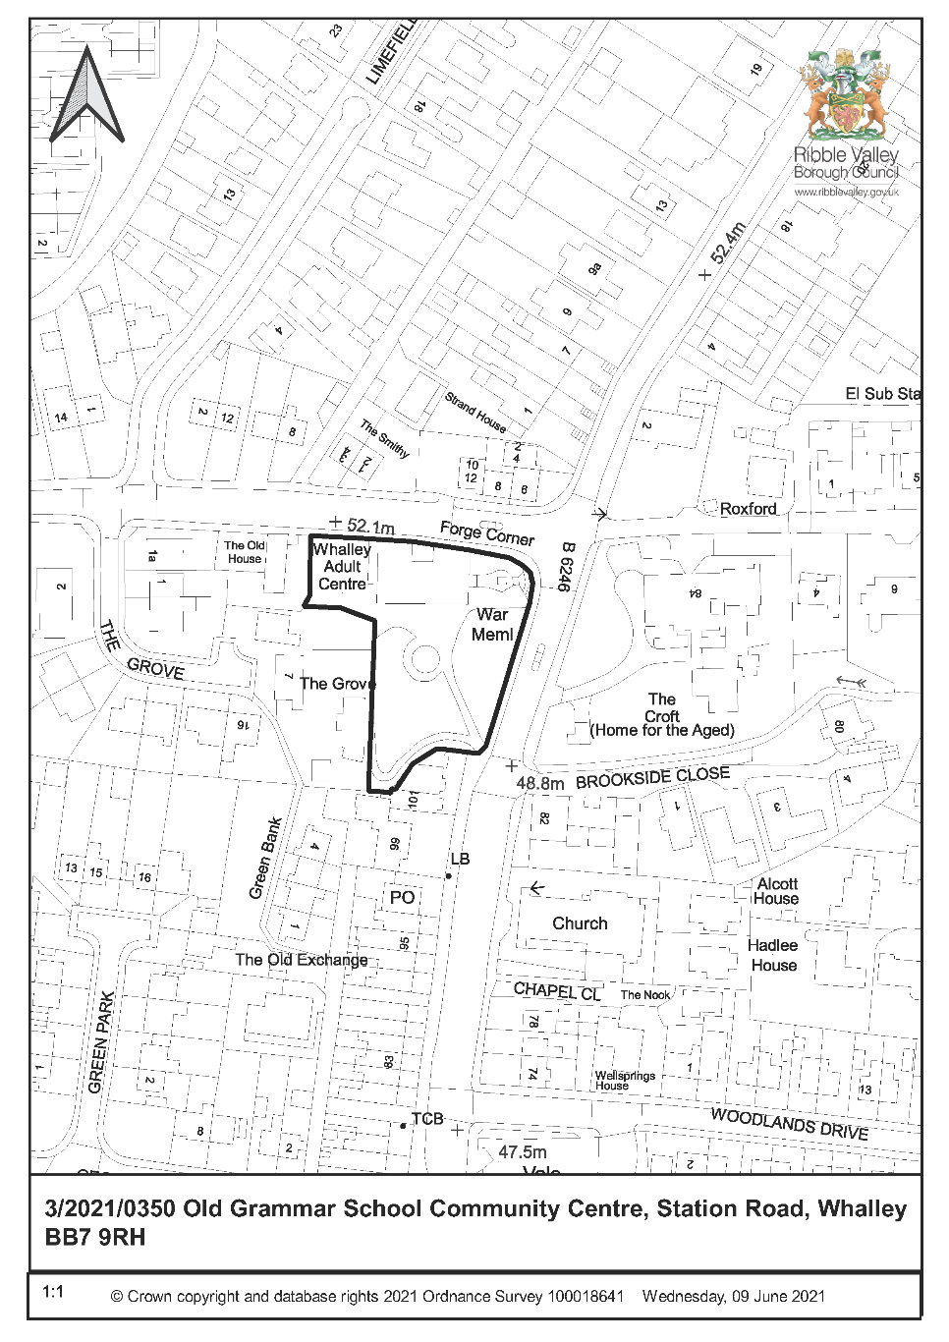
CONSULTEE RESPONSES/ REPRESENTATIONS MADE:

PARISH COUNCIL:

Appreciates that listed buildings must be protected from unnecessary changes. Hope that revised plans accommodate RVBC concerns. Building serves the whole of the Ribble Valley and wish to see facility last.

HISTORIC AMENITY SOCIETIES:

Consulted, no comments received.

LCC ARCHAEOLOGY:

No objection. Proposed changes to the interior and exterior will continue the cycle of alterations and adaptions to keep the site in educational use. With exception of the proposed external play area, none of the changes appear to have a substantial impact on significance.

Outdoor play area - proposed glass barrier is not an improvement on railings and may be more obtrusive against the historic stonework and thus have a bigger impact on the setting of the listed building. Suggest reconsideration (height; justification of design and visual impact). Also – any play equipment, games, decorations, planters or storage painted on or fixed to the building.

Planning condition unnecessary if Heritage Statement and Schedule of Architectural Features formally submitted to the Historic Environment Record.

HISTORIC ENGLAND:

Do not wish to comment. Suggest seeking the views of the RVBC specialist conservation adviser.

LCC HIGHWAYS:

Consulted, response will be reported verbally to Committee.

RVBC COUNTRYSIDE:

Consulted, response will be reported verbally to Committee.

RVBC ENVIRONMENTAL HEALTH:

Consulted, response will be reported verbally to Committee.

ADDITIONAL REPRESENTATIONS:

None received.

1. Site Description and Surrounding Area

1.1 ‘Old Grammar School’ is a Grade II listed (13 March 1986) former grammar school (now ‘adult education centre’ – list description), prominently sited within Whalley Conservation Area. The Ribble Valley Core Strategy Housing and Economic Development DPD Proposals Map identifies the site to be ‘Existing Open Space’ (Policy DMB4) and to adjoin (but be outside of) the ‘Main Centre Boundary’ (Policy DMR2).

1.2 The Old Grammar School is immediately adjacent to and within the setting of Whalley War Memorial (Grade II listed; list description identifies “An elegant example of the type, the war memorial has group value with the school behind and possesses civic presence”). It is also within the setting of 82 King Street (Grade II).

wall” (Whalley Conservation Area Management Guidance: Boundary Treatments).

2. Proposed Development for which Consent is Sought

2.1 Planning permission is sought for:

Demolition of existing modern brick-built extension (built 1882 – 1912) to the west elevation and replacement extension. The proposal (stone walls and slate roof) is wider than existing and similarly conjoins the two plain historic gables and has the highest part of its roof in the recess between historic gables. Its windows have a horizontal emphasis at odds with the historic build.

A rooflight is proposed to the roof within the recess.

Glazed screen to create outdoor play area for pre-school at the original 1725 south front. This is shown to be 1.8m high and to obscure views of three of the 5 ground-floor bays/cruciform windows to the 1725 front. No details submitted of fixture to the ground or walls.

Reinstatement of the window in the east elevation and reinstatement of a doorway in the south elevation.

The submitted plans show that the car park historic gateposts will be removed to widen the entrance. However, no information justifying this is submitted.

3. Relevant Planning History

The applicant was encouraged to submit a pre-application proposal following feedback on 3/2021/0006 & 0007. However, this opportunity for discussion of revised proposals with officers has not been undertaken.

3/2021/0006 & 0007 Demolition of existing brick built lean-to and replacement with new extension, fencing to create outdoor play area, internal alterations to provide disabled lift, new first floor classroom, improved toilet areas, pre-school leaders office and associated works. PP and LBC refused 26 March 2021.

3/2019/0405 - Installation of three CCTV cameras within boxes to match the surrounding wall surface, one above the doorway to the main (north) entrance, one below the eaves above the emergency exit on the south side of the building and one below the eaves on the west side of the building. LBC granted 1 July 2019.

3/2019/0130 - Installation of cabinet containing a defibrillator. LBC granted 3 April 2019.

3/2017/0538 - Proposed new partition within the main hall and conversion of storage room into a unisex toilet. LBC granted 17 July 2017.

3/2017/0420 - Application for a proposed lawful development certificate for a proposed new partition within the main hall to create a storage area and conversion of existing storeroom into a unisex toilet. 16 June 2017 - The works involved do not constitute operational development that requires planning permission.

3/2016/1088 - Proposed storage area, replacement floor to the main hall and conversion of storeroom into toilet area. LBC granted 18 January 2017.

4. Relevant Policies

Ribble Valley Core Strategy:
Key Statement EN5– Heritage Assets
Key Statement EC2: Development of Retail, Shops and Community Facilities and Services
Key Statement EC1: Business and Employment Development
Policy DMG1– General Considerations
Policy DME4– Protecting Heritage Assets
Policy DMB1: Supporting Business Growth and the Local Economy

Planning (Listed Buildings and Conservation Areas) Act 1990. ‘Preservation’ in the duties at sections 16, 66 and 72 of the Act means “doing no harm to” (South Lakeland DC v. Secretary of State for the Environment [1992]).

Whalley Conservation Area Appraisal

National Planning Policy Framework (NPPF)
National Planning Practice Guidance (NPPG)

5. Assessment of Proposed Development

5.1 Impact upon the special architectural and historic interest of the listed building, the setting of listed buildings and the character and appearance of Whalley Conservation Area:

5.1.1 Planning permission is required for the proposed works to the exterior of the listed building.

5.1.2 Outdoor play area:

There is concurrence with LCC Archaeology that the glazed outdoor play area is harmful to the listed buildings and conservation area because it is prominent (original 1725 frontage), incongruous and conspicuous (1.8m high large expanses of reflective glazing) and obscures important elements of building design (cruciform windows and original front door) resulting in an imbalance to the symmetric 1725 façade of the Whalley Conservation Area Focal Building.

The list description specifically identifies the elements of significance affected:

“formerly grammar school, 1725 … The left-hand return wall, facing south, has 5 bays which have cross windows with linked hoods”.

The submitted Heritage Statement confirms that the south elevation is the original front elevation, that its setting is important and that fenestration is an intrinsic element of building interest:

“the form and size of the 1725 school are not known. It does however appear to have … a south-facing front which comprised the five bays at the right-hand end of the present south elevation. The row of ground floor windows here has a continuous hoodmould, and the central opening is believed to have been the front entrance originally, later altered to form the present window” (5.2).

“setting, the open space to the south makes an important contribution to significance, and had been established as part of the garden by the early 19th century. Within it is a stone plinth for a garden ornament” (7.3).

“The Old Grammar School has heritage significance arising predominantly from its architectural and historical interest … The architectural interest derives mostly from its exterior … with differences in the forms of openings expressing the various phases and room uses … The south side of the former school contains some of the earliest visible fabric, in which there are four original crosswindows with hoodmould over, on both floors. These contrast strongly with the early 19th century sash windows to the left” (7.1).

Furthermore, the Whalley Conservation Area Appraisal (The Conservation Studio consultants; adopted by the Borough Council 3 April 2007) confirms the importance of the south front to Whalley townscape:

The Townscape Appraisal Map identifies the Old Grammar School to be a ‘Focal Building’ and the view of the site from King Street to be an ‘Important View’. Spaces and views states “A number of the larger, more prestigious buildings in Whalley act as focal points in views … the Adult Education Centre (the former Grammar school) are significant in views along King Street”. Both ‘King Street Character Area: Principal positive features’ and ‘Strengths: the most important positive features of Whalley Conservation Area’ identify “The Whalley Arms (1781), the Swan Hotel (1780) and Whalley Adult Education Centre are the most significant listed buildings”.

The Appraisal is also relevant in respect to the impact on immediate setting of the overtly modern and conspicuous glazed screen enclosure:

“Rural, open character with trees and open green spaces” (Strengths: the most important positive features of Whalley Conservation Area).

“Continuing loss of original architectural details and use of inappropriate modern materials or details” (Threats to the Whalley Conservation Area).

Consideration has therefore been made to Historic England advice (’Making changes to heritage assets’, 2016) which identifies that “It would not normally be good practice for new work to dominate the original asset or its setting in either scale, material or as a result of its siting”. (paragraph 41) and “doors and windows are frequently key to the significance of a building” (paragraph 15).

5.1.3 Demolition of C20 extension and replacement extension:

The removal of the incongruous C20 extension is welcomed and would restore the modest and contrasting character of the west elevation of gables and few openings. However, the replacement extension’s large, horizontally emphasised windows and linkage of the gables is not sympathetic to the architectural form of the historic building. The historic building is characterised by vertically emphasised window types typical of the C18 and C19. The roof height and inclusion of a conspicuous rooflight at the ‘link’ is unfortunate.
5.1.4 Removal of historic stone gate piers:

The Heritage Statement paragraph 7.3 identifies that car park boundary walls and gateway are a significant contributor. The proposed removal of historic stone gate piers is harmful.

5.1.5 Reinstatement of the window in the east elevation and reinstatement of a doorway in the south elevation:

‘Making changes’ paragraph 25 identifies that “changes in response to the changing needs of owners and occupants over time may themselves be a key part of the asset’s significance”. However, the submitted Heritage Statement identifies that “the alterations to the two openings in the Main Hall would not have an impact on significance, if carried out sensitively, with regard for the existing wall finishes, which include a moulded plaster dado”.

5.1.6 Section 66 of the Planning (Listed Buildings and Conservation Areas) Act 1990 requires that in considering whether to grant planning permission or permission in principle for development which affects a listed building or its setting, the local planning authority or, as the case may be, the Secretary of State shall have special regard to the desirability of preserving the building or its setting or any features of special architectural or historic interest which it possesses.

5.1.7 Section 72 of the Planning (Listed Buildings and Conservation Areas) Act 1990 requires that in the exercise, with respect to any buildings or other land in a conservation area, of any functions under or by virtue of the planning acts, special attention shall be paid to the desirability of preserving or enhancing the character or appearance of that area.

5.1.8 NPPF paragraph 193 requires that when considering the impact of a proposed development on the significance of a designated heritage asset, great weight should be given to the asset’s conservation (and the more important the asset, the greater the weight should be). This is irrespective of whether any potential harm amounts to substantial harm, total loss or less than substantial harm to its significance.

NPPF paragraph 194 requires any harm to, or loss of, the significance of a designated heritage asset (from its alteration or destruction, or from development within its setting), should require clear and convincing justification. In this regard, there is concurrence with the Parish Council that listed buildings must be protected from unnecessary changes. Whilst the submitted information suggests that some form of enclosure is necessary to the outdoor play area (presumably building use cannot be reconfigured so that advantage can be taken of the less prominent car park area), it has not been established that the scheme proposed minimises the harm to the designated heritage assets. Despite the Heritage Statement’s identification of significance, no justification for the proposed loss of historic stone gate piers is submitted.

5.1.9 Ribble Valley Core Strategy Policy DME4 states that in considering development proposals the council will make a presumption in favour of the conservation and enhancement of heritage assets and their settings. Alterations or extensions to listed buildings or buildings of local heritage interest, or development proposals on sites within their setting which cause harm to the significance of the heritage asset will not be supported. Proposals within, or affecting views into and out of, or affecting the setting of a conservation area will be required to conserve and where appropriate enhance its character and appearance and those elements which contribute towards its significance. This should include considerations as to whether it conserves and enhances the special architectural and historic character of the area as set out in the relevant conservation area appraisal. Development which makes a positive contribution and conserves and enhances the character, appearance and significance of the area in terms of its location, scale, size, design and materials and existing buildings, structures, trees and open spaces will be supported.

Ribble Valley Core Strategy Policy DMG1 states that in determining planning applications, all development must: Design: 1. be of a high standard of building design which considers the 8 Building in Context Principles (from the CABE/English Heritage Building on Context Toolkit. 2. be sympathetic to existing and proposed land uses in terms of its size, intensity and nature as well as scale, massing, style, features and building materials. Environment … 3. all development must protect and enhance heritage assets and their settings.

The most relevant Building in Context Principle in respect to the harmful external alterations to the historic building is Principle 3 - A successful project will be informed by its own significance so that its character and identity will be appropriate to its use and context.

The National Design Guide (2021) is particularly relevant at C1 and C2:

“Well-designed new development is integrated into its wider surroundings, physically, socially and visually. It is carefully sited and designed, and is demonstrably based on an understanding of the existing situation, including: the landscape character and how places or developments sit within the landscape, to influence the siting of new development and how natural features are retained or incorporated into it” (paragraph 43).

“Well-designed places and buildings are influenced positively by the history and heritage of the site, its surroundings and the wider area, including cultural influences” (paragraph 48).

5.1.10 NPPG states that “substantial harm is a high test, so it may not arise in many cases”. The external additions to the listed building are potentially reversible (although no details of attachment of glazed screen to historic fabric submitted) and most boundary walling is retained. Harm to the architectural and historic interest of the listed building, the setting of listed buildings and the character and appearance of Whalley Conservation Area is ‘less than substantial’.

5.1.11 NPPF paragraph 196 requires that ‘less than substantial’ harm be weighed against any public benefits of proposals. The Ribble Valley Core Strategy also identifies:

“The expansion of existing businesses will, wherever appropriate, be considered favourably” (Key Statement EC1).

“Development that supports and enhances the vibrancy, consumer choice and vitality and unique character of the area’s important retail and service centres of Clitheroe, Longridge and Whalley will be supported in principle” (Key Statement EC2).

“Proposals that are intended to support business growth and the local economy will be supported in principle … The expansion of existing firms within settlements will be permitted on land within or adjacent to their existing sites, provided no significant environmental problems are caused and the extension conforms to the other plan policies of the LDF” (Policy DMB1).

The submitted Justification for the Need for an Outdoor Play Space identifies:

“Whalley Pre-School … have been serving the needs of local families for sixty years”.

“The provision of a safe, enclosed area from their room would enable free flow play giving the children the ability and choice to move indoors and outdoors within their learning environment. The benefits to the children of free flow to the outdoors will be immense; the importance of free flow access to the outdoors is universally accepted by all in education. It boosts physical wellbeing, it allows the children to make their own choices promoting greater independence, it promotes decision making, it allows the different learning styles of children to be respected and catered for, it enhances knowledge of the outdoors and their surroundings, it promotes creativity and relationships. In addition are obvious benefits that we all recognise of being able to access the outdoors to our mental health and wellbeing. These benefits are currently denied to our children and cannot be matched by simply taking the children outdoors daily”.

“The importance of free flow to the outdoors to children is well acknowledged by all who work within education. The statutory curriculum Pre-School is required to follow is the Early Years Foundation Stage framework (EYFS) and we are judged against this by Ofsted”.

The submitted OFSTED report (11/4/2018) identifies:
“This provision is good … It is not yet outstanding because the outdoor environment has not yet been fully developed to help children achieve their maximum learning potential”.

A letter from Whalley Pre-School identifies:

“The ability to access the outdoors from our room is essential in meeting the requirements of the Early Years Foundation Stage Framework which is the statutory curriculum we are required to follow. This has been confirmed by Lancashire County Council’s Early Years Team. We are judged against this framework by Ofsted”.

“due another Ofsted inspection from September 2021 and the first thing that the Inspector will do is look to see whether we have followed the recommendations they made in the last report. If we have not, and even if this is for circumstances outside of our control, then this will reflect in their report and judgement. There is a real danger that we may then be judged as “requires improvement” which would have a devastating impact on the setting leading to the withdrawal of much of our funding and the real possibility of closure. We are gravely concerned about the future of Whalley Pre-School if we are not able to comply with Ofsted’s instructions as to what we should do”.

The proposals requiring planning permission and listed building consent (the latter includes changes to the interior) have potential for public benefit in ensuring the continued educational (the historic and optimum viable) use of the listed building. However and mindful of NPPF 194, it is not clear from the submitted information why the extent of proposed harm is required (e.g. can the impact of an outdoor enclosure be minimised by re-design? Can the large horizontally emphasised windows be replaced by windows sympathetic to the historic building?). NPPF 194 also requires that harm justification be convincing – it has not been explained why the existing provision of facilities at the pre-school might be considered to require improvement when they were considered ‘good’ in 2018 (does the Early Years Foundation Stage Framework requirement postdate the last OFSTED inspection?) . The submitted information does not provide a convincing case for public benefits (including construction employment) which outweigh the harm to the designated heritage assets.

5.2 Highways:

5.2.1 Any comments received from LCC Highways will be reported verbally to Committee.

5.3 Residential Amenity:

5.3.1 Any comments received from RVBC Environmental Health will be reported verbally to Committee. However, the proposals are not considered to have a significant impact on resident’s amenity as the site is open space adjoining the village shopping centre, an outdoor play area (detached from the building) already exists and external boundary walls ensure no significant overlooking from extensions.

5.4 Protected Species (Bats):

5.4.1 Any comments received from RVBC Countryside will be reported verbally to Committee.

5.4.2 However, the submitted Preliminary Bat Roost Assessment Report identifies that no evidence was recorded to suggest bats were roosting within the building and no bats were observed or recorded using the building for roosting.

6. Observations/Consideration of Matters Raised/Conclusion

6.1 In giving considerable importance and weight to the duties at section 16, 66 and 72 of the Planning (Listed Buildings and Conservation Areas) Act 1990 and in consideration to NPPF and Key Statement EN5, EC1 and EC2 and Policies DME4, DMG1 and DMB1 of the Ribble Valley Core Strategy it is recommended that planning permission be refused.

RECOMMENDATION: That the application be REFUSED for the following reason:

1. The proposals have a harmful impact upon the special architectural and historic interest of the listed building, the setting of listed buildings and the character and appearance of Whalley Conservation Area because of the undue prominence, incongruity and conspicuousness of the west elevation extension and south elevation enclosed play area. This is contrary to Key Statement EN5 and Policy DME4 and DMG1 of the Ribble Valley Core Strategy.

BACKGROUND PAPERS

https://www.ribblevalley.gov.uk/site/scripts/planx_details.php?appNumber=3%2F2021%2F0350
UPDATE FOLLOWING 1 JULY PLANNING AND DEVELOPMENT COMMITTEE MEETING:

On 1 July 2021 Committee resolved that the harm of the development is outweighed by the benefits, were Minded to approve the application and requested that the application be brought back to committee with appropriate conditions.

Should Committee still be minded to approve the application the following conditions and notes are recommended for consideration:

- The development must be begun not later than the expiration of three years beginning with the date of this permission.
Reason: Required to be imposed by Section 51 of the Planning and Compulsory Purchase Act 2004.

- Unless explicitly required by condition within this consent, the development hereby permitted shall be carried out in complete accordance with the proposals as detailed on drawings:
TBC

REASON: For the avoidance of doubt and to clarify which plans are relevant to the consent.

- In the event that any bats are found or disturbed during any part of the development/roofing work, all work shall cease until further advice has been sought from a licensed ecologist.
Reason: To ensure that in the event that any bats are present there will be no adverse effects on the favourable conservation status of a bat population and bats will be protected from the damaging activities of development.

Notes

- Cadent Gas advise that due to the presence of Cadent and/or National Grid apparatus in proximity to the specified area, the contractor should contact Plant Protection before any works are carried out to ensure the apparatus is not affected by any of the proposed works. (See full comments from Cadent Gas).

- Further alteration to the listed building at the outdoor play area may require listed building consent and/or planning permission.

- It is advised that site contractors and site project managers be made aware of the legal protection afforded all species of bats in the UK and that occasionally solitary roosting bats are disturbed or exposed beneath some roof material such as roof slates, timber battens and roofing membranes. It is therefore advised that building contractors take additional care when removing fascia boards, verge tiles, ridge tiles and lead flashing.

