APPLICATION REF: 3/2022/0356

GRID REF: SD 362405 443396

DEVELOPMENT DESCRIPTION:

MODERNISATION OF AGRICULTURAL BUILDINGS, REPLACING EXISTING HOUSING WITH A COMPLETE DAIRY UNIT TO ACCOMMODATE 70 COWS AT WHARF FARM GREEN LANE, CHIPPING PRESTON PR3 2QE

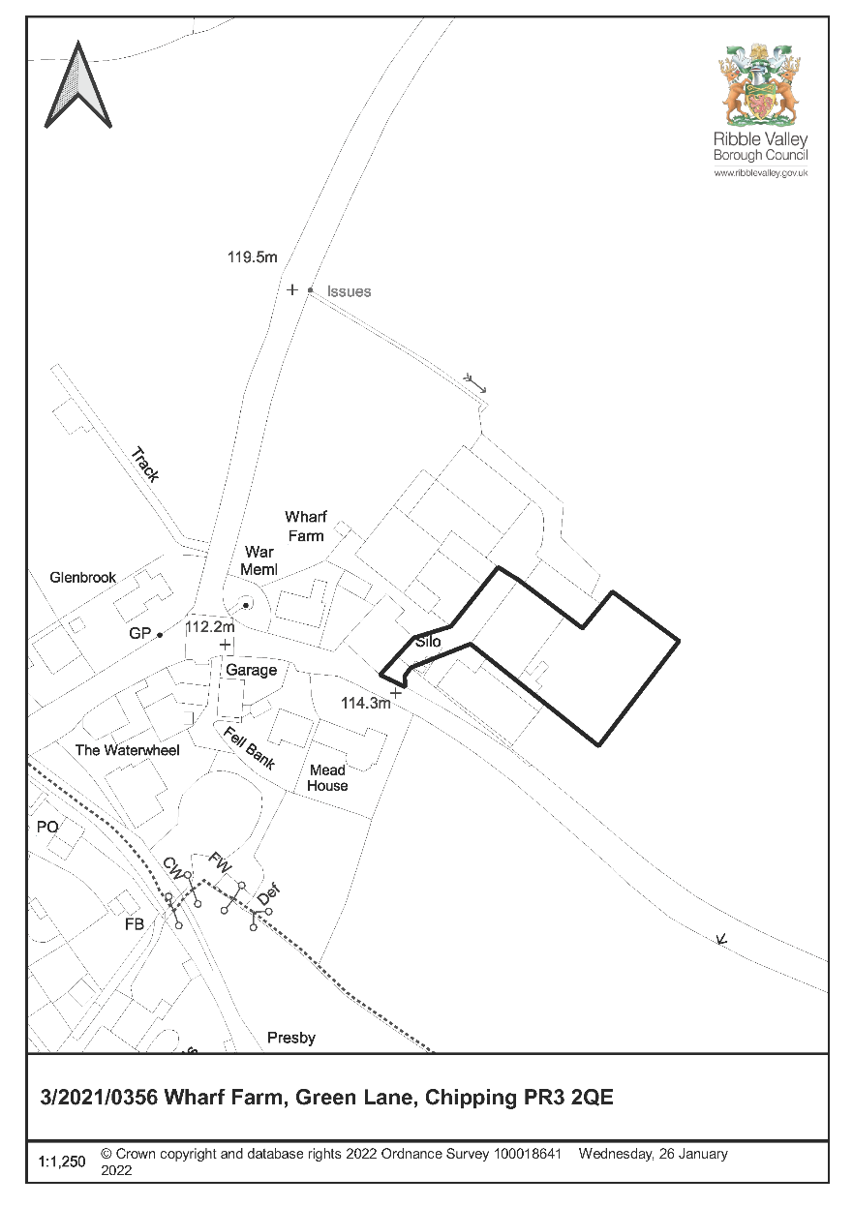

CONSULTEE RESPONSES/ REPRESENTATIONS MADE:

PARISH COUNCIL:

No observations received

ENVIRONMENT DIRECTORATE (COUNTY SURVEYOR):

No objections regarding the proposed development.

LLFA:

Following reconsultation and subject to the additional information in relation to drainage strategy has no objection to the proposed development subject to the inclusion of the appropriate conditions.

UNITED UTILITIES:

Following reconsultation and subject to the additional information in relation to drainage strategy has no objection to the proposed development subject to the inclusion of the appropriate conditions.

ADDITIONAL REPRESENTATIONS:

None.

1. Site Description and Surrounding Area

1.1 Wharf Farm is located to the far east location of the village of Chipping and within the Chipping Conservation Area. It is located within the Ribble Valley in Lancashire. The farm occupies a prominent roadside location on the outskirts of Chipping with agricultural fields to the north and east.

2. Proposed Development for which consent is sought

2.1 The submitted details seek consent for the erection of agricultural livestock buildings adjacent and attached to existing range of buildings and also an attenuation pond on land opposite the building on a different parcel of land.

The proposal is to remove an older agricultural building and replace it with a new multi apex steel portal structure. The building is made up of 4no. apex roofs connected as one, total width 38.70m x 50.52m long, nominal 3.00m eaves and 6.23m to the highest ridge.

The proposed building is a conventional multi span agricultural steel framed structure. At time of preparing this report walling in parts is nominally 1.50m high pre-cast concrete panels with vertical treated timber boarding above. Galvanised steel doors were appropriate. The roof materials is fibre cement sheeting colour “Farmscape Anthracite”

3. Relevant Planning History

3/2014/0957 – Agricultural Building-Approved with conditions.

4. Relevant Policies

Ribble Valley Core Strategy

Key Statement DS1 – Development Strategy
Policy DMG1 – General Considerations
Policy DMG2 – Strategic Considerations
Policy DMB1 – Supporting Business Growth and the Local Economy
Policy DME4- Protecting Heritage Assets
Key Statement EN” Landscape

National Planning Policy Framework (NPPF)
National Planning Practice Guidance (NPPG)

5. Assessment of Proposed Development

5.1 Principle of Development:

5.1.1 The main considerations relate to whether proposed agricultural livestock building purposes is an acceptable use, traffic implications, residential amenity as well as the visual impact.

5.2 Highways:

5.2.1 There are no concerns in relation to highway considerations given the establishment of the existing business.

5.3 Impact upon Residential Amenity:

5.3.1 The unit may result in some additional noise and odours but given it is replacing existing buildings and will be no nearer to existing residential properties would be unlikely to have a harmful impact.

5.4 Employment:

5.4.1 The safeguarding of a business use which would include farming enterprises is an important consideration. The proposal would enable the farming enterprise to modernise and assist in viability.

5.5 Visual impact:

5.5.1 The building occupies a prominent roadside location but also relates well to the existing agricultural buildings to reduce the visual impact. In order to achieve a higher quality design, it is considered that the more visually prominent elevation should incorporate natural stone as a walling rather than concrete panels. In relation to materials and to ensure the use of natural a planning condition is imposed.

RECOMMENDATION: That the application be APPROVED subject to the following conditions.

1. The development must be begun not later than the expiration of three years beginning with the date of this permission.

REASON: Required to be imposed pursuant to section 91 of the Town and Country Planning Act 1990 as amended by Section 51 of the Planning and Compulsory Purchase Act 2004.

2. Unless explicitly required by condition within this consent, the development hereby permitted shall be carried out in complete accordance with the proposals as detailed on drawings:

Location Plan OS Map Nov 2021
Proposed Building Layout Plan March 2021
Proposed Section Plan Sept 2021
Proposed Revised Elevation Plan March 2021 received on 18/01/22

REASON: For the avoidance of doubt and to clarify which plans are relevant to the consent.

Materials

3. This permission shall relate to the materials specified on elevation plan received on 18/01/22 and photograph sent on the 19/01/22 in relation to the natural stone. The development thereafter shall be constructed in accordance with the approved materials.

REASON: To ensure that the appearance of the development is appropriate to the character and setting of the area.

Drainage

4 The development permitted by this planning permission shall be carried out in accordance with the principles set out within the flood risk assessment drainage strategy (October 2021 / 041121 - Revision A / REFORD). The measures shall be fully implemented prior to the commencement of the use of the development and in accordance with the timing arrangements embodied within the scheme, or within any other period as may subsequently be agreed, in writing, by the local planning authority in consultation with the lead local flood authority.

REASON: To ensure satisfactory sustainable drainage facilities are provided to serve the site in accordance with the Paragraphs 166 and 168 of the National Planning Policy Framework, Planning Practice Guidance and Defra Technical Standards for Sustainable Drainage Systems.

5. No development shall commence until details of how surface water and pollution prevention will be managed during each demolition and construction phase have been submitted to and approved in writing by the local planning authority. Those details shall include for each phase, as a minimum: a) Measures taken to ensure surface water flows are retained on-site during demolition and construction phase(s) and, if surface water flows are to be discharged they are done so at a restricted rate to be agreed with the Lancashire County Council LLFA. b) Measures taken to prevent siltation and pollutants from the site into any receiving groundwater and/or surface waters, including watercourses, with reference to published guidance. The development shall be constructed in accordance with the approved details.

REASON: To ensure the development is served by satisfactory arrangements for the disposal of surface water during each demolition and construction phase(s) so it does not pose an undue flood risk on site or elsewhere and to ensure that any pollution arising from the development as a result of the demolition and construction works does not adversely impact on existing or proposed ecological or geomorphic condition of water bodies.

6. No building on any phase (or within an agreed implementation schedule) of the development hereby permitted shall be occupied until a Verification Report and Operation and Maintenance Plan for the lifetime of the development, pertaining to the surface water drainage system and prepared by a suitably competent person, has been submitted to and approved by the Local Planning Authority. The Verification Report must demonstrate that the sustainable drainage system has been constructed as per the agreed scheme (or detail any minor variations), and contain information and evidence (including photographs) of details and locations (including national grid reference) of inlets, outlets and control structures; landscape plans; full as built drawings; information pertinent to the installation of those items identified on the critical drainage assets drawing; and, the submission of an final 'operation and maintenance manual' for the sustainable drainage scheme as constructed. Details of appropriate operational, maintenance and access requirements for each sustainable drainage component are to be provided, with reference to published guidance, through an appropriate Operation and Maintenance Plan for the lifetime of the development as constructed. This shall include arrangements for adoption by an appropriate public body or statutory undertaker, and/or management and maintenance by a Management Company and any means of access for maintenance and easements, where applicable. Thereafter the drainage system shall be retained, managed and maintained in accordance with the approved details.

REASON: To ensure that flood risks from development to the future users of the land and neighbouring land are minimised, together with those risks to controlled waters, property and ecological systems, and to ensure that the development as constructed is compliant with and subsequently maintained pursuant to the requirements of Paragraph 168 of the National Planning Policy Framework.

BACKGROUND PAPERS

https://www.ribblevalley.gov.uk/site/scripts/planx_details.php?appNumber=3%2F2021%2F0356

