RECOMMENDATION FOR PLANNING AND DEVELOPMENT COMMITTEE

REFUSAL

DATE: 29 July 2021
REF: JM
CHECKED BY: NH

APPLICATION REF: 3/2021/0488

GRID REF: SD 372767 437496

DEVELOPMENT DESCRIPTION:

PROPOSED CHANGE OF USE FROM CLASS E TO B2 GENERAL INDUSTRIAL AT UNITS 16-21 MITTON ROAD BUSINESS PARK MITTON ROAD WHALLEY BB7 9YE
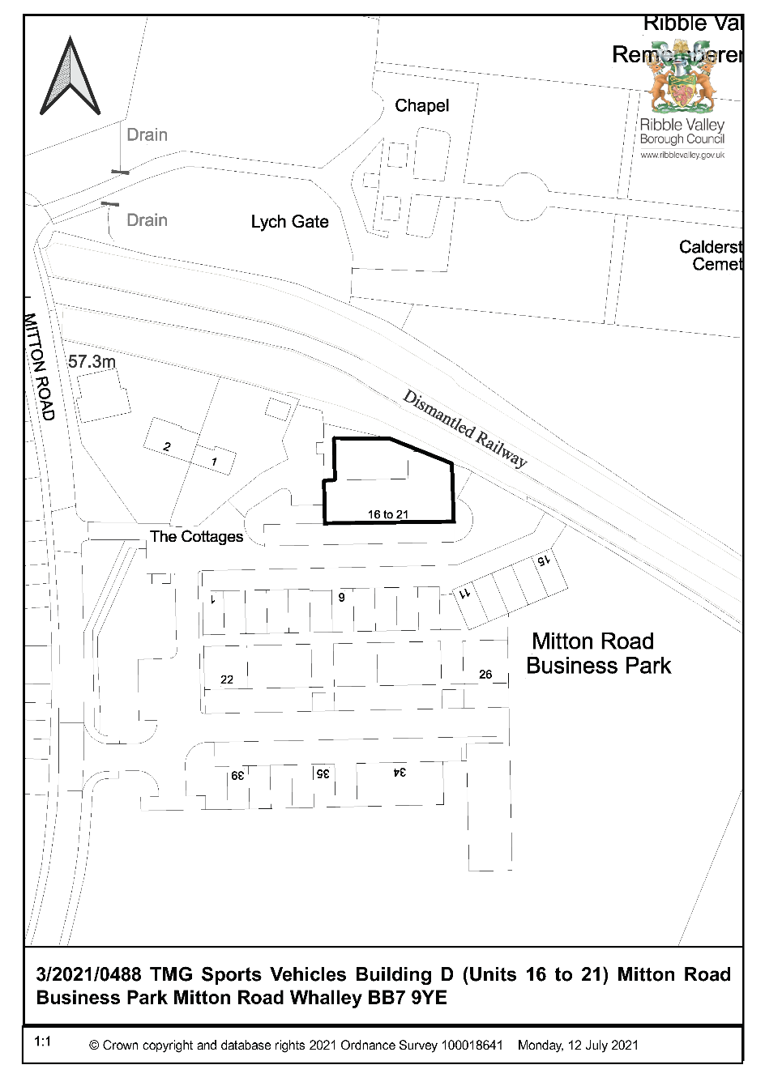
CONSULTEE RESPONSES/ REPRESENTATIONS MADE:

PARISH COUNCIL:

No observations received.

ENVIRONMENT DIRECTORATE (COUNTY SURVEYOR):

No observations received.

ADDITIONAL REPRESENTATIONS:

2 letters of objections have been received making the following comments:

- Unacceptable level of noise.
- Current restrictions not being complied in relation to noise controls including hours of business.
- Insufficient parking within the site.

1. Site Description and Surrounding Area

1.1 The application relates to units on the Mitton Road Business Park. The business was granted a temporary consent in January 2018 for two years. The units are near to the entrance of the site and has a boundary towards the cottages at Mitton Road.

2. Proposed Development for which consent is sought

2.1 The submitted details seek consent for change of use from the former light industrial use which is now Class E to General industrial use Class B2 to retain the operation of the existing business. As the consent in 2018 has lapsed technically the consent revert to the former use.

3. Relevant Planning History

3/2017/1224 - Change of use of Building D (Units 16 to 21) from B1 (business) to B2 (general industry) AC.

3/2018/0213 Discharge of condition 5 - internal workspace from planning permission 3/2017/1224.

4. Relevant Policies

Ribble Valley Core Strategy

Key Statement DS1 – Development Strategy
Key Statement DS2 – Presumption in Favour of Sustainable Development
Key Statement DMI2 – Transport Considerations
Key Statement EC1 – Business and Employment Development
Policy DMG1 – General Considerations
Policy DMG2 – Strategic Considerations
Policy DMB1 – Supporting Business Growth and the Local Economy

National Planning Policy Framework (NPPF)
National Planning Practice Guidance (NPPG)

5. Assessment of Proposed Development

5.1 Principle of Development:

5.1.1 The main considerations relate to whether the use for general industrial purposes is an acceptable use in the location having regard to traffic implications and residential amenity.

5.2 Highways:

5.2.1 No comments have been received from LCC but previously they raised no issues when a temporary consent was granted.

5.3 Impact upon Residential Amenity:

5.3.1 The units are close to residential cottages and whereas previously a temporary consent was granted subject to noise controls, operational details and a personal consent it is evident that the proposal has not been operated within the restrictive conditions which has resulted in significant noise and amenity concerns. Although the Council’s Environmental Health Officers have requested more details concern has been expressed regarding the suitability of the use of the building in close proximity to the residential properties.

5.3.2 It is considered that the proposal would have a significant impact on the residential amenity by virtue of noise operating from the activity. The conditions previously imposed in relation to effective noise attenuation measures have not be adhered to and the operational activity has also been in breach of the hours of use. The benefit of a temporary consent allowed the impact of the business to be monitored to assess its suitability and impact and it is now considered that the use of the building for this general industrial use is unacceptable.

5.4 Employment:

5.4.1 The safeguarding of a business use is an important consideration but this needs to be balanced against protecting residential amenity. The previous temporary consent allowed a business to operate and for the Council to assess its suitability. A general industrial use is one that would not normally be situated close to residential properties and it is considered that the current business should be relocated to a more suitable location.

6. Observations/Consideration of Matters Raised/Conclusion

6.1 Taking into account the above matters it is considered that the application should be refused and appropriate enforcement action taken as well as assisting where possible with the relocation of business.

RECOMMENDATION: That the application be REFUSED for the following reason:

1 The proposal, by virtue of the noise generated by the business, would result in conditions to the detriment of general residential amenity and as such would be contrary to Policy DMG1 of the Core Strategy.

BACKGROUND PAPERS

https://www.ribblevalley.gov.uk/site/scripts/planx_details.php?appNumber=3%2F2021%2F0488

