RECOMMENDATION FOR PLANNING AND DEVELOPMENT COMMITTEE

APPROVAL

DATE: 29 July 2021
REF:
CHECKED BY:

APPLICATION REF: 3/2021/0493

GRID REF: SD 374231 441623

DEVELOPMENT DESCRIPTION:

PROPOSED REPLACEMENT OF SIDE ACCESS RAMP TO THE ATRIUM GARDEN AREA AND WALKWAY. RAMP TO BE STEEL FRAME WITH COMPOSITE DECKING (MILL BOARD) AT ATRIUM CAFE CLITHEROE CASTLE CASTLE GATE CLITHEROE BB7 1BA

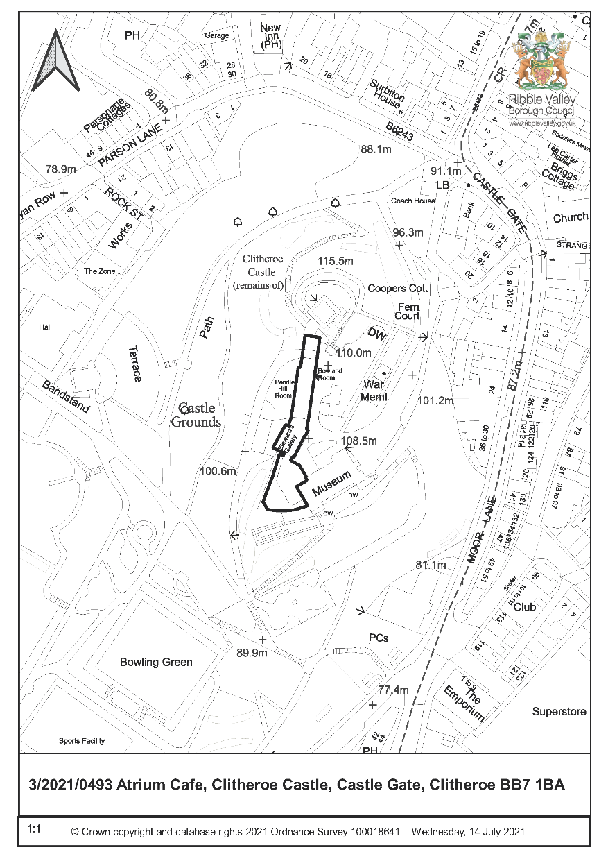

CONSULTEE RESPONSES/ REPRESENTATIONS MADE:

PARISH COUNCIL:

No comments received.

HISTORIC ENGLAND:

No impact on the significance of the Castle. Clearly a modern intervention, with any visual impact on the setting of the designated heritage assets on the site offset by the public benefit of providing visitor access. No objection.

The proposed replacement ramp is sited within the boundary of the scheduled monument. However, all modern path surfaces are specifically excluded from the scheduling; as the ramp is proposed to sit upon the surface, Scheduled Monument Consent will not be required in advance of its construction.

HISTORIC AMENITY SOCIETIES:

Consulted, no representations received.

THE GARDENS TRUST:

Do not wish to comment on the proposals at this stage. This does not signify either approval or disapproval of the proposals

ADDITIONAL REPRESENTATIONS:

None received.

1. Site Description and Surrounding Area

  - ‘Premises occupied by Ribble Valley Borough Council in grounds of Clitheroe Castle’ (Clitheroe Castle Museum; Castle House) is a Grade II listed building (30/09/76) of the early-mid C19. The list description identifies that it is included in the list as part of a group with ‘Clitheroe Castle’ (Grade I listed) and ‘Outbuilding and Stable Block to Clitheroe Castle and premises occupied by Ribble Valley Borough Council’ (Grade II listed). ‘Premises occupied by Ribble Valley Borough Council in grounds of Clitheroe Castle’ is within the immediate setting of these listed buildings and ‘Turret from Houses of Parliament in gardens of Clitheroe Castle’ (Grade II listed) and ‘Clitheroe War Memorial’ (Grade II listed).

  - The site is also within the boundary of the ‘Clitheroe Castle; medieval enclosure castle’ scheduled monument. The description identifies: “The monument includes the upstanding and buried remains of Clitheroe Castle, an enclosure castle constructed during the late 11th to early 12th centuries … A number of features are excluded from the scheduling; these are all buildings other than the keep and curtain wall, all post medieval walls and railings, all notice boards, a war memorial, all toilet blocks, all seats and benches, all greenhouses, and the surfaces of all paths and access drives; the ground beneath all these features is included”.

  - The site is within Clitheroe Castle Historic Park and Garden (Grade II listed). The list description identifies “Principal Buildings … Immediately (5m) to the south of the Castle are the former stables and outbuildings (together listed grade II), and, adjoining these to the south, the Old Courthouse building (listed grade II), now the home of the North-West Sound Archive. Castle House (listed grade II) is situated 10m to the south-west of the Old Courthouse. It was built as a private residence and opened as a museum in 1981. Although much of the present fabric of these buildings is of mid C19 date, the stables, courthouse and house all appear on a ground plan of c 1723 (Best 1990), and their existence is confirmed by the mid C18 steward’s records (ibid)”.

1.4 Clitheroe Conservation Area Appraisal Summary of special interest identifies: “Clitheroe Castle, a Scheduled Ancient Monument”; “The Castle Grounds which is included on the English Heritage Register of Parks and Gardens”; “Panoramic views from Clitheroe Castle”.

2. Proposed Development for which consent is sought

2.1 Listed building consent is sought for a replacement access ramp adjoining the north-west elevation of the modern atrium glazed link between the ‘Premises occupied by Ribble Valley Borough Council in grounds of Clitheroe Castle’ and ‘Outbuilding and Stable Block to Clitheroe Castle and premises occupied by Ribble Valley Borough Council’.

2.2 The existing side elevation ramp (2007) provides access to the rear garden area and side access to the turreted walkway. The existing ramp (timber frame and decking; wire mesh to timbers for additional grip) is dangerous because the timber decking is starting to rot. To comply with the Disability Discrimination Act 1995 and to provide access to the walkway (scenic views), a new ramp of steel frame and millboard (formed timber substitute; “Millboard Weathered Oak Embered”) decking is proposed. The submitted information identifies that the millboard has a slip rated finish and is much more resilient to the elements (last for over 25 years if no impact damage). The frame is to be fixed to the modern atrium café wall (and not historic stone walling). As the ground is uneven, the supports for the frame will be adjustable to allow for the ramp’s gradient.

3. Relevant Planning History

3/2019/0014 - Replacement of two stone lintels that are damaged beyond repair and to replace them with Waddington Fell gritstone lintels. LBC granted 15/3/2019

3/2019/0088 - Replacement of one stone mullion that is damaged beyond repair. Replacement with Waddington Fell gritstone mullion to the same profile and size as existing. LBC granted 15/3/2019.

3/2018/0950 - Removal of four existing steel casement windows (in one opening) and pinning of damaged mullion. Replacement of existing windows with new electroplated and powder coated steel casement windows. LBC granted 30/11/2018

3/2018/0950 - Removal of four existing steel casement windows (in one opening) and pinning of damaged mullion. Replacement of existing windows with new electroplated and powder coated steel casement windows. LBC granted 30 November 2018.

3/2018/0886 - Re-slating of pitched roof section lower tiers using TAPCO Shake tiles to provide a walkway behind the parapet in order to provide access to the CCTV equipment and for cleaning gutters. Over the years the existing roof finish has been damaged owing to access problems at Castle Museum. LBC granted 30 November 2018.

3/2017/1176 - Remedial works to replace defective stone lintels and repair stone lintels where possible and necessary. LBC granted 9 March 2018.

3/2017/0495 - Re-slating of pitched roof area behind parapet wall at Castle Museum. LBC
granted 1 September 2017.

3/2007/0039 - Restoration of existing Listed Museum and outbuilding incorporating newbuild link building. External re-landscaping and remodelling of 3240 sq.m. site within curtain wall of Castle site enabling greater public access. Planning permission granted 2/8/2007.

3/2006/1047 - Alteration and extension of Grade II listed Museum and outbuilding incorporating restoration of existing buildings and localised alteration - to improve access and from physical link into the new building. New building linking the existing buildings together and providing accessible entrance facilities. External re-landscaping and remodelling of 3240 sq.m site within the curtain wall of castle site enabling greater public access. All works are aimed to keep the museum buildings in public use and ensure financial viability of the facility. LBC granted 31/7/2007.

4. Relevant Policies

Planning (Listed Buildings and Conservation Areas) Act 1990. ‘Preservation’ in the duties at sections 16, 66 and 72 of the Act means “doing no harm to” (South Lakeland DC v. Secretary of State for the Environment [1992]).

Clitheroe Conservation Area Appraisal

Ribble Valley Core Strategy:
Key Statement EN5– Heritage Assets
Policy DMG1– General Considerations
Policy DME4– Protecting Heritage Assets

NPPF
NPPG

5. Assessment of Proposed Development

5.1 Impact upon the special architectural and historic interest of the listed building, the setting of listed buildings and scheduled monument, the character of the Clitheroe Castle Historic Park and Garden and the character and appearance of Clitheroe Conservation Area:

5.1.1 The proposed replacement ramp will have no impact upon historic fabric. The only visual impact will be the replacement ramp surface and it is suggested that this be controlled by condition. In consideration to the legislation, guidance and policy below the proposed works have an acceptable impact upon the special architectural and historic interest of the listed building, the setting of listed buildings and scheduled monument, the character of the Clitheroe Castle Historic Park and Garden and the character and appearance of Clitheroe Conservation Area.

5.1.2 Section 16 of the Planning (Listed Buildings and Conservation Areas) Act 1990 requires that in considering whether to grant listed building consent for any works the local planning authority or the Secretary of State shall have special regard to the desirability of preserving the building or its setting or any features of special architectural or historic interest which it possesses.

5.1.3 Section 66 of the Planning (Listed Buildings and Conservation Areas) Act 1990 requires that in considering whether to grant planning permission or permission in principle for development which affects a listed building or its setting, the local planning authority or, as the case may be, the Secretary of State shall have special regard to the desirability of preserving the building or its setting or any features of special architectural or historic interest which it possesses.

5.1.4 Section 72 of the Planning (Listed Buildings and Conservation Areas) Act 1990 requires that in the exercise, with respect to any buildings or other land in a conservation area, of any functions under or by virtue of the planning acts, special attention shall be paid to the desirability of preserving or enhancing the character or appearance of that area.

5.1.5 NPPF paragraph 193 requires that when considering the impact of a proposed development on the significance of a designated heritage asset, great weight should be given to the asset’s conservation (and the more important the asset, the greater the weight should be). This is irrespective of whether any potential harm amounts to substantial harm, total loss or less than substantial harm to its significance.

5.1.6 Ribble Valley Core Strategy Policy DME4 states that in considering development proposals the council will make a presumption in favour of the conservation and enhancement of heritage assets and their settings. Alterations or extensions to listed buildings or buildings of local heritage interest, or development proposals on sites within their setting which cause harm to the significance of the heritage asset will not be supported. Proposals within, or affecting views into and out of, or affecting the setting of a conservation area will be required to conserve and where appropriate enhance its character and appearance and those elements which contribute towards its significance. This should include considerations as to whether it conserves and enhances the special architectural and historic character of the area as set out in the relevant conservation area appraisal. Development which makes a positive contribution and conserves and enhances the character, appearance and significance of the area in terms of its location, scale, size, design and materials and existing buildings, structures, trees and open spaces will be supported.

5.1.7 Ribble Valley Core Strategy Policy DMG1 states that in determining planning applications, all development must: Design: 1. be of a high standard of building design which considers the 8 Building in Context Principles (from the CABE/English Heritage Building on Context Toolkit. 2. be sympathetic to existing and proposed land uses in terms of its size, intensity and nature as well as scale, massing, style, features and building materials. Environment … 3. all development must protect and enhance heritage assets and their settings.

6. Observations/Consideration of Matters Raised/Conclusion

6.1 Therefore, in giving considerable importance and weight to the duties at section 16, 66 and 72 of the Planning (Listed Buildings and Conservation Areas) Act 1990 and in consideration to NPPF and Key Statement EN5 and Policies DME4 and DMG1 of the Ribble Valley Core Strategy it is recommended that listed building consent be granted subject to condition.

RECOMMENDATION: That the application be APPROVED subject to the following conditions:

- The development must be begun not later than the expiration of three years beginning with the date of this permission.

REASON: Required to be imposed pursuant to Section 18 of the Planning (Listed Buildings and Conservation Areas) Act 1990.

- The permission shall relate to the development as shown on Plan Reference:
Café-Ramp Sheet 1 (14 July 2021).

REASON: For the avoidance of doubt and to ensure that the development is carried out in accordance with the submitted plans.

- Precise specifications and samples of the millboard decking shall have been submitted to and approved by the Local Planning Authority before their use in the proposed works.

REASON: In order to safeguard the special architectural and historic interest of the listed building.

BACKGROUND PAPERS

https://www.ribblevalley.gov.uk/site/scripts/planx_details.php?appNumber=3%2F2021%2F0493

