RECOMMENDATION FOR PLANNING AND DEVELOPMENT COMMITTEE

APPROVAL

DATE: 29th July 2021
REF: 3/2021/0555
CHECKED BY: NH

APPLICATION REF: 3/2021/0555

GRID REF: SD 368622 432142

DEVELOPMENT DESCRIPTION:

APPLICATION FOR FULL PLANNING PERMISSION FOR PROPOSED CHANGE OF USE FROM RESIDENTIAL USE CLASS C3 (DWELLINGHOUSES) TO C2 (RESIDENTIAL INSTITUTIONS) AR 42 KNOWSLEY ROAD, WILPSHIRE
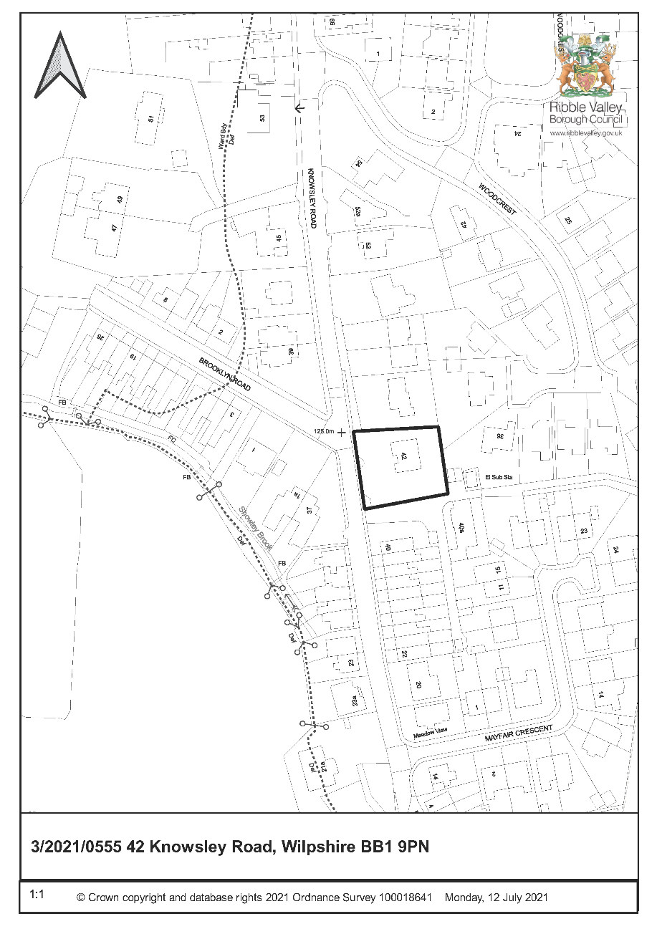

CONSULTEE RESPONSES/ REPRESENTATIONS MADE:

PARISH COUNCIL:

Wilpshire Parish Council in their formal consultation response raised no objections to the proposal. However the following subsequent comments were made:

- Serious concerns have been expressed to Wilpshire Parish Council about the application by some residents.

- Wilpshire Parish Council would ask that should permission be granted that it is a temporary permission only so that any effects on the amenity of the local area, due to the change of use from a C3 use to a C2 use, can be assessed.

ENVIRONMENT DIRECTORATE (COUNTY SURVEYOR):

The Highways Development Control Section has raised no objection to the proposal subject to the imposition of conditions but have offered a number of observations summarised as follows:

- There are no concerns with regards to the site access width however the gates must be set back a minimum of 5 metres from the highway given the slight intensification in the use. This can be controlled with a suitable condition.

- The site plan demonstrates that 4 off street parking spaces can be provided within the curtilage, this is in excess of current guidance which would be 3 spaces for this type of use.

ADDITIONAL REPRESENTATIONS:

Representations have been received from 22 individual households at the time of writing objecting to the application on the following grounds:

- Inadequate parking
- Loss of trees
- Concerns with regard to waste
- Inaccuracies within supporting statement and application form
- Antisocial behaviour / fear of crime/ local area is not suitable for this use
- Concerns about the type of residents
- Noise and disturbance
- Concerns regarding future changes of use within the use class.
- Covenants preventing business use

1. Site Description and Surrounding Area

1.1 The application relates to a detached five bed dwellinghouse located on Knowsley Road, within the settlement boundary of Wilpshire in a predominantly residential area.

1.2 The dwelling is set in a generous plot with large hardstanding area to the front and gardens to the other three sides. It is surrounding on all sides by other dwellings.

1.3 Knowsley Road is a narrow street which is accessed via Ribchester Road and Whalley Road at each end. It serves several streets but is subject to access only restrictions and a 20mph speed limit.

2. Proposed Development for which consent is sought

2.1 The application seeks consent for the change of use of the property from C3 (Dwellinghouses) to C2 (Residential Institutions).

3. Relevant Planning History

None relevant.

4. Relevant Policies

Ribble Valley Core Strategy

Key Statement DS1 – Development Strategy
Key Statement DS2 – Presumption in Favour of Sustainable Development

Policy DME1 – Protecting Trees and Woodland
Policy DME2 – Landscape and Townscape Protection
Policy DME3 – Site and Species Protection and Conservation
Policy DMG1 – General Considerations
Policy DMG2 – Strategic Considerations
Policy DMG3 – Transport and Mobility

National Planning Policy Framework (NPPF)
National Planning Practice Guidance (NPPG)
Technical Guidance to National Planning Policy Framework

5. Assessment of Proposed Development

5.1 Principle of Development:

5.1.1 The Town and Country Planning (Use Classes) Order 1987 (as amended) puts uses of land and buildings into various categories known as 'Use Classes' within which change of use can occur without planning permission.

C3 (Dwellinghouses) is split into three parts and includes:

- C3(a) covers use by a single person or a family (a couple whether married or not, a person related to one another with members of the family of one of the couple to be treated as members of the family of the other), an employer and certain domestic employees (such as an au pair, nanny, nurse, governess, servant, chauffeur, gardener, secretary and personal assistant), a carer and the person receiving the care and a foster parent and foster child;

- C3(b) covers up to six people living together as a single household and receiving care e.g. supported housing schemes such as those for people with learning disabilities or mental health problems;

- C3(c) allows for groups of people (up to six) living together as a single household. This allows for those groupings that do not fall within the C4 HMO definition, but which fell within the previous C3 use class, to be provided for i.e. a small religious community may fall into this section as could a homeowner who is living with a lodger.

C2 (Residential Institutions) includes

• Residential care homes, hospitals, nursing homes, boarding schools, residential colleges and training centres.

C2A (Secure Residential Institutions) includes:

- Use for a provision of secure residential accommodation, including use as a prison, young offenders institution, detention centre, secure training centre, custody centre, short term holding centre, secure hospital, secure local authority accommodation or use as a military barracks

5.1.2 In some respects the use described which is for a residential home for four children is very similar in nature to any of the uses which could fall within the C3(b) group and could be considered to remain within the C3 use class. However there has been case law on this subject and in summary, given that children would not be capable of living together as a family without some form of permanent live-in care and 24 hour supervision and that they could not operate as a family without this it is deemed to fall within the C2 class.

5.1.3 In terms of the development strategy the building will remain in a residential use and this does not conflict with any core strategy polices with respect to spatial planning in the borough. In principle in planning terms a residential use, albeit a specialist one, is wholly appropriate in a residential area. Furthermore, it will use an existing building within a settlement boundary which would be preferable to new building on a greenfield site. As such the proposal is considered acceptable in principle unless the material planning considerations indicate otherwise and subject to assessment against other policies within the plan.

5.2 Impact upon Residential Amenity:

5.2.1 Residential amenity relates to the developments effect upon a neighbour’s outlook, privacy, sunlight/daylight and any noise and disruption likely to arise directly or indirectly as a result of the development. The proposed change of use does not involve any physical alterations to the building that would be likely to
have an impact on outlook, privacy, or daylight.

5.2.2 It is intended that four children and carers will reside at the premises in a very similar way to a family unit although the carers may vary due to shift patterns etc. A maximum of 2 carers will be in attendance at any one time. The amount of people who are able to be present in the home is dictated by the number of bedrooms. The supporting information explains that the operators endeavour to keep the environment within the home as close to family life as possible with and any meetings with the authorities etc are conducted in a setting outside the home such as at a school as much as possible. They also arrange the shift changeovers to avoid busy times.

5.2.3 Objectors have raised concerns with regard to antisocial behaviour arising from the residents of the home. There is no definition in law as to what constitutes a material planning consideration however it is generally accepted that moral and social issues are not. Several moral and social issues have been raised by objectors such as the suggestion that this premises would result in such behaviours and crime in the vicinity; that this is not a suitable location for a children’s home due to lack of services; or that there are elderly people in the area. Requests have been made to specify or exclude certain groups from being able to reside there. Comments such as these are not material planning considerations and would not be a reason to refuse consent. Any conditions imposed must meet certain tests as per para 55 of the NPPF so restrictions on the use which are not necessary or reasonable in planning terms cannot be imposed.

5.2.4 Noise and disturbance arising from the use can be considered but there is no reason to suggest that this use would result in any more noise and disturbance than any other family who have four children and are coming and going from the premises or receiving visitors.

5.2.5 Notwithstanding the above, given the location within a residential area it is proposed to impose a condition which restricts the use to a residential care home only which could include children or adult care. Planning permission would be required to change to any other use within use class C2 such as a hospital or boarding school as they may raise further planning issues that would need to be considered. The concerns with regard to future changes to a secure residential institution are also noted however C2a is a separate use class and therefore planning permission would be required for a change to a use within this group.

5.3 Impact upon Visual Amenity

5.3.1 As aforementioned no physical alterations are proposed to the building other than those renovations required to suit the use. As such it is not considered that the proposal will have a material impact on the appearance of the property or the appearance of the wider area.

5.4 Highway Safety and Accessibility:

5.4.1 The Highways Development Control Officer has raised no objections to the proposal. The concerns of residents in respect of increased traffic and lack of parking are noted and it is acknowledged that this is a narrow road heavily used for on street parking. However, LCC have commented the parking provision exceeds the recommended amount and that they consider that the intensification of use of the premises is minor. The dwelling has five bedrooms and therefore without the change of use could be occupied by a large family with teenagers who all have their own vehicles and receive visitors. It is not considered that this proposal would result in a significant increase in vehicular movements or demand for on street parking over the established use and considering that at least 4 cars can be accommodated within the curtilage.

5.4.2 It is accepted that there is information within the submission that suggests that ten cars can be accommodated off street however the form states four. Regardless of this, four spaces is considered adequate.

5.4.3 Highways have further commented that the gates must be set back from the highway by five metres to allow cars to pull clear of the road and this can be secured with a suitable condition.

5.5 Landscape/Ecology:

5.5.1 The submitted information states that the change of use of the premises does not involve the removal of any protected trees and there are no works proposed that would be likely to impact on any protected species. Therefore, there are no concerns raised in respect of these issues.

5.6 Other issues:

5.6.1 As aforementioned 24 objections to this proposal have been received and the material planning issues raised have been addressed above. Social and moral issues and private legal matters with regards to covenants are not material planning considerations.

6. Observations/Consideration of Matters Raised/Conclusion

6.1 For the reasons outlined above the proposed development is considered to be in accordance with the main aims and objectives of the adopted development plan and do not consider that there are any material planning reasons that would warrant the refusal to grant consent.

RECOMMENDATION: That the application be APPROVED subject to conditions:

- The development hereby permitted shall be commenced before the expiration of three years from the date of this permission.

REASON: Required to be imposed pursuant to Section 51 of the Planning and Compulsory Purchasing Act 2004.

- Unless explicitly required by condition within this consent, the development hereby permitted shall be carried out in complete accordance with the proposals as detailed on drawings:

Location Plan
Existing Plans and Elevation
Proposed Floor Plans

REASON: For the avoidance of doubt and to clarify which plans are relevant to the consent hereby approved.

- Notwithstanding the provisions of Part 2 of Schedule 2, Article 3 of the Town and Country Planning (General Permitted Development) (England) Order 2015 (or any Order revoking and re-enacting that Order) no vehicular access gates, barriers, bollards, chains or other such obstructions shall be erected within a distance of 5 metres of the highway boundary, nor shall any be erected within a distance of 5 metres of the highway boundary unless hung to open away from the highway.

REASON: To enable a vehicle to stand clear of the highway in order to protect the free and safe passage of traffic including pedestrians in the public highway in accordance with the National Planning Policy Framework (2019).

- Notwithstanding the provisions of the Town and Country Planning (Use Classes) Order 1987 (as amended or re-enacted) and the Town and Country Planning (General Permitted Development)(England) Order 2015 (as amended or re-enacted) and the Town and Country Planning (General Permitted Development) (England) (Amendment) Order 2016 (as amended or re-enacted) the property shall only be used for the purposes of residential care home (C2) and for no other purpose, including any other purpose within Use Class C2.

To define the scope of the permission hereby approved and to ensure that the development remains compatible with the character of the area.

BACKGROUND PAPERS

https://www.ribblevalley.gov.uk/site/scripts/planx_details.php?appNumber=3%2F2021%2F0555

