RECOMMENDATION FOR PLANNING AND DEVELOPMENT COMMITTEE

APPROVAL

DATE: 21 October 2021
REF: AD
CHECKED BY:

APPLICATION REF: 3/2021/0699

GRID REF: SD 374247 441621

DEVELOPMENT DESCRIPTION:

DISMANTLE PARAPET TO LEVEL OF COPPER/LEAD TRAY. MAKE ADJUSTMENTS/REPLACE LEAD/COPPER TRAYS AND REBUILD PARAPET USING THE RETAINED STONE AND MATCHING MORTAR AT CASTLE MUSEUM, CLITHEROE CASTLE

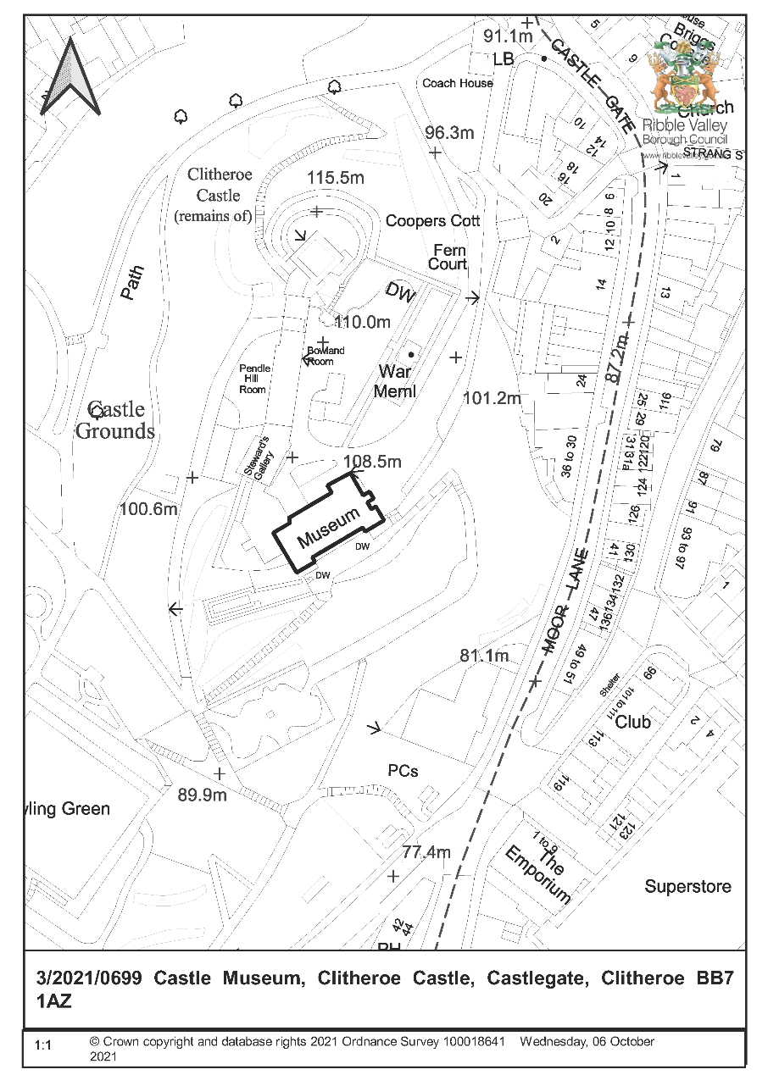
CONSULTEE RESPONSES/ REPRESENTATIONS MADE:

PARISH COUNCIL:

No comments received at time of preparing report.

HISTORIC ENGLAND:

Do not wish to offer any comments. Suggest seeking views of the RVBC specialist conservation adviser.

CADENT:

No objections (but request informative to prevent damage to assets).

LCC ARCHAEOLOGY:

No comments received at time of preparing report

HISTORIC AMENITY SOCIETIES:

No comments received at time of preparing report.

THE GARDENS TRUST:

No comments received at time of preparing report.

RVBC COUNTRYSIDE:

No comments received at time of preparing report.

ADDITIONAL REPRESENTATIONS:

No comments received at time of preparing report

1. Site Description and Surrounding Area

  - The site is within Clitheroe Castle Historic Park and Garden (Grade II listed). and the site is also within the boundary of the ‘Clitheroe Castle and Clitheroe Conservation Area.

2. Proposed Development for which consent is sought

2.1 The proposed repair works relate to the crenelated parapet atop all elevations of the museum building and the intention is to undertake works (dismantle castellated parapet and rebuild) to all areas of the parapet requiring lead/copper tray re-fitting.

3. Relevant Planning History

3/2021/0493 - Proposed replacement of side access ramp to the atrium garden area and walkway. ramp to be steel frame with composite decking (mill board) at Atrium Cafe Clitheroe Castle. LBC granted 30 July 2021.

3/2019/0014 - Replacement of two stone lintels that are damaged beyond repair and to replace them with Waddington Fell gritstone lintels. LBC granted 15/3/2019

3/2019/0088 - Replacement of one stone mullion that is damaged beyond repair. Replacement with Waddington Fell gritstone mullion to the same profile and size as existing. LBC granted 15/3/2019.

3/2018/0950 - Removal of four existing steel casement windows (in one opening) and pinning of damaged mullion. Replacement of existing windows with new electroplated and powder coated steel casement windows. LBC granted 30/11/2018

3/2018/0950 - Removal of four existing steel casement windows (in one opening) and pinning of damaged mullion. Replacement of existing windows with new electroplated and powder coated steel casement windows. LBC granted 30 November 2018.

3/2018/0886 - Re-slating of pitched roof section lower tiers using TAPCO Shake tiles to provide a walkway behind the parapet in order to provide access to the CCTV equipment and for cleaning gutters. Over the years the existing roof finish has been damaged owing to access problems at Castle Museum. LBC granted 30 November 2018.

3/2017/1176 - Remedial works to replace defective stone lintels and repair stone lintels where possible and necessary. LBC granted 9 March 2018.

3/2017/0495 - Re-slating of pitched roof area behind parapet wall at Castle Museum. LBC granted 1 September 2017.

3/2007/0039 - Restoration of existing Listed Museum and outbuilding incorporating newbuild link building. External re-landscaping and remodelling of 3240 sq.m. site within curtain wall of Castle site enabling greater public access. Planning permission granted 2/8/2007.

3/2006/1047 - Alteration and extension of Grade II listed Museum and outbuilding incorporating restoration of existing buildings and localised alteration - to improve access and from physical link into the new building. New building linking the existing buildings together and providing accessible entrance facilities. External re-landscaping and remodelling of 3240 sq.m site within the curtain wall of castle site enabling greater public access. All works are aimed to keep the museum buildings in public use and ensure financial viability of the facility. LBC granted 31/7/2007.

4. Relevant Policies

Planning (Listed Buildings and Conservation Areas) Act 1990. ‘Preservation’ in the duties at sections 16, 66 and 72 of the Act means “doing no harm to” (South Lakeland DC v.
Secretary of State for the Environment [1992]).

Clitheroe Conservation Area Appraisal

Ribble Valley Core Strategy:
Key Statement EN5– Heritage Assets
Policy DMG1– General Considerations
Policy DME4– Protecting Heritage Assets
NPPF
NPPG

5. Assessment of Proposed Development

5.1 Impact upon the special architectural and historic interest of the listed building and the setting of listed buildings:

5.1.1 The proposed works appear to be necessary to address the ongoing problem of damp and building fabric deterioration and ensure the proper preservation of the listed building.

5.1.2 Section 16 of the Planning (Listed Buildings and Conservation Areas) Act 1990 requires that in considering whether to grant listed building consent for any works the local planning authority or the Secretary of State shall have special regard to the desirability of preserving the building or its setting or any features of special architectural or historic interest which it possesses.

5.1.3 Section 66 of the Planning (Listed Buildings and Conservation Areas) Act 1990 requires that in considering whether to grant planning permission or permission in principle for development which affects a listed building or its setting, the local planning authority or, as the case may be, the Secretary of State shall have special regard to the desirability of preserving the building or its setting or any features of special architectural or historic interest which it possesses.

5.1.4 Section 72 of the Planning (Listed Buildings and Conservation Areas) Act 1990 requires that in the exercise, with respect to any buildings or other land in a conservation area, of any functions under or by virtue of the planning acts, special attention shall be paid to the desirability of preserving or enhancing the character or appearance of that area.

5.1.5 NPPF paragraph 199 requires that when considering the impact of a proposed development on the significance of a designated heritage asset, great weight should be given to the asset’s conservation (and the more important the asset, the greater the weight should be). This is irrespective of whether any potential harm amounts to substantial harm, total loss or less than substantial harm to its significance.

5.1.6 Ribble Valley Core Strategy Policy DME4 states that in considering development proposals the council will make a presumption in favour of the conservation and enhancement of heritage assets and their settings. Alterations or extensions to listed buildings or buildings of local heritage interest, or development proposals on sites within their setting which cause harm to the significance of the heritage asset will not be supported. Proposals within, or affecting views into and out of, or affecting the setting of a conservation area will be required to conserve and where appropriate enhance its character and appearance and those elements which contribute towards its significance. This should include considerations as to whether it conserves and enhances the special architectural and historic character of the area as set out in the relevant conservation area appraisal. Development which makes a positive contribution and conserves and enhances the character, appearance and significance of the area in terms of its location, scale, size, design and materials and existing buildings, structures, trees and open spaces will be supported.

5.1.7 Ribble Valley Core Strategy Policy DMG1 states that in determining planning applications, all development must: Design: 1. be of a high standard of building design which considers the 8 Building in Context Principles (from the CABE/English Heritage Building on Context Toolkit. 2. be sympathetic to existing and proposed land uses in terms of its size, intensity and nature as well as scale, massing, style, features and building materials. Environment … 3. all development must protect and enhance heritage assets and their settings.

5.1.8 The proposed specifications do not include details of how it will be ensured that building stones will return to their original positions following repairs or mortar mix specifications (which may vary across the building). It is suggested that this information be subject to condition as well as the precise repair of the lead/copper tray.

5.2 Landscape/Ecology:

5.2.1 The bat survey identifies that a precautionary approach to development is necessary with suitable reasonable avoidance measures, mitigation in the form of timing of works and compensatory bat boxes (roost compensation commensurate with that expected by Natural England for the purposes of licencing should it be necessary). Compensatory bat boxes (two Greenwood Eco Habitats two crevice boxes) will be placed on site prior to work commencing.

6. Observations/Consideration of Matters Raised/Conclusion

6.1 Therefore, in giving considerable importance and weight to the duties at section 16, 66 and 72 of the Planning (Listed Buildings and Conservation Areas) Act 1990 and in consideration to NPPF and Key Statement EN5 and Policies DME4 and DMG1 of the Ribble Valley Core Strategy it is recommended that listed building consent be granted subject to condition.

RECOMMENDATION: That the application be APPROVED subject to the following conditions:

1. The development must be begun not later than the expiration of three years beginning with the date of this permission.

REASON: Required to be imposed pursuant to Section 18 of the Planning (Listed Buildings and Conservation Areas) Act 1990.

2. The permission shall relate to the development as shown on Plan Reference:

Elevation and castellation detail plan
Location Plan

REASON: For the avoidance of doubt and to ensure that the development is carried out in accordance with the submitted plans.

3. Precise specifications of the proposed dismantling, labelling, and safe storage of historic fabric shall have been submitted to and approved by the Local Planning Authority before its use in the proposed works.

REASON: In order to safeguard the special architectural and historic interest of the listed building.

4. Precise specifications and samples of proposed pointing (including mortar mixes) shall have been submitted to and approved by the Local Planning Authority before their use in the proposed works.

REASON: In order to safeguard the special architectural and historic interest of the listed building.

5. Precise specifications of proposed lead tray repairs shall have been submitted to and approved by the Local Planning Authority before their use in the proposed works.

REASON: In order to safeguard the special architectural and historic interest of the listed building.

BACKGROUND PAPERS

https://www.ribblevalley.gov.uk/site/scripts/planx_details.php?appNumber=3%2F2021%2F0699

