RECOMMENDATION FOR PLANNING AND DEVELOPMENT COMMITTEE

REFUSAL

DATE: 21 October 2021
REF: 3/2021/0725
CHECKED BY: NH

APPLICATION REF: 3/2021/0725

GRID REF: SD 375940 445483

DEVELOPMENT DESCRIPTION:

PROPOSED REPLACEMENT TWO-STOREY SIDE AND SINGLE-STOREY EXTENSIONS TO REAR, EXTERNAL AND INTERNAL ALTERATIONS INCLUDING FIRST FLOOR CONVERSION FROM MANAGER'S ACCOMMODATION TO FOUR TO-LET ENSUITE BEDROOMS AT BUCK INN SAWLEY ROAD GRINDLETON
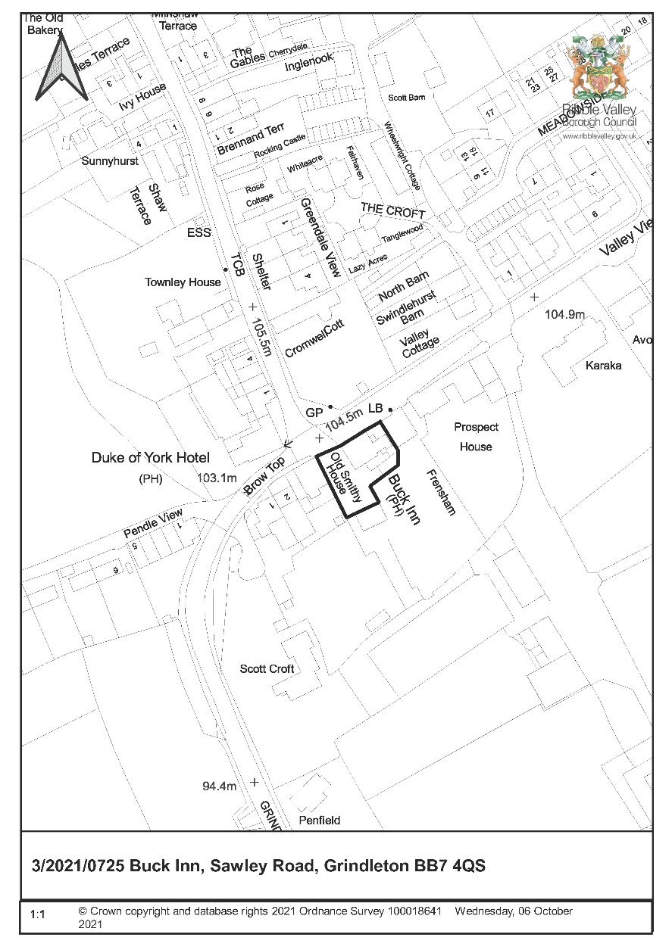
CONSULTEE RESPONSES/ REPRESENTATIONS MADE:

PARISH COUNCIL:

Support (heart back to community; stop building dereliction; tourism and employment) but concern at: excessive hours of operation; when full, parking an issue around junction opposite and for residents.

LCC HIGHWAYS:

9 August 2021-Further information required because:

- Intensification of use of the existing access following the extension to the building and change of use of the manager's accommodation to 4 hotel rooms;
- Shortfall in 29 car parking spaces.
- Easy access and exit - require swept path analysis of largest delivery goods vehicle.
- Advise to just renovate without extending and proposing a hotel element - will not require any information and the site may not require planning permission (shortfall in car parking will be a pre-existing situation).

9 September 2021- No objection subject to conditions (access, parking and turning and car park surfacing before occupation). Removed hotel element and will remain as landlords/managers flat. Will accept the shortfall in parking.

CADENT:

Apparatus in the vicinity. Advise of likely decision as soon as possible. Note to contractor.

RVBC ENVIRONMENTAL HEALTH:

Consulted. Response will be reported verbally to Committee.

RVBC COUNTRYSIDE:

Consulted. Response will be reported verbally to Committee.

ADDITIONAL REPRESENTATIONS:

Seven objections received which make the following points:

- Parking area - right of access to neighbouring properties.
- Increased on-street parking; remaining as village pub obviates need for additional parking.
- Noise after midnight including no supervision of hotel guests; outdoor seating.
- Re-opening of the Buck will affect (competition) the proposed Duke of York (Grade II listed) Community Hub (more than pub/restaurant).
- Over-development.
- Loss of light from extension location and finish.
- Overlooking from outdoor seating area.
- Restaurant more than village pub.
- Detrimental to conservation village.

Seventy-three letters of support which make the following points:

- Village needs pub and shop.
- Best plan.
- Not harmful to the conservation area or setting of Duke of York (Pre-application advice); enhance views.
- Good for economy – jobs; tourism
- Community facility – focal point, social cohesion and mental health. 200 people supported the Community Pub Project.
- Duke of York – offers to purchase rejected; continues to deteriorate (what RVBC doing about?).
- The Pavilion is a village hall (not pub/restaurant; more-bookable only).
- Prevent another pub deteriorating.
- Re-opening of the Buck will not affect (competition) the Duke of York.

1. Site Description and Surrounding Area

  - The Buck Inn is a prominently sited C18 public house (vacant for c.3 years) within Grindleton Conservation Area. It fronts Sawley Road and is close to the juncture of Brow Top/Sawley Road and Main Street and within the immediate setting of the Duke of York Hotel (Grade II listed; ‘Public house, early C19th’; corner site; Focal Building in the Grindleton Conservation Area Appraisal). It is one of the very few non-listed buildings in Grindleton Conservation Area which the Appraisal (The Conservation Studio consultants) identifies as making a positive contribution to character and appearance (Building of Townscape Merit).

  - The Buck Inn has a symmetrical frontage with ground floor bay-windows (with castellated parapet) either side of a central pedimented front door. Quoins at each return. Chimneys at each gable. Adjoining traditional wall and gates to the front of a yard and recessed single-storey stone and render extensions. Modern rear extensions occupy just over half of the rear curtilage with adjoining stone flagged space to the west.

  - The 1890s OS map shows the ‘Buck Inn’ with yard and extension to the north-east as existing. The 1840s OS map shows a building of square plan with extensions to the rear and side in this location.

2. Proposed Development for which consent is sought

2.1 Planning permission is sought for a proposed 2-storey extension in the yard to the east of the frontage (with demolition of side extensions and front wall/gates; roadside frontage of arch-headed openings including ground floor cart-door type openings), single-storey extension to the rear (replacement of existing extensions; construction to whole of rear yard; flat roof) and external and internal alterations including the loss of walling identifying the historic double-pile planform.

2.2 Revised plans were received on 3rd September 2021 (following LCC Highways initial objection) deleting the proposed hotel accommodation and incorporating a revised parking design and numbers (now seven spaces).

2.3 The submitted application form identifies hours of operation as:
  - Mon – Thurs 1100 to 0000
  - Fri-Sat 1100 to 0100
  - Sun and BH 1200 to 0000

2.4 The submitted application form identifies that the development will employ 10 Full-time and 10 Part- Time employees.

2.5 The submitted Design Statement summarises the Borough Council’s Pre-application advice of May 2021. It suggests that the proposed en-suite boutique bedrooms at first floor (now deleted following LCC Highways concerns) are required to facilitate a viable business (paragraph 3.5).

3. Relevant Planning History

3/2007/0812 – Installation of a new stainless steel extract system with galvanised ductwork and associated fittings to exhaust fumes from the kitchen, away from neighbouring properties. PP granted 12/10/2007.

3/2007/0481 – Proposed erection of slate mono-pitch roofed shelter attached to existing flat roofed extension to rear of premises and replacement of existing sliding patio doors with French style doors and glazed side panels. PP granted 20/06/2007.

3/1986/0331 – Rear lounge to form covered way from main building to toilets. PP granted 16/7/1986.

3/1986/0180 – Family room to rear by roofing across main building to toilets. PP refused 6/5/1986.

BO1459 – Toilet. PP granted 1/8/1969.

4. Relevant Policies

Ribble Valley Core Strategy:
Key Statement EN2 - Landscape
Key Statement EN5– Heritage Assets
Key Statement EC2: Development of Retail, Shops and Community Facilities and Services
Key Statement EC1: Business and Employment Development
Policy DMG1– General Considerations
Policy DMG2 – Strategic Considerations
Policy DME4– Protecting Heritage Assets
Policy DMB1: Supporting Business Growth and the Local Economy

Planning (Listed Buildings and Conservation Areas) Act 1990. ‘Preservation’ in the duties at sections 66 and 72 of the Act means “doing no harm to” (South Lakeland DC v. Secretary of State for the Environment [1992]).
Grindleton Conservation Area Appraisal

National Planning Policy Framework (NPPF)
National Planning Practice Guidance (NPPG)

5. Assessment of Proposed Development

5.1 Impact upon the character and appearance of Grindleton Conservation Area, the setting of the Duke of York Hotel and the cultural heritage of the Forest of Bowland AONB:

5.1.1 It is considered that the proposed extensions are harmful to the character and appearance of Grindleton Conservation Area, the setting of the Duke of York Hotel and the cultural heritage of the Forest of Bowland AONB.

5.1.2 The side extension is large (two-storey, two bay width and having little set-back or set-down), prominent and incongruous, unbalancing the carefully and intentionally designed symmetric façade (“The Duke of York and The Buck Inn – dating from the 18th century, both symmetrical double pile houses”; “two public houses … but the streetscape is largely made up of vernacular houses, without church (until 1805), manor, rectory or ‘polite’ houses” – Grindleton Conservation Area Appraisal”).

5.1.3 The side extension’s cart-door openings have no provenance to this site and undermine the significance and authenticity of the conservation area’s buildings which do possess such characteristics (“a number of former agricultural buildings, with carriage arches …at Stone Hill Farm, Swindlehurst Barn, Duck House Farm and Wythenstocks Barn, for example” – Grindleton Conservation Area Appraisal).

5.1.4 Construction of the side extension will result in the loss of a historic extension, traditional boundary walling, gates and yard (“Boundary walls: built from the abundant local gritstone, these are a distinctive feature of the conservation area”; “Railings and gates” - Grindleton Conservation Area Appraisal: Local details) and distinct planform (“the double pile layout of the building remains legible at ground floor level” – Heritage Statement).

5.1.5 Buildings along the southern side of Sawley Lane are characterised by spaces between buildings allowing through views to the open countryside. The spaces around the Buck and views of relatively undetailed gable walls additionally provides emphasis to its impressive symmetrically designed facade. This will be lost.

5.1.6 The Duke of York is diagonally opposite the Buck and the proposed rear flat-roofed and largely glazed extension (which is flush with the gable wall). The extension is unsympathetic to the C18 double-pile building in form and materials and unduly prominent in the streetscene.

5.1.7 In considering the proposed development due regard has been had to:

- Section 66 and 72 of the Planning (Listed Buildings and Conservation Areas) Act 1990
- The Framework paragraphs 199 and 200
- Ribble Valley Core Strategy Policy DME4
- Ribble Valley Core Strategy Policy DMG1
- Building in Context Principles
- The National Design Guide (2021)
- Making changes to heritage assets’ (Historic England, 2016)
- The Forest of Bowland AONB Management Plan

5.1.8 The National Planning Practice Guidance states that “substantial harm is a high test, so it may not arise in many cases”. The external additions are potentially reversible and most historic fabric is retained. Harm to the character and appearance of Grindleton Conservation Area and the setting of the Duke of York Hotel is ‘less than substantial’.

5.1.9 NPPF paragraph 202 requires that ‘less than substantial’ harm be weighed against any public benefits of proposals including, where appropriate, securing its optimum viable use”. The Ribble Valley Core Strategy also identifies:

- “The expansion of existing businesses will, wherever appropriate, be considered favourably” (Key Statement EC1).
- “Proposals that are intended to support business growth and the local economy will be supported in principle … The expansion of existing firms within settlements will be permitted on land within or adjacent to their existing sites, provided no significant environmental problems are caused and the extension conforms to the other plan policies of the LDF” (Policy DMB1).

5.1.10 The re-use of the public house is welcomed for its economic (business growth and employment generation) and social (meeting place for the local and wider community) public benefits. Re-use for a public house also helps safeguard the historic interest of the site.

5.1.11 However, it is unclear whether the extent of development proposed, in particular the two-storey extension, which will appear incongruous and conspicuous, is necessary. Following concerns from the Highway Engineer the en-suite bedroom accommodation, which it was originally understood to be integral to business viability, were deleted from the scheme however the built form originally proposed was retained with Manager accommodation. Given the deletion of the en-suite accommodation it is considered that there is potential for a smaller scheme to be developed which would have the benefits associated with the development but result in less harm to the character and appearance of Grindleton Conservation Area and the setting of the Duke of York Hotel (Grade II listed). It is not considered that the harm resulting from the proposed development is outweighed by the benefits.

5.2 Impact upon Residential Amenity:

5.2.1 The concerns of local residents have been considered. The proposal (subject to minor amendment) does not have a significant impact on adjoining properties in respect to overshadowing, overbearing or overlooking. The rear extension windows do overlook the neighbour’s garden to the south but this could be resolved by obscure glazing. The proposed side extension will overshadow part of the west gable ground floor window of the neighbour to the east but this is a secondary window to what appears to be a kitchen.

5.2.2 A noise assessment has not been submitted with the application. The comments of RVBC Environmental Health (including hours of operation) will be reported to Committee.

5.3 Highway Safety and Accessibility:

5.3.1 The comments and advice (including suggested conditions) of LCC Highways has been considered. Appropriate conditions could be secured in the event of a positive recommendation.

5.4 Landscape/Ecology:

5.4.1 The submitted bat survey identifies that bats will not be disturbed during demolition, the extension will not have a negative impact on a local bat population, no high value bat roost habitat will be removed and no mitigation is required. The comments of RVBC Countryside will be reported to Committee.

6. Observations/Consideration of Matters Raised/Conclusion

6.1 In giving considerable importance and weight to the duties at section 66 and 72 of the Planning (Listed Buildings and Conservation Areas) Act 1990 and in consideration to NPPF and Key Statement EN2, EN5, EC1 and EC2 and Policies DME4, DMG1, DMG2 and DMB1 of the Ribble Valley Core Strategy it is recommended that planning permission be refused.

RECOMMENDATION: That the application be REFUSED for the following reason:

- The proposed extensions are incongruous and conspicuous and have a harmful impact upon the character and appearance of Grindleton Conservation Area and the setting of the Duke of York Hotel (Grade II listed) because of their form, size, location and materials. This is contrary to Ribble Valley Core Strategy Key Statement EN5 and Policy DME4 and DMG1.

BACKGROUND PAPERS

https://www.ribblevalley.gov.uk/site/scripts/planx_details.php?appNumber=3%2F2021%2F0725

