RECOMMENDATION FOR PLANNING AND DEVELOPMENT COMMITTEE

Approve
DATE: 23 September 2021
REF: JM
CHECKED BY: NH

APPLICATION REF: 3/2021/0748

GRID REF: SD 374241 438293

DEVELOPMENT DESCRIPTION:

PROPOSED CREATION OF 16 BASE PLOTS FOR HOLIDAY LODGES AND PROVISION OF SALES OFFICE AND SITE MANAGER'S ACCOMMODATION WITHIN EXISTING BUILDING ON SITE (PURSUANT TO PREVIOUSLY APPROVED DEVELOPMENT UNDER 3/2015/0426 AMENDED BY 3/2017/0775) AT PENDLE VIEW FISHERIES, WHALLEY, CLITHEROE BYPASS, WISWELL BB7 9DH

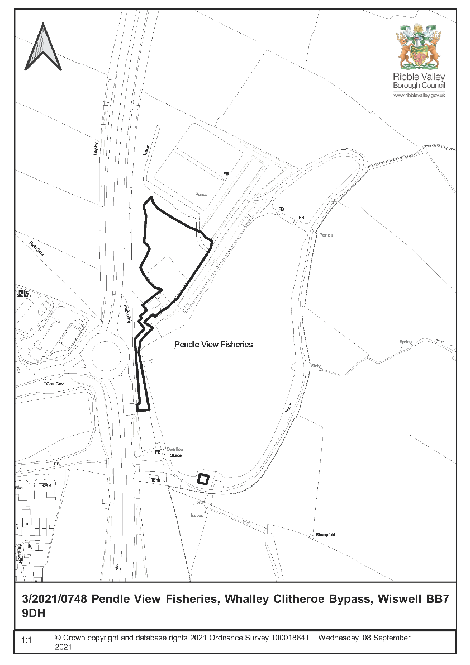
CONSULTEE RESPONSES/ REPRESENTATIONS MADE:

PARISH COUNCIL:

Raise concern in relation to accuracy of the application form and lack of details and request consideration of pedestrian footbridge or controlled crossing light across the A59 in the interests of safety of residents and users of the site.

ENVIRONMENT DIRECTORATE (COUNTY SURVEYOR):

No objection subject to a planning conditions imposed under consent 3/2021/0431.

LEAD LOCAL FLOOD AUTHORITY (LLFA):

No comment to make as not within the consultation procedure so LLFA standing advice should be applied.

UNITED UTILITIES:

No objections subject to the imposition of appropriate conditions with the site drained on a separate system with foul water draining to the public sewer and surface water draining in the most sustainable way.

ADDITIONAL REPRESENTATIONS:

None

1. Site Description and Surrounding Area

1.1 The application site is located along the A59 on the eastern edge of Barrow, approximately 3.5km south of Clitheroe and 2km north of Whalley. The site is on the outskirts of the AONB. The site is bound by the fishing lake to the east and the A59 to the west.

1.2 The overall site is currently being developed under an extant consent and the current proposal relates to part of and the was previously used as carparking for the former fisheries and covers part of the previously approved scheme, namely the area proposed for the 10 cabins, the large car parking area and the former Manager’s house and café.

1.3 The site is surrounded by agricultural fields to the north and east with the settlements of Barrow located to the west of the site, including an existing employment area.

1.4 Permission for the entire site was granted in October 2015 for the change of use of the former fishery to a leisure park that included 19 lodges, 11 woodland lodges, 10 cabins, warden's lodge, conversion, extension and amenity building to form one bedroom holiday cottage, conversion of storage buildings to form one 2 bed holiday cottage, conversion and extension of existing manager's house and café to form restaurant public house and manager's accommodation, 100 car parking space, ground work, recontouring and creation of ecological wetland and ancillary landscaping. Groundworks pertaining to the extant permissions 3/2015/0426 and 3/2017/0775 are underway.

2. Proposed Development for which consent is sought

2.1 The proposed development includes the following elements:

- Erection of 16 caravans/ holiday lodges including decking area and associated landscaping,
- Creation of a sales office and Site Manager’s accommodation within an existing building on-site (the former Site Managers accommodation and café building).

2.2 The scheme includes the siting of 16 base plots for caravans/holiday lodges with car parking spaces next to each proposed lodge. These caravans/lodges will replace the 10 smaller cabins that were approved as part of the 2015 consent, and the large car parking area that was proposed to service the new Gastro pub/restaurant that was proposed within the former Site Manager’s/cafe building. As some work has already commenced the application is part retrospective.

2.3 The caravans/holiday lodges have a range of colours with some of the units having a different palette. The colours are either shades of brown or green with a profiled roof. The decking area is timber and there is an internal access way with low level lighting and a bin store area. There is a communal landscaped area with each plot also having a grassed area and individual parking spaces,

2.4 The former Site Manager’s/cafe building is proposed to be retained as self-contained accommodation for a Site Manager with a sales office at ground floor with associated office and staff rooms at first floor. The proposal includes parking area for the sales office and two spaces for the Site Manager’s dwelling will be retained solely for their use.

3. Relevant Planning History

3/2015/0426 | Change of use of fishery to leisure park with 19 lodges, 11 woodland lodges, 10 cabins, warden's lodge, conversion, extension and amenity building to form one bedroom holiday cottage, conversion of storage buildings to form one 2 bed holiday cottage, conversion and extension of existing manager's house and café to form restaurant, public house and manager's accommodation, 100 car parking space, ground work, re-contouring and creation of ecological wetland and ancillary landscaping | Approved with Conditions.

3/2016/0245 | Discharge of conditions 3 (phasing programme) 4 (surface water drainage scheme) 5 (drainage adoption plan) 6 (foul water drainage scheme) 7 (ecological wetland) 8 (detailed groundwork layout) 9 (details of lakeside structures) 12 (landscaping) 13 (construction method statement) and 19 (site access) of planning permission 3/2015/0426 |Approved with Conditions.

3/2017/0775 | Variation of condition two from planning permission 3/2015/0426 to allow layout revisions in order to retain existing pond and to revise the locations of the lodges and cabins to the north west of the site | Approved.

3/2017/0827 | Discharge of condition 9 (details of structures along shore and projecting into the water), 10 (lighting details) and 19 (site access and off-site works highway improvements) from planning permission 3/2015/0426 | Approved.

3/2017/0999 | Discharge of conditions 11 (cabin and lodge details) and 13 (construction management plan) planning permission 3/2015/0426 | Approved.

3/2017/0998 | Discharge of condition 8 (earthworks, finished ground levels, infrastructure) from planning permission 3/2015/0426 | Approved.

3/2021/0431 | Variation of conditions of planning application 3/2015/0426. Condition 19 - Site Access and Highways, Condition 20 – Occupancy Approved.

3/2021/0512 | Discharge of Condition 6 (Ecologist Report) from planning permission Approved.

4. Relevant Policies

Ribble Valley Core Strategy

Key Statement DS1 – Development Strategy
Key Statement DS2 – Presumption in Favour of Sustainable Development
Key Statement EC3 – Visitor Economy
Key Statement EN2 - Landscape
Key Statement EN3 – Sustainable Development and Climate Change
Key Statement DMI2 – Transport Considerations
Policy DMB1 – Supporting Business Growth
Policy DMB3- Recreation and Tourism Development
Policy DMB5 – Footpaths and Bridleways
Policy DMG1 – General Considerations
Policy DMG2 – Strategic Considerations
Policy DMG3 – Transport and Mobility
Policy DME6 – Water Management

National Planning Policy Framework (NPPF)
National Planning Practice Guidance (NPPG)
Technical Guidance to National Planning Policy Framework

5. Assessment of Proposed Development

5.1 Principle of Development:

5.1.1 It is evident that given the previous approval and extant consent that principle of tourism-based development has previously been established on this site and is policy compliant.

5.2 Impact upon Residential Amenity:

5.2.1 The issues relevant here relate to additional noise and light pollution caused by the additional lodges and the loss of a Gastro pub facility. Although there may be a perceived loss of a facility to the local residents this is not considered significant and there would be benefits resulting from less traffic movements and reduction in noise.

5.3 Visual Amenity/External Appearance:

5.3.1 It is evident that given the existing consents and the proposed landscaping and suitable materials that any visual impact is limited and to an acceptable level. There would only be long distant views of the lodges and any incursion into the open countryside would have a limited visual impact.

5.3.2. The siting of additional lodges, as proposed by this application, will not have a significant visual impact on the existing site or the surrounding area. Furthermore, it is intended that existing tree cover on the site will be retained and additional tree planting and landscaping will be undertaken as part of the development.

5.4 Highway Safety:

5.4.1 The highway authority has not objected to the development and subject to the imposition of appropriate planning conditions would not create an adverse highway condition.

5.5 Landscape/ Arboricultural/Ecological issues:

5.5.1 A Preliminary Ecological Appraisal and tree survey has been submitted with the application. It is considered the additional landscaping and planting proposed will promote wildlife diversity and encourage a wider variety of wildlife to use the site than already occurs. Any trees that are to be removed are identified as low quality and not worthy of retention. There is only a limited impact on ecology and biodiversity as result of this proposal and negligible impact when compared with the extant consent and such it is deemed to be in accordance with Policy EN4.

5.5.2 The planting of additional local species of trees and plants, as part of the landscaping scheme for the development will assist in biodiversity on the site.

5.6 Drainage:

5.6.1 Based on the previous response from the LLFA and United Utilities it would not lead to detrimental conditions appertaining to drainage issues. Mindful that no formal response has been received from the LLFA and on the understanding that drainage is a technical matter and any recommendation would be subject to compliance of any conditions required by the LLFA should Committee be minded to approve the scheme.

6 Observations/Consideration of Matters Raised/Conclusion

6.1 The observations of the Parish Council are noted and in relation to a footway crossing, this was an issue considered by LCC in the initial application and deemed necessary. Notwithstanding that point it is considered that this scheme may reduce the possible need further due to the removal of the Gasto Pub element from the scheme. It is accepted that some of the users of the caravan would benefit form a crossing or foot bridge and possible highway benefits but it is evident that the highway authority does not consider it necessary.

6.2 Considering all of the above and having regard to all material considerations the proposal is considered to be acceptable subject to the imposition of appropriate conditions.
RECOMMENDATION: That the application be APPROVED subject to the following conditions:

1. Unless explicitly required by condition within this consent, the development hereby permitted shall be carried out in complete accordance with the proposals as detailed on drawings:

Location Plan PPD1192/01/01
Proposed General Arrangement PPD1192/01/03
Proposed Level Plan Planting Plan PPD1192/01/06
Proposed Development Section Plan and Base Detail PPD1192/01/04
Proposed Manager Accommodation and Sales Office Plan PPD1192/01/07

REASON: For the avoidance of doubt and to clarify which plans are relevant to the consent.

2. Prior to the erection of caravans/holiday lodges on site precise details of the caravan including the colouring shall be submitted to and approved in writing by the Local Planning Authority. The caravan/ holiday lodges thereafter shall be erected in accordance with the approved details.

REASON: In the interest of visual amenity.

Drainage

3. Prior to occupation of the development a sustainable drainage management and maintenance plan for the lifetime of the development shall be submitted to the local planning authority and agreed in writing. The sustainable drainage management and maintenance plan shall include as a minimum:
a. Arrangements for adoption by an appropriate public body or statutory undertaker, or management and maintenance by a resident’s management company and,
b. Arrangements for inspection and ongoing maintenance of all elements of the sustainable drainage system to secure the operation of the surface water drainage scheme throughout its lifetime.

The development shall subsequently be completed, maintained and managed in accordance with the approved plan.

REASON: To ensure that management arrangements are in place for the sustainable drainage system in order to manage the risk of flooding and pollution during the lifetime of the development.

4. No development shall commence until a surface water drainage scheme has been submitted to and approved in writing by the Local Planning Authority. The drainage scheme must include:

(i) An investigation of the hierarchy of drainage options in the National Planning Practice Guidance (or any subsequent amendment thereof). This investigation shall include evidence of an assessment of ground conditions and the potential for infiltration of surface water;
(ii) A restricted rate of discharge of surface water agreed with the local planning authority (if it is agreed that infiltration is discounted by the investigations); and
(iii) A timetable for its implementation.

The approved scheme shall also be in accordance with the Non-Statutory Technical Standards for Sustainable Drainage Systems (March 2015) or any subsequent replacement national standards.

The development hereby permitted shall be carried out only in accordance with the approved drainage scheme.

REASON: To promote sustainable development, secure proper drainage and to manage the risk of flooding and pollution.

5. Foul and surface water shall be drained on separate systems.

REASON: To secure proper drainage and to manage the risk of flooding and pollution.

Highways

6. A scheme for the construction of the site access and the off-site works of highway improvement shall be submitted to and approved in writing by the Local Planning Authority within 6 months of the opening of the sales office on site. The applicant shall advise the Council on the completion of any associated works relating to the sales office and its opening to enable this time period to be begun.

REASON: In order to satisfy the Local Planning Authority and Highway Authority that the final details of the highway scheme/works are acceptable.

7. None of the holiday lodges or cabins hereby approved shall be occupied until the approved scheme referred to in the preceding condition number 8 has been constructed in accordance with the approved details.

REASON: In the interest of highway safety.

8. For the full period of construction, facilities shall be available on site for the cleaning of the wheels of vehicles leaving the site and such equipment shall be used as necessary to prevent mud and stones being carried onto the highway. The roads adjacent to the site shall be mechanically swept as required during the full construction period.

REASON: To prevent stones and mud being carried onto the public highway to the detriment of road safety.

Ecology/ landscape

9. Prior to the siting of any caravans/holiday lodges full details of the location of a minimum of 3 bat boxes, to be attached to mature trees within the site, shall be submitted to and approved in writing by the Local Planning Authority. The bat boxes shall be erected prior to the first use of the caravans/holiday lodges hereby permitted.

REASON: To encourage and promote biodiversity.
10. The landscaping proposals hereby approved shall be implemented in the first planting season following occupation or use of the development unless otherwise required by the reports above, whether in whole or part and shall be maintained thereafter for a period of not less than 10 years to the satisfaction of the Local Planning Authority. This maintenance shall include the replacement of any tree or shrub which is removed, or dies, or is seriously damaged, or becomes seriously diseased, by a species of similar size to those originally planted.

REASON: To ensure the proposal is satisfactorily landscaped and appropriate to the locality.

Amenity

11. Each holiday unit hereby approved shall not be let to or occupied by the owner, any one person or group of persons for a combined total period exceeding 28 days in any one calendar year and in any event shall not be used as a unit of permanent accommodation or any individual(s) sole place of residence.

The owner shall maintain a register of all guests of each unit of accommodation hereby approved at all times and shall be made available for inspection by the Local Planning Authority on request. For the avoidance of doubt the register shall contain:

- the name and address of the owner's permanent residence (where they pay Council tax and/ or are registered to vote and keep the majority of their possessions);
- the name and address (permanent residence) of main guest who made the booking together with dates of occupation.

For the avoidance of doubt permanent residence is where the owner/ guest pay Council tax and/or are registered to vote and keep the majority of their possessions.

REASON: The permission relates to the provision of holiday accommodation. The condition is necessary to define the scope of the permission hereby approved and to ensure that the development promotes sustainable tourism and contributes to the area's economy.

12. Prior to the first use of the caravans/holiday lodges hereby permitted a scheme showing dedicated electric vehicle charging points throughout the application site shall be submitted to and approved in writing by the Local Planning Authority. Thereafter, the electric vehicle charging points shall be provided in accordance with the approved scheme prior to the first use of the caravans/holiday lodges hereby permitted.

REASON: To promote options for sustainable modes of transport within the site.

13. The residential accommodation associated with the development contained within the proposed sales office and site managers building shall be occupied by persons employed in connection with the operational management of the proposed complex.

REASON: In the interests of safeguarding the accommodation specific to the site and the operational requirements of the business.

14. No phase of development shall be occupied until a management plan for the site has been submitted to and approved in writing by the local planning authority. The site shall be operated at all times in accordance with the approved plan. As a minimum, the management plan shall provide details of:

1. Access arrangements
2. Security arrangements
3. Site maintenance arrangements
4. Site rules and regulations for residents

REASON: In the interests of the amenity of the area.

BACKGROUND PAPERS

https://www.ribblevalley.gov.uk/site/scripts/planx_details.php?appNumber=3%2F2021%2F0748

