RECOMMENDATION FOR PLANNING AND DEVELOPMENT COMMITTEE

DEFER AND DELEGATE FOR APPROVAL

DATE: 6 JANUARY 2022
REF: LE
CHECKED BY:

APPLICATION REF: 3/2021/0760

GRID REF: 373515 436677

DEVELOPMENT DESCRIPTION:

CHANGES TO HOUSE TYPES ON PLOTS 35, 36, 73, 74, 75, 79, 80, 81, 82, 86, 99, 102, 109, 113, 143, 144, 145, 146, 147, 157 AND MINOR LAYOUT CHANGES TO PLOTS 82, 83, 84 OF APPROVED PLANNING PERMISSION 3/2018/0914 FOR THE ERECTION OF 188 NEW DWELLINGS. SPRINGWOOD DRIVE WHALLEY BB7 9XL PHASE 2 LAWSONSTEADS

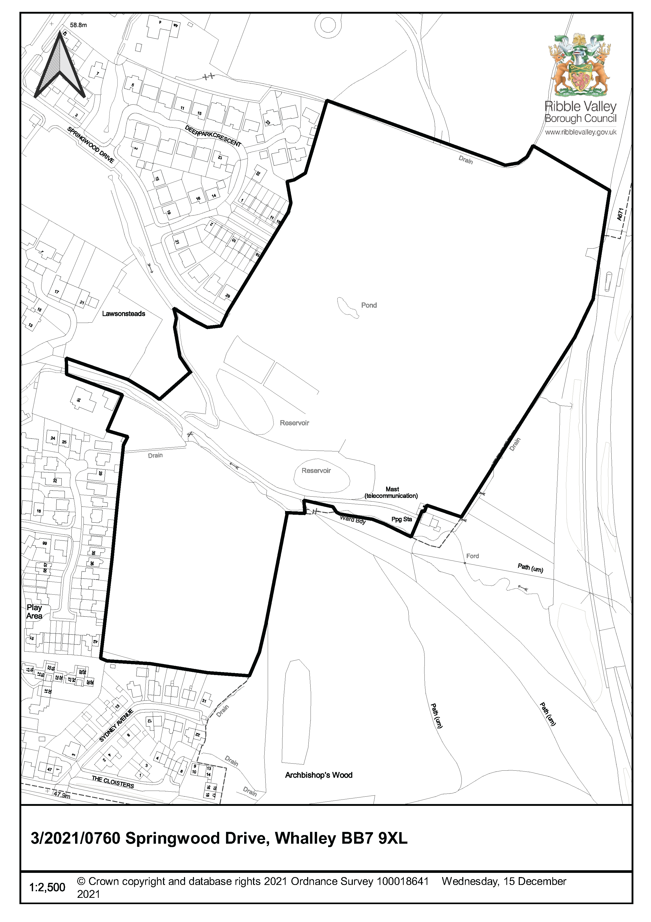
CONSULTEE RESPONSES/ REPRESENTATIONS MADE:

PARISH COUNCIL:

Whalley Parish Council – Noted the application.

ENVIRONMENT DIRECTORATE (COUNTY SURVEYOR):

The Highways Development Control Section has raised no objection to the proposal subject to the imposition of technical conditions which are discussed further in the report.

LCC ARCHAEOLOGY:

The proposed development site was subject to archaeological evaluation in 2018, and no significant remains were identified. As such it is recommended that the condition applied to the planning consent could be discharged.

ENVIRONMENT AGENCY (EA):

Have no further comments to add to their response on the original planning approval. Request that the developer remains engaged with EA and LLFA with regard to flood management in the area.

LEAD LOCAL FLOOD AUTHORITY (LLFA):

Have no further comments to add to their response on the original planning approval.

LANCASHIRE COUNTY COUCIL – EDUCATION:

Have no further comments to add to their response on the original planning approval as the pupil yield remains the same.

ADDITIONAL REPRESENTATIONS:

2 letters of objection have been received summarised as:

- Whalley does not have the infrastructure to cope with more houses
- The development is too high density
- Poor relationship to surrounding developments
- Not in keeping with the scale or character of Whalley
- Flooding

2. Proposed Development for which consent is sought

2.1 The application seeks consent for changes to planning permission 3/2018/0914 for the erection of 188 new dwellings. The changes are summarised as follows

- House type C (plots 73, 74, 75, 80, 81, 82) 4 bed with integral garage redesigned because the living space was felt to be significantly compromised. This typology has been replaced with a large detached 3 bed with no integral garage.

- House type D (plot 157) has increased in area from 101m2 to 108.9m2.

- House type E (plots 79, 86, 99, 102, 109, 113 previously house type D) to be replaced with a new 4 bed wide frontage house type.

- This means that the overall mix of property sizes remains unchanged.

- House type K (plots 35, 36, 143, 144, 145, 146, 147) this property has slightly increased in footprint and a further window has been added to bedroom 2.

- Changes to layout: rearrangement of plots 82 - 84 inclusive has been updated to create a stronger street scene with larger properties now bookending the southern end of the crescent.

It should be noted that there is a concurrent S73 application currently under to vary the approved plans this is approved pending a legal agreement. This seeks the following amendments
- HouseType A: Full height masonry chimneys replaced with ridge chimneys on plots 30, 112 & 118. First floor bathroom window moved to allow for attached garage to plot 151.
- HouseType B: Ground floor bay windows added to plots 21, 31, 34, 50, 72, 76 & 84. As above, full height masonry chimneys replaced with ridge chimneys on plots 5, 21, 34, 39, 46, 55, 68, 85, 155, 158 & 159.
- HouseType F:Semi-detached houses have been mirrored to allow external access from utility room
- HouseType G:Semi-detached houses have been handed to allow external access from the kitchen / dining room.

The more significant amendments which involve increase footprint and changes of house type are covered within this current application.

3. Relevant Planning History

3/2018/0914 - Erection of 188 new dwellings including means of access and associated works. To include 57 affordable dwellings (29 affordable rent and 28 shared ownership).

3/2021/0196 - Variation of condition 2 (Approved Plans) of 3/2018/0914. Proposed changes to plot/house type – Approved subject to the legal agreement.

3/2021/1201 - Discharge of Condition 18 - Surface water drainage and Condition 19 - Surface water drainage during the construction phase from planning consent.

3/2018/0914 – Registered (UU have indicated that the information with regard to condition 19 is acceptable but condition 18 is not addressed).

4. Relevant Policies

Ribble Valley Core Strategy

Key Statement DS1 – Development Strategy
Key Statement DS2 – Sustainable Development
Key Statement H1 – Housing Provision
Key Statement H2 – Housing Balance
Key Statement H3 – Affordable Housing
Key Statement EN4 – Biodiversity and Geodiversity
Key Statement DMI1 – Planning Obligations
Key Statement DMI2 – Transport Considerations
Key Statement DMG1 – General Considerations
Key Statement DMG2 – Strategic Considerations
Key Statement DMG3 – Transport and Mobility
Key Statement DME2 Landscape and Townscape Protection
Key Statement DMH1 Affordable Housing Criteria
Key Statement DMB4 – Open Space Provision
Key Statement DME3 — Site and Species Protection and Conservation
Key Statement DME6 — Water Management
Key Statement DMB5 — Footpaths and Bridleways

National Planning Policy Framework (NPPF)

5. Assessment of Proposed Development

5.1 Principle of Development:

5.1.1 The principle of development was established under application 3/2018/0914 which granted consent for the construction of 188 dwellings. This application seeks to amend the house types on 20 plots and alter the layout of 3 plots. The overall total number of houses and bedroom mix remains as previously approved.

5.1.2 The site is a committed housing site in the Housing and Economic Development DPD, adopted October 2019 and the proposal is considered to be acceptable in principle, subject to the material planning considerations.

5.2 Impact upon Residential Amenity:

5.2.1 The plots affected by the changes to house type and layout are within the site and those located along the perimeter adjacent to existing developments are unaffected. Whilst the concerns of the objector are noted there are no changes to the previously approved buffer around the edge of the site. As such the changes proposed are not considered to have any impact on the amenity of residents of adjacent sites.

5.2.2 The footprint of the affected dwellings has slightly increased but this will not result in a detrimental effect on any of the surrounding dwellings. House type K is a bungalow and has an additional bedroom window on the gable elevation to the front which would not result in any additional overlooking. As such there are no concerns raised with respect to residential amenity within the site.

5.3 Visual Amenity / Landscape:

5.3.1 As aforementioned this application seeks to vary house types on 20 selected plots and the layout of 3. The changes proposal will have a minimal impact visually, when taken in the context of the site as a whole. Previous conditions imposed with regard to materials and landscaping will still be relevant and this permission will vary the conditions relating to the site layout and house types specified.

5.4 Highway Safety and Accessibility:

5.4.1 Lancashire County Council Highways had some initial concerns with regard to the loss of parking spaces however having received a revised plan they do not raise an objection regarding the proposed development and are of the opinion that the proposed development will not have a significant impact on highway safety, capacity or amenity in the immediate vicinity of the site subject to technical conditions being imposed on any approval

5.4.2 No formal comments have been received but it is acknowledged that concerns have been raised by various interested parties with regards to connectivity to Springwood. The junction to Whalley Road to the new vehicular access is controlled by traffic lights. If pedestrians cross here it does not link up with any footpaths or pavements. However, there are public footpaths further south which link the site to this area via the pedestrian crossing at the Accrington Road A671 junction opposite the entrance to Springwood car park. No concerns were raised with regard to this during the consideration of the original consent. However section 106 monies were secured for offsite highway works for:

- Improvements to zebra crossing £15,000 to supplement existing contributions to convert the existing crossing to a puffin crossing
- De-cluttering of unnecessary signing and lining £30,000

Given the nature of this application for house type substitutions only, this issue cannot now be revisited.

5.5 Ecology / Trees:

5.5.1 There are no issues raised with regards to this. Those conditions imposed on the original consent which are not yet discharged will still be relevant.

5.6 Drainage and Water Management:

5.6.1 The LLFA and EA have no further comments to add following consultation on the original approval. The drainage of the site can be controlled by technical conditions. It is noted that several conditions relating to this have not yet been discharged at the time of writing this report.

5.7 Infrastructure, Services and Developer Contributions:

5.7.1 A linking agreement will be required to the original section 106 agreement attached to application 3/2018/0914 but there are no changes to the amount of contributions sought.

6. Observations/Consideration of Matters Raised/Conclusion

6.1 Taking account of the above matters and all material considerations it is considered that when read in the context of the site as a whole the proposed changes are minor and will not result in a development that is significantly different to that approved.

6.2 For the reasons outlined above the proposed development is considered to be in accordance with the main aims and objectives of the adopted development plan and it is therefore recommended accordingly.

RECOMMENDATION: That the application be DEFERRED and DELEGATED to the Director of Economic Development and Planning for approval following the satisfactory completion of a Legal Agreement, within 3 months from the date of this Committee meeting or delegated to the Director of Economic Development and Planning in conjunction with the Chairperson and Vice Chairperson of Planning and Development Committee should exceptional circumstances exist beyond the period of 3 months and subject to the following conditions:

Plans

1. Unless explicitly required by condition within this consent, the development hereby permitted shall be carried out in complete accordance with the proposals as detailed on drawings:

Plans
Location Plan AA7403-2001 Rev C
Materials layout AA7403C 2012 Rev F
Materials schedule AA7403 – 01-13 001
Site layout AA7403C 2010 Rev F
Proposed Unit Mix AA7403C 2011 Rev U
Proposed Boundary layout: AA7403 2015 Rev: C
Proposed Boundary Treatments: AA7403 2014 Rev: C

Supporting Documents
Wildlife Movement Report
Bat Roost Assessment
Bat Emergence Survey
Breeding Bird Check
Biodiversity Enhancement
House Types
House Type C, D, E and K

REASON: For the avoidance of doubt and to clarify which plans are relevant to the consent hereby approved.

Materials

2. The materials to be used on the external surfaces of the development hereby approved shall be implemented as per approved on the material schedule re AA7403 – 01-13 001 as follows:

Forticrete Anstone Walling - Olde Heather Black
Forterra Light Buff Brick - Cathedral Cream
Dark Brick - Michelmerch - Blockleys Synthesis S09
Through Coloured White Render
Mid-Grey Windows (Upvc)
Dark Grey Rainwater Goods

REASON: In order that the Local Planning Authority may ensure that the materials to be used are appropriate to the locality and respond positively to the inherent character of the area.

Boundary Treatments

3. The boundary treatments to be used in the development hereby approved shall be implemented as per the approved plans

REASON: In order that the Local Planning Authority may ensure that the materials to be used are appropriate to the locality and respond positively to the inherent character of the area.

Landscape and Ecology

4. Notwithstanding the submitted details, the first dwelling on the site shall not be occupied until full details of the timings and phasing of the equipping of the public open space provision, play areas and delivery of the trim-trail/cycle-ways have been submitted to and approved in writing by the Local Planning Authority.

For the avoidance of doubt the submitted details shall provide the details of the numbers of dwellings, within a phase, to be constructed/occupied prior to each area of usable public open space becoming fully equipped/available for use. The provision and equipping of such areas shall thereafter be carried out in strict accordance with the approved details including the agreed timetable for implementation.

REASON: To ensure the adequate provision for public open space and play areas is brought forward in an appropriate phased manner to serve occupiers/residents of the development and wider community.

5. The landscaping proposals hereby approved shall be implemented in the first planting season following occupation or use of the first dwelling, whether in whole or part and shall be maintained thereafter for a period of not less than 10 years to the satisfaction of the Local Planning Authority.

All trees/hedgerow shown as being retained within the approved details shall be retained as such in perpetuity.

REASON: To ensure the proposal is satisfactorily landscaped and trees/hedgerow of landscape/visual amenity value are retained as part of the development.

6. The provisions for building dependant species shall be implemented in accordance with the approved details as follows:

REASON: In the interests of biodiversity and to enhance nesting/roosting opportunities for species of conservation concern and to minimise/mitigate the potential impacts upon protected species resultant from the development

7. During the construction period, all trees as shown to be retained within the submitted Tree and hedgerow Survey Report (August 2018 18-0886.02) shall be protected in accordance with British Standard BS 5837 (2012) or any subsequent amendment to the British Standard.

All protective fencing shall be in accordance with BS5837 (2012): 'Trees in Relation to Construction' and be erected in its entirety prior to any other operations taking place on the site. The agreed tree protection shall remain in place and be maintained for the duration of the construction phase of the development. For the avoidance of doubt no vehicle, plant, temporary building or materials, including raising and or, lowering of ground levels, shall be allowed within the protection areas(s) specified.

REASON: To protect trees/hedging of landscape and visual amenity value on and adjacent to the site or those likely to be affected by the proposed development hereby approved.

8. No removal of vegetation including trees or hedges shall be undertaken within the nesting bird season (1st March - 31st August inclusive) unless a pre-clearance check on the day of removal, by a licenced ecologist, confirms the absence of nesting birds. A letter from the ecologist confirming the absence of nesting birds shall be submitted to the Local Planning Authority within one month of the pre-clearance check being undertaken.

REASON: To ensure that there are no adverse effects on the favourable conservation status of birds, to protect the bird population and species of importance or conservation concern from the potential impacts of the development.

9. Notwithstanding the submitted details, precise details including a long-term management plan and timings of planting of the landscape buffer margin to the west of plots 143-150 (Proposed Unit Mix Plan AA7403 2011 Rev: R) shall have been submitted to and approved in writing by the Local Planning Authority prior to the construction of any of the aforementioned plot numbers.

The development shall be carried out in strict accordance with the approved details/timings and the approved long-term management plan for the area shall be adhered to for the lifetime of the development.

REASON: To ensure the proposal is satisfactorily landscaped and appropriate to the locality and to ensure that adequate landscape mitigation is provided at an appropriate stage in development to successfully minimise the impacts of the development upon existing neighbouring occupiers.

10. No works to or within 5m of the tree identified as having bat roosting potential (Figure 5 - Ecological Appraisal September 2018) shall be undertaken unless further surveys are undertaken, as specified in section 6.0 of the aforementioned report, have first been submitted to and agreed in writing by the Local Planning Authority.
The mitigation measures shall be implemented in accordance with the approved details as follows:

Wildlife Movement Report
Bat Roost Assessment
Bat Emergence Survey
Breeding Bird Check
Biodiversity Enhancement Measures

REASON: In the interests of biodiversity and to enhance nesting/roosting opportunities for species of conservation concern and to minimise/mitigate the potential impacts upon protected species resultant from the development

Highways

11. The development shall be carried out in strict accordance with the approved Construction Management Plan, Construction and Environmental management Plan Rev: A March 2021

REASON: To limit the number of access points to the highway network and mitigate the potential negative impacts of construction traffic upon the safe operation of the immediate highway network within Whalley.

12. There shall be no occupation of any of the approved dwellings within the development hereby permitted until such time as the parking and turning facilities have been implemented in accordance with PRP drawing number Rev H. Thereafter the onsite parking provision shall be so maintained in perpetuity.

REASON: To ensure that adequate off-street parking provision is made to reduce the possibility of the proposed development leading to on-street parking problems locally, and to enable vehicles to enter and leave the site in a forward direction, in the interests of highway safety.

13. Prior to the first occupation of any of the dwellings hereby approved, details of electric vehicle charging points for each dwelling shall have been submitted to and approved in writing by the Local Planning Authority unless otherwise agreed. These shall be installed prior to the first occupation of each dwelling and thereafter retained as such.

REASON: To support sustainable transport objectives and contribute to the reduction of harmful carbon emissions.

Water management

14. There shall be no occupation of any of the approved dwellings within the development hereby permitted, until final details of the design, based on sustainable drainage principles, and implementation of an appropriate surface water sustainable drainage scheme have been submitted to and approved in writing by the Local Planning Authority. Those details shall include, as a minimum:

a) Information about the lifetime of the development, design storm period and intensity, temporary surface water storage facilities, details of the methods employed to delay and control surface water discharged from the site, details of any measures taken to prevent flooding and pollution of the receiving groundwater and/or surface waters, including watercourses, and details of flood levels in AOD;
b) The drainage strategy should demonstrate that post development surface water run-off from the application site will not exceed a maximum rate of 57.7 L/s. The scheme shall subsequently be implemented in accordance with the approved details before the development is completed;
c) A site layout plan showing flood water exceedance routes, both on and off site;
d) A timetable for implementation, including phasing as applicable;
e) Details of water quality controls, where applicable.
f) Details of an appropriate management and maintenance plan for the surface water drainage scheme for the lifetime of the development. This should also include details regarding the future management and maintenance of any ordinary watercourses located within or adjacent to the application site.

The scheme shall be implemented in accordance with the approved details prior to first occupation of any of the approved dwellings, or completion of the development, whichever is the sooner. Thereafter the drainage system and ordinary watercourses shall be retained, managed and maintained in accordance with the approved details.

REASON: To ensure that the proposed development can be adequately drained, to ensure that there is no flood risk on or off the site resulting from the proposed development, to ensure that water quality is not detrimentally impacted by the development proposal and to ensure that appropriate maintenance mechanisms are put in place for the lifetime of the development.

15. Notwithstanding the submitted details, there should be no occupation of the first dwelling until the means of ensuring the water mains that are laid within the site boundary are protected from damage as a result of the development have been submitted to and approved in writing by the Local Planning Authority in writing. The details shall outline the potential impacts on the water mains from construction activities and the impacts post completion of the development on the water mains infrastructure that crosses the site and identify mitigation measures to protect and prevent any damage to the water mains. Any mitigation measures shall be implemented in full in accordance with the approved details.

REASON: In the interest of public health and to ensure protection of the public water supply.

16. The drainage for the development hereby approved, shall be carried out in accordance with principles set out in the submitted Foul & Surface Water Drainage Design Drawing D0102, Rev P2 - Dated Aug 18 which was prepared by Civic Engineers. For the avoidance of doubt no surface water will be permitted to drain directly or indirectly into the public sewer. The development shall be completed in strict accordance with the approved details.

REASON: To ensure a satisfactory form of development and to prevent an undue increase in surface water run-off and to reduce the risk of flooding.

17. The development shall be carried out in strict accordance with the approved details of the pumping-station/sub-station and/or all utility-structures/buildings and their precise location as follows:

APT-ED revision 05

REASON: In order that the Local Planning Authority may ensure that the detailed design of the proposal is appropriate to the locality and responds appropriately to the character of the area.

BACKGROUND PAPERS

https://www.ribblevalley.gov.uk/site/scripts/planx_details.php?appNumber=3%2F2021%2F0720

