APPLICATION REF: 3/2021/1118

GRID REF: SD 367396 437862

DEVELOPMENT DESCRIPTION:

CHANGE OF USE OF LAND TO CREATE A 15 PITCH STATIC CARAVAN HOLIDAY PARK AT LAND TO THE REAR OF THE FORMER PUNCH BOWL INN LONGRIDGE ROAD HURST GREEN.
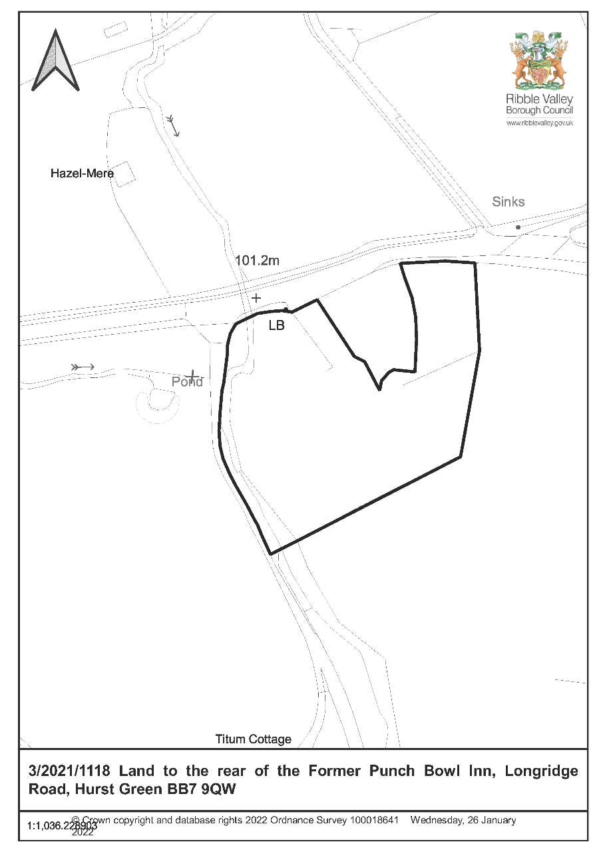

CONSULTEE RESPONSES/ REPRESENTATIONS MADE:

PARISH COUNCIL:

Object because of over-development of the site, highway safety, demolition of the Punch Bowl as a grade two listed building, visual amenity (no screening; obtrusive; design of static caravans) and harm to AONB. Can no longer piggy-back a holiday park on the back of an existing hospitality venue.

LCC HIGHWAYS:

No objection subject to conditions (implementation of access arrangements; visibility splay; surfacing; implementation of parking and turning facilities; preventing site materials on public highway).

LANCASHIRE FIRE AND RESCUE SERVICE:

Recommendations to applicant.

ENVIRONMENT AGENCY:

No objection. Informatives suggested.

LANCASHIRE LOCAL LEAD FLOOD AUTHORITY:

No comment.

UNITED UTILITIES:

Informatives suggested.

ADDITIONAL REPRESENTATIONS:

11 letters of objection have been received which make the following points:

- Demolition of listed building;
- Not in-keeping with a re-built Punch Bowl Inn;
- Highway safety;
- Visual amenity, no longer screened; intrusive;
- Site not accurately marked;
- Overdevelopment;
- Detached from Hurst Green;
- Boundary of AONB and adjoining public footpath – design and density do not conserve
- landscape or reflect local distinctiveness, vernacular style, scale, features and building
- materials;
- Ensure holiday homes are not occupied permanently

1. Site Description and Surrounding Area

  - As Members are aware the application site forms part of the curtilage of the former Punch Bowl Inn (listed Grade II) which was demolished in 2021. Whilst the component materials of the building are retained in situ the demolition of the building has resulted in the loss of an important heritage asset recognised by its listed status. The demolition is subject to separate legal action.

  - The site is within open countryside immediately adjacent the Forest of Bowland Area of Outstanding Natural Beauty.

  - The site is at a nodal point in respect to the public rights of way network. Public footpath FP13 runs north-south following the west site boundary (and coinciding with the tree-lined Bailey Brook). Bridleway BW5 and footpath FP15 (within the AONB) run north-south and end at the Longridge Road near to the site.

  - Trees lining the Bailey Brook are an Ancient Woodland (Ribble Valley Core Strategy DME1).

2. Proposed Development for which consent is sought

2.1 Planning permission is sought for change of use of the Punch Bowl curtilage to a 15 pitch static caravan holiday park. The static caravans are arranged in a semi-circle around the south of the listed building.

2.2 Two static caravan types are proposed – Eight 12.8m length x 5.8m width and seven 12.8m length x 4m width. The agent has confirmed that the static caravans will be raised on average 0.75m off the ground (dependant on site contours) and will measure 2.7m to the eaves and 3.2m to the ridge from decking level (land levels would be secured by condition in the event of a positive recommendation). Walls – timber cladding/’timber effect boarding’; roof – ‘tile effect’; windows and doors – upvc.

3. Relevant Planning History

3/2019/0470- Removal of unsafe roof and replace with new truss and slate roof. Removal of defective render to assess the quality of stonework beneath. If good quality stonework to be cleaned and kept. If not suitable rendered areas to renewed with K render. Refused 24/03/2020.

3/2019/0260- Application for the discharge of condition 3 (details of the Proposed Elevations of the South Elevation and First Floor Plan), 4 (storage area), 5 (revised parking layout), 6 (Heritage Statement), 7 (specifications of proposed windows and doors including elevations cross - sections, glazing type, opening mechanism and surface finish) and 8 (phasing plan) from planning permission 3/2018/0363.

3/2018/0363- Conversion of the former Punch Bowl Inn (Grade II listed building) into 5 Holiday Lets and Café, including demolition and extensions. New pitch holiday lodge park with 15 units within curtilage. Listed Building Consent Granted

3/2018/0362- Conversion of the former Punch Bowl Inn (Grade II listed) into five holiday lets and cafe including demolition and extensions. New pitch static caravan holiday park with 15 units with curtilage. Permitted 11/10/2018.

3/2017/0607- Conversion of the former Punch Bowl Inn (Grade II listed building) into 5 Holiday Lets and Café, including demolition and extensions. New pitch holiday lodge park with 15No units within curtilage. Withdrawn 14/09/2017.

3/2017/0294- Conversion of former Punch Bowl Inn into five holiday lets and cafe including demolition and extensions. Creation of new caravan park with fifteen units. Withdrawn 19/06/2017.

3/2016/0056- Conversion of the former Punch Bowl Inn (Grade II Listed) into 5 no. holiday lets and cafe including demolition and extensions. New pitch static caravan holiday park with 20 units. Refused 26/05/2016.

4. Relevant Policies

Ribble Valley Core Strategy

Key Statement DS1 – Development Strategy
Key Statement DMI2 – Transport Considerations
Key Statement EC1 – Business and Employment Development
Key Statement EN5 – Heritage Assets
Key Statement EC3: Visitor Economy
Policy DME4 – Protecting Heritage Assets
Policy DMB1 – Supporting Business Growth and the Local Economy
Policy DMG1 – General Considerations
Policy DMG2 – Strategic Considerations
Policy DMG3 – Transport and Mobility
Policy DME1 - Protecting Trees and Woodlands
Policy DME2 – Landscape and Townscape Protection
Policy DME3 – Site and Species Protection and Conservation
Policy DME6 – Water Management
Policy DMB5 – Footpaths and Bridleways

National Planning Policy Framework (NPPF)
National Planning Practice Guidance (NPPG)

5. Assessment of Proposed Development

5.1 Impact upon the special architectural and historic interest and setting of the listed building:

5.1.1 Whilst the application is not accompanied by a heritage statement the heritage statement accompanying application 3/2019/0470 identifies:

  - In 1793 a row of three single unit adjoined cottages were built. Early – mid C19 the buildings became the Fenton Arms Inn. Mid-late C19 a tall addition of classical design built (landlord’s house?; 2.6-2.8);
  - The building provides illustrative historic value as a countryside inn (3.12);
  - The building’s rural setting is a key contributor to its aesthetic value (3.20);
  - The westerly approach is more open and the land to the south is more prominent (3.21);

5.1.2 The 1840s and 1890s OS maps show the Punch Bowl to have outbuildings (now demolished) to the west and southwest of the principle building. These maps show that the site has a long-established visual association with the open countryside to the south.

5.1.3 NPPG ‘Historic Environment’ identifies that whilst views of or from an asset will play an important part in the assessment of impacts on setting the contribution that setting makes to the significance of a heritage asset does not depend on there being public rights of way or an ability to otherwise access or experience that setting (paragraph 13). The above significance identifies the proposed development to be prominent, incongruous, conspicuous (public footpath and roadside visual receptors) and discordant in location (immediately around the listed building), scale (much larger footprint than listed building), form (overtly modern) and materials (overtly modern) and harmful to the setting of the listed building.

5.1.4 Section 66 of the Planning (Listed Buildings and Conservation Areas) Act 1990 requires that in considering whether to grant planning permission for development which affects a listed building or its setting, the local planning authority shall have special regard to the desirability of preserving the building or its setting or any features of special architectural or historic interest which it possesses.

5.1.5 NPPF paragraph 199 requires that when considering the impact of a proposed development on the significance of a designated heritage asset, great weight should be given to the asset’s conservation (and the more important the asset, the greater the weight should be). This is irrespective of whether any potential harm amounts to substantial harm, total loss or less than substantial harm to its significance.

5.1.6 NPPF paragraph 199 identifies that any harm to, or loss of, the significance of a designated heritage asset (from its alteration or destruction, or from development within its setting), should require clear and convincing justification. The submitted Planning Supporting Statement does not consider the impact of development to the listed building and no justification is offered in respect to harm to its setting.

5.1.7 Therefore, the proposals are contrary to Ribble Valley Core Strategy Policy DME4. This states that in considering development proposals the council will make a presumption in favour of the conservation and enhancement of heritage assets and their settings. Development proposals on sites within the setting of a listed building which cause harm to the significance of the heritage asset will not be supported.

5.1.8 The proposals are also contrary to Ribble Valley Core Strategy Policy DMG1 states that in determining planning applications, all development must: Design: 1. be of a high standard of building design which considers the 8 Building in Context Principles (from the CABE/English Heritage Building on Context Toolkit). 2. be sympathetic to existing and proposed land uses in terms of its size, intensity and nature as well as scale, massing, style, features and building materials. Environment … 3. all development must protect and enhance heritage assets and their settings.

5.1.9 The harm to the setting of the listed building is substantial. NPPF paragraph 201 identifies of ‘substantial harm’ to designated heritage assets:

Where a proposed development will lead to substantial harm to (or total loss of significance of) a designated heritage asset, local planning authorities should refuse consent, unless it can be demonstrated that the substantial harm or total loss is necessary to achieve substantial public benefits that outweigh that harm or loss, or all of the following apply:
a) the nature of the heritage asset prevents all reasonable uses of the site; and
b) no viable use of the heritage asset itself can be found in the medium term through appropriate marketing that will enable its conservation; and
c) conservation by grant-funding or some form of not for profit, charitable or public ownership is demonstrably not possible; and
d) the harm or loss is outweighed by the benefit of bringing the site back into use.

5.1.10 The supporting information does not set out the substantial public benefit associated with the development nor has any such benefit been identified contrary to the above guidance.

5.1.11 Members will note that both planning permission and listed building consent were previously granted at this site for development which included 15 holiday lodges. As part of the assessment of those applications the harm to the heritage asset was outweighed by the benefit of bringing the Punch Bowl back into use. Such a consideration cannot be attributed to this application as the application does not include the Punch Bowl.

5.2 Impact upon the character of the Forest of Bowland AONB:

5.2.1 The Longridge Road forms the southern boundary of the AONB. The transition from AONB to open countryside is gradual with the historic Punch Bowl Inn and fields to the south contributing to an almost imperceptible change in character. The Forest of Bowland AONB Management Plan (April 2014 - March 2019) identifies “The natural beauty of AONBs is partly due to nature, and is partly the product of many centuries of human modification of ‘natural’ features … The area was designated as a landscape of national significance due to a variety of factors, including… The landscape’s historic and cultural associations … Collectively these historic and cultural elements of the environment serve to enrich the landscape’s scenic quality, meaning and value”. The proposed development will result in a conspicuous and incongruous intrusion into this landscape.

5.2.2 NPPG Natural Environment identifies that the duty to have regard to their purposes for which the AONB was designated is relevant in considering development proposals that are situated outside the AONB boundary, but which might have an impact on its setting or protection.

5.2.3 The proposed development is prominent, incongruous, conspicuous (public footpath and roadside visual receptors) and discordant in location and scale (immediately around the historic building; much larger footprint than historic building; dominates historic building setting), form (overtly modern) and materials (overtly modern).

5.2.4 The proposals are contrary to Ribble Valley Core Strategy Key Statement EN2 which identifies that “the landscape and character of those areas that contribute to the setting and character of the Forest of Bowland Areas of Outstanding Natural Beauty will be protected and conserved and wherever possible enhanced. As a principle the Council will expect development to be in keeping with the character of the landscape, reflecting local distinctiveness, vernacular style, scale, style, features and building materials”.

5.2.5 Ribble Valley Core Strategy Policy DMG2 identifies “in protecting the designated Area of Outstanding Natural Beauty the council will have regard to the economic and social wellbeing of the area. However, the most important consideration in the assessment of any development proposals will be the protection, conservation and enhancement of the landscape and character of the area avoiding where possible habitat fragmentation. Where possible new development should be accommodated through the re-use of existing buildings, which in most cases is more appropriate than new build. Development will be required to be in keeping with the character of the landscape and acknowledge the special qualities of the AONB by virtue of its size, design, use of material, landscaping and siting. The AONB Management Plan should be considered and will be used by the council in determining planning applications”. It is not considered that the introduction of 15 modern holiday lodges on this site will protect or enhance either the landscape or the character of the area contrary to Policy DMG2.

5.2.6 Ribble Valley Core Strategy Policy DMG1 also requires that all development to be sympathetic to existing and proposed land uses in terms of its size, intensity and nature as well as scale, massing, style, features and building materials. The introduction of 15 holiday lodges within this landscape area will create a prominent and conspicuous development which does not assimilate into the area contrary to policy DMG1.

5.3 Employment and Economy:

5.3.1 Ribble Valley Core Strategy Policy DMB1 identifies that proposals that are intended to support business growth and the local economy will be supported in principle.

5.3.2 Ribble Valley Core Strategy DMB3 identifies that planning permission will be granted for development proposals that extend the range of tourism and visitor facilities in the Borough. However, this is subject to criteria being met including: the proposal must not conflict with other policies of this plan, the proposal must be physically well related to an existing main settlement or village or to an existing group of buildings and the development should not undermine the character, quality or visual amenities of the plan area by virtue of its scale, siting, materials or design. Furthermore, in the Forest of Bowland Area of Outstanding Natural Beauty the following criteria will also apply:

1. the proposal should display a high standard of design appropriate to the area.
2. the site should not introduce built development into an area largely devoid of
structures (other than those directly related to agriculture or forestry uses).

5.3.4 For the reasons set out within the preceding section the proposals do not meet the criteria in the Core Strategy.

5.4 Highway Safety and Accessibility:

5.4.1 The comments of LCC Highways identify that the development would have an acceptable impact on highway safety and accessibility subject to conditions.

5.5 Ecology:

5.5.1 The submitted Ecological Assessment makes recommendations in respect to habitats (buffer area; pollution prevention plan; new planting), Himalayan Balsam, Breeding Birds and Otters.

5.5.2 The submitted Arboricultural Implications Assessment makes recommendations to minimise any negative factors of development affecting trees.

6. Observations/Consideration of Matters Raised/Conclusion

6.1 Therefore, in giving considerable importance and weight to the duty at section 66 of the Planning (Listed Buildings and Conservation Areas) Act 1990 and in consideration to NPPF and Key Statement EN5 and EN2 and Policy DME4, DMG2 and DMG1 of the Ribble Valley Core Strategy it is recommended that planning permission be refused.

RECOMMENDATION: That the application be REFUSED for the following reasons:

1. The proposed development is harmful to the setting of the listed building because it is unduly prominent, incongruous, conspicuous, discordant and dominant in location, scale, form and materials. This is contrary to Key Statement EN5 and Policy DME4 and DMG1 of the Ribble Valley Core Strategy.

2. The proposed development is harmful to the character of the open countryside in the immediate setting of the Forest of Bowland AONB because it is unduly prominent, incongruous, conspicuous and discordant in the landscape. This is contrary to Key Statement EN2 and Policy DMG2 and DMG1 of the Ribble Valley Core Strategy.

BACKGROUND PAPERS

https://www.ribblevalley.gov.uk/site/scripts/planx_details.php?appNumber=3%2F2021%2F1118

