APPLICATION REF: 3/2021/1134

GRID REF: SD 360397 438052

DEVELOPMENT DESCRIPTION:

DEVELOPMENT OF 47 NO. HOMES INCLUDING AFFORDABLE HOUSING AND HOUSING FOR THE ELDERLY AT LAND EAST OF CHIPPING LANE, LONGRIDGE.

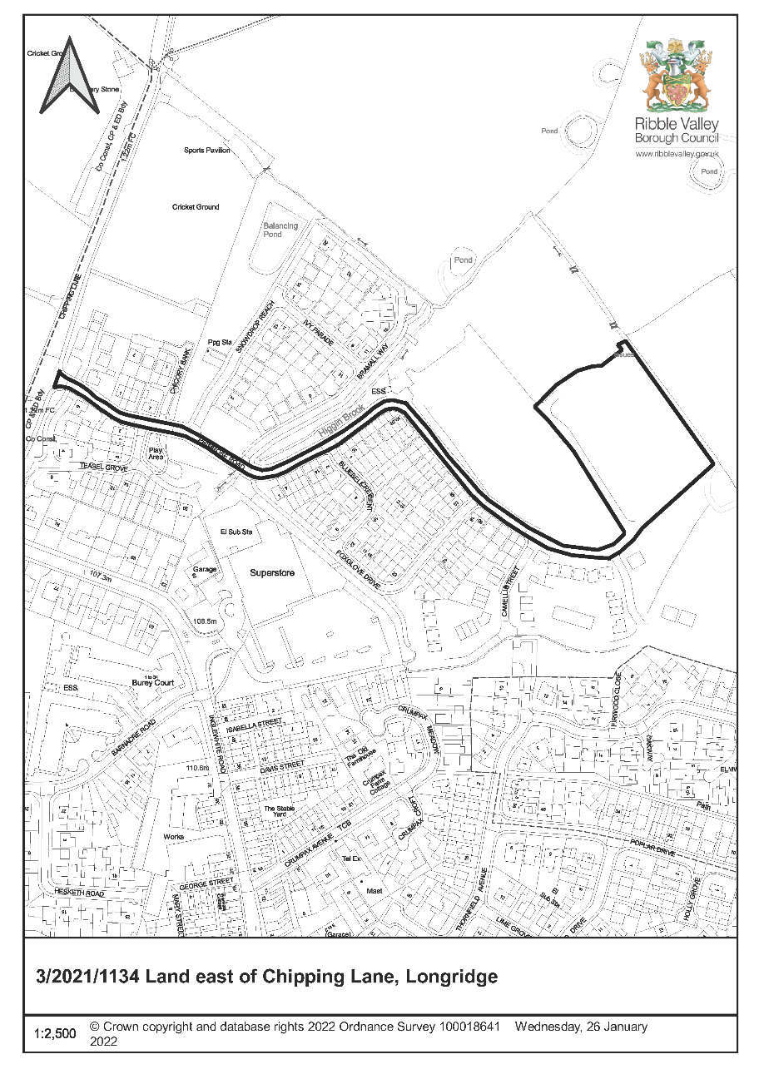
CONSULTEE RESPONSES/ REPRESENTATIONS MADE:

PARISH COUNCIL:

(Longridge) Provision for education, older resident housing and affordable housing?

(Thornley with Wheatley) 193 dwellings approved; 198 proposed – concerned at impact to local services and highways.

LCC HIGHWAYS:

No objection subject to conditions.

Off-site highway works conditioned at outline - completed.

Layout – acceptable.

Car parking level – acceptable subject to provision of a secure, covered cycle store to all dwellings without garage and all dwellings an electric vehicle charging point.

Dwellings on private driveway – hardstanding for waste receptacles on collection days required.

LCC SCHOOLS:

5 dwelling uplift - no additional requirement. The content of the existing s106 (outline 3/2014/0764) relating to education should remain in any linked agreement or Deed of Variation that brings in this new application.

LANCASHIRE FIRE AND RESCUE SERVICE:
Advice for access for fire appliances and water supplies (firefighting).
EAST LANCASHIRE NHS TRUST:
Population increase of c.455. The Trust will be able to obtain funding to meet the needs of the population (but not be in place for approximately three years). Therefore, request a contribution for this development in the sum of £337,889.00 under the terms of the s.106 and prior to first occupation.

ENVIRONMENT AGENCY:

Consulted, no representations received.

LANCASHIRE LOCAL LEAD FLOOD AUTHORITY:

Objects in the absence of an acceptable drainage strategy to assess the principle of surface water sustainable drainage.

UNITED UTILITIES:

Acceptable in principle and subject to conditions (implementation of drainage scheme; construction risk assessment method statement – water main protection).

ADDITIONAL REPRESENTATIONS:

None received.

1. Site Description and Surrounding Area

  - The application site comprises agricultural land located towards the western extents of the settlement of Longridge and is currently a committed housing site (DS1 allocation). Earlier phases of development to the west and south are currently under construction. Agricultural land bounds the site to the north and east.

2. Proposed Development for which consent is sought

  - The full planning application relates to part of outline application 3/2014/0754 (granted consent 8 September 2014). The reserved matters application 3/2018/0975 (granted 27 February 2019) has now expired. The current application proposes an increase in the number of dwellings for this area from 42 (3/2018/0975) to 47.

  - The application seeks consent for dwellings with the following housing mix:

Affordable Housing (21)

- 13 x 2 bedroom dwellings (Denford)
- 7 x 3 bedroom dwellings (Brandon)
- 1 x 2 bedroom dwelling (Over 55) (Belmont)

Open market (26)

- 1 x 2 bedroom dwelling (Over 55) (Belmont)
- 20 x 3 bedroom dwellings (Ellerton/Moresby/Kingsville /Denby)
- 5 x 4 bedroom dwellings (Windermere/Alderney)

  - The submitted layout proposes that this phase of development will interface with earlier phases through the continuation of a previously approved internal estate road and associated footway/cycleway. The proposal further benefits from the inclusion of a small network of pedestrian/cycle links within the development that also provide connectivity between areas of usable open space.

  - The majority of the development will be two-storeys in height (including 3 and 4 dwelling terrace blocks) with two semi-detached and one three dwelling block of 2.5 storeys in height.

  - Indicative tree planting is shown.

3. Relevant Planning History

3/2021/0010 - Variation of Condition of planning application 3/2018/0975. Condition 1 - Proposed plot substitutions and house types. Approved 10/6/2021.

3/2021/0009 - Discharge of Conditions of planning application 3/2018/0975. Condition 5 - Emergency Link Road. Approved 15/3/2021.

3/2019/0870 - Discharge of conditions 8 (drainage strategy) and 11 (construction management plan) of planning permission 3/2017/0232. Approved 24/6/2021.

3/2019/0601 - Discharge of conditions 2 (materials) and 4 (public open space) from planning permission 3/2018/0975. Approved 10/7/2019.

3/2018/0975 - Approval of reserved matters (layout, scale, appearance and landscaping) for phases 2 and 3 for the erection of 193 dwellings, pursuant to outline planning permission 3/2014/0764 (Approved with conditions)

3/2018/0404 - Application for the detailed approval of appearance, landscaping, layout and scale for the erection of 124 dwellings (Phase 1) pursuant to outline consent 3/2014/0764 as amended by 3/2017/0232. (Approved with conditions)

3/2017/0232 - Variation of condition 8 (drainage strategy) of planning permission 3/2014/0764. (Approved)

3/2016/0193 - Application for the detailed approval of appearance, landscaping , layout and scale for the erection of 118 dwellings (Phase 1) pursuant to outline consent 3/2014/0764 for the development of up to 363 homes including affordable housing and housing for the elderly, relocation of Longridge Cricket Club to provide a new cricket ground, pavilion, car park and associated facilities, new primary school, vehicular and pedestrian access landscaping and public open space, with all matters reserved except for access. (Approved with conditions)

3/2014/0764 - Development of up to 363 homes including affordable housing and housing for the elderly, relocation of Longridge Cricket Club to provide a new cricket ground, pavilion, car park and associated facilities, new primary school, vehicular and pedestrian access landscaping and public open space, with all matters reserved except for access. (Approved with conditions)

3/2014/0438 - Proposed development of 106 residential units, including affordable housing, new vehicular and pedestrian accesses, landscaping, public open space and ecological enhancement - Refused (appeal received - subsequently withdrawn).

4. Relevant Policies

Ribble Valley Core Strategy

Key Statement DS1 – Development Strategy
Key Statement DS2 – Presumption in Favour of Sustainable Development
Key Statement EN3 – Sustainable Development and Climate Change
Key Statement DMI2 – Transport Considerations

Policy DMG1 – General Considerations
Policy DMG2 – Strategic Considerations
Policy DMG3 – Transport and Mobility
Policy DME3 – Site and Species Protection and Conservation
Policy DME6 – Water Management

National Planning Policy Framework (NPPF)
National Planning Practice Guidance (NPPG)
Technical Guidance to National Planning Policy Framework

5. Assessment of Proposed Development

5.1 Principle of Development:

5.1.1 The principle of the development of the site for residential purposes has been established as acceptable through the granting of outline consent 3/2014/0764.

5.2 Affordable Housing:

5.2.1 There are ongoing considerations with respect to the affordable housing scheme offer (the amount of discount being offered is 20% as opposed to the 30% standard request; the affordable rent units also need to be limited to LHA rate). Unless there is specific justification to do otherwise (which may be reported to Committee for decision), any approval would require these requirements to be met.

5.2.2 Therefore, it is recommended that if Members are minded to approve the application that Committee delegate and defer their approval to the Director of Economic Development and Planning subject to resolution of all matters concerning the affordable housing scheme offer.

5.3 Impact upon Residential Amenity:

5.3.1 The proposals have an acceptable impact upon residential amenity.

5.4 Visual Amenity/External Appearance:

5.4.1 The proposal remains in broad accordance with the overall framework/masterplan established as being acceptable at the outline stage.

5.4.2 It is proposed that the dwellings will be faced in a mixture of stone, render and brickwork with the materials pallet varying to define character areas, street hierarchy and parcels of development. The submitted details propose that the development will employ similar house-types to those which have already been approved as part of earlier phases of the development. As, such, and taking account of the overall arrangement of the proposal, it is not considered that the development will be of detriment to the character or visual amenities of the immediate area or wider context.

5.5 Highway Safety and Accessibility:

5.5.1 The comments of LCC Highways identify an acceptable development subject to conditions.

5.6 Landscape/Ecology:

5.6.1 A revised scheme (24/2/2022) for bat and bird box provision has been received. This is acceptable.

5.6.2 The proposals have an acceptable impact upon trees and hedgerows.

5.7 Flood Risk and Drainage:

5.7.1 Paragraph 169 of the NPPF requires major developments to incorporate sustainable drainage systems that:

a) take account of advice from the lead local flood authority;
b) have appropriate proposed minimum operational standards;
c) have maintenance arrangements in place to ensure an acceptable standard of operation for the lifetime of the development; and
d) where possible, provide multifunctional benefits.

5.7.2 The lack of adequate information in relation to surface water drainage means the LLFA cannot assess whether the development proposal meets the requirements of Paragraph 169.

5.7.3 Therefore, it is recommended that if Members are minded to approve the application that Committee delegate and defer their approval to the Director of Economic Development and Planning subject to resolution of all objections from the Lancashire Local Lead Flood Authority.

5.8 Other Matters:

5.8.1 The applicant has drafted a Deed of Variation to tie in the existing S106 obligations to 3/2021/1134. It is recommended that if Members are minded to approve the application that Committee delegate and defer their approval to the Director of Economic Development and Planning subject to completion of this legal agreement.

5.8.2 The comments of the East Lancashire NHS Trust have been considered. The Trust is a public sector body which is funded through central government funds, which are administered through NHS East Lancashire Clinical Commissioning Group (“CCG”). The Trust is obliged to treat all patients who attend, however, they are only funded for those persons who are within catchment at the point at which the services are commissioned by the CCG. This does not account for any planned or unplanned development which will facilitate an increase in population. In due course (typically three years) the funding model is updated to reflect any increase in population which has arisen. As such, there is always a three year delay in funding being provided for new development from the date on which it is occupied. The Trust is paid for activity in line with the National Tariff Payment by Results System (“PbR”). Failure to deliver on-time interventions puts the Trust at risk of financial penalties being imposed.

The East Lancashire NHS Trust will receive funding (albeit after approximately 3 years) to meet the needs of the population resulting from the proposed development. The initial shortfall in payment is a product of the funding model and requesting a S106 contribution would not meet the CIL tests.

6. Observations/Consideration of Matters Raised/Conclusion

6.1 Given the separation distances between existing and proposed dwellings and taking account of the overall proposed layout it is not considered that the proposal would result in any significant detrimental impact upon existing/future residential amenities by virtue of direct over-looking.

6.2 Taking account of the overall scale and layout of the proposed development it is not considered that the proposal would be of detriment to the visual amenities and character of the area.

6.3 It is further considered that the site layout and spatial arrangements resultant from the proposed development are sufficient to ensure that the proposal would not be of detriment to existing/future residential amenities by virtue of a loss of light, overbearing or over dominant impact

6.4 It is for the above reasons and having regard to all material considerations and material matters raised that the application is recommended for approval.

RECOMMENDATION: That Committee DEFER and DELEGATE their approval to the Director of Economic Development and Planning subject to resolution of all objections from the Lancashire Local Lead Flood Authority, resolution of all matters concerning the affordable housing scheme offer and completion of a legal agreement to tie in the existing S106 obligations to 3/2021/1134 and the following conditions:

- The development hereby permitted shall be commenced before the expiration of three years from the date of this permission.

REASON: Required to be imposed pursuant to Section 91 of the Town and Country Planning Act 1990 as amended by Section 51 of the Planning and Compulsory Purchase Act 2004.

2. Unless explicitly required by condition within this consent, the development hereby permitted shall be carried out in complete accordance with the proposals as detailed on drawings:

Location Plan
Affordable Housing Layout 459-AF06 Rev A
Alderney (Det) MS07
Alderney (Det) MS08
Belmont End HBC2 1STE/02
Boundary Layout 459-BT06 Rev A
Brandon (End) BBRN 00CE
Brandon (Mid) BBRN 5BRI
Brandon (Mid) BBRN 00CI
Denby (Det-Gable) BDBY 56CD MS03
Denby (Det-Gable) BDBY 5BRD MS00
Denford Classic (End) BDNF 00CE
Denford Classic (Mid) BDNF 00CI
Denford (End) BDNF 5BRE
Ellerton Brick Render (Mid) BLLE 5BRI MS04
Ellerton (End - Gable) BLLE 5BRE MS04
Ellerton Stone (End - Gable) BLLE 5SRE MS04
Kingsville (End) BKIS 5BRE MS00
Kingsville (End) BKIS 00CE
Kingsville (Mid) BKIS 5BRI MS00
Moresby Classic (Det) BMMS 00CD
Moresby (Det) BMMS 5BRD MS08
Moresby (End) BMMS 5BRE MS07
Moresby (End) BMMS 5SRE MS08
Planning Layout 459-PL06 Rev A (Notwithstanding ‘red-line’)
Planting Plan

- The internal estate roads shall be constructed in accordance with LCC specification for estate roads and to at least base course level prior to first occupation of any dwelling,

REASON: In the interests of highway safety.

- Prior to the occupation of each dwelling the driveways and parking areas shall be constructed in a bound porous material and made available for use and maintained for that purpose for as long as the development is occupied.

REASON: In the interests of highway safety.

5. Prior to first occupation each dwelling shall have a secure cycle store at a ratio of 1 cycle space per bedroom details of which shall have been provided to and approved in writing by the local planning authority.

The approved cycle stores shall be retained in perpetuity.

REASON: In the interests of supporting sustainable travel.

6. Prior to the first occupation each dwelling shall have an electric vehicle charging point. Charge points must have a minimum power rating output of 7kW, be fitted with a universal socket that can charge all types of electric vehicle currently.

REASON: In the interests of supporting sustainable travel.

7. This permission shall relate to the proposed locations and specifications for bird and bat boxes submitted 24 February 2022 (Drawing 11319/P08a, February 2022; notwithstanding, the Red Line Boundary shown on this plan). The bird and bat boxes shall be installed before first occupation of each dwelling.

REASON: For the avoidance of doubt as the application was subject to revisions and in the interests of biodiversity and to enhance habitat opportunities for species of conservation concern/protected species.

8. Prior to the occupation of each dwelling and notwithstanding the proposed Refuse Strategy Layout 459-RS06 Rev A, revised details including plans for those dwellings located on the block paved private driveway, shall be submitted to and approved in writing by the local planning authority which show (i) areas of hardstanding for receptacles to be left on refuse collection days and (ii) details of the management arrangements to ensure receptacle collection points are left free of receptacles on non-collection days.

REASON: To avoid receptacles being left on the footways.

9. Notwithstanding the submitted details, precise specifications or samples of all external surfaces, including surfacing materials and their extents, of the development hereby permitted shall have been submitted to and approved in writing by the Local Planning Authority before their use in the proposed development. The approved materials shall be implemented within the development in strict accordance with the approved details.

REASON: In order that the Local Planning Authority may ensure that the materials to be used are appropriate to the locality.

10. The garage(s) hereby approved shall be kept available for the parking of vehicles ancillary to the enjoyment of the household(s) and shall not be used for any use that would preclude the ability for their use for the parking of private motor vehicles, whether or not permitted by the provisions of the Town and Country Planning (General Permitted Development) Order 2015 or any order amending or revoking and re-enacting that order.

REASON: To ensure to ensure that adequate parking provision is retained on site that limits the visual impact of the parked motor-vehicle upon the street scene and limits parking upon the highway.

11. Notwithstanding the submitted details, precise specifications including drawings of proposed detached garages shall have been submitted to and approved by the Local Planning Authority before their use in the proposed development. The approved detached garages shall be implemented within the development in strict accordance with the approved details.

REASON: In the interests of highway safety.

12. The drainage for the development hereby approved, shall be carried out in accordance with principles set out in the submitted Foul & Surface Water Drainage Design Drawing 459/ED/105, Rev L - Dated 25/10/2021 which was prepared by BARRATT HOMES. No surface water will be permitted to drain directly or indirectly into the public sewer. The development shall be completed in accordance with the approved details.

REASON: To ensure a satisfactory form of development and to prevent an undue increase in surface water run-off and to reduce the risk of flooding.

13. No development shall commence (including any earthworks) until details of the means of ensuring the water main/s that is/are laid within the site boundary are protected from damage as a result of the development have been submitted to and approved by the Local Planning Authority in writing. The details shall include a survey of the exact location of the water main/s and outline the potential impacts on the water main/s from construction activities and the impacts post completion of the development and identify mitigation measures to protect and prevent any damage to the water mains both during construction and post completion of the development. The details shall include a pre and post construction condition survey. Any mitigation measures shall be implemented in full in accordance with the approved details.

REASON: In the interest of public health and to ensure protection of the public water supply.

14. Any conditions required by the LLFA.

15. Notwithstanding the submitted information and before the commencement of development, full details of both hard and soft landscaping works shall have been submitted to and approved by the LPA in writing. For the avoidance of doubt the submitted details shall include:

i) planting details (including species, numbers, planting distances/densities and plant sizes);
ii) surfacing including full details of the colour, form and texture of all hard landscaping (ground surfacing materials);
iii) street furniture;
iv) boundary treatments;
v) a programme for the implementation of the landscaping works including all boundary treatments.

The development shall be implemented in accordance with the approved details.

REASON: In order to ensure a development which is sympathetic to the character and appearance of the area.

16. Prior to the commencement of the development details of the proposed finished floor levels, ridge and eaves heights of the buildings hereby approved shall have been submitted to and approved in writing by the local planning authority. The submitted levels details shall be measured against a fixed datum and shall show the existing and finished ground levels, eaves and ridge heights of surrounding property. The development shall be carried out as approved.

REASON: In order to protect residential amenity and ensure a development which is sympathetic to the character and appearance of the area.

INFORMATIVES

The Lancashire Fire and Rescue Service has provided advice for access for fire appliances and water supplies (firefighting). Recommendations are made to make the applicant aware of conditions which will have to be satisfied on a subsequent Building Regulation application.

United Utilities advise that it is the applicant's responsibility to investigate the possibility of any United Utilities’ assets potentially impacted by their proposals and to demonstrate the exact relationship between any United Utilities' assets and the proposed development.

BACKGROUND PAPERS

https://www.ribblevalley.gov.uk/site/scripts/planx_details.php?appNumber=3%2F2021%2F1134

