**APPLICATION REF: 3/2021/1153**

GRID REF: SD 376632 444055

**DEVELOPMENT DESCRIPTION:**

PROPOSED DWELLING WITH BASEMENT ACCOMMODATION ON AN IN-FILL SITE ADJACENT TO NO 9 OLD ROAD, CHATBURN, BB7 4AB

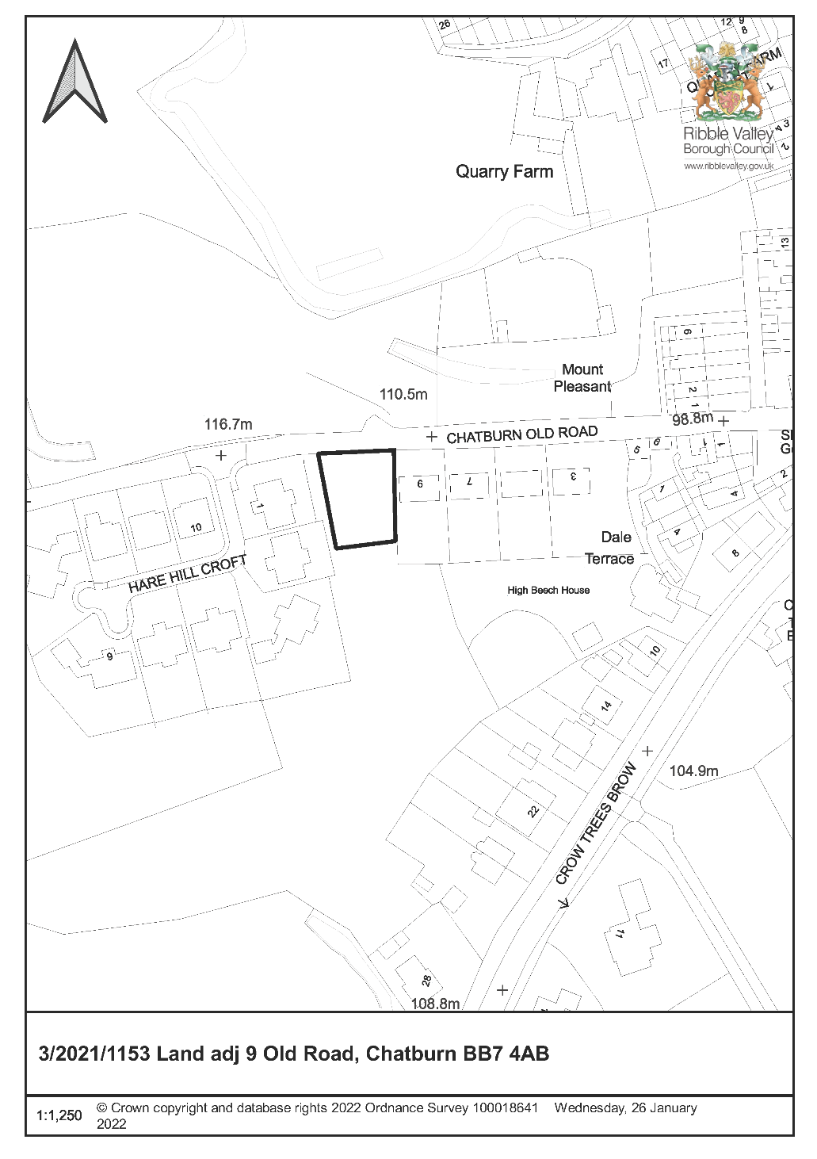

**CONSULTEE RESPONSES/ REPRESENTATIONS MADE:**

**PARISH COUNCIL:**

Chatburn Parish Council has viewed the above planning application and has the following comment to make.

* The proposed development will have serious detrimental implications to No. 9 Old

Road due to the loss of light in the main living quarters.

* The proposed development will also be an intrusion of privacy to No 9 Old Road
* Chatburn has already had the mandatory quota of housing developments.

**ENVIRONMENT DIRECTORATE (COUNTY SURVEYOR):**

The Local Highway Authority does not raise an objection regarding the proposed development and are of the opinion that the proposed development will not have a significant impact on highway safety, capacity or amenity in the immediate vicinity of the site subject to technical conditions being stated on any approval.

**UNITED UTILITIES:**

The site should be drained on separate systems. Technical conditions are recommended.

**ADDITIONAL REPRESENTATIONS:**

A total of 11 objection letters have been received the concerns raised are summarised as:

* The development is a sizeable property and would reduce light and sun into windows and gardens of neighbouring properties.
* Concerns regarding impact on privacy.
* Inconvenience to Hare Hill Croft residents.
* Noise from development.
* Impact of cumulative development on traffic at local road junctions.
* This part of the site is subject to an application to regularise the illegal dumping of material.
* The site is outside the village boundary.
* No demonstrable need to larger homes in Chatburn.
* Road surface of Chatburn Old Road in poor condition with no footway.
* Highway safety concerns.
* Noise from construction vehicles.
* Housing requirement for Chatburn has been met.

1. **Site Description and Surrounding Area**

1.1 The application site lies within the Chatburn settlement boundary as denoted on the Proposals Map. The site is a rectangular plot of land that fronts onto Chatburn Old Road. The site is currently a small, grassed area. To the east of the site is no.9 Chatburn Old Road, a detached split-level dwelling and to the north is a previously consented, partially completed, residential scheme of 10no. dwellings. At present site forms a gap between the properties.

2. **Proposed Development for which consent is sought**

2.1 Planning consent is sought for the erection of one new detached dwelling at land adjacent to 9 Chatburn Old Road, Chatburn. The proposed dwelling is a five-bed detached property over three floors. The property would be faced with natural stone with stone surrounds and ‘k’ rend and aluminium windows and doors. The roof would be finished in natural blue/grey slate. A garage would also be provided at lower ground floor.

2.2 Planning applications 3/2019/0498 and 3/2020/0145 sought approval for a single dwelling at the application site. Negotiations took place to overcome issues due to concerns relating to privacy, overlooking and appearance. However, the applications were both refused under delegated powers for the following reason:

*The proposed development would result in the loss of unimproved calcareous grassland which is identified as a Habitat of Principal Importance for conservation in England (section 41 Natural Environment and Rural Communities (NERC) Act 2006) without adequate compensation and would therefore have a negative effect on the biodiversity value of the area contrary to Core Strategy Key Statement EN4 and Policy DME3 and paragraphs 170 (a) and (d) and 175 (a) of the National Planning Policy Framework.*

2.3 The applicant has again sought to overcome the reason for refusal by reducing the site area to therefore exclude a small parcel of protected grassland that was identified in past ecology reports for the site.

3. **Relevant Planning History**

3/2020/0145 - Proposed 2.5 storey dwelling with basement garage. Refused.

3/2019/0498 - Proposed 2.5 storey dwelling with basement garage. Refused.

3/2016/0748 - Variation of Condition 02 (substitution of house types/designs for plots 1, 2, 3, 4, 5, 7, 8, 9 & 10, including repositioning of plots 3, 7, 9 & 10, and alteration to internal access road) and Removal of Condition 10 (un-associated condition) of planning permission.

3/2014/0618 - Erection of 10 dwellings. Approved with Conditions.

3/2011/0025 - Outline planning application for residential development (ten dwellings). Refused.

APP/Q2371/C/19/324/3448 - Appeal against enforcement notice issued by Lancashire County Council. For alleged tipping of waste soils – Appeal allowed and enforcement notice quashed.

APP/Q2371/W/20/3264309 – Appeal against refusal of planning permission by Lancashire County Council for importation of soils – Appeal allowed and planning permission granted subject to conditions.

4. **Relevant Policies**

Key Statement DS1 – Development Strategy

Key Statement DS2 – Sustainable Development

Key Statement H1 – Housing Provision

Policy DMG1 – General Considerations

Policy DMG2 – Strategic Considerations

Policy DMG3 – Transport and Mobility

Policy DME1 – Protecting Trees and Woodlands

National Planning Policy Framework (NPPF)

5. **Assessment of Proposed Development**

5.1 Principle of Development:

5.1.1 The Development Strategy put forward in Key Statement DS1 seeks to direct the main focus of new house building to the Strategic Site, the principal settlements of Clitheroe, Longridge and Whalley. Development is also focused towards Tier 1 villages which are considered the more sustainable of the 32 defined settlements. Chatburn is identified as a Tier 1 Village and as such, the provision of one dwelling within the settlement of Chatburn is considered acceptable in principle.

5.1.2 Policy DMG2 requires development proposals in the principal settlement and Tier 1 villages should consolidate, expand or round-off development so that it is closely related to the main built up area, ensuring this is appropriate to the scale of, and in keeping with, the existing settlement. The application site is an infill plot with residential development on each side and is therefore considered to comply with Policy DMG2.

5.2 Impact upon Residential Amenity:

5.2.1 The noted above, previously refused scheme for the erection of a dwelling at the site was the subject of amendments during the application process such that it was considered that there would be no adverse impact of the residential amenity of neighbours. This application is almost identical to that previously refused aside from the marginal reduction in site area to the south and reduction in height of the retaining wall and minor elevational changes.

5.2.2 The west-facing side elevation of 9 Old Road would face the application site. There would be a separation distance of 6 metres provided between the proposed dwelling and 9 Old Road. There is a ground floor window on the gable of 9 Old Road serving a living room however this is a secondary opening and, as such, sufficient outlook and daylight would be provided to the room in question from the primary window located on the principal elevation. Although it is noted that light and outlook from the side window would be reduced as a result of the development proposals any impact would not be so severe as to warrant refusal of the planning application.

5.2.3 Concern has also been raised in relation to overshadowing and overlooking of the garden of no.9. It is not considered that the proposed development would result in overshadowing of the rear garden of this neighbouring property given that it is south facing. Further, whilst there may be opportunity for some overlooking to arise from the rear patio area of the proposed dwelling into the garden of no.9 this would only be possible from very limited points and would not be sufficiently elevated to result in significant overlooking issues.

5.2.4 To the west of the application site are the new properties that have been constructed as part of approved residential development comprising 10 dwellings known as Hare Hill Croft. The rear elevations of 1-2 Hare Hill Croft face the application site from an elevated position. There are numerous first floor habitable room windows facing the proposed rear private amenity space of the dwellinghouse for which consent is sought. This was raised as a concern in a pre-application enquiry response by the Council in March 2019.

5.2.5 The rear first floor windows of 1 Hare Hill Croft would be approximately 12 metres from the boundary with the proposed development and would be such that any views from the windows of 1 Hare Hill Croft would not result in privacy issues for future occupants of the proposed dwelling. The rear ground floor windows of 1 Hare Hill Croft would be around 12 metres from the gable elevation of the proposed dwelling. Taking into account the considerable level change which results in the proposed dwelling being 3 metres lower than the closest dwellings at Hare Hill Croft, it is not considered that the relationship between the proposed development and 1 Hare Hill Croft would impact unduly on the outlook of the occupants of 1 Hare Hill Croft.

5.2.6 The rear elevation of 2 Hare Hill Croft would be marginally closer to the shared boundary with the development site at a distance of 8 metres at ground floor and 10.5 metres at first floor. This relationship would have the potential to result in direct overlooking of the rear garden of the proposed dwelling if sufficient distances were not maintained. Generally a distance of 10-10.5 metres between first floor windows and a shared boundary fence is considered acceptable to reduce any overlooking into neighbouring gardens to an acceptable level. In this case the garden of the application site is approximately 3 metres lower than the garden level of 2 Hare Hill Croft and there is a greater opportunity for overlooking or perceived overlooking to occur. The applicant has sought to overcome this by erecting a retaining wall with hit and miss timber fencing above for the length of the common boundary with 1-2 Hare Hill Croft. It is considered that this effectively screens the closest part of the garden of the proposed development from unacceptable direct overlooking.

5.2.7 Screening of direct views from the first-floor bedroom windows of 2 Hare Hill Croft into the rear garden of the proposed dwelling requires a retaining wall and fencing of considerable height. On the 2 Hare Hill Croft side, the hit and miss fencing would be 1.8 metres high. On the side facing the application site, the highest part of the fencing would be a maximum of around 5 metres above the patio level and sympathetic boundary treatment has been proposed in the form of a terraced arrangement so as to reduce any overbearing impact or sense of enclosure that would have arisen from a single high fence.

5.3 Visual Amenity / Landscape:

5.3.1 Policy DMG1 places particular emphasis on the visual appearance of development proposals including its relationship with surroundings. Development must be sympathetic to existing land uses. The proposed development would continue the stepped arrangement of dwellings along Chatburn Old Road as the land rises from east to west. The dwelling, whilst being larger than the existing four dwellings on Old Road (nos 3-9), would not be out-of-scale with the surrounding buildings and the proposed materials would match those used in the construction of the housing development to the west. It is not considered that the proposed development would result in any undue visual harm to the street scene.

5.4 Highway Safety and Accessibility:

5.4.1 The County Surveyor does not raise any objections on highway safety grounds and suggests several technical conditions with regards to a construction management plan, provision of the access parking, turning and visibility splays. It should be noted that LCC highways have raised no objections to either of the previous applications however they now consider that although vehicle speeds are slow it would be beneficial to provide a turning head within the site so that vehicles can leave the site in a forward gear.

5.4.2 In response to this the agent has stated that they believe the scheme is currently setup to provide a suitable area for turning/manoeuvring within the site. The provision of an integral garage, which is sized so it can accommodate 2 vehicles, means the available forecourt/drive can be kept clearer from obstruction. The forecourt itself is generous with the property being set back from the highway – the total area is currently around 92sq.m with maximum distances of 11m (depth) by 9m (width) available. They consider that this area is more than adequate to accommodate turning within the site and would allow cars to enter and exit in a forward gear, if necessary, during general day-to-day use.

5.5 Ecology / Trees:

5.5.1 The site has been previously identified as containing semi-improved and unimproved calcareous grassland which is identified as a Habitat of Principal Importance for conservation in England (section 41 Natural Environment and Rural Communities (NERC) Act 2006).

5.5.2 It is understood that the calcareous grass in the area became compromised upon the development of the neighbouring Hare Hill Croft site. LCC raised an initial enforcement notice in relation to the works (i.e. tipping of waste soils) and a retrospective application and subsequent appeal were determined. The Inspectorate considered many issues, of which one was the calcareous grass. Ultimately, it was considered that providing a larger area of compensatory calcareous grassland was a reasonable mitigation measure and would not be of detriment to the area – causing no harm to biodiversity and not conflicting with local policies so both appeals in relation to this matter were allowed.

5.5.3 It is also worth noting that the compromised calcareous grass, as detailed in ERAP Ltd’s previous report (accompanying app.3/2020/0145), is not within the current application boundary.

6. **Observations/Consideration of Matters Raised/Conclusion**

6.1 Taking account of the above matters and all material considerations it is considered that the proposal is in accordance with the requirements of the adopted development plan. Several objections have been received and the material planning considerations are discussed in the appraisal above. The applicant has sought to improve the visibility at the junction through the submission of revised plans and conditions are imposed to ensure that a Construction Management Plan is in place and that parking turning and visibility are acceptable. The proposal is on an infill plot within a settlement boundary and is considered acceptable in terms of its design and impact on surrounding properties.

6.2 The preceding two applications were refused due to the resultant loss of unimproved calcareous grassland which is identified as a Habitat of Principal Importance for conservation in England (section 41 Natural Environment and Rural Communities (NERC) Act 2006). The applicant has sought to overcome the reason for refusal by reducing the site area, moving the southern boundary of the site further north on the understanding that it therefore excludes a small parcel of protected grassland that was identified in the May 2019 Ecology Appraisal. Further the appeal decision which has been made in the interim between the 2020 refusal and this submission addressed the issue of the calcareous grass and mitigation for the previous losses has been provided outside the site. In terms of all the other material planning considerations the proposal was previously considered acceptable.

6.3 The proposed development would be acceptable in principle and would accord with Key Statement DS1 and Policy DMG2 of the Core Strategy. It would not result in any undue visual impact, nor would it unduly harm the residential amenity of existing or future occupants. The situation regarding the loss of unimproved calcareous grassland is considered to have been resolved.

RECOMMENDATION: That the application be APPROVED subject to the following conditions:

1. The development hereby permitted shall be commenced before the expiration of three years from the date of this permission.

REASON: Required to be imposed pursuant to Section 51 of the Planning and Compulsory Purchasing Act 2004.

1. Unless explicitly required by condition within this consent, the development hereby permitted shall be carried out in complete accordance with the proposals as detailed on drawings:

1909_EX-01

1909_06 Rev E

1909_03 Rev C

1909_02 Rev H

1909_04 Rev E

1909_05 Rev E

REASON: For the avoidance of doubt and to clarify which plans are relevant to the consent hereby approved.

1. The materials to be used on the external surfaces of the development as indicated within the approved details shall be implemented in accordance with the approved details.

REASON: In order that the Local Planning Authority may ensure that the materials to be used are appropriate to the locality and respond positively to the inherent character of the area.

1. Notwithstanding the provisions of the Town and Country Planning (General Permitted Development) Order 2015 (as amended) (Schedule 2, Part 1, Class A-E) or any subsequent re-enactment thereof no extensions, roof alterations or outbuildings shall be constructed without express planning permission first being obtained.

REASON: To enable the Local Planning Authority to exercise control over development which could materially harm residential or visual amenities in the immediate area.

1. The garage(s) hereby approved shall be kept available for the parking of vehicles ancillary to the enjoyment of the household(s) and shall not be used for any use that would preclude the ability for their use for the parking of private motor vehicles, whether or not permitted by the provisions of the Town and Country Planning (General Permitted Development) Order 2015 or any order amending or revoking and re-enacting that order.

REASON: To ensure that adequate parking provision is retained on site that limits parked motor-vehicles on the street in the interests of highway safety.

1. No development shall take place, including any works of demolition or site clearance, until a Construction Management Plan (CMP) or Construction Method Statement (CMS) has been submitted to, and approved in writing by the local planning authority. The approved plan / statement shall provide:

* 24 Hour emergency contact number;
* Details of the parking of vehicles of site operatives and visitors;
* Details of loading and unloading of plant and materials;
* Arrangements for turning of vehicles within the site;
* Swept path analysis showing access for the largest vehicles regularly accessing the site and measures to ensure adequate space is available and maintained, including any necessary temporary traffic management measures;
* Measures to protect vulnerable road users (pedestrians and cyclists);
* The erection and maintenance of security hoarding including decorative displays and facilities for public viewing, where appropriate;
* Wheel washing facilities;
* Measures to deal with dirt, debris, mud or loose material deposited on the highway as a result of construction;
* Measures to control the emission of dust and dirt during construction; Details of a scheme for recycling/disposing of waste resulting from demolition and construction works;
* Construction vehicle routing; Delivery, demolition and construction working hours.

The approved Construction Management Plan or Construction Method Statement shall be adhered to throughout the construction period for the development.

REASON: In the interests of the safe operation of the adopted highway during the demolition and construction phases.

1. No part of the development hereby permitted shall be occupied until such time as the access arrangements shown on drawing number 1909_02 Rev H have been implemented in full.

REASON: To ensure that vehicles entering and leaving the site may pass each other clear of the highway, in a slow and controlled manner, in the interests of general highway safety and in accordance with the National Planning Policy Framework (2021).

1. Nothing shall be erected, retained, planted and / or allowed to grow at or above a height of 0.9 metres above the nearside carriageway level which would obstruct the visibility splay. The visibility splays shall be maintained free of obstruction at all times thereafter for the lifetime of the development.

REASON: To ensure adequate inter-visibility between highway users at the street junction or site access, in the interests of highway safety.

1. The development hereby permitted shall not be occupied until such time as the access drive (and any turning space) has been surfaced with tarmacadam, or similar hard bound material (not loose aggregate) for a distance of at least 5 metres behind the highway boundary and, once provided, shall be so maintained in perpetuity.

REASON: To reduce the possibility of deleterious material being deposited in the highway (loose stones etc.) in the interests of highway safety and in accordance with the National Planning Policy Framework (2021).

1. The development hereby permitted shall not be occupied until such time as the parking and turning facilities have been implemented in accordance with drawing number 1909_02 Rev H. Thereafter the onsite parking provision shall be so maintained in perpetuity.

REASON: To ensure that adequate off-street parking provision is made to reduce the possibility of the proposed development leading to on-street parking problems locally and to enable vehicles to enter and leave the site in a forward direction in the interests of highway safety and in accordance with the National Planning Policy Framework (2021).

1. The development hereby permitted shall not be occupied until such time as an electric vehicle charging point has been erected / installed within the curtilage of the site and this shall be retained in perpetuity.

REASON: To contribute to sustainable travel objectives and the reduction of harmful vehicle emissions.

INFORMATIVES:

1. Construction Management Plan:

* There must be no reversing into or from the live highway at any time – all vehicles entering the site must do so in a forward gear and turn around in the site before exiting in a forward gear onto the operational public highway.
* There must be no storage of materials in the public highway at any time.
* There must be no standing or waiting of machinery or vehicles in the public highway at any time.
* Vehicles must only access the site using a designated vehicular access point.
* There must be no machinery operating over the highway at any time, this includes reference to loading/unloading operations – all of which must be managed within the confines of the site.
* A licence to erect hoardings adjacent to the highway (should they be proposed) may be required. If necessary, this can be obtained via the County Council (as the Highway Authority) by contacting the Council by telephoning 01772 533433 or emailing lhsstreetworks@lancashire.gov.uk
* All references to public highway include footway, carriageway and verge.

2 The grant of planning permission will require the applicant to enter into an appropriate legal agreement (Section 278), with Lancashire County Council as Highway Authority prior to the start of any development. The applicant should be advised to contact the county council for further information by telephoning the Development Support Section on 0300 123 6780 or email 5 developeras@lancashire.gov.uk, in the first instance to ascertain the details of such an agreement and the information to be provided, quoting the location, district and relevant planning application reference number.

BACKGROUND PAPERS

<https://www.ribblevalley.gov.uk/site/scripts/planx_details.php?appNumber=3%2F2021%2F1153>