APPLICATION REF: 3/2022/0046

GRID REF: SD 368622 432142

DEVELOPMENT DESCRIPTION:

VARIATION OF CONDITION 2 OF PLANNING PERMISSION 3/2021/0555. AMENDED PLANS IN RELATION TO THE CONVERSION OF THE INTEGRAL GARAGE (RETROSPECTIVE). 42 KNOWSLEY ROAD, WILPSHIRE BB1 9PN

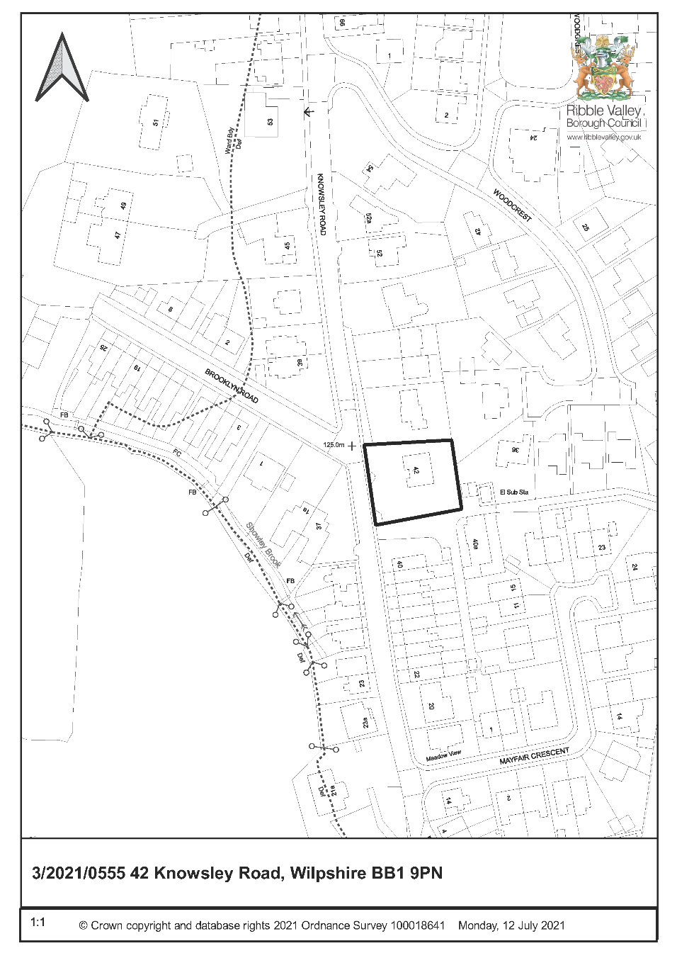

CONSULTEE RESPONSES/ REPRESENTATIONS MADE:

PARISH COUNCIL:

Wilpshire Parish Council have raised concerns regarding parking provision and highway safety issues in the vicinity and breaches of planning conditions.

ENVIRONMENT DIRECTORATE (COUNTY SURVEYOR):

The Highways Development Control Section has raised no objection to the proposal.

The garage was previously proposed to be used as one of the parking spaces for the residential institution.

Notwithstanding this 3 car parking spaces can still be provided at the site, on the existing driveway.

Therefore, even without the garage, the site will still comply with parking standards

ADDITIONAL REPRESENTATIONS:

3 representations have been received objecting to the application on the following grounds:

- Loss of parking, highway safety concerns
- Work carried out in breach of original planning permission
- Change to layout not shown on original plans
- Concerns regarding potential future increase in bedrooms

A ward councillor has requested that this application is determined by Planning and Development committee for the following reasons:

- The development is in breach of planning conditions
- Highway safety

1. Site Description and Surrounding Area

1.1 The application relates to a detached five bed dwellinghouse located on Knowsley Road, within the settlement boundary of Wilpshire in a predominantly residential area.

1.2 The dwelling is set in a generous plot with large hardstanding area to the front and gardens to the other three sides. It is surrounding on all sides by other dwellings.

1.3 Knowsley Road is a narrow street which is accessed via Ribchester Road and Whalley Road at each end. It serves several streets but is subject to access only restrictions and a 20mph speed limit.

1.4 Planning permission was granted for the change of use of the premises to a residential institution in July 2021 and works have been carried out to facilitate the conversion. Some additional works which were not granted as part of this application have also been carried out involving the conversion of the garage to a habitable room and construction of a bay window.

2. Proposed Development for which consent is sought

2.1 The application seeks consent for the variation of condition 2 of planning permission 3/2022/0555. This application is retrospective and seeks to regularise works which have been carried out to convert the garage to a habitable room and construction of a bay window in place of the garage door.

3. Relevant Planning History

3/2021/0555 - Proposed change of use from Residential Class C3 (dwellinghouse) to C2 (residential institution). – Approved with conditions – 29 July 2021.

4. Relevant Policies

Ribble Valley Core Strategy

Key Statement DS1 – Development Strategy
Key Statement DS2 – Presumption in Favour of Sustainable Development

Policy DME1 – Protecting Trees and Woodland
Policy DME2 – Landscape and Townscape Protection
Policy DME3 – Site and Species Protection and Conservation
Policy DMG1 – General Considerations
Policy DMG2 – Strategic Considerations
Policy DMG3 – Transport and Mobility

National Planning Policy Framework (NPPF)
National Planning Practice Guidance (NPPG)
Technical Guidance to National Planning Policy Framework

5. Assessment of Proposed Development

5.1 Principle of Development:

5.1.1 Section 73 of the Town and Country Planning Act 1990 allows applications to be made for permission to develop without complying with a condition(s) previously imposed on a planning permission. As such this mechanism can be used to seek to vary the plans approved on a previous planning application. This application seeks to vary the plans approved on application reference 3/2022/0555 to include the conversion of a garage to a room and construction of a bay window. The original planning permission will continue to subsist whatever the outcome of the application under section 73 and therefore this application does not seek to revisit the material planning issues associated with the change of use only whether the variations to the approved plans are acceptable.

5.1.2 Minor amendments to the previously approved plans are acceptable in principle subject to an assessment of the material planning issues. In this case the now converted garage was previously included in the parking provision for the site and therefore the implications of the loss of a parking space must be considered. The proposal also changes the appearance of the principal elevation of the building.

5.2 Impact upon Residential Amenity:

5.2.1 The proposal will introduce a new habitable room window to the front elevation of the property as well as creating additional living accommodation within the property. It is understood that the room is to be used as a cinema room for residents. It is not considered that these alterations will have any detrimental impact on neighbouring properties and adequate facing distances between habitable rooms will still be met. It is noted that concerns have been raised with regard to the number of residents potentially increasing, as there is additional habitable floor space created, but the planning conditions imposed limiting the number of residents will still apply.

5.3 Impact upon Visual Amenity

5.3.1 The bay window matches the existing bay window on the opposite side of the property and gives the front elevation a balanced appearance. The alterations do not raise any concerns with regard to their visual impact on the property or wider street scene.

5.4 Highway Safety and Accessibility:

5.4.1 The Highways Development Control Officer has raised no objections to the proposal. The concerns of residents in respect of increased traffic and lack of parking are noted and as before it is acknowledged that this is a narrow road heavily used for on street parking. However, LCC have commented the parking provision would meet guidance for parking provision for this type of use, even without the garage.

5.4.2 It is accepted that there is information within the submission that suggests that ten cars can be accommodated off street and there is a generous driveway to the front of the property, but no parking layout is provided. However, it was previously accepted that 4 spaces would be more than adequate and the removal of one space resulting in 3 would still meet the Local Highway Authority’s parking standards for this type of use.

5.4.2 Previous conditions requiring gates to be set back from the highway by five metres to allow cars to pull clear of the road and limits on number of residents will still apply in the interests of amenity and highway safety.

5.5 Landscape/Ecology:

5.5.1 There are no works proposed that would be likely to impact on any protected species. Therefore, there are no concerns raised in respect of these issues.

5.6 Other issues:

5.6.1 As aforementioned 3 objections to this proposal have been received and the material planning issues raised have been addressed above. The fact that an application is retrospective is not a reason to refuse consent for a development that is acceptable and the application before the Local Planning Authority (LPA) has to be considered on its own merits. The LPA cannot prejudge potential future breaches of planning control and if this occurred the planning issues would be considered at the time.

6. Observations/Consideration of Matters Raised/Conclusion

6.1 For the reasons outlined above the proposed development is considered to be in accordance with the main aims and objectives of the adopted development plan and it is not considered that there are any material planning reasons that would warrant the refusal to grant consent.

RECOMMENDATION: That the application be APPROVED subject to conditions:

- Unless explicitly required by condition within this consent, the development hereby permitted shall be carried out in complete accordance with the proposals as detailed on drawings:

Location Plan 21.052.pl.01
Floor Plans and Elevations 21.052.pl.02

REASON: For the avoidance of doubt and to clarify which plans are relevant to the consent hereby approved.

- Notwithstanding the provisions of Part 2 of Schedule 2, Article 3 of the Town and Country Planning (General Permitted Development) (England) Order 2015 (or any Order revoking and re-enacting that Order) no vehicular access gates, barriers, bollards, chains or other such obstructions shall be erected within a distance of 5 metres of the highway boundary, nor shall any be erected within a distance of 5 metres of the highway boundary unless hung to open away from the highway.

REASON: To enable a vehicle to stand clear of the highway in order to protect the free and safe passage of traffic including pedestrians in the public highway in accordance with the National Planning Policy Framework (2019).

- Notwithstanding the provisions of the Town and Country Planning (Use Classes) Order 1987 (as amended or re-enacted) and the Town and Country Planning (General Permitted Development)(England) Order 2015 (as amended or re-enacted) and the Town and Country Planning (General Permitted Development) (England) (Amendment) Order 2016 (as amended or re-enacted) the property shall only be used for the purposes of residential care home (C2) and for no other purpose, including any other purpose within Use Class C2.

To define the scope of the permission hereby approved and to ensure that the development remains compatible with the character of the area.

4. The premises shall only be used as a residential care home for children, with a maximum of 4 children in residence at any one time who shall be from a 40 mile radius of the application site.

REASON: In the interest of a community cohesion and safeguarding residential amenity.

5. The residential care home for children hereby approved shall not be used to provide care to children requiring an emergency placement.

REASON: To safeguard residential amenity,

BACKGROUND PAPERS

https://www.ribblevalley.gov.uk/site/scripts/planx_details.php?appNumber=3%2F2022%2F0046

