APPLICATION REF: 3/2022/0055/P

GRID REF: SD 373410 44812

DEVELOPMENT DESCRIPTION:

PROPOSED SINGLE STOREY REAR EXTENSION AT OLD EAVES HALL, WADDINGTON ROAD, WEST BRADFORD BB7 3JF

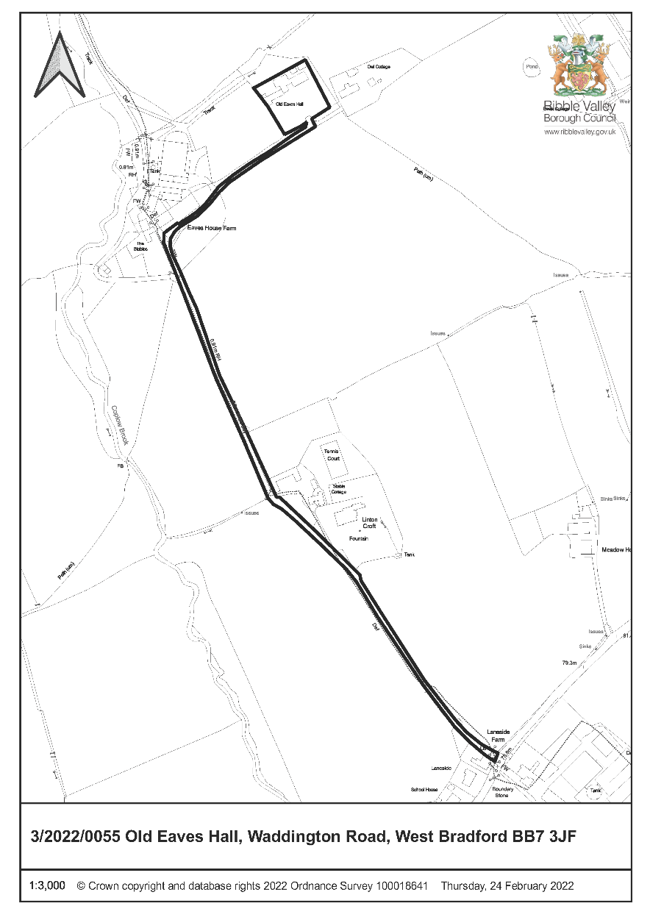

CONSULTEE RESPONSES/ REPRESENTATIONS MADE:

PARISH COUNCIL:

No observations received at time of preparing this report

ADDITIONAL REPRESENTATIONS:

None

1. Site Description and Surrounding Area

  - The site is an isolated dwelling situated within the Forest of Bowland AONB. The boundary of the site adjoins the curtilage of Owl cottage a Grade 2 listed building and the land to the rear is open countryside. The main building is predominantly constructed of natural stone and a blue slate roof. There is an existing timber outbuilding at the rear of the building.

2. Proposed Development for which consent is sought

2.1 The development includes the removal of an existing timber shed and dog kennels to the rear of the property which is to be replaced by a single storey extension is proposed to provide kitchen and dining area. The proposal is approximately 9m by 7m and has a pitched roof of a maximum height of 4.9m.

2.2 The building is on the area of the existing shed and the design includes a high-level glass window on the north east elevation as well as the north west elevation. The extension is predominantly stone with blue slate roof.

3. Relevant Planning History

3/2020/0386- New attached double garage and elevational changes. Approved with conditions

4. Relevant Policies

Policy DMG1: General Considerations.
Policy DME4: Protecting Heritage Assets
National Planning Policy Framework (NPPF)

5. Assessment of Proposed Development

5.1 Principle

5.1.1 It is normally the case that the principle of a domestic extension is acceptable subject to normal Development Management criteria having regard to residential amenity and design issues including in this instance heritage issues.

5.2 Highway Safety and Accessibility

5.2.1 None.

5.3 Design

5.3.1 It is considered that having regard to the location of the extension, its modest size and the removal of an existing timber outbuilding that the scheme would not have an adverse impact on the character of the existing building. It is accepted that the the additional height and massing would result in a bulkier appearance on the rear roof scape, but this is well screened and not readily visible.

5.3.2 The extension is set back and would not be readily seen from the main elevation of the building or the wider landscape in which it is located.

5.4 Heritage/Cultural

5.4.1 This proposal is adjacent to a listed building but effectively screened by existing landscape and it is not considered to have an impact on the setting of the Listed building.

5.5 Residential Amenity/ Noise

5.5.1 The extension would not have any impact on adjacent residential amenity in relation to overlooking or other such amenity issues.

6. Conclusion

6.1 Consideration has been given to the public benefit, which is limited, and importance and weight to the duty at Section 66 of the Planning Listed Buildings and Conservation Areas Act 1990 and it is concluded to have an acceptable impact.

RECOMMENDED: the application be DEFERRED and DELEGATED to the Director of Economic Development to await the statutory consultation period and subject to the following conditions:

Time
1. The development hereby permitted shall be commenced before the expiration of three years from the date of this permission.

REASON: Required to be imposed pursuant to Section 91 of the Town and Country Planning Act 1990 as amended by Section 51 of the Planning and Compulsory Purchasing Act 2004.

Plans

2. Unless explicitly required by this consent, the development hereby permitted shall be carried out in complete accordance with the proposals as detailed on plan references:

Location Plan 6048-E00
Proposed Elevation and Floor Plans s 6048-P05

REASON: For the avoidance of doubt and to clarify which plans are relevant to the consent.

Materials

3. Prior to the commencement of the construction of the development hereby approved full details of the external materials and surfacing materials shall be submitted to and approved in writing by the Local Panning Authority. The development thereafter shall be constructed in accordance with the approved materials.

REASON: To ensure that the appearance of the development is appropriate to the character and setting of the area.

BACKGROUND PAPERS

https://www.ribblevalley.gov.uk/site/scripts/planx_details.php?appNumber=3%2F2022%2F0055

