APPLICATION REF: 3/2022/0091

GRID REF: SD 374385 441880

DEVELOPMENT DESCRIPTION:

PROPOSED SINGLE STOREY REAR EXTENSION TO RETAIL UNIT AT 2 MARKET PLACE, CLITHEROE, BB7 2DB
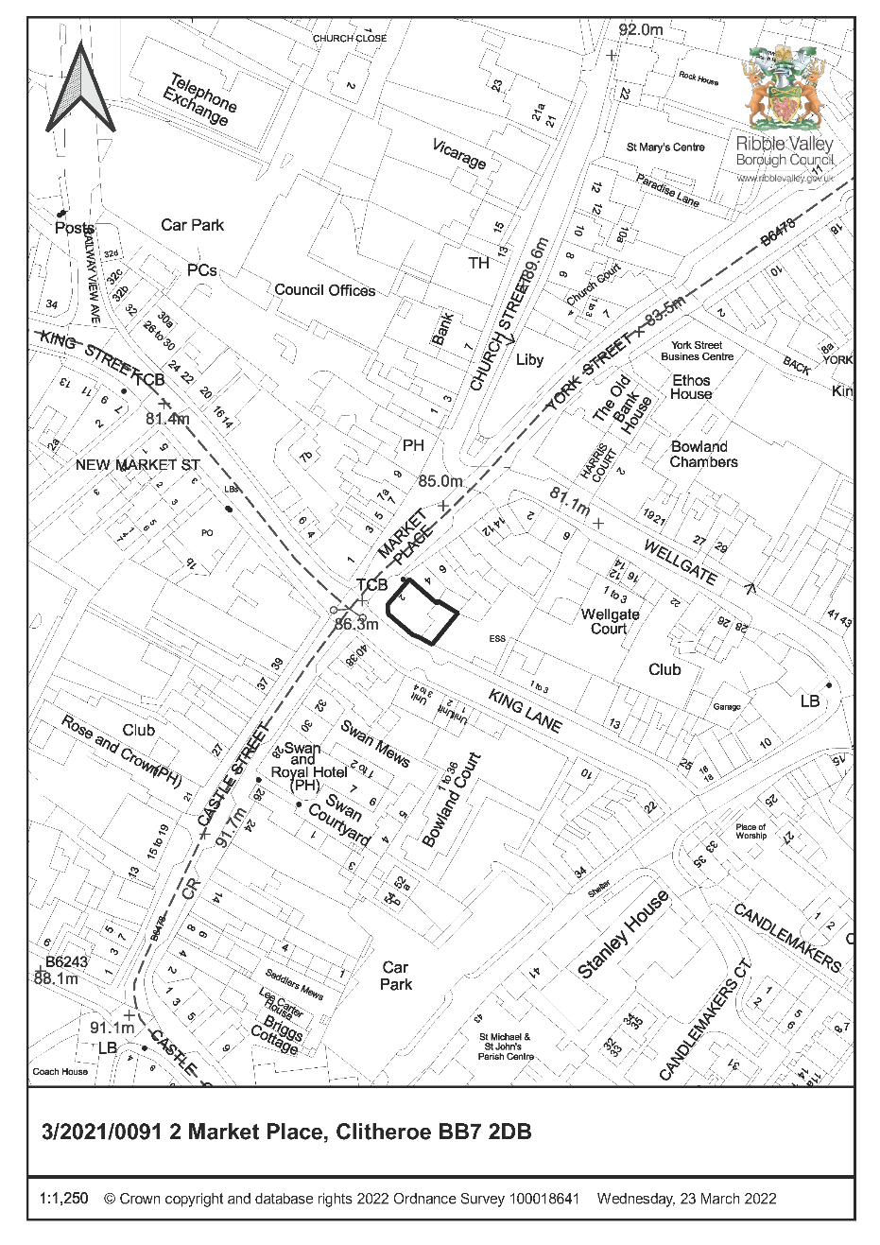

CONSULTEE RESPONSES/ REPRESENTATIONS MADE:

PARISH COUNCIL:

No objection.

ENVIRONMENT DIRECTORATE (COUNTY SURVEYOR):

The Highways Development Control Section has raised no objection to the proposal subject to the imposition of conditions requiring the submission of a Construction Management Plan/Method Statement prior to the commencement of development.

ADDITIONAL REPRESENTATIONS:

No representations received in respect of the application.

1. Site Description and Surrounding Area

1.1 The application relates to an existing retail premises fronting both King Lane and Market Place Clitheroe. The site is located within the defined Clitheroe Conservation Area, with the application building being identified as a Building of Townscape Merit. The building was previously Grade II listed having been de-listed in September 2016.

2. Proposed Development for which consent is sought

2.1 The proposal seeks consent for the erection of a single-storey extension to the eastern elevation of the building, the extension will be sited within an existing gated enclosed area that is currently utilised for the storage of waste receptacles, with the area also providing parking provision for one vehicle.

2.2 It is proposed that the extension will benefit from a flat parapet-roofed appearance benefitting from a footprint of approximately 6.9m by 6.9m. It is proposed that the extension will provide extended Class E retail floorspace associated with the existing retail unit. The extension interfaces directly with an existing boundary wall on the eastern extents of the application site upon which the extension will be constructed, resulting in a partial increase in height of a portion of the wall by approximately 800mm.

3. Relevant Planning History

3/2020/1045:
Replacement hanging signs, acrylic white letter signage to west and south elevation (ground floor) acrylic white letter signage to east elevation (first floor) and internal window transfers. (Approved)

3/2019/0410:
One non-illuminated fascia sign, two non-illuminated projecting signs. (Approved)

4. Relevant Policies

Ribble Valley Core Strategy

Key Statement EC2: Development of Retail, Shops and Community facilities and Services
Key Statement EN5: Heritage Assets

Policy DME4: Protecting heritage Assets
Policy DMG1: General Considerations
Policy DMR1: Retail Development in Clitheroe

Planning (Listed Buildings and Conservation Areas) Act
National Planning Policy Framework (NPPF)
Clitheroe Conservation Area Appraisal

5. Assessment of Proposed Development

5.1 Principle of Development:

5.1.1 Given the proposal seeks to extend an existing retail premises within the defined Main Centre Boundary of Clitheroe, both key Statement EC2 and Policy DMR1 are engaged for the purposes of determining the compatibility of the proposal with the aims and objectives of the adopted development plan.

5.1.2 In this respect, Key Statement EC2, bin principle, seeks to support development that enhances the vibrancy, consumer choice and vitality and unique character of the area’s important retail and service centres of Clitheroe, Longridge and Whalley.

5.1.3 With Policy DMR1 also stating that ‘proposals for shopping developments within the main shopping centre of Clitheroe, as defined on the proposals map, will be approved subject to the other policies of the LDF special regard will be had to the likely contribution of the proposals to the vitality and viability of the centre and their effect on the character and appearance of the area as well as the arrangements for vehicular movement and parking’.

5.1.3 Taking account of the nature of the proposal, notwithstanding other development management considerations, the principle of the development is considered to be in broad compliance with Key statement EC2 and Policy DMR1 in that it will result in the creation of additional retail floorspace that will contribute to the viability and vitality of the Main Centre of Clitheroe.

5.2 Impact upon Residential Amenity:

5.2.1 Taking account of the nature of the proposal and the relationship of the proposed extension with nearby existing residential receptors it is not considered that the proposal will result in any measurable impact upon existing or future residential amenities.

5.3 Impact upon Visual Amenity

5.3.1 The submitted details propose that the extension will be of a flat-parapet roofed appearance, being single storey in nature and directly interface with the existing building on its eastern elevation.

5.3.2 The extension will be faced in materials to match that of the existing building with the eastern extents of the extension interfacing with an existing stone-built boundary wall that will be partially increased in height by approximately 800mm as a result of the construction of the extension.

5.3.3 The are within which the extension is to be sited is currently utilised as a small service yard by the existing premises, also providing parking provision for one vehicle. The internal area of the yard is offered limited visibility from the public realm by virtue of the area being gated, with views only available at times when the gates fronting King Lane are open.

5.3.4 the proposed extension is of a simple utilitarian language, being largely austere in external appearance and as such will remain visually subservient to the primary building. The siting of the extension ensures that it will not be read in direct conjunction with the primary elevations of the building, preserving its overall inherent character.

5.3.5 As such, taking account of the above matters, the external appearance of the proposed extension, the siting of the extension and its overall relationship with the primary building, it is not considered that the proposal will result in any detrimental impacts upon the inherent character or visual amenities of the parent building nor that of the defined Clitheroe Conservation Area.

6. Observations/Consideration of Matters Raised/Conclusion

6.1 It is for the above reasons and having regard to all material considerations and matters raised that the application is recommended for approval insofar that it is not considered that the proposal will result any measurable or significant conflict with the aims and objectives of the adopted development plan.

RECOMMENDATION: That the application be APPROVED subject to the imposition of the following conditions:

- The development must be begun not later than the expiration of three years beginning with the date of this permission.

REASON: Required to be imposed pursuant to Section 18 of the Planning (Listed Building and Conservation Areas) Act 1990.

- Unless explicitly required by condition within this consent, the development hereby permitted shall be carried out in complete accordance with the proposals as detailed on drawings:

6142-E00 - Location Plan
6142-P03 Rev: A – Proposed Plans and Elevations

REASON: For the avoidance of doubt and to clarify which plans are relevant to the consent hereby approved.

- Notwithstanding the submitted details, details or specifications of all materials to be used on the external surfaces of the development hereby approved shall have been submitted to and approved in writing by the Local Planning Authority before their use in the proposed development. The approved materials shall be implemented within the development in strict accordance with the approved details.

REASON: In order that the Local Planning Authority may ensure that the materials to be used are appropriate to the locality and respond positively to the inherent character of the area.

- No development shall take place, including any works of demolition or site clearance, until a Construction Management Plan (CMP) or Construction Method Statement (CMS) has been submitted to, and approved in writing by the local planning authority. For the avoidance of doubt the submitted information shall provide:

- 24 Hour emergency contact number;
- Details of the parking of vehicles of site operatives and visitors;
- Details of loading and unloading of plant and materials;
- Arrangements for turning of vehicles within the site;
- Swept path analysis showing access for the largest vehicles regularly accessing the site and measures to ensure adequate space is available and maintained, including any necessary temporary traffic management measures;
- Measures to protect vulnerable road users (pedestrians and cyclists);
- The erection and maintenance of security hoarding including decorative displays and facilities for public viewing, where appropriate; Wheel washing facilities (where appropriate);
- Measures to deal with dirt, debris, mud or loose material deposited on the highway as a result of construction;
- Measures to control the emission of dust and dirt during construction;
- Details of a scheme for recycling/disposing of waste resulting from demolition and construction works;
- Construction vehicle routing;
- Delivery, demolition and construction working hours.

The approved details shall be adhered to throughout the construction period for the development.

REASON: In the interests of the safe operation of the adopted highway during the demolition and construction phases of the development hereby approved.

BACKGROUND PAPERS

https://www.ribblevalley.gov.uk/site/scripts/planx_details.php?appNumber=3%2F2022%2F0091

