APPLICATION REF: 3/2022/0140

GRID REF: SD 369707 450419

DEVELOPMENT DESCRIPTION:

APPLICATION FOR THE REGULARISATION OF THE UNAUTHORISED CREATION OF A SELF-CONTAINED FLAT FROM AN EXISTING STORE. EAST VIEW CHAPEL LANE NEWTON IN BOWLAND CLITHEROE BB7 3DY

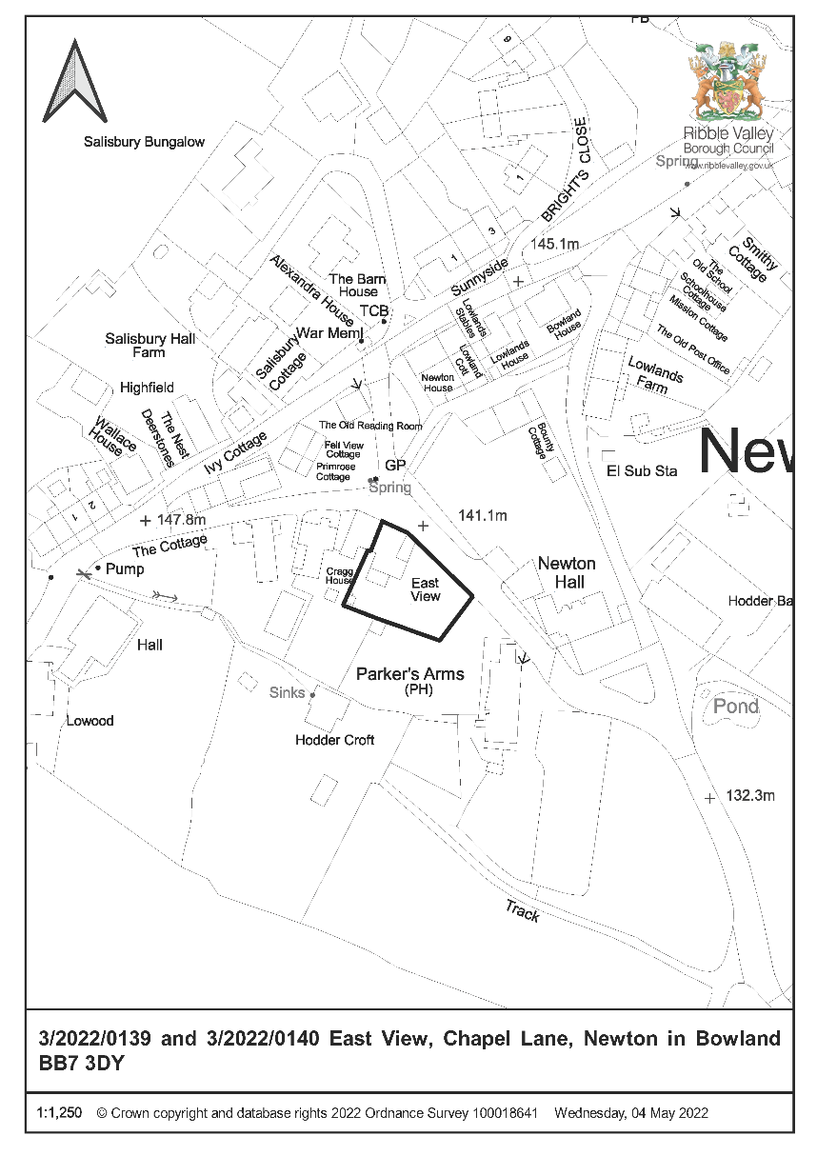

CONSULTEE RESPONSES/ REPRESENTATIONS MADE:

PARISH COUNCIL:

Newton in Bowland Parish Council have raised no objection to the proposal.

ENVIRONMENT DIRECTORATE (COUNTY SURVEYOR):

No objection subject to the imposition of a condition limiting the use of the ‘apartment’ to that of an annexe to the main dwelling.

LCC ARCHAEOLOGY:

LCC Archaeology have offered the following observations:

As this is a retrospective application for works to the Heritage Asset there is no archaeological response which would be applicable to this case as any impact has already taken place with no record of the asset prior to its conversion. There are issues such as the use of uPVC windows on a Listed structure which is also within a Conservation Area.

ADDITIONAL REPRESENTATIONS:

No representations have been received in respect of the application.

1. Site Description and Surrounding Area

1.1 The application relates to a semi-detached two-storey cottage style property fronting Chapel Lane in Newton in Bowland. The dwelling located within the defined Newton in Bowland Conservation Area, also being Grade II listed. The application relates solely to an attached two-storey domestic storage building that is located on the south elevation of the primary dwelling.

2. Proposed Development for which consent is sought

2.1 The application seeks retrospective consent for the conversion of an existing domestic store to that of self-contained annexe apartment ancillary to East View, Chapel Lane, newton in Bowland.

2.2 The submitted details propose that the ground floor area of the storage building will remain in use as a store linked to the primary dwelling, with the first-floor accommodating a single-bedroom annexe apartment consisting of an open-plan kitchen/living area with single bedroom and shower room.

2.3 It is proposed that the annexe accommodation will be accessed via the ground floor domestic storage area with an internal stairwell and lobby area that facilitates access between the ground-floor and first-floor. The submitted details also seek to regularise the installation of Upvc, double doors at ground floor and a Upvc double-window arrangement at first floor of the annexe on the north-east facing elevation of the building fronting Chapel Lane.

3. Relevant Planning History

No recent planning history directly relevant to the determination of the application.

4. Relevant Policies

Ribble Valley Core Strategy

Key Statement DS1 – Development Strategy
Key Statement DS2 – Presumption in Favour of Sustainable Development
Key Statement EN5 – Heritage Assets

Policy DMG1 – General Considerations
Policy DMG2 – Strategic Considerations
Policy DMG3 – Transport and Mobility
Policy DME4 – Protecting Heritage Assets

National Planning Policy Framework (NPPF)
National Planning Practice Guidance (NPPG)
Technical Guidance to National Planning Policy Framework

5. Assessment of Proposed Development

5.1 Principle of Development:

5.1.1 The proposal seeks retrospective consent for that of annexe accommodation, as such Policy DMH5 is primarily engaged for the purposes of assessing the acceptability of the principle of the development and whether such development will result in direct conflict with the adopted development plan.

5.1.2 In this respect the criterion of Policy DMH5, the primary criterion of the policy states that proposals for the creation of annexe accommodation will be supported whereby such accommodation is ‘capable of integration into the main dwelling or a use that is ancillary to the use of the main household when circumstances change’ with the policy further stating that the level of accommodation proposed should ‘provide only a modest level of accommodation’.

5.1.3 In respect of the above criterion, taking account of the configuration of the building to which the application relates, in that it is directly attached to the primary dwelling. It is considered that the annexe accommodation could reasonably be reintegrated into the main dwelling or be utilised for a use that is ancillary to the use of the main household, therefore fulfilling and satisfying the secondary criterion of Policy DMH5.

5.1.4 Furthermore, given the proposed annexe accommodation is limited to that of the first-floor of the storage building - providing an open-plan living/kitchen area, single bedroom and shower room, the scale and level of the provision of the accommodation proposed is considered to be of a modest scale that would satisfy the secondary criterion of Policy DMH5.

5.1.5 As such, taking account of the above matters and notwithstanding other development management considerations, the principle of the development for the creation of annexe accommodation in this location and in the proposed configuration, is considered to be in direct alignment with the requirements of the inherent criterion of Policy DMH5 of the Ribble Valley Core Strategy.

5.2 Impact upon Residential Amenity:

5.2.1 Taking account of the of windows associated with the orientation of the proposed annexe accommodation and the orientation of the window arrangement in relation to other nearby or adjacent residential receptors it is not considered that the proposal, as submitted, will result in any undue measurable impacts of nearby or adjacent residential amenity.

5.3 Impact upon Visual Amenity

5.3.1 The submitted details, in addition to the creation of annexe accommodation, seeks retrospective consent for the installation of Upvc double doors on north-east facing elevation of the storage building at ground floor and a Upvc double-window arrangement at first floor, on the same elevation, to match those of the ground floor in appearance.

5.3.2 The application property not only lies within the defined Newton in Bowland Conservation Area but is also Grade II listed. As such, at a local-level, Key Statement EN5 and Policies DMG1 and DME4 are engaged for the purposes of determining the impacts of the proposal upon not only the designated heritage asset, but also that of the character and visual amenities of the immediate area and wider Conservation Area.

5.3.3 The installation of Upvc windows/doors not only upon a listed building, but also within the defined Conservation area is considered to represent the introduction of anomalous and incongruous architectural features of a material an appearance that would not be considered to be appropriate for use upon a Grade II designated heritage asset or within the defined conservation area. As such it is proposed that a condition be imposed that seeks removal of the already installed windows/door and their replacement of a type and of materials that are considered to be more appropriate to their setting.

5.3.4 in this respect it is proposed that a condition be imposed that requires details of replacement windows/doors to be submitted within two months from the date of this consent. The condition will further require that the submitted details l include a programme of works for the installation of the approved replacement doors/windows, the installation of which shall not exceed a period of 6 months from the date of the approval of the submitted details.

5.3.5 Taking account of the requirements of the condition to be imposed and providing appropriate details are received that satisfy the requirements of the condition, it is not considered that the proposal- following the submission and installation of the agreed details, will result in any significant detrimental impact upon the inherent character of the Grade II designated heritage asset or the character and visual amenities of the Newton in Bowland Conservation Area.

5.4 Highway Safety and Accessibility:

5.4.1 The Highways Development Control Officer has raised no objections to the proposal provided that a condition is imposed upon the building that limits occupation to that which is considered to be ancillary to the enjoyment of the existing household.

5.5 Landscape/Ecology:

5.5.1 No implications resultant from the proposal.

6. Observations/Consideration of Matters Raised/Conclusion

6.1 For the reasons outlined above, notwithstanding the requirement to install replacement windows/doors of a type, design and materiality that are more appropriate to the character of the area and parent building, the proposed development is considered to be in broad alignment with the main aims and objectives of the adopted development plan and it is not considered that there are any over-riding material planning reasons that would warrant the refusal to grant consent.

RECOMMENDATION: That the application be APPROVED subject to the following conditions:

- Unless explicitly required by condition within this consent, the development hereby permitted shall be carried out in complete accordance with the proposals as detailed on drawings:

1305-1001: Location Plan
1305-03: Proposed Ground Floor Plan
1305-04: Proposed First Floor Plan
1305-05: Existing Elevation
1305-08: Proposed Site Plan

REASON: For the avoidance of doubt and to clarify which plans are relevant to the consent hereby approved.

- The annexe accommodation hereby approved shall not be occupied or used for any other purposes than those ancillary to the residential use of the dwelling known as East View (BB7 3DY) and shall only be occupied as an extended family unit in conjunction with the property to which it is related.

The annex shall not be used as a separate unit of living accommodation nor be divided by way of sale or sub-letting to form a unit or units of separate residential accommodation.

REASON: To define the scope of the permission hereby approved and prevent the use of the building for purpose(s) that would cause direct conflict with the adopted development plan.

- Notwithstanding the submitted details, precise specifications and details of replacement windows/doors on the north-east facing elevation of the storage building (indicated as ‘white u.p.v.c’ on drawing’ 1305-05) shall be submitted within two months from the date of this consent.

The submitted details shall include a programme of works for the installation of the approved replacement doors/windows, the installation of which shall not exceed a period of 6 months from the date of the approval of the submitted details. The development shall be carried out in strict accordance with the approved details and timings.

REASON: To ensure that the replacement windows/doors respond positively to the inherent character of the original building and the defined Newton in Bowland Conservation Area.

BACKGROUND PAPERS

https://webportal.ribblevalley.gov.uk/site/scripts/planx_details.php?appNumber=3%2F2022%2F0140

