APPLICATION REF: 3/2022/0217

GRID REF: SD

DEVELOPMENT DESCRIPTION:

PROPOSED UP TO 40 2500MM X 750MM ALUMINIUM/COMPOSITE BOARDS TO SURROUND A FOOTBALL PITCH ON TWO ADJACENT SIDES AT RECREATION GROUND ADJACENT CHIPPING AND DISTRICT MEMORIAL HALL, GARSTANG ROAD, CHIPPING PR3 2QH
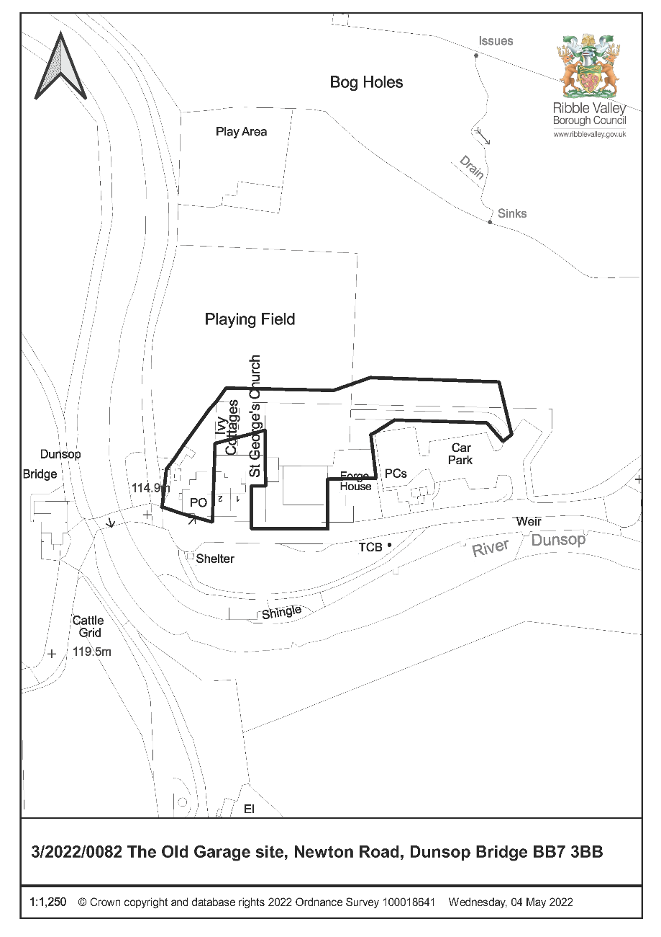

CONSULTEE RESPONSES/ REPRESENTATIONS MADE:

PARISH COUNCIL:

Chipping Parish Council support the proposal and whilst they have considered the location within the AONB the revenue from the advertising will benefit the club and the community.

ADDITIONAL REPRESENTATIONS:

4 representations have been received objecting to the application on the following grounds:

- The playing fields are for the benefit of all residents not just the football club
- The boards will detract from the AONB landscape
- The boards are not in keeping with the character of the village

A ward councillor has requested that this application is determined by Planning and Development Committee for the following reasons:

- The advertising will have an urbanising effect on the area
- The proposal would be harmful to the AONB
- The area is not enclosed

1. Site Description and Surrounding Area

1.1 The site the subject of the application is a playing field within a larger recreational area including two playing pitches and a MUGA located to the rear of Chipping and District Memorial Hall. The site is surrounding by dwellings and located in the heart of the village. The three pitches step upwards from the rear of the Hall and the lower pitch is the proposed location for the sign boards. The long sides of this pitch are already demarcated by a post and rail fence and the one to the west side abuts the rising land.

2. Proposed Development for which consent is sought

2.1 The application seeks advertisement consent for the display of up to 40 advertising boards along the long sides of the playing field. Each board will measure 750mm high by 2250mm width.

3. Relevant Planning History

None relevant.

4. Relevant Policies

Ribble Valley Core Strategy

Policy DMG1 – General Considerations

Town and Country Planning (Control of Advertisement) Regulations 2007

5. Assessment of Proposed Development
5.1 Principle of Development:

5.1.1 The proposed advertisements are intended to advertise local businesses to bring in revenue to support the football club which is a well-attended facility for the community.

5.1.2 As this is an application for advertisement consent the regulations only allow local authorities to have regard to considerations of 'amenity' and 'public safety'.

5.2 Impact upon Amenity:

5.2.1 The signs will be located along either side of the football pitch where there is already a fence in situ. Those located on the Western side will be set against the backdrop of the embankment and they are only 75 cm in height.

5.2.2 The site is a playing field located in the centre of the village surrounded by dwellings and whilst it is a rural village it is not considered that the proposal is out of place at a sports club. Similar advertising boards are often seen around playing fields. The signs will be non-illuminated and the rear of them will be painted green to reduce their impact.

5.2.3 The signs will be along the long sides of the pitch and will not affect the use of the pitch by other members of the public.

5.2.4 The concerns with regards to the length of time proposed for the display of the boards are noted. The regulations only permit their display for 5 years after which the authority may require them to be removed unless a further consent has been granted. Adverts are also subject to other standard conditions to ensure that they are kept in a safe and tidy manner.

5.3 Impact upon Public Safety:

5.3.1 The signs will be set back from the highway within the site boundary and will not be an obstruction of the highway or distraction to motorists. The will located along the boundary of the playing field and will not interfere with public access to the area. As such there are no safety concerns raised providing the adverts are kept in a tidy and safe condition.

6. Observations/Consideration of Matters Raised/Conclusion

6.1 The display of advertisements for a temporary period is acceptable for the reasons discussed above and therefore it is recommended accordingly.

RECOMMENDATION: That the application be APPROVED subject to conditions:

1. The permission shall relate to the development as shown on Plan Reference;

Advertisement Location Plan
Site Plan
Board Details

REASON: For the avoidance of doubt as amended plans have been received and to ensure that the development is carried out in accordance with the submitted plans.

2. The advertisements hereby permitted shall be removed from the site on or before 19 May 2027 and the site restored to its former condition to the full satisfaction of the Local Planning Authority unless a further advertisement consent has been granted by the Authority.

REASON: In the interests of visual amenity.

3. Any structure or hoarding erected or used principally for the purpose of displaying advertisements shall be maintained in a safe condition.

REASON: In the interests of visual amenity.

4. Where an advertisement is required under these Regulations to be removed, the removal shall be carried out to the reasonable satisfaction of the Local Planning Authority.

REASON: In the interests of visual amenity.

5. No advertisement shall be sited or displayed so as to obscure, or hinder the ready interpretation of, any road traffic sign, railway signal or aids to navigation by water or air, or so as otherwise to render hazardous the use of any highway, railway, waterway or aerodrome (civil or military).

REASON: In the interests of visual amenity.

6. The rear of the advertising boards hereby approved shall be coloured green.

REASON: In the interests of visual amenity.

BACKGROUND PAPERS

https://webportal.ribblevalley.gov.uk/site/scripts/planx_details.php?appNumber=3%2F2022%2F0217

