APPLICATION REF: 3/2022/0217

GRID REF: SD

DEVELOPMENT DESCRIPTION:

PROPOSED UP TO 40 2500MM X 750MM ALUMINIUM/COMPOSITE BOARDS TO SURROUND A FOOTBALL PITCH ON TWO ADJACENT SIDES AT RECREATION GROUND ADJACENT CHIPPING AND DISTRICT MEMORIAL HALL, GARSTANG ROAD, CHIPPING PR3 2QH
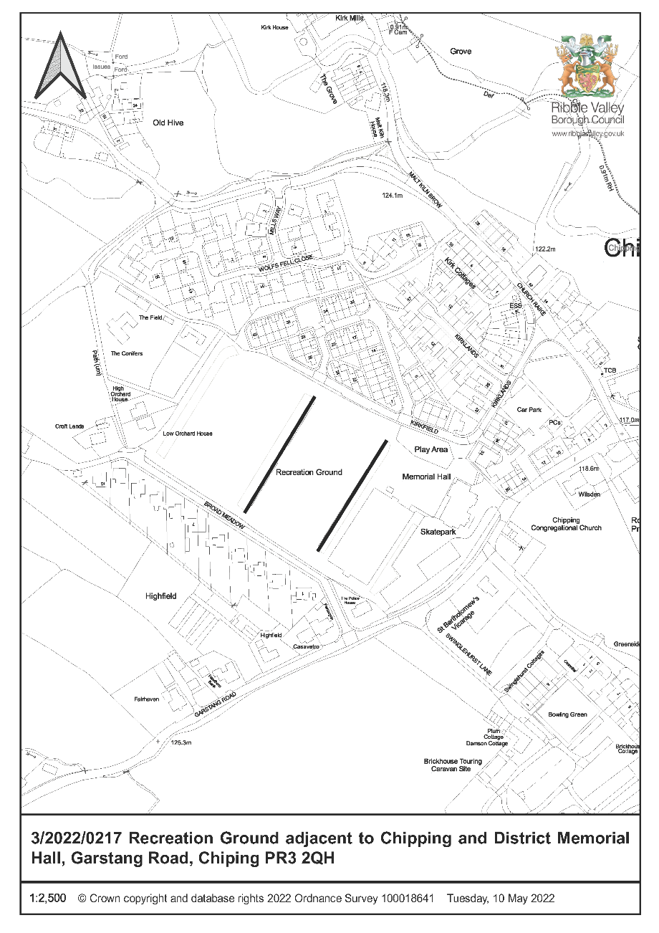

CONSULTEE RESPONSES/ REPRESENTATIONS MADE:

PARISH COUNCIL:

Chipping Parish Council originally stated that they support the proposal and whilst they have considered the location within the AONB the revenue from the advertising will benefit the club and the community.

Further comments were received from the Parish Council as follows:

Chipping Parish Council notes the letters from residents objecting to Chipping FC's application for 40 x permanent advertising boards on the playing fields at Chipping Memorial Hall. The letters of objection highlight that the playing fields are a public open space available for the general public to use, they are not owned by Chipping FC. There are also concerns that permanent advertising boards are not appropriate for the location in a small rural village and would cause undesirable urbanisation.

The Parish Council also recognises the good work that the Chipping FC volunteers do to facilitate boys and girls from around the district to play football in a safe, well-organised setting as well as running senior football teams.

On balance the Parish Council is of the opinion that a compromise should be implemented to allow Chipping FC to gain revenue from advertising to help run their club but does not have the permanent visual impact that the current application proposes. It has been suggested that advertising boards are designed and fabricated like a book so that they can be 'opened' on match days but remain 'closed' at other times. When closed they will be unobtrusive because only the backs of the adverts (coloured green) would be visible.

The Parish Council believes that approving the application with the above condition for advertising only visible on match days is a reasonable compromise compatible with the aims of the Football Club and addressing the concerns of local residents.

ADDITIONAL REPRESENTATIONS:

4 representations have been received objecting to the application on the following grounds:

- The playing fields are for the benefit of all residents not just the football club
- The boards will detract from the AONB landscape
- The boards are not in keeping with the character of the village

A ward councillor has requested that this application is determined by Planning and Development Committee for the following reasons:

- The advertising will have an urbanising effect on the area
- The proposal would be harmful to the AONB
- The area is not enclosed

1. Site Description and Surrounding Area

1.1 The site the subject of the application is a playing field within a larger recreational area including two playing pitches and a MUGA located to the rear of Chipping and District Memorial Hall. The site is surrounding by dwellings and located in the heart of the village. The three pitches step upwards from the rear of the Hall and the lower pitch is the proposed location for the sign boards. The long sides of this pitch are already demarcated by a post and rail fence and the one to the west side abuts the rising land.

2. Proposed Development for which consent is sought

2.1 The application seeks advertisement consent for the display of up to 40 advertising boards along the long sides of the playing field. Each board will measure 750mm high by 2250mm width.

3. Relevant Planning History

None relevant.

4. Relevant Policies

Ribble Valley Core Strategy

Policy DMG1 – General Considerations

Town and Country Planning (Control of Advertisement) Regulations 2007

5. Assessment of Proposed Development

5.1 Principle of Development:

5.1.1 The proposed advertisements are intended to advertise local businesses to bring in revenue to support the football club which is a well-attended facility for the community.

5.1.2 As this is an application for advertisement consent the regulations only allow local authorities to have regard to considerations of 'amenity' and 'public safety'.

5.2 Impact upon Amenity:

5.2.1 The signs will be located along either side of the football pitch where there is already a fence in situ. Those located on the Western side will be set against the backdrop of the embankment and they are only 75 cm in height.

5.2.2 The site is a playing field located in the centre of the village surrounded by dwellings and whilst it is a rural village it is not considered that the proposal is out of place at a sports club. Similar advertising boards are often seen around playing fields. The signs will be non-illuminated and the rear of them will be painted green to reduce their impact.

5.2.3 The signs will be along the long sides of the pitch and will not affect the use of the pitch by other members of the public.

5.2.4 The concerns with regards to the length of time proposed for the display of the boards are noted. The regulations only permit their display for 5 years after which the authority may require them to be removed unless a further consent has been granted. Adverts are also subject to other standard conditions to ensure that they are kept in a safe and tidy manner.

5.3 Impact upon Public Safety:

5.3.1 The signs will be set back from the highway within the site boundary and will not be an obstruction of the highway or distraction to motorists. The will located along the boundary of the playing field and will not interfere with public access to the area. As such there are no safety concerns raised providing the adverts are kept in a tidy and safe condition.

6. Observations/Consideration of Matters Raised/Conclusion

6.1 The display of advertisements for a temporary period is acceptable for the reasons discussed above and therefore it is recommended accordingly.

RECOMMENDATION 1
That the application be APPROVED subject to conditions:

1. The permission shall relate to the development as shown on:

Advertisement Location Plan
Site Plan
Board Details

REASON: For the avoidance of doubt as amended plans have been received and to ensure that the development is carried out in accordance with the submitted plans.

2. The advertisements hereby permitted shall be removed from the site on or before 21st June 2027 and the site restored to its former condition to the full satisfaction of the Local Planning Authority unless a further advertisement consent has been granted by the Authority.

REASON: In the interests of visual amenity.

3. Any structure or hoarding erected or used principally for the purpose of displaying advertisements shall be maintained in a safe condition.

REASON: In the interests of visual amenity.

4. Where an advertisement is required under these Regulations to be removed, the removal shall be carried out to the reasonable satisfaction of the Local Planning Authority.

REASON: In the interests of visual amenity.

5. No advertisement shall be sited or displayed so as to obscure, or hinder the ready interpretation of, any road traffic sign, railway signal or aids to navigation by water or air, or so as otherwise to render hazardous the use of any highway, railway, waterway or aerodrome (civil or military).

REASON: In the interests of visual amenity.

6. Prior to the installation of the advertisement boards hereby approved the rear of the advertising boards shall be painted dark green and this colour shall be maintained in perpetuity.

REASON: In the interests of visual amenity of the area and to ensure the advertisement boards blend into the surrounding area.

RECOMMENDATION 2: UPDATE FOLLOWING 19 MAY PLANNING AND DEVELOPMENT COMMITTEE MEETING:

On 19 May 2022 Committee were Minded to refuse the application on the basis of the visual impact and requested that the application be brought back to committee with an appropriate reason for refusal.

Following the resolution at 19th May Committee the agent for the application has provided the following additional information in an attempt to address Members concerns and propose a compromise:

- We are aware of a letter which has been submitted by a member of the local parish council suggesting a folding ‘book-like’ design which would allow any boards to be folded shut following each event. After consulting several manufacturers about such a design I have found someone who had suggested they may possibly be able to make a bespoke sign like this, however the cost to the customer more than doubles.
- This alteration to design and the substantial increase in cost it brings would mean that the price of using these boards as advertising space would be undesirable to most businesses. Especially as the target market to whom the sale of this advertising space would be focussed, would be small, local businesses who may directly benefit from someone seeing their advertisement pitch-side and subsequently using their nearby business. It is our hope that local companies wish to advertise their goods/services with us whilst helping to support a volunteer run sports organisation in the process.
- It is my conclusion that the suggested folding design is not a realistic compromise.
- Taking on board feedback and working within the boundaries of what would be both realistically achievable and would still yield the financial gain anticipated, the football club would be happy to only display any advertisement hoardings during the football season. The club would then remove them all and place them into storage annually where they could remain throughout the close season. An average football season at our level of the amateur football pyramid spans Aug-May.
- We would also ensure that all the back sides of every board are Green to help to in-keep with the surrounding area [NOTE THIS WAS ALREADY SECURED BY CONDITON 6]
- We feel these compromises would help to minimise the visual impact as much as is possible whilst still allowing the project to remain financially viable and worthwhile.

If Members consider this is a suitable compromise the following additional condition would be attached to RECOMMENDATION 1

- The advertisement boards hereby permitted shall only be displayed during the football season (August to May inclusive) and shall be removed from site and placed into storage during June and July each calendar year.

REASON: In the interests of visual amenity and to reduce the impact on the AONB by removing the signage when the pitch is not in use by the football club.

Notwithstanding the above suggested compromise should Committee wish to refuse the application the following reason is suggested:

The proposal by virtue of its size and location would be detrimental to visual amenity of the area and have an adverse impact on the Area of Outstanding Natural Beauty and as such be contrary to Policy DMG1 of the Core Strategy

BACKGROUND PAPERS

https://webportal.ribblevalley.gov.uk/site/scripts/planx_details.php?appNumber=3%2F2022%2F0217

