APPLICATION REF: 3/2022/0278

GRID REF: SD 362283 443328

DEVELOPMENT DESCRIPTION:

LISTED BUILDING CONSENT FOR CONVERSION OF PUBLIC HOUSE INTO ONE DWELLING AND ONE HOLIDAY LET. LIMITED EXTERNAL ALTERATIONS TO TALBOT HOTEL. CONVERSION OF ADJACENT BARN INTO THREE NEW DWELLINGS WITH ASSOCIATED WORKS. FORMATION OF PARKING AND MANOEUVRING AREAS TO REAR. HARD AND SOFT LANDSCAPING AT TALBOT HOTEL, 5 TALBOT STREET, CHIPPING PR3 2QE
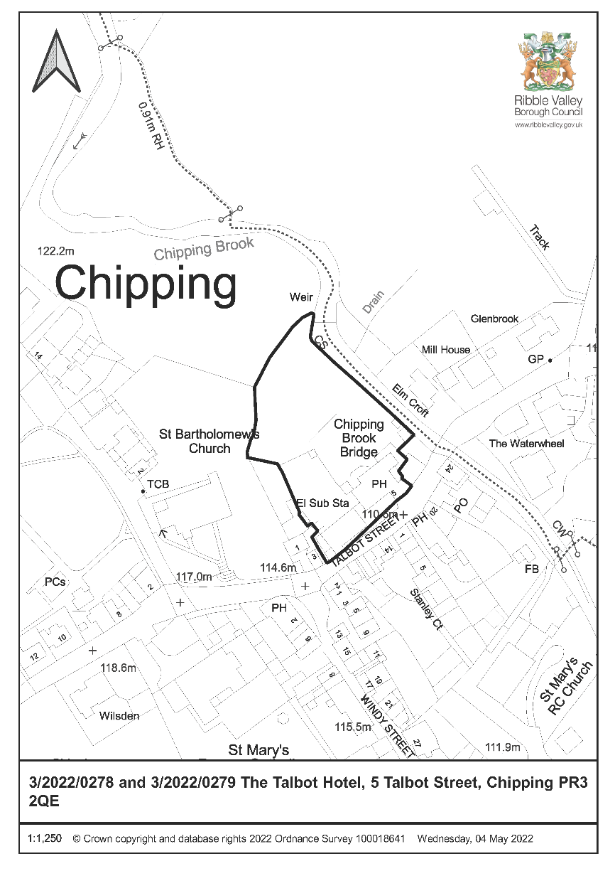

CONSULTEE RESPONSES/ REPRESENTATIONS MADE:

PARISH COUNCIL:

Chipping: Supportive of the scheme and welcome the development as it would improve the visual amenity of the area and prevent further deterioration of these buildings.

LCC ARCHAEOLOGY

The applications are accompanied by a Heritage Statement which describes and illustrates the buildings and assesses the impact of the scheme upon their significance. There will be negative impacts upon this significance, but the changes proposed appear to have a less than substantial impact when balanced against the advantage of bringing the buildings back into economic use. Given the detail provided in the Heritage Statement we considered if any further building recoding was necessary and have concluded that sufficient questions over the buildings’ features, history and development remain to justify the creation of a formal record to level 3 as set out in “Understanding Historic Buildings” (Historic England 2016). This can be required by an appropriate planning condition.

This is in accordance with the NPPF Para 205 which requires LPA to require developers to record heritage assets to be lost (wholly or in part).

HISTORIC ENGLAND:

Not offering any advice but suggests seeks the views of our specialist conversion and archaeological advisers.

OTHER AMENITY GROUPS:

No representation received.

ADDITIONAL REPRESENTATIONS:

One supporting letter has been received stating the scheme will positively improve Talbot Street and support local businesses.

1. Site Description and Surrounding Area

  - The site consists of two Grade II Listed Buildings and is located with Chipping Parish. The site is within Chipping Conservation Area and the Forest of Bowland Area of Natural Beauty they are also protected trees within the site.

  - One building was last in use as a public house and the other has been in use as a Barn.

  - The site is served by an established access off Talbot Street
.
2. Proposed Development for which consent is sought

2.1 The proposed development at site is to convert the public house into one dwellinghouse with holiday let with limited external alterations and convert the barn into three dwellinghouses with associated external works. Formation of car park and manoeuvring to rear and hard and soft landscaping.

2.2 A structural Survey has been submitted which details the existing internal and external condition of the buildings. In general, the Hotel has some signs of water ingress and timber decay with some internal ceilings partially collapsed. In terms of the barn areas of slating have partially collapsed internally and externally a partial collapse and missing slate to the rear roof pitch and the excessive bulge to the right-hand gable wall raises some concerns notwithstanding the metal tie bar installed to prevent outward movement and separation. The rear wall shows distortion along its length where stonework has eroded.

2.3 The proposed development will retain the existing built form of both buildings with external changes kept to a minimum particularly on the front, public elevations. New windows and doors are in the main limited to previous openings with some rooflights and new openings being proposed. Some new boundary fencing to separate the rear gardens, formation of car parking and timber bin stores are proposed.

2.4 Internally the scheme for the Public House would require the removal of some internal walls as well as the re-siting of the staircase from ground to first floor to the suggested original position. With regards to the barn some internal diversions to create three units will also be required.

3. Relevant Planning History

2012/0962 & 2012/0963 – Full and LBC: Refurbishment and extension to existing hotel to create 9no. ensuite bedrooms, function suite, bistro restaurant and bar area with ancillary hotel, kitchen and staff facilities; change of use of existing barn to form 11no. ensuite bedrooms ancillary to the hotel accommodation: extension and refurbishment of existing car parking facilities to create 46no. parking spaces including the repair and refurbishment of the existing cobbled forecourt (Resubmission of 3/2011/0821) (Listed Building Consent) and 3/2011/0822 (Full) – Approved with conditions.

2011/0822 & 2011/08821 – Full and LBC: Demolition of existing single storey extension and removal of render to front elevation; repair and repointing of stonework; refurbishment and extension to existing hotel to create 9no. ensuite bedrooms; function suite, bistro restaurant and bar area with ancillary hotel, kitchen and staff facilities; change of use of the existing barn to form 11no. ensuite bedrooms ancillary to the hotel accommodation; extension and refurbishment of existing car parking facilities to create 50no.car parking spaces including the repair and refurbishment of the existing cobbled forecourt – Refused 16th March 2012.

2010/0131 – LBC: Partial careful demolition of bulge in gable wall of barn and rebuild in stone from demolition (using a mix of 1-part NHL 3.5:3 parts sand)

4. Relevant Policies

Ribble Valley Core Strategy (Adopted Version)
Key Statement DS1 – Development Strategy
Key Statement DS2 – Presumption in Favour of Sustainable Development
Key Statement EN1 – Green Belt
Key Statement EN3 – Sustainable Development and Climate Change
Key Statement EN5 – Heritage Assets
Key Statement EC1 – Business and Employment Development

Policy DMG1 – General Considerations
Policy DMG3 – Transport and Mobility
Policy DME3 – Site and Species Protection and Conservation
Policy DMH3: Dwellings in the Open Countryside & the AONB
Policy DMH4: The Conversion of Barns and other Buildings to Dwellings
Policy DME4 – Protecting Heritage Assets

National Planning Policy Framework
National Planning Policy Guidance
Sections 66 and 72 of the Planning (Listed Buildings and Conservation Areas) Act 1990.

5. Assessment of Proposed Development

5.1 Members will be aware that consent has been issued for the redevelopment of this site in 2012, however, since the development was not commenced on the previous permissions there is no extant permission in place.

5.2 Principle:

It is proposed to use the hotel as a 5 bedroomed dwelling and a two bedroomed holiday let to the southern end of the building in the later coach house element.

The Barn is proposed to be converted into two three bedroomed dwellings and one two bedroomed dwellinghouse.

In terms of external alterations to the public house two flush fitting conservation roof lights are proposed to the front elevation to serve the two bedrooms in the attic with the removal of the external first floor staircase and then infill the doorway with a glazed screen. The adjacent first floor window would be reinstated as well as the rear window to the single storey north extension. The single storey rear extension will now remain with the pitched roof removed and a parapet roof installed and the proposed alterations to the bay window to allow for full length bi-fold windows to be installed whilst this is not desirable in overall terms it would not remove any original fabric and this element was originally proposed to be removed altogether which would have been acceptable and therefore this raises no undue concerns.

In terms of external alterations to the Barn 3no. flush fitting conservation rooflights are now proposed to the roof slopes with one to the front and two to the rear. The agent has been requested to remove these as they do not serve habitable rooms and are not necessary. On the north elevation the existing openings would be re-instated including the cart door. The south elevation would have an additional window inserted with the downpipe moved and two doors formed out of an existing window opening. Two first floor windows would also be formed. As this is the rear elevation and would be used as primary access to the units then this is, in my view, acceptable subject to the removal of the rooflights.

Changes to the western gable would be limited to one new first floor window being formed and the reinstatement of two doors with full length glazing and two existing openings to windows.

The existing blocked/boarded up windows to the east gable would be reinstated with full glazing. This is considered to be acceptable.

Whilst no details of the windows have been submitted these will all be timber and original frames in the Public House will be repaired where necessary. Details of all replacement and repairs to windows and doors can be controlled by appropriate conditions.

Internally in the Hotel the existing modern staircase would be removed and a replacement to access the first floor would be sited where the original was thought to be. This is acceptable subject to details being submitted.

Internally in the Barn some original fabric will be removed to all for three units to be formed. Internal walls will need to formed to sub-divide the building and details of these and the staircases to access the first floor will need to be submitted and agreed

In this case the buildings are capable of being converted and this will bring these two vacant listed buildings back into an appropriate use. Albeit there are concerns regarding the condition of the barn and slight changes to the scheme which need to be addressed these issues can be dealt with by appropriate conditions and submission of details to be agreed.

5.3 Residential Amenity

There are residential properties in close proximity to the site and the potential impact on these has been fully addressed in the Planning Application.

5.4 Heritage/Cultural:

The Talbot Hotel and stable and barn to the south west are both Grade II listed in recognition of their national architectural and historic interest. Both buildings date from the late 18th Century and derive significance from their relationship and make an important contribution to the Chipping Conservation Area therefore regard must be had to the level of harm to the Heritage Assets that may result from this proposal.

A Heritage Statement has been submitted with the application which sets out the history of the site and the potential impact of the proposed development upon the Heritage Assets.

The buildings are unoccupied and have remained so since 2004 despite a number of previous planning applications being submitted and approved. The latest approved scheme was in 2012 and entailed the public house being brought back into use together with ancillary bedrooms within the barn. Although this has not been implemented regard must had to this approved scheme and how this compares with this proposal.

In 2012 a scheme for a similar use was refused due to harmful impact on the character and setting of the stables and barn due to loss of historic fabric and the insertion of overly domesticated windows and rooflights and harmful impact to the Hotel due to loss of historic fabric and the dominant size of the new build element.

The subsequent scheme was approved subject to conditions.

The previous two schemes involved an intensification of the uses of the site in order to enable the use as a hotel to continue. These included extensions to the buildings as well as increase in car parking facilities and activities such as functions

This scheme proposes to use the buildings as dwellings and a holiday let and whilst this use would affect the historic and communal use of the Hotel this must be balanced against the current vacant state of the buildings which have not been in use for over 15 years and the benefit that bringing these important buildings back into a viable use would obtain. There would be limited impact on the Hotel in terms of the appearance and fabric of the building.

The reinstatement of the windows and removal of the external staircase would be of limited benefit in this respect. However, this would result in less harm than the previous schemes and therefore would preserve more of the character and historic fabric of these buildings. Albeit this would be to the detriment of the historic interest particularly in terms of the Barn which would require less sub-diversion and alteration with the open plan living space at ground floor retaining some of the open character of the original interior and creating an active frontage to the street.

In my opinion whilst this would result in less than substantial harm to the listed buildings this would need to be weighed against the public benefits of the scheme.

In this case the public benefits are limited. Whilst the amendments provided have improved the scheme and removed some of the elements such as the single storey rear extension, additional windows and rooflights in order to achieve a more acceptable scheme which retains more of the fabric of the structure and clearly retains its historical character. Not all the requested changes have been addressed and there are still minor changes which would improve the scheme and agent has been requested to address these elements.

Key Statement EN5: Heritage Assets and Policy DME4: Protecting Heritage Assets

Aims to allow development which conserves and enhances heritage assets and their settings.

Proposals within a Conservation Area will be required to conserve and where appropriate enhance it character and appearance and those elements which contribute towards its significant.

Alterations and/or extensions to listed buildings which cause harm to the significance of the heritage asset will not be supported.

Proposals which involve the demolition or loss of important historic fabric will be refused unless it can be demonstrated that exceptional circumstances apply.

Parking along the frontage on the setts which should be avoided for due to impact on the Listed Buildings and highway safety and this can be controlled by an appropriate condition.

Whilst a Heritage Statement has been submitted with these applications it fails to fully consider the impact of the loss of the public house in economic and social terms and does not provide any reasoned justification that three units for the barn would provide the optimum viable use of the building.

Moreover, the viable use has only been considered in terms of profitability and not impact on the Listed structures.

It is considered that the proposed development would not result in a greater impact on the wider environment in which the listed building is experienced, it would allow for a reduced and a better impact on its immediate setting, and on the building itself. It is important to note that the significance of the listed buildings is considered to derive primarily from its physical fabric and its architectural interest within the streetscene.

As no new built elements are now proposed and there are limited external and internal changes it is concluded that although the proposed changes would result in limited impact on the Listed Buildings this would not be so harmful as to warrant a refusal when balanced with the slight benefits of removing some of the external elements from the Listed Public House and the limited public benefits that may result from the scheme including limited employment and increased tourism provision in the area.

5.4. Visual Amenity

The site is within the Forest of Bowland Area of Outstanding Natural Beauty and is prominent within the centre of this small village location.

It is beneficial that these two important buildings are brought back into a viable use in order from them to be able to contribute towards the local area and to enhance the buildings in an appropriate manner.

These buildings are suitably located and their form and general design is in keeping with and structurally sound and capable of conversion without the need for substantial reconstruction.

In this case the buildings are capable of being converted, albeit there are concerns regarding the condition of the barn which still need to be addressed.

The proposed scheme would retain the majority of the public frontages with changes proposed to the barn in order to enable its re-use as a dwellinghouse. These changes do propose new openings and rooflights and the agent has been requested to amend some of these elements in order to provide a more acceptable scheme.

Parking would be to the rear accessed via the new vehicular entrance to the site between the two buildings. Two spaces for the proposed holiday let are now proposed to be sited to the rear.

The proposed scheme would be acceptable in this location and whilst not as active as the former use would create a renewed and active frontage.
5.5 Highways:

The car parking arrangements have the potential to impact on the Listed Buildings and
these could be improved by providing tandem parking to the rear of the proposed units
closer to the rear gardens and access doors. No parking will be permitted on the setts
along the frontage of both buildings and this can be controlled by condition.

5.6 Landscaping:
Appropriate boundary treatments and hard surfacing the for access and parking to the
rear needs to be provided. The setts to the frontage need to be repaired and retained.
This can be controlled by condition.

6. Conclusion

6.1 It is accepted that the proposal would not lead to significant harm to the heritage asset and there would be some public benefits with the retention of the buildings and new uses proposed. Subject to the conditions listed below the scheme would be acceptable with regard to the public benefit and importance and wight to the duty at Section 66 of the Planning (Listed Buildings and Conservation Areas) Act 1990.

RECOMMENDED: That the application be APPROVED subject to the following conditions:

Time Scale for Implementation of Consent
1. The development hereby permitted must be begun not later than three years from the date of this permission.

REASON: Required to be imposed by Section 18 of the Planning (Listed Buildings and Conservation Areas) Act, 1990.

Approved Plans and Documents

2. The development hereby permitted shall not be carried out otherwise than in conformity with the following submitted plans and details and recommendations therein received by the Local Planning Authority unless prohibited by any other condition:

Plans

6251-E10 Location Plan
6251-E01 Existing Plans and Elevations
6251-E02 Existing Barn Plans and Elevations
6251-E03 Existing Site Plan

6251-P01B Proposed Plans and Elevations
6251-P02A Proposed Barn Plans and Elevations
6251-P03 Proposed Barn Sections
6251-P04A Proposed Site Plan

Reports

Structural Inspection – Reid Jones Partnership Ltd
Planning Statement – MacMarshalls
Viability Report – Westlake & Co
Tree Survey – Lakeland Tree Consultancy
Arboricultural Impact Assessment – Lakeland Tree Consultancy
Flood Risk Assessment – PSA Design
Heritage Appraisal – Sunderland Peacock and Associates Ltd
Preliminary Bat Roost Assessment Report – Dave Anderson

Materials and Construction

3. Prior to their use in the development details of the following shall be submitted to and agreed in writing by the Local Planning Authority:

- Samples of all external walling materials
- Samples of all external roofing materials
Thereafter the development shall be carried out in accordance with the approved details.

REASON: To ensure a satisfactory standard of development and finish for the conversion of this Grade II* heritage asset.

4. Precise specifications of proposed windows and doors including elevations cross – sections, glazing type, opening mechanism and surface finish shall have been submitted to and approved in writing by the Local Planning Authority prior to their installation.

The approved windows shall be implemented within the development in strict accordance with the approved details and thereafter retained.

REASON: In order that the Local Planning Authority may ensure that the detailed design of the proposal safeguards the special architectural and historic interest of the listed buildings the character and appearance of the conservation area and to ensure that the detailed design of the proposal responds positively to the inherent character of the area.

5. Prior to any development taking place details of the following shall be submitted to and agreed in writing by the Local Planning Authority:

- Details of any replacement rainwater goods
- Details of any repairs to stonework
- Details of the replacement staircase in the Hotel from ground to first floor including materials, design, siting and methodology
- Details of staircases to access the first floor of the Barn including materials, design, siting and methodology
- Details of existing fireplaces and chimney breasts to be retained with details of any repairs and methodology
- Details of the amount of internal fabric in the Barn to be removed and internal walls to be formed including materials and methodology
- Details of repairs or replacement of any roof trusses
Thereafter the development shall be carried out in accordance with the approved details.
REASON: To ensure a satisfactory standard of development and finish for the conversion of this Grade II* heritage asset.

6. Notwithstanding the details shown upon the approved plans, the proposed roof lights shall be of the Conservation Type, recessed with a flush fitting, details of which shall be submitted to and approved in writing by the Local Planning Authority prior to installation. The development shall be carried out in strict accordance with the approved details.

REASON: In order that the Local Planning Authority may ensure that the detailed design of the proposal does not undermine the character and appearance of the Listed Buildings.

7. Notwithstanding the details shown upon the approved plans, no approval is given for the three roof lights on the Barn to be converted. The development shall be carried out in strict accordance with the approved details.

REASON: In order that the detailed design of the proposal does not undermine the character and appearance of the Listed Buildings.

8. No development other than groundworks shall take place until a Construction Management Plan (CMP) or Construction Method Statement (CMS) has been submitted to and approved in writing by the local planning authority. The approved plan / statement shall provide:

- Details of the parking of vehicles of site operatives and visitors;
- Details of loading and unloading of plant and materials;
- Arrangements for turning of vehicles within the site;
- Wheel washing facilities;
- Construction vehicle routing;
- Delivery and construction working hours.

REASON: In the interest of safeguarding residential amenity and highway safety.

8. Details of the proposed access drive, turning area and parking spaces including materials shall be submitted to and approved in writing by the Local Planning Authority prior to any works being undertaken and shall thereafter be carried out strict accordance with the approved details and shall thereafter be maintained in perpetuity.

REASON: In order to ensure an acceptable form of development for the setting of these Listed Buildings.

9. The setts to the frontage shall be repaired in accordance with a scheme to be submitted to and approved in writing with the Local Planning Authority prior to any works being undertaking and shall thereafter be carried out strict accordance with the approved details and retained and maintained in perpetuity. No parking of any motor vehicles shall be allowed in this area at any time.

REASON: To ensure that the setts along the frontage of these Listed Buildings are protected and in the interests of highway safety.

Archaeology

10. No development, site clearance/preparation, or demolitions shall take place on site until the applicant, or their agent or successor in title, has secured the implementation of a programme of building recording and analysis. This must be carried out in accordance with a written scheme of investigation, which shall first have been submitted to and agreed in writing by the Local Planning Authority. The programme of works should comprise the creating of a record of the building to Level 3 as set out in ‘Understanding Historic Buildings’ (Historic England 2016). It should include a full description of the building, inside and out, a drawn plan, elevations and at least one section and a full photographic coverage, inside and out. The record should also include a rapid desk-based assessment, putting the building and its features into context. This work should be undertaken by an appropriately qualified and experienced professional contractor to the standards and guidance of the Chartered Institute of Archaeologists. A digital copy of the report and the photographs shall be places in the Lancashire Historic Environment Report prior to the any of the dwellings consented being first occupied.

REASON: To ensure and safeguard the recording and inspection of matters of archaeological/historical importance associated with the buildings/site.

Boundary Treatments

11. Notwithstanding the submitted plans no approval is given for the proposed timber fence in terms of materials and position. Details of the boundary treatments shall be submitted to and approved in writing by the Local Planning Authority prior to any works being undertaken and shall thereafter be implemented in strict accordance with the approved details.

REASON: In order to ensure an acceptable form of development for the setting of these Listed Buildings.

BACKGROUND PAPERS

https://webportal.ribblevalley.gov.uk/site/scripts/planx_details.php?appNumber=3%2F2022%2F0278

