APPLICATION REF: 3/2022/0279

GRID REF: SD 362283 443328

DEVELOPMENT DESCRIPTION:

PLANNING APPLICATION FOR PARTIAL DEMOLITION OF A GRADE II LISTED BUILDING; CONVERSION OF PUBLIC HOUSE INTO ONE DWELLING AND ONE HOLIDAY LET. LIMITED EXTERNAL ALTERATIONS TO TALBOT HOTEL. CONVERSION OF ADJACENT BARN INTO THREE NEW DWELLINGS WITH ASSOCIATED WORKS. FORMATION OF PARKING AND MANOEUVRING AREAS TO REAR. HARD AND SOFT LANDSCAPING AT TALBOT HOTEL, 5 TALBOT STREET, CHIPPING PR3 2QE
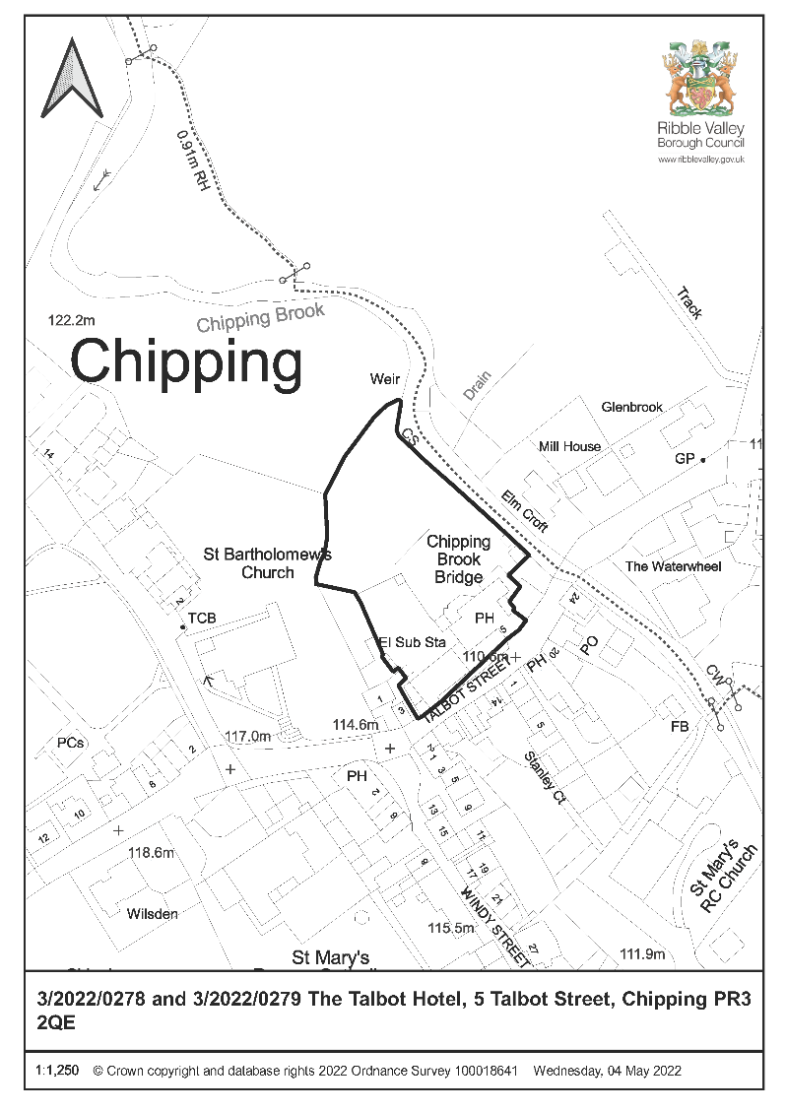

CONSULTEE RESPONSES/ REPRESENTATIONS MADE:

PARISH COUNCIL:

Chipping: Supportive of the scheme and welcome the development as it would improve the visual amenity of the area and prevent further deterioration of these buildings.

ENVIRONMENT DIRECTORATE (COUNTY SURVEYOR):

Following further information raise no objections to the proposal subject to conditions relating to construction traffic management plan, implementation of access arrangements, surfacing of access drive, implementation of parking and turning facilities and electric vehicle charging points.

UNITED UTILITIES:

That the applicant submits proposed levels and an indicative foul and surface water drainage strategy (including cover and invert levels). This information has been submitted and is awaiting response. Request a condition relating to sustainable surface water drainage.

LCC ARCHAEOLOGY:

The applications are accompanied by a Heritage Statement which describes and illustrates the buildings and assesses the impact of the scheme upon their significance. There will be negative impacts upon this significance, but the changes proposed appear to have a less than substantial impact when balanced against the advantage of bringing the buildings back into economic use. Given the detail provided in the Heritage Statement we considered if any further building recoding was necessary and have concluded that sufficient questions over the buildings’ features, history and development remain to justify the creation of a formal record to level 3 as set out in “Understanding Historic Buildings” (Historic England 2016). This can be required by an appropriate planning condition.

This is in accordance with the NPPF Para 205 which requires LPA to require developers to record heritage assets to be lost (wholly or in part).

HISTORIC ENGLAND:

Not offering any advice but suggests seeks the views of our specialist conversion and archaeological advisers.

OTHER AMENITY GROUPS:

No representation received.

ADDITIONAL REPRESENTATIONS:

One supporting letter has been received stating the scheme will positively improve Talbot Street and support local businesses.

1. Site Description and Surrounding Area

  - The site consists of two Grade II Listed Buildings and is located with Chipping Parish. The site is within Chipping Conservation Area and the Forest of Bowland Area of Natural Beauty they are also protected trees within the site.

  - One building was last in use as a public house and the other has been in use as a Barn.

  - The site is served by an established access off Talbot Street
.
2. Proposed Development for which consent is sought

2.1 The proposed development at site is to convert the public house into one dwellinghouse with holiday let with limited external alterations and convert the barn into three dwellinghouses with associated external works. Formation of car park and manoeuvring to rear and hard and soft landscaping.

2.2 A structural Survey has been submitted which details the existing internal and external condition of the buildings. In general, the Hotel has some signs of water ingress and timber decay with some internal ceilings partially collapsed. In terms of the barn areas of slating have partially collapsed internally and externally a partial collapse and missing slate to the rear roof pitch and the excessive bulge to the right-hand gable wall raises some concerns notwithstanding the metal tie bar installed to prevent outward movement and separation. The rear wall shows distortion along its length where stonework has eroded.

2.3 The proposed development will retain the existing built form of both buildings with external changes kept to a minimum particularly on the front, public elevations. New windows and doors are in the main limited to previous openings with some rooflights and new openings being proposed. Some new boundary fencing to separate the rear gardens, formation of car parking and timber bin stores are proposed.

2.4 Internally the scheme for the Public House would require the removal of some internal walls as well as the re-siting of the staircase from ground to first floor to the suggested original position. With regards to the barn some internal diversions to create three units will also be required.

3. Relevant Planning History

2012/0962 & 2012/0963 – Full and LBC: Refurbishment and extension to existing hotel to create 9no.ensuite bedrooms, function suite, bistro restaurant and bar area with ancillary hotel, kitchen and staff facilities; change of use of existing barn to form 11no. ensuite bedrooms ancillary to the hotel accommodation: extension and refurbishment of existing car parking facilities to create 46no. parking spaces including the repair and refurbishment of the existing cobbled forecourt (Resubmission of 3/2011/0821) (Listed Building Consent) and 3/2011/0822 (Full) – Approved with conditions.

2011/0822 & 2011/08821 – Full and LBC: Demolition of existing single storey extension and removal of render to front elevation; repair and repointing of stonework; refurbishment and extension to existing hotel to create 9no. ensuite bedrooms; function suite, bistro restaurant and bar area with ancillary hotel, kitchen and staff facilities; change of use of the existing barn to form 11no. ensuite bedrooms ancillary to the hotel accommodation; extension and refurbishment of existing car parking facilities to create 50no.car parking spaces including the repair and refurbishment of the existing cobbled forecourt – Refused 16th March 2012.

2010/0131 – LBC: Partial careful demolition of bulge in gable wall of barn and rebuild in stone from demolition (using a mix of 1-part NHL 3.5:3 parts sand)

4. Relevant Policies

Ribble Valley Core Strategy (Adopted Version)
Key Statement DS1 – Development Strategy
Key Statement DS2 – Presumption in Favour of Sustainable Development
Key Statement EN1 – Green Belt
Key Statement EN3 – Sustainable Development and Climate Change
Key Statement EN5 – Heritage Assets
Key Statement EC1 – Business and Employment Development

Policy DMG1 – General Considerations
Policy DMG3 – Transport and Mobility
Policy DME3 – Site and Species Protection and Conservation
Policy DMH3: Dwellings in the Open Countryside & the AONB
Policy DMH4: The Conversion of Barns and other Buildings to Dwellings
Policy DME4 – Protecting Heritage Assets

National Planning Policy Framework
National Planning Policy Guidance
Sections 66 and 72 of the Planning (Listed Buildings and Conservation Areas) Act 1990.

5. Assessment of Proposed Development

5.1 Members will be aware that consent has been issued for the redevelopment of this site in 2012, however, since the development was not commenced on the previous permissions there is no extant permission in place.

5.2 Principle:

It is proposed to use the hotel as a 5 bedroomed dwelling and a two bedroomed holiday let to the southern end of the building in the later coach house element.

The Barn is proposed to be converted into two three bedroomed dwellings and one two bedroomed dwellinghouse.

In terms of external alterations to the public house two flush fitting conservation roof lights are proposed to the front elevation to serve the two bedrooms in the attic with the removal of the external first floor staircase and then infill the doorway with a glazed screen. The adjacent first floor window would be reinstated as well as the rear window to the single storey north extension. The single storey rear extension will now remain with the pitched roof removed and a parapet roof installed and the proposed alterations to the bay window to allow for full length bi-fold windows to be installed whilst this is not desirable in overall terms it would not remove any original fabric and this element was originally proposed to be removed altogether which would have been acceptable and therefore this raises no undue concerns.

In terms of external alterations to the Barn 3no. flush fitting conservation rooflights are now proposed to the roof slopes with one to the front and two to the rear. On the north elevation the existing openings would be re-instated including the cart door. The south elevation would have an additional window inserted with the downpipe moved and two doors formed out of an existing window opening. Two first floor windows would also be formed. As this is the rear elevation and would be used as primary access to the units then this is, in my view, acceptable.

Changes to the western gable would be limited to one new first floor window being formed and the reinstatement of two doors with full length glazing and two existing openings to windows.

The existing blocked/boarded up windows to the east gable would be reinstated with full glazing. Again, this is considered to be acceptable.

Whilst no details of the windows have been submitted these will all be timber and original frames in the Public House will be repaired where necessary. Details of all replacement and repairs to windows and doors can be controlled by appropriate conditions.

5.3 Policy DMH3: Dwellings in the Open Countryside & the AONB seeks to limited residential development in these areas to the following:

- Essential for agriculture or which meets an identified local need;
- Appropriate conversion provided they are suitably located and their form and general design are in keeping with and structurally sound and capable of conversion without the need for substantial reconstruction; and
- Rebuilding or replacement of existing dwellings.

In this case the buildings are capable of being converted, albeit there are concerns regarding the condition of the barn which still need to be addressed.

5.4 Whilst there are two existing hostelries in the area which serve the needs of the residents and visitors as well as function facilities at Chipping Village Hall, Gibbon Bridge Hotel and the Inn at Whitewell there would be some impact from the loss of the community facility as a public house even taking into account that the pub has not operated as such for over 15 years this impact needs to be fully considered prior to assessing whether these properties can be brought back into an appropriate alternative use.

In terms of economic and social impact that would result from the loss of employment this has not been fully considered in terms of attempts to secure any alternative employment use for the site. It is acknowledged that a viability report has been undertaken and submitted, however, this only consider the use as a public house and not for any other business use or tourism outlet which could result in more public benefits and economic than the scheme as submitted.

Policy DMB1: Supporting Business Growth and the Local Economy seeks to assess potential alterative uses for employment sites which are supported by evidence that the property has been marketed for business use for a minimum of six months or provided information that demonstrates that the current use is not viable for employment purposes.

This is not the case here and therefore the proposal therefore fails to accord with this policy.

5.3 Residential Amenity

There are residential properties in close proximity to the site including no. 7 Talbot Street immediately adjoins the public house on its eastern side and no. 3 Talbot Street is sited adjacent to the barn on the western side separated by a small gap of around 3m which also accommodates the external stone stairs serving that property. No.’s 2 - 16 Talbot Street are sited opposite the barn across the highway at approx. 5.5m. There is an existing Public House (Tillotson’s Arms) is sited across from the Talbot at a slight angle and a shop/café adjoins that with further residential properties.

None of these properties would be unduly affected by the proposal due to the existing relationships. The proposed rear extension would have a smaller footprint than at present and is located to the north west corner between the Public House and the Barn. No. 7 is the nearest residential property which shares an existing boundary with the Talbot no changes are proposed to the eastern elevation that would affect this property although car parking is proposed to the northern boundary which would require appropriate boundary treatment to ensure no adverse impacts.

No. 3 is separated from the barn to the west by a 3m gap and this would not change in the proposed scheme. Albeit the proposed use would result in more activity with this gap providing a joint pedestrian access to this property and one of the dwellings proposed as part of the barn conversion.

Elm Croft is located to the north east of Chipping Brook would bounds the north east boundary of the site. This property is sufficiently distant that it would not be unduly impacted by the proposed scheme and could, to some degree, benefit from the use as dwellings and holiday let rather than its current use as a Public House due to the less intensive use and public use of the building and its grounds. There is some parking proposed in the eastern corner of the site, however, this does not raise any adverse amenity issues.

Taking the above into account the proposal would result in a less intensive use than at present and previously approved and would not result in any undue amenity issues subject to appropriate conditions.

5.4 Heritage/Cultural:

The Talbot Hotel and stable and barn to the south west are both Grade II listed in recognition of their national architectural and historic interest. Both buildings date from the late 18th Century and derive significance from their relationship and make an important contribution to the Chipping Conservation Area therefore regard must be had to the level of harm to the Heritage Assets that may result from this proposal.

A Heritage Statement has been submitted with the application which sets out the history of the site and the potential impact of the proposed development upon the Heritage Assets.

The buildings are unoccupied and have remained so since 2004 despite a number of previous planning applications being submitted and approved. The latest approved scheme was in 2012 and entailed the public house being brought back into use together with ancillary bedrooms within the barn. Although this has not been implemented regard must had to this approved scheme and how this compares with this proposal.

In 2012 a scheme for a similar use was refused due to harmful impact on the character and setting of the stables and barn due to loss of historic fabric and the insertion of overly domesticated windows and rooflights and harmful impact to the Hotel due to loss of historic fabric and the dominant size of the new build element.

The subsequent scheme was approved subject to conditions.

The previous two schemes involved an intensification of the uses of the site in order to enable the use as a hotel to continue. These included extensions to the buildings as well as increase in car parking facilities and activities such as functions

This scheme proposes to use the buildings as dwellings and a holiday let and whilst this use would affect the historic and communal use of the Hotel this must be balanced against the current vacant state of the buildings which have not been in use for over 15 years and the benefit that bringing these important buildings back into a viable use would obtain. There would be limited impact on the Hotel in terms of the appearance and fabric of the building.

The reinstatement of the windows and removal of the external staircase would be of limited benefit in this respect. However, this would result in less harm than the previous schemes and therefore would preserve more of the character and historic fabric of these buildings. Albeit this would be to the detriment of the historic interest particularly in terms of the Barn which would require less sub-diversion and alteration with the open plan living space at ground floor retaining some of the open character of the original interior and creating an active frontage to the street.

In my opinion whilst this would result in less than substantial harm to the listed buildings this would need to be weighed against the public benefits of the scheme.

In this case the public benefits are limited. Whilst the amendments provided have improved the scheme and removed some of the elements such as the single storey rear extension, additional windows and rooflights in order to achieve a more acceptable scheme which retains more of the fabric of the structure and clearly retains its historical character. Not all the requested changes have been addressed and there are still minor changes which would improve the scheme and agent has been requested to address these elements.

Key Statement EN5: Heritage Assets and Policy DME4: Protecting Heritage Assets

Aims to allow development which conserves and enhances heritage assets and their settings.

Proposals within a Conservation Area will be required to conserve and where appropriate enhance it character and appearance and those elements which contribute towards its significant.

Alterations and/or extensions to listed buildings which cause harm to the significance of the heritage asset will not be supported.

Proposals which involve the demolition or loss of important historic fabric will be refused unless it can be demonstrated that exceptional circumstances apply.

Parking along the frontage on the setts which should be avoided for due to impact on the Listed Buildings and highway safety and this can be controlled by an appropriate condition.

Whilst a Heritage Statement has been submitted with these applications it fails to fully consider the impact of the loss of the public house in economic and social terms and does not provide any reasoned justification that three units for the barn would provide the optimum viable use of the building.

Moreover, the viable use has only been considered in terms of profitability and not impact on the Listed structures.

It is considered that the proposed development would not result in a greater impact on the wider environment in which the listed building is experienced, it would allow for a reduced and a better impact on its immediate setting, and on the building itself. It is important to note that the significance of the listed buildings is considered to derive primarily from its physical fabric and its architectural interest within the streetscene.

As no new built elements are now proposed and there are limited external and internal changes it is concluded that although the proposed changes would result in limited impact on the Listed Buildings this would not be so harmful as to warrant a refusal when balanced with the slight benefits of removing some of the external elements from the Listed Public House and the limited public benefits that may result from the scheme including limited employment and increased tourism provision in the area.

5.4. Visual Amenity

The site is within the Forest of Bowland Area of Outstanding Natural Beauty and is prominent within the centre of this small village location.

It is beneficial that these two important buildings are brought back into a viable use in order from them to be able to contribute towards the local area and to enhance the buildings in an appropriate manner.

The proposed scheme would retain the majority of the public frontages with changes proposed to the barn in order to enable its re-use as a dwellinghouse. These changes do propose new openings and rooflights and the agent has been requested to remove some of these elements.

Parking would be to the rear accessed via the new vehicular entrance to the site between the two buildings. Two spaces for the proposed holiday let are proposed to be sited on the setts to the front of the former pub. The agent has been requested to move these to the rear.

Subject to these changes the proposed scheme would be acceptable in this location and whilst not as active as the former use would create a renewed and active frontage.

Policy DMH3: Dwellings in the Open Countryside & the AONB allows for residential development where it is an appropriate conversion provided, they are suitably located and their form and general design is in keeping with and structurally sound and capable of conversion without the need for substantial reconstruction.

In this case the buildings are capable of being converted, albeit there are concerns regarding the condition of the barn which still need to be addressed.

5.5 Highways:

LCC as the highway authority have no objection subject to the imposition of appropriate conditions. A vehicular access will be formed between the pub and barn. Parking for the main dwelling, converted barn and holiday let will be to the rear.

The site will be accessed off Talbot Street which is a C classified road subject to a 30mph speed limit. The access will be approximately 4.15m wide at the public highway but will reduce to 3.6m, a total distance of 2.3m from the adopted highway and will be bound on one side by the converted barn.

The car parking arrangements to the rear could be improved to provide tandem parking to
the rear of the proposed units closer to the rear gardens and access doors. This matter
has been raised with the agent and any update will be reported to the meeting.

5.6 Flood Risk
Chipping Brook lies to the east of the site which results in part of the site falling within Flood Zone 2 and 3. The Talbot Hotel lies closest to this boundary but is outside of the area at risk of flooding. Floor levels will remain at or above existing.

A Flood Risk Assessment has been submitted with the application which states that any fencing should be open to allow for the free passage of water and the entrance door to the workshop area should be flood resistant as this would be the most vulnerable area and closest to the brook. A large area of the existing tarmac car park will be broken up with a 30% reduction in drained surface area.

It is concluded that the proposed scheme would not result in any increased flood risk on or off site.

5.7 Ecology/Trees/Landscaping:
A Bat and Bird Survey has been submitted with the application which concludes that no
concerns have been raised subject to installation of bat and bird boxes to promote
biodiversity.

Group 1 includes 7 Ash trees which are displaying signs of ash die back and need to be
removed subject to appropriate replacement this would be acceptable. T2 is a Cherry
which is proposed to be removed to facilitate parking. This tree should be retained and
the parking layout amended to reflect this.

Subject to the above and adequate tree protection of the retained trees to be erected to
BS then this is acceptable

6. Conclusion

6.1 It is accepted that the proposal would not lead to significant harm to the heritage asset and there would be some public benefits with the retention of the buildings and new uses but the applicant has failed to evidence any marketing exercise for other employment uses and as such is contrary to adopted policy DMB1.

RECOMMENDED: That the application be REFUSED on the following grounds:

- The proposal as submitted does not provide sufficient evidence that the buildings could not be retained or re-used for employment purposes and that sufficient marketing has been carried out for this purpose and therefore fails to accord with Policy DMB1 of the Ribble Valley Borough Council Core Strategy 2008 – 2028.

BACKGROUND PAPERS

https://webportal.ribblevalley.gov.uk/site/scripts/planx_details.php?appNumber=3%2F2022%2F0279

