

TREE WORK ASSESSMENT

DATE INSPECTED: |  |  |  |  |  |  |  | 28/04/2022
TPO: | 227 -2022 High Beech House, 8A Crow Trees Brow, Chatburn
CONSERVATION AREA: |  |  |  |  | No
APPLICATION NO: |  |  |  | 3/2022/0333
SPECIES: |  | Beech (T1) & Sycamore (T2)
BS5837 CAT: |  |  | U (T1) & B (T2) |  |  | ASSESSOR: |  |  | A Shutt
 |  |  |  |  |  | SIGNATURE:
VISUAL TREE ASSESSMENT / COMMENTS

Both trees have amenity value and are important features especially when entering the village from the eastern approach.

T1 has been surveyed by a Council approved arborist who has concluded that the Beech Tree (T1) has significant structural defects due to the advanced effects of the soft rot decay fungus Kretzschmaria deusta, which can cause a brittle fracture of the stem at ground level, and its removal is subsequently recommended.

Replacement trees will be conditioned to mitigate the loss of T1.

T2 had no professional recommendations.

The High Beech House, 8A Crow Trees Brow, Chatburn TPO 2022 is going to the Planning and Development Committee on the 19 May 2022 to decide whether or not the order should be confirmed.

RELATED ISSUES: | YES |  | NO |  |  |  |  | YES | NO
Planning Application |  |  |  |  | Highway issue |  |  |  | 
Statutory Undertaker |  |  |  |  | Damage to property (proven) |  |  |  | 
Health & safety issues |  |  |  |  | Nuisance |  |  |  | 
Other (describe)* | 
T2 Tree Maintenance
AMENITY EVALUATION: |  | YES |  | NO
Carried out |  | N/A |  | N/A
Necessary |  | N/A |  | N/A

Application works appropriate? | YES  & NO  SPLIT DECISION
Why?
T1 has a number of structural defects and showing advanced signs of Kretzschmaria deusta, the risk of failure is unacceptable. 2 replacement beech trees will be conditioned for mitigation.

The stem of T1 could be retained as a habitat pole/natural sculpture once the canopy has been removed.

T2 has no significant defects and no evidence that the tree works applied for are required. Crown reduction, lifting and thinning of T2 will be refused due to the detrimental effect the pruning will have on T2’s amenity value and the works do not conform to BS:3998 Tree Work recommendations. Due to the loss of T1 the amenity value of T2 is increased as the tree is more prominent within the landscape
Alternative works more appropriate? | YES  FOR T2
Describe Alternative Works:

Crown clean T2 to remove all the dead or diseased wood and dead hanging branch.

T1 BEECH
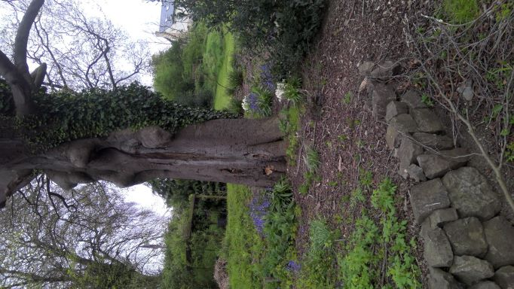

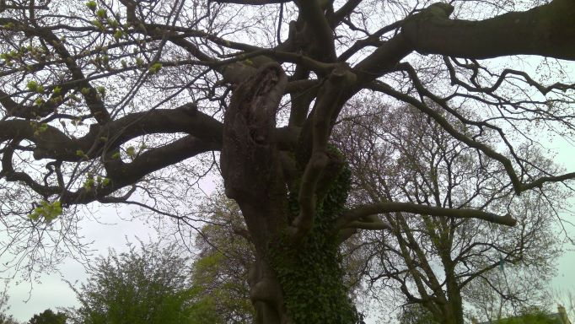

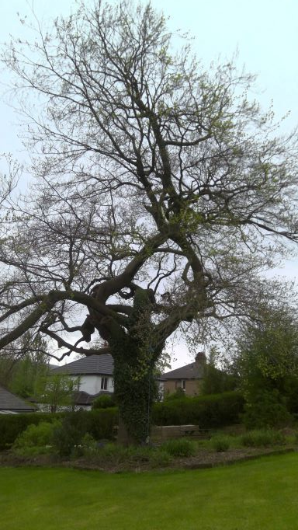

T2 SYCAMORE
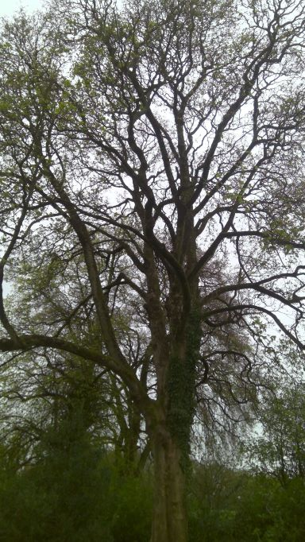

WESTERLY VIEW

