

TREE WORK ASSESSMENT

DATE INSPECTED: |  |  |  |  |  |  |  | 1/07/2022
TPO: | 160 – 2000 Vicarage Lane Wilpshire
CONSERVATION AREA: |  |  |  |  | No
APPLICATION NO: |  |  |  | 3/2022/0458
SPECIES: |  | Oak And Ash
BS5837 CAT: |  |  | C - U |  |  | ASSESSOR: |  |  | A Shutt
 |  |  |  |  |  | SIGNATURE:
VISUAL TREE ASSESSMENT / COMMENTS

Trees form an important part of the urban landscape within this area. However, the Ash trees are showing advanced signs of Ash dieback and the retrenchment pruning of the 2 oaks is of sound arboricultural management and will enable T25 (oak) which is in good condition to flourish.
Replacement planting for the 2 ash trees will be conditioned.
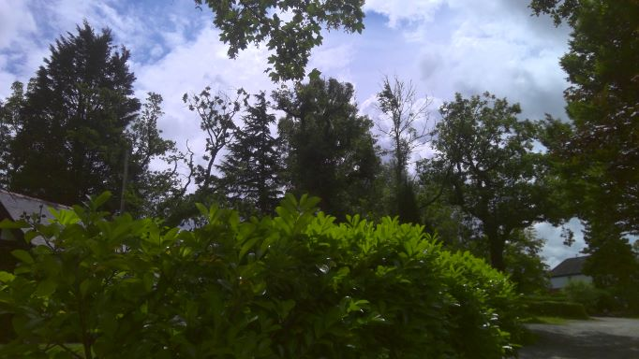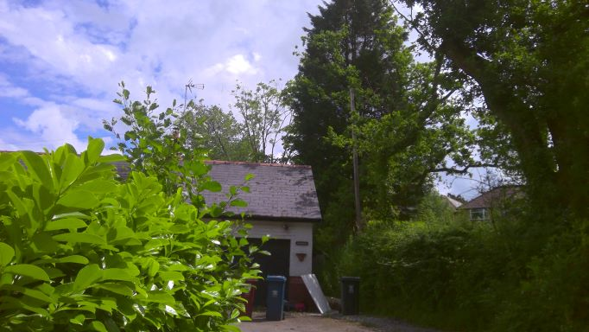

RELATED ISSUES: | YES |  | NO |  |  |  |  | YES | NO
Planning Application |  |  |  |  | Highway issue |  |  |  | 
Statutory Undertaker |  |  |  |  | Damage to property (proven) |  |  |  | 
Health & safety issues |  |  |  |  | Nuisance |  |  |  | 
Other (describe)* |  |  | 
AMENITY EVALUATION: |  | YES |  | NO
Carried out |  | N/A |  | N/A
Necessary |  | N/A |  | N/A

Application works appropriate? | YES 
Why?

The 2 ash trees are showing advanced signs of ash dieback and the retrenchment pruning of the 2 oaks is of sound arboricultural management and will enable T25 (oak) which is in good condition to flourish.

Replacement planting for the 2 ash trees will be conditioned.

Alternative works more appropriate? | NO 
Describe Alternative Works:

