APPLICATION REF: 3/2022/0469

GRID REF: SD 368573 438134

DEVELOPMENT DESCRIPTION:

OUTLINE PLANNING APPLICATION FOR THE ERECTION OF THREE NEW RESIDENTIAL DWELLINGS. THE WARREN, WARREN FOLD, HURST GREEN, BB7 9QH

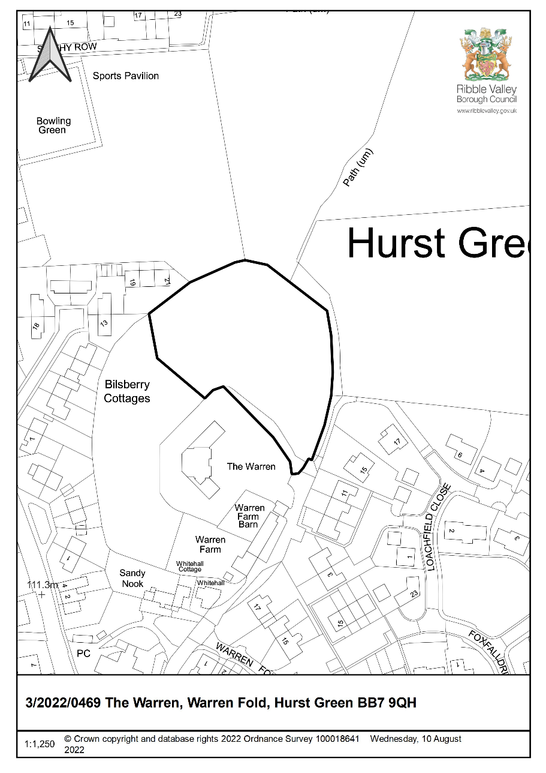

CONSULTEE RESPONSES/ REPRESENTATIONS MADE:

PARISH COUNCIL:

No representations received in respect of the proposal.

ENVIRONMENT DIRECTORATE (COUNTY SURVEYOR):

The Highways Development Control Section has raised no objection to the proposal subject to the imposition of conditions requiring the submission of a Construction Method Statement.

ADDITIONAL REPRESENTATIONS:

Four letters of representation have been received objecting to the application on the following grounds:

- Loss of privacy
- Impacts upon wildlife
- Impacts upon character and visual amenities of the area
- Significant ecological impact by virtue of woodland removal
- Proposed built-form will alter the character of the Tolkien trail to its detriment
- Narrow lane and inadequate access which would result in conflict with existing walkers

Members will additionally note that a ward councillor has requested that this application is determined by Planning and Development committee for the following reasons:

- Significant due to impact on area
- High level of public interest
- Significant departure from policy

1. Site Description and Surrounding Area

1.1 The application relates to an area of land outside of but directly adjacent to the defined settlement limits of Hurst Green. The site is located within the defined Forest of Bowland Area of Outstanding Natural Beauty also being adjacent, at its south-eastern extents, the defined Hurst Green Conservation Area.

1.2 The area of land to which the application relates lies directly to the north of the dwelling known as ‘The Warren’ and currently accommodates an area of extensive woodland/shrubland with the site also being directly adjacent a Public Right of Way (footpath 64) which bounds the site to the east.

2. Proposed Development for which consent is sought

2.1 The application seeks outline consent (all matters reserved) for the erection of three self-build dwellings. During the course of the application the agent acting on behalf of the applicant has confirmed that ‘the units are to be single storey bungalows, self-build and for over 55's only’. An amendment to the description of the development has not been secured as the agent was on holiday at the time of writing this report.

2.2 The application has been accompanied by an illustrative layout which shows pedestrian and vehicular access being provided by way of the existing access serving the existing dwelling.

3. Relevant Planning History

3/2013/0963: New dwelling in garden of The Warren.
Land adjacent to The Warren Warren Fold Hurst Green BB7 9QS. (Withdrawn)

3/2014/0204:
Outline planning application for the erection of one new residential dwelling. (Refused) (Appeal Dismissed)

4. Relevant Policies

Ribble Valley Core Strategy

Key Statement DS1 – Development Strategy
Key Statement DS2 – Sustainable Development
Key Statement DMI2 – Transport Considerations#
Key Statement EN2 - Landscape

Policy DMG1 – General Considerations
Policy DMG2 – Strategic Considerations
Policy DMG3 – Transport & Mobility
Policy DMH3 – Dwellings in the Open Countryside

National Planning Policy Framework (NPPF)
National Planning Practice Guidance (NPPG)
Technical Guidance to National Planning Policy Framework

5. Assessment of Proposed Development

5.1 Principle of Development:

5.1.1 The application site lies within the defined Forest of Bowland Area of Outstanding Natural Beauty (AONB) being located outside of, but directly adjacent the defined settlement limits of Hurst Green, as such given the application seeks consent for new residential development, Policies DMH3 and DMG2 are fully engaged.

5.1.2. Policies DMH3 and DMG2 of the Ribble Valley Core Strategy seeks to restrict residential development within the open countryside and AONB to that which meets a number of explicit criterion, with Key Statement DS1 setting out the overall spatial aspirations for general development within the Borough. Given the proposal site is located outside of any defined settlement limits, being upon land that benefits from an AONB designation, Policy DMG2 is fully engaged for the purposes of assessment of the application.

5.1.3 Policy DMG2 is two-fold in its approach to guiding development. The primary part of the policy DMG2(1) is engaged where development proposals are located ‘in’ principal and tier 1 settlements with the second part of the policy DMG2(2) being engaged in circumstances when proposed development is located ‘outside’ defined settlement areas or within tier 2 villages, with each part of the policy therefore being engaged in isolation and independent of the other dependant on the locational aspects of a proposal.

5.1.4 The mechanics and engagement of the policy are clear in this respect insofar that it contains explicit triggers as to when the former or latter criterion are applied and the triggers are purely locational and clearly based on a proposals relationship to defined settlement boundaries and whether, in this case, such a proposal is ‘in’ or ‘outside’ a defined settlement.

5.1.5 The proposal is located outside of any defined settlement boundary, in this respect, when assessing the locational aspects of the development, it is the secondary element of Policy DMG2 that is engaged (Policy DMG2(2)) which states that:

Within the tier 2 villages and outside the defined settlement areas development must meet at least one of the following considerations:

- The development should be essential to the local economy or social wellbeing of the area.
- The development is needed for the purposes of forestry or agriculture.
- The development is for local needs housing which meets an identified need and is secured as such.
- The development is for small scale tourism or recreational developments appropriate to a rural area.
- The development is for small‐scale uses appropriate to a rural area where a local need or benefit can be demonstrated.

5.1.6 Given the site is located outside of any defined settlement limits, DMH3 is also applicable, with the policy being engaged in parallel with Policy DMG2. In this respect Policy DMH3 states that:

Within areas defined as open countryside or AONB on the proposals map, residential development will be limited to:

- Development essential for the purposes of agriculture or residential development which meets an identified local need. In assessing any proposal for an agricultural, forestry or other essential workers dwellings a functional and financial test will be applied.
- The appropriate conversion of buildings to dwellings providing they are suitably located and their form and general design are in keeping with their surroundings. buildings must be structurally sound and capable of conversion without the need for complete or substantial reconstruction.

5.1.7 In respect of the above first criterion, it is clear from the submitted details that the proposal could not be argued as being ‘essential to the local economy or social wellbeing of the area’ nor could it be considered that the proposal ‘is needed for the purposes of forestry or agriculture’.

5.1.8 Turning to the secondary criterion, in respect of the matter of ‘local need’, no evidence has been provided to suggest that the proposal would align with the definition of ‘local needs housing’. The Ribble Valley Core Strategy states that local needs housing is ‘the housing developed to meet the needs of existing and concealed households living within the parish and surrounding parishes which is evidenced by the Housing Needs Survey for the parish, the Housing Waiting List and the Strategic Housing Market Assessment.’ and that ‘the most recent SHMA and Housing Needs Survey and waiting list evidence would always be used in determining if the proposed development meets the identified need’.

5.1.9 Members will note that the submitted details propose that the dwellings will be self-build in nature (for those aged 55 or over), as defined within the Self-build and Custom Housebuilding Act 2015 (as amended by the housing and planning act 2016). However, the proposal remains for that of residential development and as such the proposal must be assessed against relevant adopted development plan policies relating to the locational aspirations for new residential development in the borough with policies DMH3 and DMG2 of the Adopted Core Strategy, once again, remaining fully engaged.

5.1.10 In this respect the authority does not consider that the current application for self-build housing can be considered as ‘local needs housing’ for the purposes of the secondary criterion of Policy DMH3, particularly given it fails to fall within the definition contained within the current adopted development plan.

5.1.11 This matter has been clarified through recent inspectors’ decisions, the ‘Wiswell Decision’ (APP/T2350/W/18/31210850) and the ‘Stables Decision’ (APP/T2350/W/19/3235162) whereby both inspectors concurred with the Local Planning Authority approach in that self-building housing cannot be considered as ‘local-needs housing’ as defined within the adopted development plan. As such, in this respect, it is considered that the proposal cannot be considered as an ‘exception’ given it fails to meet the exception criterion of both Policies DMH3 and DMG2 in respect of new housing outside of a defined settlement.

5.1.12 At the time of writing this report, the number of individuals/groups registered on the self-build register held by the authority are as follows:

- Part 1 Register - 12 individuals and two associations.
- Part 2 Register – 1 individual

5.1.13 The Self-Build Act places a duty on authorities to comply with their duty to grant sufficient permissions to match demand as reflected on Part 1 of the self-build register, within a three-year period from the end of each base period. The first base period ended on the 30th of October 2016 therefore the time for ‘compliance’ with the duties imposed under the act is imminent in respect of the first base period only. To date the authority has only granted consent for one self-build housing unit, with the unit having been considered in compliance with the requirements of DMG2 in that it was wholly located within the defined settlement limits of a principal settlement.

5.1.14 However, the authority does not consider that the ‘duty to grant sufficient consents’ releases ‘self-build’ housing proposals from the need to comply with the compliment of policies relating to the location of new residential development within the borough as contained within the adopted development plan, which in this case are primarily Policies DMG2 and DMH3.

5.1.15 As such, the authority does not consider that the ‘self-build’ nature of the proposal allows for ‘exceptional site release’ nor does it exempt such proposals from having to meet policy specific locational criterion, regardless of the outstanding demand on part one of the Self-build Register.

5.1.16 Turning to the matter of the dwellings being for occupation solely by those aged 55 or over. Notwithstanding the potential occupancy restrictions that would be required to be imposed, the proposal would still remain for that of open market housing albeit occupancy of the dwellings would be age restricted. In this respect the imposition or engagement of an age-related occupancy restriction alone would also fail to satisfy any of the explicit exception criterion contained within Policies DMG2 and DMH3.

5.1.17 A recent Inspectors decision, whereby an appeal was dismissed, also considered similar matters elsewhere in the borough (APP/T2350/W/20/3247676) also outside of defined settlement limits. In reaching their conclusions the Inspector concluded that:

‘The SHMAs –one of the documents referred to in the Core Strategy glossary – include reference to the proportion of older people within the borough’s demographic and the implications for housing provision within the borough. However, even having regard to the appellant’s LHNAs (Local housing Needs assessment) as a further material consideration, I am not satisfied that a compelling local housing need for the older people’s market bungalows proposed has been demonstrated to justify the development in the open countryside’. With the Inspector further stating that ‘It is common ground that the Council is currently able to demonstrate a 5 year supply of deliverable housing sites. Taking those factors together, from the evidence before me I am satisfied that the Council’s development strategy and housing policies are functioning to deliver the type of housing identified in the LHNAs and proposed in this case.

5.1.18 In respect of the current proposal, the applicant has not provided any evidence whatsoever in respect of over 55 housing need in the parish or adjacent parishes that would warrant the proposal being considered as being for that of an identified and outstanding local need. Notwithstanding this matter, members will note that the Inspector determined that the currently adopted policies are ‘functioning’ to deliver these house types in any case.

5.1.19 In light of the above matters, and in the absence of any other evidence to suggest otherwise, it cannot be considered that the proposal meets any of the exception criterion contained within Policies DMG2 nor DMH3 in relation to new dwellings outside of defined settlement limits.

5.1.20 As such, the clear, significant and direct conflict with both Policies DMG2 and DMH3 of the Ribble Valley Core Strategy, in that the proposal fails to meet any explicit residential exception criterion, precludes the ability for the principle of residential development to be supported in this location.
5.2 Impact upon Residential Amenity:

5.2.1 Given the proposal seek outline consent with all matters reserved, no definitive assessment of the impacts upon residential amenity or the level of residential amenity that will be afforded to future occupiers of the dwellings can be made at this stage. However given the size of the application site and the siting of the immediate neighbours it is considered that a scheme could be developed which protects both the amenities of the existing and future residents.

5.3 Visual Amenity/External Appearance

5.3.1 The application is made in outline with all matters reserved, as such no definitive determination can be made in respect of the likely impacts upon the character or visual amenities of the area that may be resultant from the proposal.

5.3.2 Notwithstanding this matter, the applicant has submitted an indicative site layout that illustrates how the quantum of development could be accommodated on-site, with the submitted details indicating three detached dwellings being located within significant individual plots with access being provided via the existing shared access that proved access the ‘The Warren’

5.3.3 Whilst potential landscape or visual harm cannot be fully ascertained at this stage, members will note that a historic Inspectors decision (APP/T2350/A/14/2221778) on the site, which sought outline consent (access, layout and scale) for the erection of one residential dwelling was dismissed with the Inspector concluding, in addition to other matters, that there would be visual harm stating the following:

The site is surrounded by a stone wall and is elevated in relation to the adjoining fields. As such, it is already visually delineated from the wider countryside to the north and east. I also appreciate that the proposed house could be further screened by additional landscaping to lessen its visual impact. Nevertheless, in my view the further containment of the site would itself be harmful to the open character and appearance of the surrounding area.

Thus, whilst I appreciate that the matters of scale, layout, appearance and landscaping are reserved for future consideration, a dwelling on the appeal site would protrude into the open countryside and extend built development into it. Moreover it would be highly visible from the open fields to the north and east. This being so, I cannot see that the proposal would appear sympathetic to the surrounding countryside or that it would conserve the natural beauty of the AONB. That the site is not in the Green Belt does not alter my view.

5.3.4 As such, taking account of the above, given visual harm was determined to be evident resultant by virtue of the introduction of one single dwelling, it must therefore be concluded that the siting of three dwellings on the site would also undoubtedly result in a similar if not greater level of visual harm upon the character and visual amenities of the area and that of the Forest of Bowland Area of Outstanding Natural Beauty.

5.4 Highway Safety and Accessibility:

5.4.1 The Highways Development Control Officer has raised no objections to the proposal subject to the imposition of a condition relating to the requirement for a Construction Method Statement to be submitted should consent be granted.

6. Observations/Consideration of Matters Raised/Conclusion

6.1 For the reasons outlined above the proposed development is considered to be in significant direct conflict with conflict with both Policies DMG2 and DMH3 of the Ribble Valley Core Strategy, in that the proposal fails to meet any explicit residential exception criterion in relation to the creation of new residential dwellings outside of defined settlement limits.

RECOMMENDATION: That the application be REFUSED for the following reason(s):

- The proposal is considered to be in direct conflict with Policies DMG2 and DMH3 of the Adopted Ribble Valley Core Strategy insofar that approval would lead to the creation of new residential dwellings, located outside of a defined settlement boundary, without sufficient justification. It has not been adequately demonstrated that the proposal is for that of local needs housing that meets a current identified and evidenced outstanding need or that the proposal would meet any of the exception criterion inherently contained within either policy.

- The proposal is considered to be in direct conflict with Key Statement EN2 and Policy DMG1 of the Adopted Ribble Valley Core Strategy insofar that the introduction of built form and resultant quantum of development in this location, would result in a level of development that would appear both anomalous and incongruous, undermining the character and visual amenities of the immediate area and that of the Forest of Bowland Area of Outstanding natural beauty.

BACKGROUND PAPERS

https://webportal.ribblevalley.gov.uk/planningApplication/34309

