RECOMMENDATION FOR PLANNING AND DEVELOPMENT COMMITTEE
APPROVAL

DATE: 29th June 2023
REF: BT
CHECKED BY: LH
APPLICATION REF: 3/2022/0754

GRID REF: SD 370048 443535

DEVELOPMENT DESCRIPTION:

LAWFUL DEVELOPMENT CERTIFICATE FOR THE CONTINUED USE OF COAR BROOK
HOUSE AS A SINGLE DWELLING HOUSE UNFETTERED BY AN AGRICULTURAL OCCUPANCY RESTRICTION
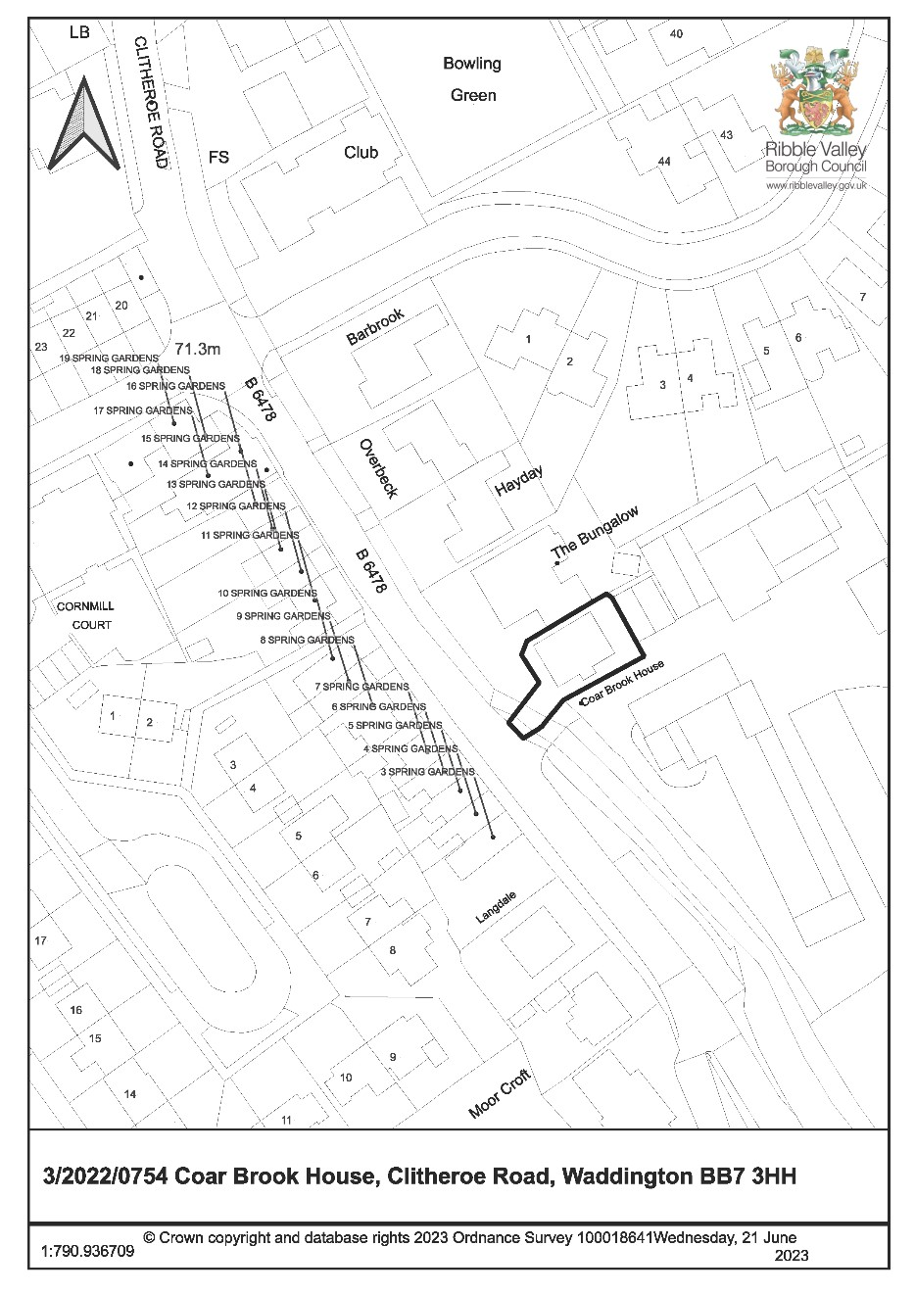
CONSULTEE RESPONSES/ REPRESENTATIONS MADE:

None.

ADDITIONAL REPRESENTATIONS:

None.

1. Site Description and Surrounding Area

1.1 The application relates to a detached dormer bungalow property situated on the Southern edge of Waddington. The property consists of stone elevations, slate roof tiles and mock timber UPVC doors and windows. The property’s two front dormers comprise a hipped roof design with horizontally cladded cheeks.

1.2 Access to the property is from Clitheroe Road over a footbridge which crosses the Waddington Brook. The property’s access is shared with Fields Farm which lies directly adjacent to Coar Brook House. The surrounding area is largely residential in character and comprises a variety of housetypes. An area of open countryside between Waddington and Clitheroe lies to the South-east of the application site.

2. Proposed Development for which consent is sought

2.1 This is an application for a Certificate of Lawfulness to establish the continued use of the application property as a single dwellinghouse unfettered by an agricultural occupancy restriction. The application is being brought before Planning & Development Committee because the applicant is a former Council employee and was employed by the Council at the time the application was submitted.

2.2 Planning permission was granted for the construction of the application property under planning application ref: 3/1995/0564 on 10th February 2000. Condition 2 from this permission reads as follows:

“The occupation of the dwelling shall be limited to a person solely or mainly employed or last employed in the locality in agriculture as defined in Section 336(1) of the town and Country Planning Act 1990 or in forestry, or a dependent of such a person residing with him or her or a widow or widower of such a person.”

2.3 It is the applicant’s claim that they have resided in the application property for in excess of 10 years and are not, or were not solely, mostly or lastly employed in agriculture or forestry. As such, the applicant seeks confirmation of the above in the form of a Lawful Development Certificate.

3. Relevant Planning History

3/1995/0564: Erection of detached bungalow (Approved with conditions 10/02/2000)

4. Relevant Policies

Town and Country Planning Act 1990, Section 171(B); Section 191

National Planning Practice Guidance: Lawful Development Certificates

5. Assessment of Proposed Development

5.1 The lawfulness of the existing use in question rests upon a detailed assessment of the supporting information provided as part of the application in relation to the provisions of Section 171(B) of the Town and Country Planning Act 1990 (the Act). Section 171(B) of the Act provides timescales whereby unauthorised development becomes immune from enforcement action and as such becomes lawful as follows:

- Where there has been a breach of planning control consisting in the carrying out without planning permission of building, engineering, mining or other operations in, on, over or under land, no enforcement action may be taken after the end of the period of four years beginning with the date on which the operations were substantially completed.

- Where there has been a breach of planning control consisting in the change of use of any building to use as a single dwellinghouse, no enforcement action may be taken after the end of the period of four years beginning with the date of the breach.

- In the case of any other breach of planning control, no enforcement action may be taken after the end of the period of ten years beginning with the date of the breach.

- The preceding subsections do not prevent —

    - the service of a breach of condition notice in respect of any breach of planning control if an enforcement notice in respect of the breach is in effect; or

    - taking further enforcement action in respect of any breach of planning control if, during the period of four years ending with that action being taken, the local planning authority have taken or purported to take enforcement action in respect of that breach.

  - In addition, Section 191 (4) of the Act states:

‘If, on an application under this section, the local planning authority are provided with information satisfying them of the lawfulness at the time of the application of the use, operations or other matter described in the application, they shall issue a certificate to that effect.’

  - The above is reiterated in National Planning Practice Guidance which states:

‘The applicant is responsible for providing sufficient information to support an application…if a local planning authority has no evidence itself, nor any from others, to contradict or otherwise make the applicant’s version of events less than probable, there is no good reason to refuse the application, provided the applicant’s evidence alone is sufficiently precise and unambiguous to justify the grant of a certificate on the balance of probability.’

  - In this instance as there was a restrictive use condition imposed, the application is required to be considered against Section 171B (3) of the Act where the relevant (minimum) time
period for immunity from any enforcement action is ten years. Therefore the main issue is whether or not there is sufficient evidence to support the applicant’s claim that the dwelling has been occupied continuously for ten years or more by someone who has not been solely, mostly or lastly employed in agriculture or forestry.

  - The evidence provided by the applicant includes:-

- correspondence from the Council’s Revenues department which confirms the applicants as being joint liable parties for council tax at Coar Brook House from June 1st 2012 to June 20th 2022
- correspondence in the form of a home insurance policy renewal letter which indicates that occupancy of the application property was taken up by the applicants from June 1st 2012
- P60 documents, PAYE documents and correspondence from each of the applicant’s previous employers which shows that both applicants have been in continuous full time employment unrelated to agriculture whilst residing at Coar Brook House.

  - There is nothing to suggest that the applicants have dependents previously or currently living with them who were solely, mostly or lastly employed in agriculture or forestry. Moreover, the Council’s Planning Enforcement Team have confirmed that no enforcement notices have been served in relation to the breach of condition 2 from planning application 3/1995/0564.

  - Taking into account the submitted supporting information and in the absence of any other evidence to suggest otherwise, on balance the property known as Coar Brook House, Clitheroe Road, Waddington, BB7 3HH appears to have been in use as a single open market dwelling, unfettered by agricultural occupancy restrictions for over 10 years, contrary to the provisions of condition 2 of planning consent reference 3/1995/0564.

- Observations/Consideration of Matters Raised/Conclusion:

  - Sufficient evidence has been provided to satisfy the Local Planning Authority that the applicants have continuously resided in the application property for a period in excess of 10 years and are not, or were not solely, mostly or lastly employed in agriculture or forestry during this period.

  - On this basis there are not considered to be any reasons to refuse to grant the certificate of lawfulness.

RECOMMENDED: To approve the application for a Certificate of Lawfulness.

BACKGROUND PAPERS

https://webportal.ribblevalley.gov.uk/site/scripts/planx_details.php?appNumber=3%2F2022%2F 0754

