

TREE WORK ASSESSMENT

DATE INSPECTED: |  |  |  |  |  |  |  | 26/08/22
TPO: | 135 – 1994 Old Print Works Barrow
CONSERVATION AREA: |  |  |  |  | No
APPLICATION NO: |  |  |  | 3/2022/0769
SPECIES: |  | Lime
BS5837 CAT: |  |  | A |  |  | ASSESSOR: |  |  | A Shutt
 |  |  |  |  |  | SIGNATURE:
VISUAL TREE ASSESSMENT / COMMENTS

The trees form part of a protected avenue of lime trees that are of High Amenity value to the new estate and the local area. The trees are in good health and are subjected to an informal management plan by residents, owners and where applicable the developers, evidence of this can be found through past applications.

By carrying out the approved tree works the probability of failure of the trees will be minimised.
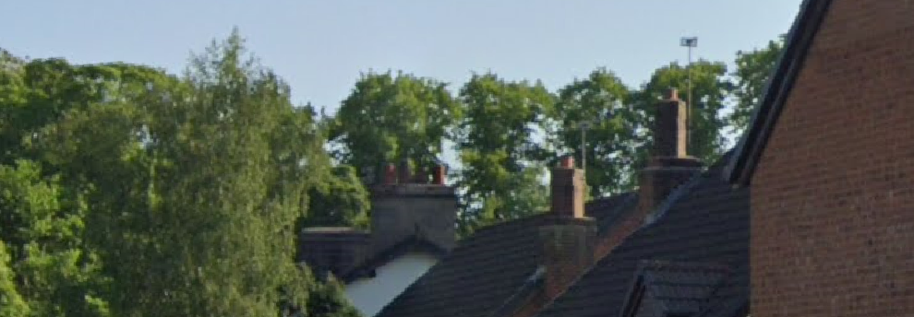
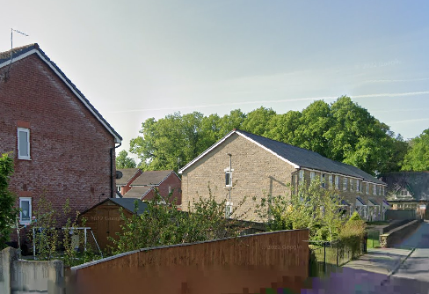

RELATED ISSUES: | YES |  | NO |  |  |  |  | YES | NO
Planning Application |  |  |  |  | Highway issue
Statutory Undertaker |  |  |  |  | Damage to property (proven)
Health & safety issues |  |  |  |  | Nuisance
Other (describe)*
AMENITY EVALUATION: |  | YES |  | NO
Carried out |  | N/A |  | N/A
Necessary |  | N/A |  | N/A

Application works appropriate? | YES
Why?

Deadwood and removal of epicormic growth are Best Practice tree management in an urban area and the works will not affect the amenity value
Alternative works more appropriate? | NO
Describe Alternative Works:

