APPLICATION REF: 3/2022/0857

GRID REF: SD 370635 424267

DEVELOPMENT DESCRIPTION:

RETENTION OF THE UNAUTHORISED CREATION OF AN ACCESS TRACK, A PARKING AREA, HARD STANDING AREAS, PATHWAYS AND THE ERECTION OF A TOILET/SHOWER BLOCK. CROASDALE FARM 1 WHINNEY LANE LANGHO BB6 8DQ

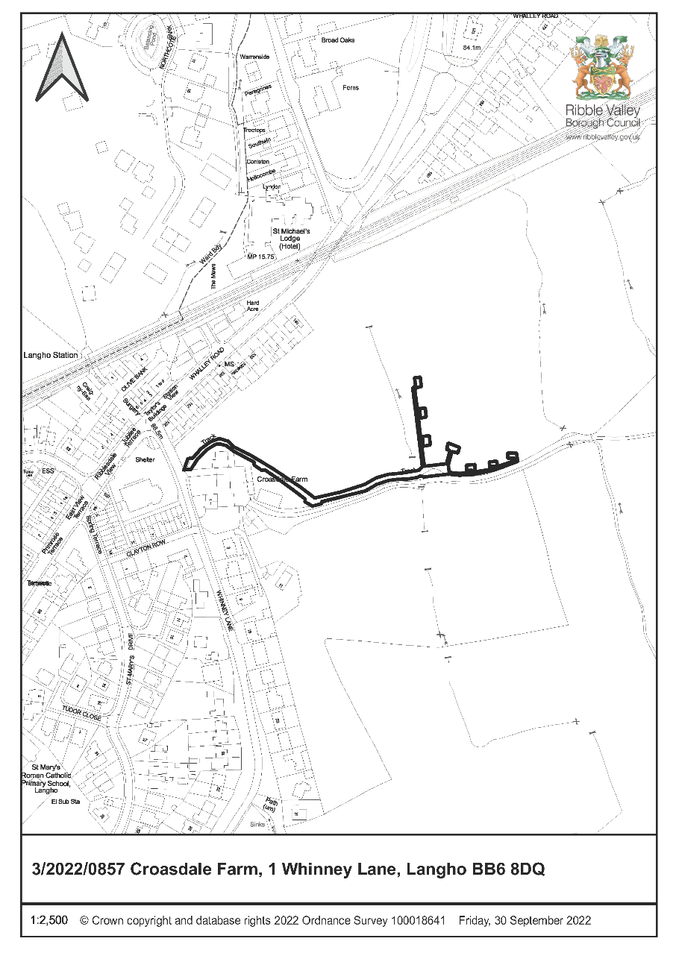

CONSULTEE RESPONSES/ REPRESENTATIONS MADE:

PARISH COUNCIL:

Billington and Langho Parish Council support the application stating the following:

- There is a lot of community support for this application.
- This application is supporting local businesses with increased footfall to local shops and pubs etc
- The applicant has been nominated as Best Newcomer for the tourist award via Visit Lancashire, and the parish council are proud of a parishioner achieving this – it benefits the area.
- A similar application for twice this space, 40 square meters as appose to 20 square meters which is comparable to this one was permitted, and the parish council would like to see this one passed by planning
- The applicant needs to gravel track and toilets in order to attract the right clientele.
- Members of the parish council have visited the site found the small site has been carefully planned with consideration for the landscape.
- The parish council found the gravel farm track unobtrusive and can barely be seen from nearby roads or a passing train.
- The current wooden toilet/shower block is in keeping with the agricultural setting and has the appearance of a stable.
- The tents on this development are taken down in the winter months, so only erected for months of the year.

ENVIRONMENT DIRECTORATE (COUNTY SURVEYOR):

The Highways Development Control Section have raised no objection to the proposal subject to the imposition of the following conditions.

- No part of the development hereby permitted shall be occupied until such time as the access arrangements shown on ALH Design Service drawing number 00A have been implemented in full.

Reason: To ensure that vehicles entering and leaving the site may pass each other clear of the highway, in a slow and controlled manner, in the interests of general highway safety and in accordance with the National Planning Policy Framework (2021). 2. The development hereby permitted shall not be occupied until such time as the access drive (and any turning space) has been surfaced with tarmacadam, or similar hard bound material (not loose aggregate) for a distance of at least 10 metres behind the highway boundary and, once provided, shall be so maintained in perpetuity.

- The development hereby permitted shall not be occupied until such time as the access drive (and any turning space) has been surfaced with tarmacadam, or similar hard bound material (not loose aggregate) for a distance of at least 10 metres behind the highway boundary and, once provided, shall be so maintained in perpetuity.

Reason: To reduce the possibility of deleterious material being deposited in the highway (loose stones etc.) in the interests of highway safety and in accordance with the National Planning Policy Framework (2021).

- The development hereby permitted shall not be occupied until such time as the parking and turning facilities have been implemented in accordance with ALH drawing number 00. Thereafter the onsite parking provision shall be so maintained in perpetuity.

Reason: To ensure that adequate off-street parking provision is made to reduce the possibility of the proposed development leading to on-street parking problems locally (and to enable vehicles to enter and leave the site in a forward direction) in the interests of highway safety and in accordance with the National Planning Policy Framework (2021).

RVBC ENVIRONMENTAL HEALTH:

The Environmental Health Officer has raised no objections to the proposal but has suggested, that should consent be granted, that it may be beneficial if charging points for electric vehicles were incorporated into the proposal to aid in reducing carbon emissions.

ADDITIONAL REPRESENTATIONS:

Seven letters of representation have been received objecting to the application on the following grounds:

- Impacts upon character and visual amenities of the area
- Increase in traffic
- Noise disturbance
- Ecological impacts
- On-going noise complaints
- Light Pollution
- Inappropriate development in the Green Belt
- Location unsuitable
- The running of the site is deviating from the exemption criteria and as such is nor permitted development

Nine letters of representation have been received in support of the application stating the following:

- The proposal is in keeping with the area
- Benefits to local economy
- Brings visitors into the area
- No landscape impacts

Members will additionally note that a ward councillor has requested that this application is determined by Planning and Development committee for the following reason:

- High level of public interest

1. Site Description and Surrounding Area

  - The application relates to an area of open aspect agricultural land associated with Croasdale farm, Langho The area of land to which the application relates is located within the designated Green Belt also being located outside of any defined settlement limits.

2. Proposed Development for which consent is sought

2.1 The application seeks retrospective consent for the retention of the unauthorised creation of an access track, a parking area, hard standing areas, pathways and the erection of a toilet/shower block. The development is located towards the southern extents of an existing parcel of agricultural land associated with Croasdale Farm.

2.2 The hardstandings benefit from a dispersed arrangement along the southern and western boundary of the field, all of which are served by an access track for users/occupiers with a parking area being located in the corner of the field acting as a central axis to the overall arrangement. The development includes a toilet/shower block located at the northern extents of the site along the western extents of the filed boundary.

3. Relevant Planning History

3/2022/0300:
The creation of an access track a parking area hard standing areas pathways and the erection of a toilet/shower block. (Withdrawn)

3/2021/0751:
Change of use of land from agricultural to camping with resurfaced track, gravel pitches and amenities. (Refused)

3/2019/0642:
Change of use of agricultural land to D2 (assembly and leisure) and installation of up to six camping pods/holiday cabin accommodation and associated site works. (Withdrawn)

4. Relevant Policies

Ribble Valley Core Strategy

Key Statement DS1 – Development Strategy
Key Statement DS2 – Sustainable Development
Key Statement DMI2 – Transport Considerations
Key Statement EC1 – Business and Employment Development
Key Statement EC3 – Visitor Economy
Key Statement EN1 – Green Belt
Key Statement EN3 – Sustainable Development
Key Statement EN4 – Biodiversity and Geodiversity

Policy DMB1 – Supporting Business Growth
Policy DMB3 – Recreation and Tourism Development
Policy DME1 – Protecting Trees and Woodlands
Policy DME2 – Landscape and Townscape protection
Policy DMG1 – General Considerations
Policy DMG2 – Strategic Considerations
Policy DMG3 – Transport & Mobility
Policy DME6 – Water Management

National Planning Policy Framework (NPPF)
National Planning Practice Guidance (NPPG)

Technical Guidance to National Planning Policy Framework

5. Assessment of Proposed Development

5.2 Visual Impact/ Appearance

5.2.1 Given the proposal lies within the defined Green Belt consideration must be given for the potential of the development to undermine the intrinsic character and openness of the area. Planning Practice Guidance provides clear guidance in respect of what factors that can be taken into account when considering the potential impact(s) of development on the openness of the Green Belt, in this respect the guidance states that:

Assessing the impact of a proposal on the openness of the Green Belt, where it is relevant to do so, requires a judgment based on the circumstances of the case. By way of example, the courts have identified a number of matters which may need to be taken into account in making this assessment.

These include, but are not limited to:

  - openness is capable of having both spatial and visual aspects – in other words, the visual impact of the proposal may be relevant, as could its volume;
  - the duration of the development, and its remediability – taking into account any provisions to return land to its original state or to an equivalent (or improved) state of openness; and
  - the degree of activity likely to be generated, such as traffic generation.

5.2.2 Key Statement EN1 and Policy DMG1 of the Ribble Valley Core Strategy are also primarily engaged for the purposes of assessing the proposal. Key Statement EN1 is engaged given that the proposal lies within land that benefits from a Green Belt designation, with Policy DMG1 being engaged given the policy largely relates to a wide range of design considerations for all proposals within the Borough.

5.2.3 The proposal seeks retrospective consent for the creation of 6 hardstanding areas to accommodate ‘tents/caravans’, with retrospective consent also being sought for the creation of associated track areas, parking area and the erection of an associated timber-clad shower/toilet block with access ramp.

5.2.3 The area in which the development is located is in characterised by being relatively open-aspect agricultural land delineated by occasional hedgerow planting with the immediate area being of a typical open agricultural appearance. Taking account of the character of the immediate area and land to which the application relates, the introduction of structures or engineered elements, of a non-agricultural appearance, are inevitably read as being both incongruous and discordant.

5.2.4 In respect of this matter, whilst the submitted details do not seek consent for the siting of tents or caravans, the proposed hardstanding areas are to facilitate the siting of such typologies of accommodation. In this respect the hardstandings will give these elements (and associated paraphernalia) an uncharacteristic level of visual permanence and prominence, within the designated Green Belt. Whereas if such elements were to be sited on the land without the benefit of such ‘standings’, it is considered that they would appear more informal and temporary in nature.

5.2.5 Notwithstanding the above matter, consideration must also be given in respect of the track areas, parking areas and associated shower/toilet block. The proposed shower/toilet block is of a timber-clad appearance benefitting from a mono-pitch roof arrangement, being of a largely rectilinear form. The block is located towards the northern extents of the proposal site, with both the building and other hardstandings benefitting from a somewhat dispersed arrangement. The shower/toilet block building, given its relative isolation from any nearby similar built-form, reads as being a largely incongruous and alien introduction into the landscape by virtue of its siting, design and overall form.

5.2.6 Further to the above, the shower/toilet block read in conjunction with the other associated elements for which consent is sought, only serves to exacerbate the discordant of the development cumulatively when considered as a whole. With the development undermining the sense of openness of the designated area and being of significant harm to the character and appearance of the immediate vicinity and such also proves injurious to the character and visual amenities of designated Green Belt.

5.9.9 It is for these reasons that the proposal is considered to be in direct significant conflict with Key Statement EN1 and Policy DMG1 of the Ribble Valley Core Strategy insofar that the proposal results in unwarranted visual harm to the character and visual amenities of the designated Green Belt.

5.3 Principle of Development:

5.3.1 The application site is located within the defined Green Belt, as such, in respect of the principle of the development, at a local level Key Statement EN1 is primarily (but not solely) engaged and at a national level Paragraphs 147 to 150 of the National Planning Policy Framework are also primarily engaged for the purposes of assessing the proposal, particularly in relation to any harm to the Green Belt which may be resultant from the proposal.

5.3.2. Key Statement EN1 is explicit insofar that ‘the overall extent of the green belt will be maintained to safeguard the surrounding countryside from inappropriate encroachment. The development of new buildings will be limited to the purposes of agriculture, forestry, essential outdoor sport and recreation, cemeteries and for other uses of land which preserve the openness of the Green Belt and which do not conflict with the purposes of the designation’.

5.3.3 In respect of the Framework, Para.149(b) states that authorities should regard the construction of new buildings as being inappropriate in the Green belt, with one of exceptions being ‘the provision of appropriate facilities (in connection with the existing use of land or a change of use) for outdoor sport, outdoor recreation, cemeteries and burial grounds and allotments; as long as the facilities preserve the openness of the Green Belt and do not conflict with the purposes of including land within it’.

5.3.4 Therefore, whilst Para.149(b) may be considered to be permissive of the provision of facilities for outdoor sport and outdoor recreation, this exception is only engaged where the facilities would ‘preserve the openness of the Green Belt’. As such, should it be determined that the proposal undermines the openness of the Green Belt, the initial support offered by being considered an ‘exception’ is considered fully disengaged with thew proposal being considered to be in conflict with this part of the Framework.

5.3.5 Given visual harm has already been identified (Visual Amenity/External Appearance) that considers the proposal would fundamentally undermine the visual and spatial openness of the Green Belt, it must therefore be considered that the proposed development also fails to benefit from the permissive exceptions of Paragraph 149 of the framework, in particular those intrinsic to para 149(b).

5.3.5 Policy DMB3 of the adopted development plan is also relevant given the proposed development seeks consent for a number of elements relating to that which would be considered to be recreation and tourism development. In this respect Policy DMB3 states that planning permission will be granted for development proposals that extend the range of tourism and visitor facilities in the borough subject to a number of criteria, one of which being that ‘the proposal must not conflict with other policies’ of the adopted development plan and that ‘the development should not undermine the character, quality or visual amenities of the plan area by virtue of its scale, siting, materials or design’.

5.3.6 As with para 149, given that visual harm has been identified that undermines the character, quality and visual amenities of the area, it must therefore also be considered that the proposal is in direct conflict with Policy DMB3 and as such the supportive and permissive nature of the policy in respect of tourism and recreational development is also considered fully disengaged

5.3.7 It is recognised that Paragraph 148 of the Framework, allows for harm within the Green Belt if such harm is outweighed by other considerations that would constitute ‘very special circumstances’. However, it is not considered that such special circumstances have been adequately or robustly demonstrated that would outweigh the significant identified visual and landscape harm resultant from the proposal. As such it is considered that the proposal is contrary to Paragraph 148 of the National Planning Policy Framework insofar that ‘very special circumstances’ have not been demonstrated that would outweigh the identified visual harm to the Green Belt resultant from the development.

5.3.8 Taking account the above matters and taking account of the identified visual harm, the proposal is considered to be in direct conflict with Key Statement EN1 and Policies DMG1 and DMB3(3) of the Ribble Valley Core Strategy and Paragraphs 147 and 149(b) of the National Planning Policy Framework.

5.4 Landscape and Ecology:

5.4.1 The application has been accompanied by a Preliminary Ecological Appraisal, the report concludes that there will be no significant impacts upon protected species or species of conservations concern resultant from the proposal. However, the report recommends that any lighting be directed by the use of baffles to prevent light spread on hedgerows and treelines that may disturb foraging and commuting bats.

5.4.2 The report also recommends the installation of four bat and four bird boxes on adjacent trees within the site to aid in ensuring biodiversity enhancement on site. The submitted details further propose the planting of areas of hedgerow on a parcel of land located to the east of the existing hardstanding’s with additional hedgerow being proposed along the southern and eastern boundaries of the land parcel.

5.5 Highway Safety and Accessibility:

5.5.1 The Highways Development Control Officer has raised no concerns in respect of the proposal subject to the imposition of conditions as outlined earlier within this report.

5.6 Other Matters:

5.6.1 Members will note that the site has been operational and accommodating holiday accommodation since 2020, during which period the use of the site has been subject to an ongoing enforcement investigation. The site has also been the subject of noise complaints in respect of music, noise, anti-social behaviour, and fireworks which are an Environmental Health matter. As such these matters are not considered material to the determination of the current application which solely seeks consent for the retention of an access track, parking area, hard standing areas, pathways and a toilet/shower block and does not relate to the ‘use’ of the land.

6. Observations/Consideration of Matters Raised/Conclusion

6.1 For the reasons outlined above the proposed development is considered to be in significant direct conflict with Key Statement EN1 and Policies DMG1 and DMB3 of the Ribble Valley Core Strategy and Paragraphs 147 and 149(b) of the National planning Policy Framework insofar that approval would result in development that significantly undermines and compromises the character and visual amenities of the designated Green Belt.

RECOMMENDATION: That the application be REFUSED for the following reason(s):

- The proposal is considered to be in direct conflict with Key Statement EN1 and Policies DMG1 and DMB3 of the Ribble Valley Core Strategy and Paragraphs 147 and 149(b) of the National planning Policy Framework in that the proposed development would result in significant measurable visual harm to the character, appearance and visual amenities of the designed Green Belt. Particularly insofar that the proposed hard standing areas, shower/toilet block, tracks and parking areas, when considered cumulatively, constitute an incongruous, unsympathetic, and discordant form of development that significantly detracts for the inherent open rural character of the designated area.

- The proposal is considered to be in direct conflict with Key Statement EN1 and Policies DMG1 and DMB3 of the Ribble Valley Core Strategy in that the proposed hard standing areas will afford sited structures (tents/caravans) and associated paraphernalia an uncharacteristic level of visual permanence and prominence, within the designated Green Belt, that would result in significant harm to the character and visual amenities of the designated area by virtue of their combined incongruous and anomalous appearance. As such, it is further considered that the proposal is contrary to Paragraph 148 of the National Planning Policy Framework insofar that ‘very special circumstances’ have not been demonstrated that would outweigh the identified visual harm to the Green Belt resultant from the development.

BACKGROUND PAPERS

https://webportal.ribblevalley.gov.uk/site/scripts/planx_details.php?appNumber=3%2F2022%2F0857

