

TREE WORK ASSESSMENT

DATE INSPECTED: |  |  |  |  |  |  |  | 11/01/23
TPO: | 60 – 1982 Crow Trees Brow, Chatburn
CONSERVATION AREA: |  |  |  |  | No
APPLICATION NO: |  |  |  | 3/2022/1078
SPECIES: |  | Sycamore
BS5837 CAT: |  |  | B |  |  | ASSESSOR: |  |  | A Shutt
 |  |  |  |  |  | SIGNATURE: |  |  | L Hayes
VISUAL TREE ASSESSMENT / COMMENTS

Trees are situated in a prominent position on the periphery of the Chatburn Conservation Area.

T1 is touching the house especially in high winds and full leaf. Following discussions with the landowner and arborist the description of works has been changed slightly to minimise impact on the overall amenity value but making sure the property will not sustain any damage form the trees eastern canopy.

T2 does have elongated limbs and due to historic crown raising, (HCR) static loading in the tips has been exacerbated, however due to the HCR the canopy area has been reduced significantly and greater than 10-15% of the upper canopy’s removal could be detrimental to the trees health and amenity value.

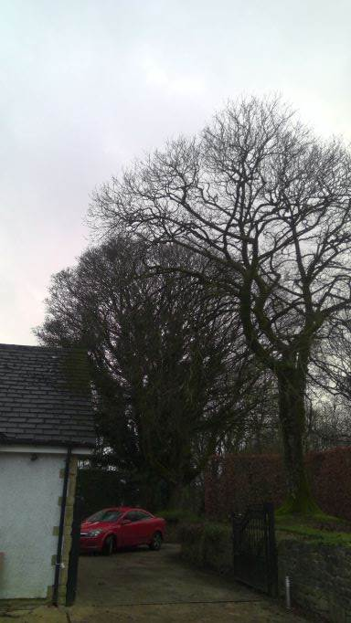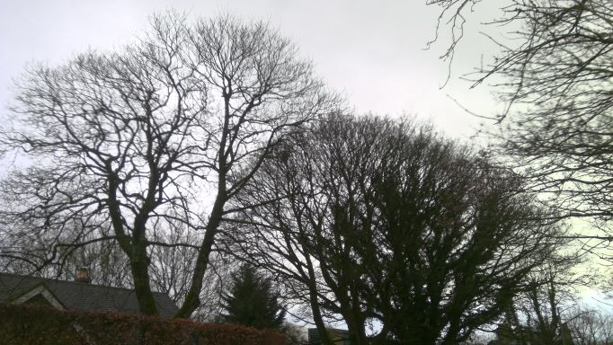

RELATED ISSUES: | YES |  | NO |  |  |  |  | YES | NO
Planning Application |  |  |  |  | Highway issue |  |  |  | 
Statutory Undertaker |  |  |  |  | Damage to property (proven) |  |  |  | 
Health & safety issues |  |  |  |  | Nuisance |  |  |  | 
Other (describe)* | 
Tree Management
AMENITY EVALUATION: |  | YES |  | NO
Carried out |  | N/A |  | N/A
Necessary |  | N/A |  | N/A

Application works appropriate? | YES 
Why?

T1 works will not affect the trees amenity value due to target pruning on the eastern side of the crown.

T2 works will minimise probability of failure and ensure the trees retention and ability to regenerate.
Alternative works more appropriate? | NO 
Describe Alternative Works:

