

TREE WORK ASSESSMENT

DATE INSPECTED: |  |  |  |  |  |  |  | 06/01/23
TPO: | No
CONSERVATION AREA: |  |  |  |  | Whalley
APPLICATION NO: |  |  |  | 3/2022/1121
SPECIES: |  | Cypress and Cedar
BS5837 CAT: |  |  | B - C (Group) |  |  | ASSESSOR: |  |  | A Shutt
 |  |  |  |  |  | SIGNATURE: |  |  | L Hayes
VISUAL TREE ASSESSMENT / COMMENTS

Trees are situated in a prominent, elevated position on the main road through Whalley. The cypresses are of low amenity value, however from the northern approach the cedar does have amenity value and Tree Preservation Order (TPO) could be justified if not for the suppression caused by the cypresses on the southern side creating an asymmetrical crown.

NORTHERN ASPECT
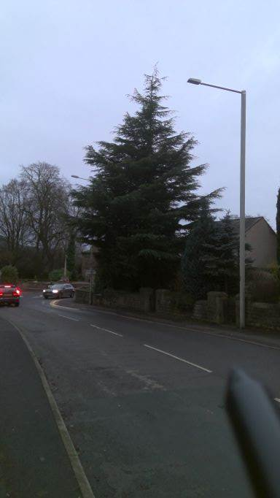

SOUTHERN ASPECTS
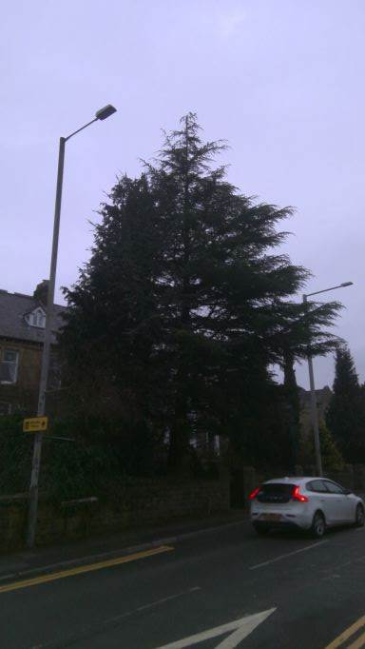
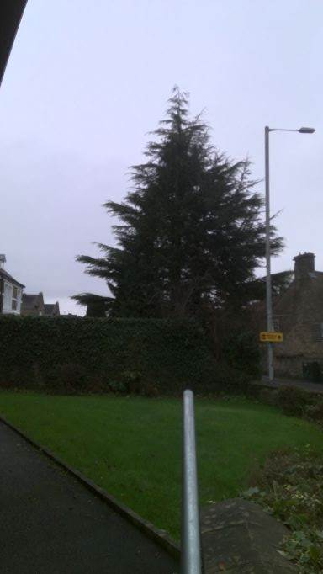

RELATED ISSUES: | YES |  | NO |  |  |  |  | YES | NO
Planning Application |  |  |  |  | Highway issue |  |  |  | 
Statutory Undertaker |  |  |  |  | Damage to property (proven) |  |  |  | 
Health & safety issues |  |  |  |  | Nuisance |  |  |  | 
Other (describe)* | 
Garden & Tree management
AMENITY EVALUATION: |  | YES |  | NO
Carried out |  | 
Necessary |  |  |  | 

Application works appropriate? | YES 
Why?

Tree group unsuitable for TPO protection
Alternative works more appropriate? | NO 
Describe Alternative Works:

