RECOMMENDATION FOR PLANNING AND DEVELOPMENT COMMITTEE

APPROVE WITH CONDITIONS

DATE: 16 FEBRUARY 2023
REF: LH
CHECKED BY: NH

APPLICATION REF: 3/2022/1128

GRID REF: SD 362179 443352

DEVELOPMENT DESCRIPTION:

PROPOSED NEW WINDOW OPENING TO NEW INTERNAL GROUND FLOOR SHOWER ROOM AT 6 CHURCH RAIKE, CHIPPING

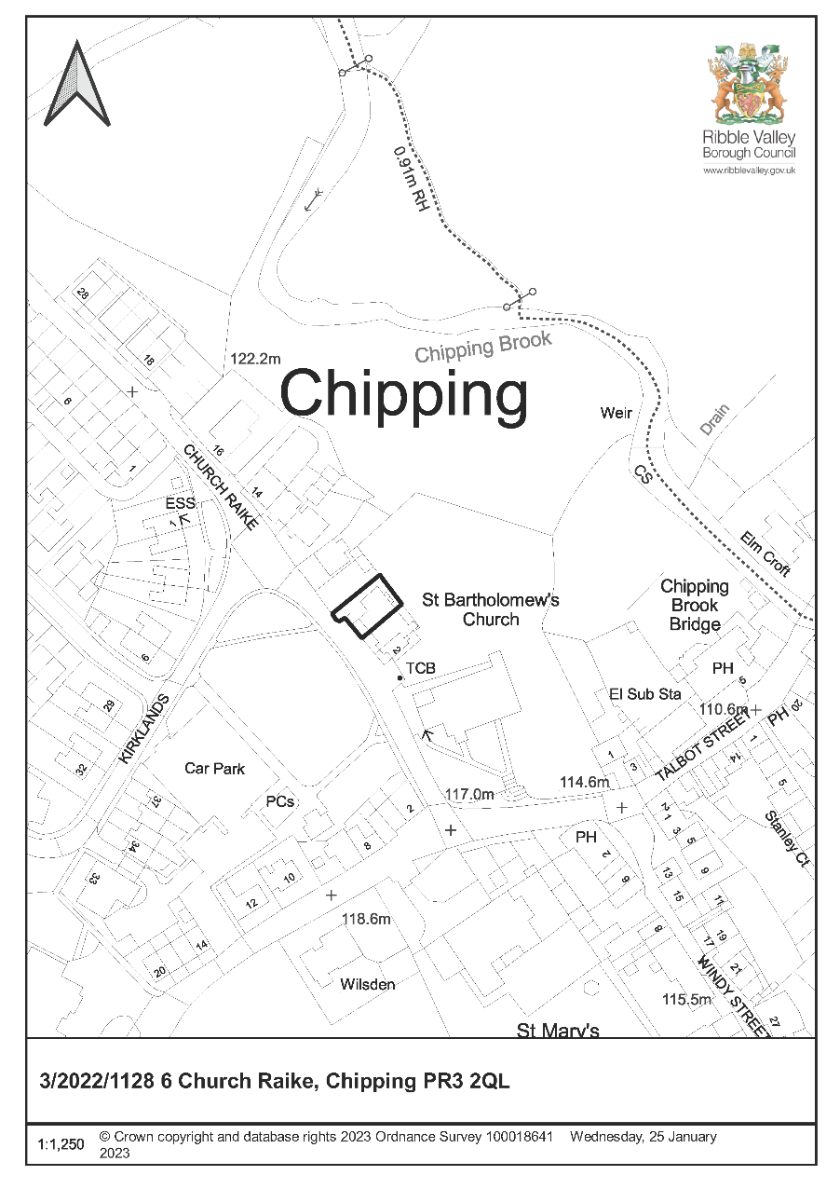

CONSULTEE RESPONSES/ REPRESENTATIONS MADE:

PARISH COUNCIL:

No comments received.

ADDITIONAL REPRESENTATIONS:

No representations received in respect of the application.

1. Site Description and Surrounding Area

  - The application relates to a two-storey stone-built cottage with a single storey side lean-to, single storey rear extension, and garden with detached garage to the side. The cottage adjoins no’s 2 and 4 Church Raike (Grade II Listed) to the south, beyond which is St Bartholomew’s Church (Grade II* Listed and a focal building within the village). The churchyard adjoins the eastern boundary of the site. To the north is a detached bungalow. The property is located at the northern extent of Chipping Conservation Area and is noted as a building of townscape merit.

  - This application is brought before Planning and Development Committee as the property is owned by a Local Councillor.

2. Proposed Development for which consent is sought

2.1 The application seeks planning consent for the erection of a new window opening in the single storey side addition (north elevation). This new opening would replicate an existing opening in that same elevation with matching stone head, cill and jamb detailing. It would serve a new shower room as such it would have obscure glazing.

3. Relevant Planning History

3/2013/0097: Proposed single storey extension of utility space and including removal of NW facing roof slope and door. (Approved)

3/2001/0568: Certificate of Lawfulness for a proposed conversion of garage to a dining area, WC and lobby. Parking area in front garden. (ls Lawful)

4. Relevant Policies

Planning (Listed Buildings and Conservation Areas) Act 1990

66. In considering whether to grant planning permission for development which affects a listed building or its setting, the local planning authority or, as the case may be, the Secretary of State shall have special regard to the desirability of preserving the building or its setting or any features of special architectural or historic interest which it possesses.

72. Special attention shall be paid to the desirability of preserving or enhancing the character or appearance of conservation areas.

Ribble Valley Core Strategy

Key Statement EN5 – Heritage Assets
Policy DMG1 – General Considerations
Policy DME4 – Protecting Heritage Assets
Policy DMH5 – Residential and Curtilage Extensions
National Planning Policy Framework (NPPF)
National Planning Practice Guidance (NPPG)

5. Assessment of Proposed Development

5.1 Principle of Development:

5.1.1 The proposed alteration is within the curtilage of a dwelling and is acceptable in principle.

5.2 Impact upon the character and appearance of Chipping Conservation Area and the setting of No’s 2 and 4 Church Raike

5.2.1 The LPA must accord with their duties at sections 66 and 72 of the Planning (Listed Buildings and Conservation Areas) Act 1990. ‘Preservation’ of conservation areas means “doing no harm to” (South Lakeland DC v. Secretary of State for the Environment [1992]).

5.2.2 This legislation is consistent with Key Statement EN5 of the Core Strategy which states there will be a presumption in favour of the conservation and enhancement of the significance of heritage assets and their settings. Policy DME4 of the Core Strategy supports development which makes a positive contribution and conserves and enhances the character, appearance and significance of conservation area in terms of its location, scale, size, design and materials.

5.2.3 The Chipping Conservation Area Appraisal identifies the stone historic buildings of traditional construction being one of the positive features of the Chipping Conservation Area. This appraisal identifies key unlisted buildings – buildings of townscape merit - which have been judged as making a positive contribution to the character and appearance of the conservation area and should be protected. The application property is one of these key buildings.

5.2.4 The proposed window would be located on the north elevation of the application property, facing away from No’s 2 and 4 Church Raike, a pair of C17th Grade II Listed cottages. The affected elevation is set back approximately 9 metres from the road and well screened by garden planting, some of which sits at a higher level than the property. The side window is modest in scale and would be read in the same frame as an existing window which it is replicating.

5.2.5 Due to its modest scale and discreet location on the side elevation of the property, the window would not be harmful to the setting of the adjoining Grade II Listed cottages or Church, or harmful to the character and appearance of the conservation area.

5.3 Visual Impact and Impact upon Residential Amenity

5.3.1 Policy DMG1 of the Ribble Valley Core Strategy states that all development must ‘be sympathetic to existing and proposed land uses in terms of its size, intensity and nature as well as scale, massing, style, features and building materials’ and ‘not adversely affect the amenities of the surrounding area’.

5.3.2 Due to its discreet location on the side elevation of the property, the window is not readily visible in the streetscene. Due to its sympathetic design it would not be harmful to the character of the existing building. Due to its distance from the neighbouring bungalow to the north and obscure glazed design, the window would not adversely affect the amenities of the neighbouring bungalow property to the north in terms of loss of privacy.

5.4 Other Matters:

5.4.1 No ecology impacts identified.

6. Observations/Consideration of Matters Raised/Conclusion

6.1 For the reasons outlined above, the proposal is considered to be in accordance with the Planning (Listed Buildings and Conservation Areas) Act 1990 and Key Statement EN5 and Policies DMG1, DME4 and DMH5 of the Ribble Valley Core Strategy.

RECOMMENDATION: That the application be APPROVED subject to the following conditions:

- The development hereby permitted shall be commenced before the expiration of three years from the date of this permission.

REASON: Required to be imposed pursuant to Section 91 of the Town and Country Planning Act 1990 as amended by Section 51 of the Planning and Compulsory Purchase Act 2004.

- The development hereby permitted shall be carried out in complete accordance with the proposals as detailed on drawings:

Site Location Plan Drawing A3948/PL02
Existing and Proposed Plans and Elevations Drawing A3948/PL01 Rev B

REASON: For the avoidance of doubt and to clarify which plans are relevant to the consent.

- The materials to be used on the external surfaces of the development as indicated on the application form and approved plans (Drawing A3948/PL01 Rev B) shall be implemented as indicated.

REASON: In order that the Local Planning Authority may ensure that the materials to be used are appropriate to the locality.

- The window hereby approved shall be fitted with obscure glazing (which shall have an obscurity rating of not less than 4 on the Pilkington glass obscurity rating or equivalent scale). For the avoidance of doubt the window shall be installed as such prior to first occupation of the room to which it relates and shall be retained as such in perpetuity.

REASON: To protect nearby/neighbouring residential amenities from overlooking.

BACKGROUND PAPERS

https://webportal.ribblevalley.gov.uk/site/scripts/planx_details.php?appNumber=3%2F2022%2F1128

