RECOMMENDATION FOR PLANNING AND DEVELOPMENT COMMITTEE

APPROVE WITH CONDITIONS

DATE: 16 FEBRUARY 2023
REF: LH
CHECKED BY: NH

APPLICATION REF: 3/2022/1164

GRID REF: SD 359757 436154

DEVELOPMENT DESCRIPTION:

PROPOSED TWO SINGLE STOREY EXTENSIONS SITUATED ON THE SIDE ELEVATIONS OF THE EXISTING CHANGING PAVILION, MARDALE PAVILION, LONGRIDGE

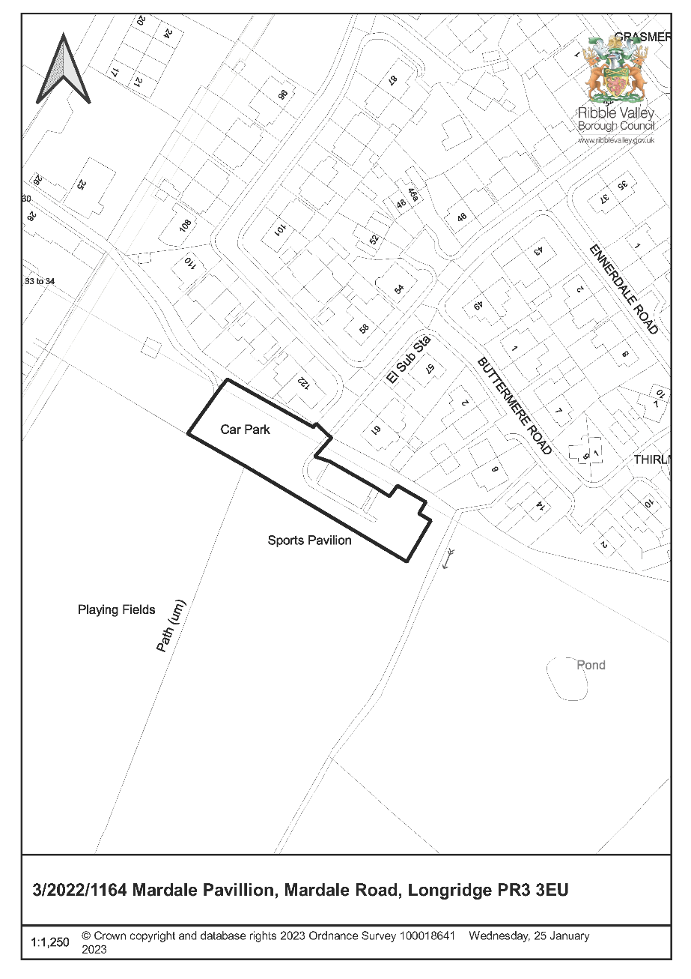
CONSULTEE RESPONSES/ REPRESENTATIONS MADE:

PARISH COUNCIL:

No comments received.

ADDITIONAL REPRESENTATIONS:

No representations received in respect of the application.

1. Site Description and Surrounding Area

  - The application site relates to a single-storey building used for changing facilities and associated car park at Mardale Playing Fields, Longridge. The playing fields extend to the south of the building. To the north is the site access, leading directly from Mardale Road, and a number of residential properties situated along Mardale Road, Hacking Drive and Buttermere Road. A public footpath runs across the western portion of the site.

  - This application is brought before Planning and Development Committee as the applicant is Ribble Valley BC.

2. Proposed Development for which consent is sought

2.1 The application seeks planning consent for the erection of two single storey extensions, one at each end of the pavilion building. The extensions would have very modest footprints of 4.4m x 2.26m. Each would be set back from the front of the building and run flush with the rear wall, with shallow sloping roofs to match the existing roof. They would be finished with white rendered walls and green tin roof to match the existing building, with green painted metal doors on the western elevation and roller shutter door on the eastern elevation. The extensions together with internal re-configuration of the existing building, will facilitate improved changing facilities for use in association with the playing field sports pitches.

3. Relevant Planning History

3/1998/0350: Construction of Changing Rooms (Approved)

3/1995/0240: Extension to existing car park (Approved)

4. Relevant Policies

Ribble Valley Core Strategy

Policy DMG1 – General Considerations
Policy DMG2– Strategic Considerations
Policy DMB4 – Open Space Provision

Ribble Valley Housing & Economic Development - Development Plan Document (DPD)
Policy OS1 – Open Space

Longridge Neighbourhood Development Plan

Policy LNDP12 – Protecting and Enhancing Local Green Spaces
Policy LNDP13 – Protecting and Enhancing Local Open Spaces

National Planning Policy Framework (NPPF)
National Planning Practice Guidance (NPPG)

5. Assessment of Proposed Development

5.1 Principle of Development:

5.1.1 The proposed development is outside of the defined settlement boundary of Longridge but meets the relevant criteria for development in rural areas outlined in policy DMG2 of the Ribble Valley Core Strategy being for small scale recreational development, and so is acceptable in principle.

5.1.2 The proposed extensions would not result in the loss of any playing field land nor impact on its use, therefore protecting important recreational and sporting land. Moreover, the proposal is to provide enhanced changing facilities to support the continued use of the sports pitches. Therefore, the proposal satisfies policy DMB4 of the Ribble Valley Core Strategy, Policy OS1 of the Ribble Valley Housing & Economic Development DPD, the Longridge Neighbourhood Plan and the NPPF and NPPG in respect of protecting open space and playing field provision.

5.2 Visual Impact and Impact upon Residential Amenity

5.2.1 Policy DMG1 of the Ribble Valley Core Strategy states that all development must ‘be sympathetic to existing and proposed land uses in terms of its size, intensity and nature as well as scale, massing, style, features and building materials’ and ‘not adversely affect the amenities of the surrounding area’.

5.2.2 Due to their discreet location, modest scale and sympathetic design, the extensions would be of an appropriate design and visual impact and blend in with the existing building. There would be no impact on a nearby public footpath which runs across a portion of the car park away from the pavilion.

5.2.3 A number of residential properties adjoin the northern boundary of the site with their rear elevations and gardens facing the existing building or car park, with the exception of No. 61 Mardale Road which has a side gable elevation and driveway adjoining the site access / boundary.

5.2.4 The proposed extensions would not exceed the height of the existing building nor project closer to these properties than the existing building. Due to their modest scale and intervening distance in between, the extensions would not adversely affect the amenities of these neighbouring properties in terms of being overbearing or overshadowing.

5.2.5 The proposed extensions and internal reconfiguration of the existing building would improve the existing facilities but would not directly result in an increase in the number of changing rooms. There is no proposal for the use of the site – including comings or goings - to intensify the proposals relate to the provision of suitable changing facilities for all users of the associated playing pitch. As such the proposal is not anticipated to directly result in any additional noise or disturbance to neighbouring properties.

5.3 Parking and Highway Safety

5.3.1 The proposed extensions would not result in the loss of any parking spaces nor generate the need for additional spaces, therefore there is no unacceptable impact on parking within the site nor highway safety on the wider highway network.

5.4 Other Matters:

5.4.1 No flood risk or ecology impacts identified. Part of the site is included within an area at risk of surface water flooding. The small area of grass that would be removed to accommodate the western extension is not considered to exacerbate this issue.

6. Observations/Consideration of Matters Raised/Conclusion

6.1 For the reasons outlined above, the proposal is considered to be in accordance with Policies DMG1, DMG2, DMB4 and OS1 of the Ribble Valley Core Strategy and Housing & Economic Development DPD.

RECOMMENDATION: That the application be APPROVED subject to the following conditions:

- The development hereby permitted shall be commenced before the expiration of three years from the date of this permission.

REASON: Required to be imposed pursuant to Section 91 of the Town and Country Planning Act 1990 as amended by Section 51 of the Planning and Compulsory Purchase Act 2004.

- The development hereby permitted shall be carried out in complete accordance with the proposals as detailed on drawings:

Site Location Plan
Proposed Floor Plans Drawing MARDALE 16/12/2022
Proposed Elevations Drawing MARDALE 16/12/2022

REASON: For the avoidance of doubt and to clarify which plans are relevant to the consent.

- The materials to be used on the external surfaces of the development as indicated on the application form shall be implemented as indicated.

REASON: In order that the Local Planning Authority may ensure that the materials to be used are appropriate to the locality.

BACKGROUND PAPERS

https://webportal.ribblevalley.gov.uk/site/scripts/planx_details.php?appNumber=3%2F2022%2F1164

